2002 January
一 月
Sunday | Monday | Tuesday | Wednesday | Thursday | Friday | Saturday
 |  | 1 | 2 | 3 | 4 | 5
6 | 7 | 8 | 9 | 10 | 11 | 12
13 | 14 | 15 | 16 | 17 | 18 | 19
20 | 21 | 22 | 23 | 24 | 25 | 26
27 | 28 | 29 | 30 | 31

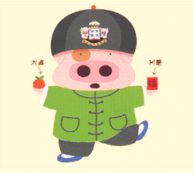
2002 February
二 月
Sunday | Monday | Tuesday | Wednesday | Thursday | Friday | Saturday
 |  |  |  |  | 1 | 2
3 | 4 | 5 | 6 | 7 | 8 | 9
10 | 11 | 12初一 | 13初二 | 14初三 | 15 | 16
17 | 18 | 19 | 20 | 21 | 22 | 23
24 | 25 | 26 | 27 | 28


2002 March
三 月
Sunday | Monday | Tuesday | Wednesday | Thursday | Friday | Saturday
 |  |  |  |  | 1 | 2
3 | 4 | 5 | 6 | 7 | 8 | 9
10 | 11 | 12 | 13 | 14 | 15 | 16
17 | 18 | 19 | 20 | 21 | 22 | 23
24/31 | 25 | 26 | 27 | 28 | 29 | 30


2002 April
四 月
Sunday | Monday | Tuesday | Wednesday | Thursday | Friday | Saturday
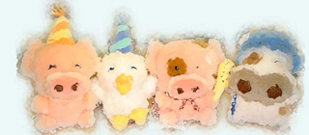 | 1 | 2 | 3 | 4 | 5 | 6
7 | 8 | 9 | 10 | 11 | 12 | 13
14 | 15 | 16 | 17 | 18 | 19 | 20
21 | 22 | 23 | 24 | 25 | 26 | 27
28 | 29 | 30

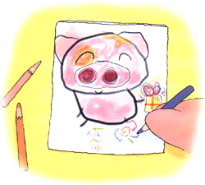
2002 May
五 月
Sunday | Monday | Tuesday | Wednesday | Thursday | Friday | Saturday
 |  |  | 1 | 2 | 3 | 4
5 | 6 | 7 | 8 | 9 | 10 | 11
12 | 13 | 14 | 15 | 16 | 17 | 18
19 | 20 | 21 | 22 | 23 | 24 | 25
26 | 27 | 28 | 29 | 30 | 31


2002 June
六 月
Sunday | Monday | Tuesday | Wednesday | Thursday | Friday | Saturday
 |  |  |  |  |  | 1
2 | 3 | 4 | 5 | 6 | 7 | 8
9 | 10 | 11 | 12 | 13 | 14 | 15
16 | 17 | 18 | 19 | 20 | 21 | 22
23/30 | 24 | 25 | 26 | 27 | 28 | 29

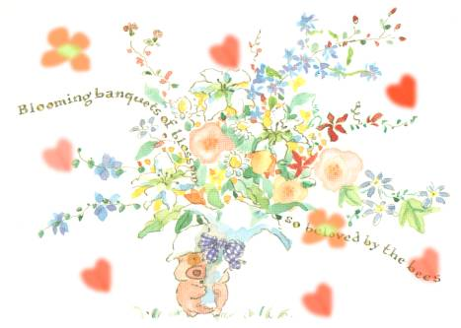
2002 July
七 月
Sunday | Monday | Tuesday | Wednesday | Thursday | Friday | Saturday
 | 1 | 2 | 3 | 4 | 5 | 6
7 | 8 | 9 | 10 | 11 | 12 | 13
14 | 15 | 16 | 17 | 18 | 19 | 20
21 | 22 | 23 | 24 | 25 | 26 | 27
28 | 29 | 30 | 31

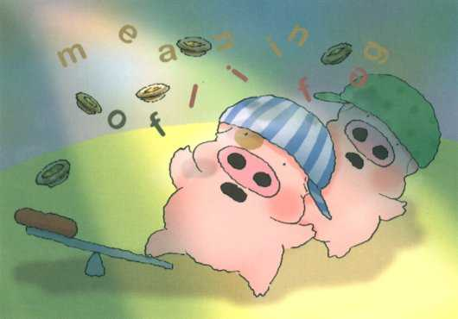
2002 August
八 月
Sunday | Monday | Tuesday | Wednesday | Thursday | Friday | Saturday
 |  |  |  | 1 | 2 | 3
4 | 5 | 6 | 7 | 8 | 9 | 10
11 | 12 | 13 | 14 | 15 | 16 | 17
18 | 19 | 20 | 21 | 22 | 23 | 24
25 | 26 | 27 | 28 | 29 | 30 | 31

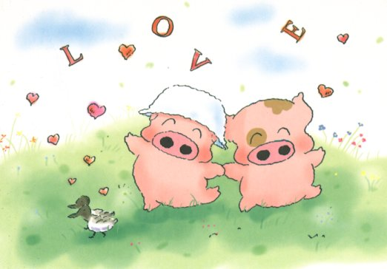
2002 September
九 月
Sunday | Monday | Tuesday | Wednesday | Thursday | Friday | Saturday
1 | 2 | 3 | 4 | 5 | 6 | 7
8 | 9 | 10 | 11 | 12 | 13 | 14
15 | 16 | 17 | 18 | 19 | 20 | 21
22 | 23 | 24 | 25 | 26 | 27 | 28
29 | 30

2002 October
十 月
Sunday | Monday | Tuesday | Wednesday | Thursday | Friday | Saturday
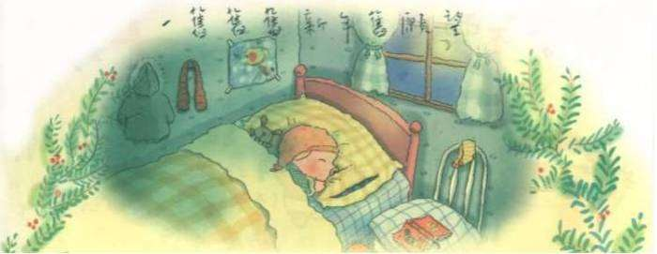 |  | 1 | 2 | 3 | 4 | 5
6 | 7 | 8 | 9 | 10 | 11 | 12
13 | 14 | 15 | 16 | 17 | 18 | 19
20 | 21 | 22 | 23 | 24 | 25 | 26
27 | 28 | 29 | 30 | 31

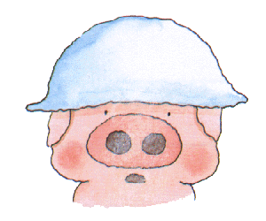
2002 November
十一 月
Sunday | Monday | Tuesday | Wednesday | Thursday | Friday | Saturday
 |  |  |  |  | 1 | 2
3 | 4 | 5 | 6 | 7 | 8 | 9
10 | 11 | 12 | 13 | 14 | 15 | 16
17 | 18 | 19 | 20 | 21 | 22 | 23
24 | 25 | 26 | 27 | 28 | 29 | 30

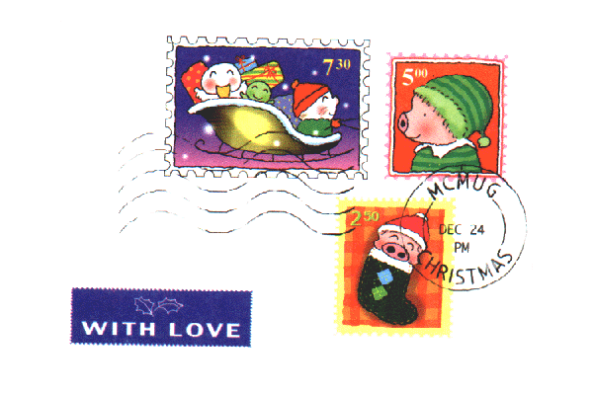
2002 December
十二 月
Sunday | Monday | Tuesday | Wednesday | Thursday | Friday | Saturday
1 | 2 | 3 | 4 | 5 | 6 | 7
8 | 9 | 10 | 11 | 12 | 13 | 14
15 | 16 | 17 | 18 | 19 | 20 | 21
22 | 23 | 24 | 25 | 26 | 27 | 28
29 | 30 | 31

