Adam Smith

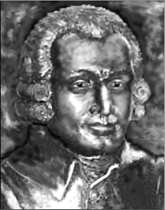
Adam Smith was born in Kirkcaldy, Fife, Scotland. The exact date of his birth is unknown, however, he was baptized on June 5, 1723. Smith was the Scottish political economist and philosopher, who became famous for his influential book "The Wealth of Nations" written in 1776.

Everyone knows Adam Smith. They know his great treatise, The Wealth of Nations. They know him to be the philosopher of "self-interest" who put avarice at the core of his values positing a mystical "invisible hand" which will take care of everybody so long as everybody takes care of himself or herself. They know him to be the philosophical mainstay of industrial capitalism in which the ever-greater "division of labour" reduces the worker to a mere "servo-mechanism" of the machine. They know him as the prophet of unrestricted free trade and the champion of” laissez-faire", "get the government off the backs of business" polity. Indeed, the ideas of Smith are the very ground of the economic and political life that we lead; hence, we absorb Smith in the very air that we breath, and know him so well that it is hardly necessary to read him at all; indeed, there are few who take the trouble to do so.

Students interested in this topic and want to go further, please browse the following related websites:
- http://www.adamsmith.org/
- http://socserv2.socsci.mcmaster.ca/~econ/ugcm/3ll3/smith/farrer.html
- http://www.ecn.bris.ac.uk/het/smith/dugald
- http://socserv2.socsci.mcmaster.ca/~econ/ugcm/3ll3/leslie/leslie01.html
- http://www.cia.gov/csi/studies/96unclass/examines.htm
- http://www.progress.org/banneker/adam.html

