
A Publication of the Calumet Chapter of the Institute of Management Accountants (IMA) (a group for anyone with an interest in accounting or finance serving Northwest Indiana and Southern suburbs of Chicago)
CALUMET ACCOUNTANT

www.geocities.com/imacalumet
Volume 64 No 7 December 2008

ANNUAL INCOMET TAX UPDATE
With the Calumet Chapter’s Very Own:
Howard D. Ellison, CPA, CMA, CVA
Anyone interested in this topic encouraged to attend
Date: Tuesday January 20, 2009
Location: Glenwood Oaks
106 N Main Street
Glenwood IL

Speaker: Howard D. Ellison, CPA, CMA, CVA Partner with the Accounting firm of Wermer, Rodgers, Doran and Ruzon

Times: 5:15 p.m. Board Meeting
6:00 p.m. Social Period
6:30 p.m. Dinner
7:40 p.m. Annual Tax Update

Cost: $30.00 For IMA members and guests
Reservations requested by
January 15, 2009
$10.00 College Students

Menu
The special will be Prime Rib Combination which is Prime Rib with choice of Chicken, Perch or Swanky shrimp
Also included: choice of soup or salad, fresh baked bread and choice of potato, Plus coffee, tea, and iced tea. Cash bar available.
To make reservations e-mail imacalumet@yahoo.com or call Mark at 219.864.8685 (H) or 630.530.6707(W) or Dick at 708.799.6234(H)

Directions:
From Illinois take the Bishop Ford Freeway to 394 toward Danville. Glenwood Dyer Road is a few miles down. The exit will be on your right.. You will curve a lot and eventually will be at Glenwood Oaks. From Indiana take US 30 West to 394 North. Once on 394 Glenwood Dyer Road. is the first exit. Glenwood Dyer Road will lead you to Main Street.

About the Speaker

The Calumet Chapter’s Very Own:
HOWARD D. ELLISON, CPA, CMA, CVA
Howard is a partner with the accounting firm of Wermer, Rodgers, Doran and Ruzon. He has B.B.A. in Accounting, summa cum laude, from the College of St. Francis with over ten years of experience in public accounting.
Member of the American Institute of Certified Public Accountants, Illinois CPA Society, National Association of Certified Valuation Analysts and Institute of Management Accountants. Howard is a Past president and board member of the Calumet Chapter of the Institute of Management Accountants.
Howard has experience in audits of manufacturing, construction, and wholesale/retail companies. Other experience includes substantial involvement in tax planning and preparation for individuals and business entities, specializing in closely-held family businesses for litigation, merger and acquisition, and estate and gift tax purposes, pension valuations, and litigation support services.

For more information about the firm visit http://www.wrdr.com

Welcome even more New members of the Calumet Chapter of the IMA

Laura Novak is a junior at Purdue Calumet. She plans on pursuing a master’s degree after graduation. Laura is extremely interested in forensic accounting and fraud examination. She is also a student member of the ACFE. Laura was at our October meeting and we hope to see her at some of the remaining meetings this year.

Mary Murphy is on track to graduate in the spring of 2009 from Davenport University. She is interested in obtaining the CMA certification. She was at our October meeting at the invitation of Jim Thomas of IUN. We thank Jim for inviting her and we are glad Mary joined the Calumet Chapter.

On behalf of the entire Calumet Chapter I welcome you to our chapter and hope you are able to attend some of our upcoming meetings. We love to meet our members in person. It is going to take me awhile to get to know all the new faces. Each month we will have introductions and name tags. We need everyone to keep spreading the word and when it is time to renew your membership please do so.

The Drive to 85 was a tremendous success. As this newsletter is written membership of the Calumet Chapter is at 86. We can not stop now we must continue the momentum as 88 would be great as we take the necessary steps to try and reach the 100 member goal for our historic 65th year coming in 2009-2010.

Details on how you too can join the Calumet Chapter (Hammond) are on the next page or click on the link to our website below

www.geocities.com/imacalumet

Welcome New Members
Of the Calumet Chapter of the IMA

Dr. Lee Schiffel who is a professor at Valparaiso University joined the Calumet Chapter since the last newsletter was published. She teaches a few courses at Valpo including auditing, accounting information systems, and Government and nonprofit accounting. She also teaches financial accounting for MBAS. The Valpo MBA program has been a proud sponsor of the Calumet Chapter of the Calumet Chapter for several years. Dr. Schiffel is originally from Utah but has been many places Turkey, Georgia, Virginia, California, Missouri, New York and now Indiana. Some of us have met her at the October and November meetings and we look for to her to seeing her at many more meetings.

Roger Goeckner is the Accounting Manager at ITW Zippak. He has been a member of the IMA since 1998. Congrats on 10 years Roger. He recently transferred to the Calumet Chapter. We have had the opportunity to meet him at the Boat Races in Kankakee as well our October meeting.

Julia Araiza is a student at Valparaiso University. We have not yet had a chance to meet her but hopefully in 2009.

Brittany Edwards is also a student at Valparaiso University who joined the Calumet Chapter recently. She was in attendance at our November meeting and we hope to get her back to future chapter meetings.

Jovanna Radlovic is a junior at Purdue University Calumet. I had the pleasure of meeting her when I spoke to the Purdue Calumet Finance and accounting Club in October. (http://www.pucfac.org) We hope to get her to some of our chapter meetings in the future.

Page 2

What You May Have Missed

On a special night Wednesday November 19, 2008 The Calumet Chapter of the IMA filled the back room of the Amarillo Roadhouse in Schererville Indiana for our Annual Ethics Presentation. All CMA certificate holders are required to have 2 hours of ethics annually and one of the chapter’s goals is to provide an opportunity to meet this requirement each year. On this night we had several students in attendance from Indiana University Northwest. (Pictured below This was the second IMA meeting that Ryan from IUN and Carmen from Loyola attended. They are pictured on the right) Unfortunately, we did not get the e-mails of those in attendance so if you know them ask these students (or anyone that would like to received our free e-mails) ask them to send their e-mail address to imacalumat@yahoo.com



On this night Valparaiso University was also well represented by Dr. Karl Reichardt as well as two of the Calumet Chapter’s newest members Dr. Lee Schiffel and Brittney Edwards who were mentioned earlier in this newsletter. Also, attending from Valparaiso University was Molly Keifer a student at the university.

Tim Anderson, CPA, partner with Clifton Gunderson LLP, Certified Public Accountants and Consultants gave the first part of the ethics presentation. Tim had the help of his colleagues from the Schererville office that added their ideas to come up with a very informative and educational presentation. He also managed to work in the IMA’s code of ethics. Members of the IMA have an obligation to the public, their profession, the organizations they serve, and themselves to maintain the highest standards of ethical conduct” The four key components to the IMA ethical standards are competence, confidentiality, integrity, and credibility.

PLEASE CONSIDER JOINING IMA-SPREAD THE WORD ABOUT THE CALUMET (HAMMOND) 081 CHAPTER

You can join IMA by going to https://www.imanet.org/membership_join.asp please make sure to select Calumet (Hammond) Chapter 081 as Chapter Affiliation. If your renewal is coming up please continue in the Calumet Chapter. I have given my word that this chapter will make it to it’s 65th year which will be 2009-2010. You do not have to be an accountant to join our group all you need is an interest in accounting.

Student Membership is an excellent deal for only $39.00
Regular membership is $195.00.
A discounted rate of $98.00 is available for full time faculty members of an accredited organization.
The membership for associate member is $65.00 first year after graduation and $130 the second year after graduation. If you require assistance with registration please contact Dick Mielcarz, Membership Acquisition, by E-mail at mycarz17@aol.com or telephone him at 708-799-6234

Page 3

Keep Your Contact Information Current

If there have moved recently, have a new job, new e-mail address please update that information with National. The website is http://imanet.org Username= your member number. If you do not know this number we can get it for you. The initial password is your last name. Once signed in go to the members only section which is the last link on the left side. Members only with a light blue section will pop up. Choose my profile and member directory. Your info will be shown. You can click on any blue link to edit the information. You can also call 1.800.638.4427 or mail in a change form which is located in the roster book.
Page 4
What Else You May Have Missed

There were many suggestions on how to implement proper internal controls in the presentation so that certain ethical dilemmas could be avoided. Below is a picture of Tim Anderson presenting although you can not see him to well. On the left we have Dick Mielcarz and Treasurer Deb Heim and that looks to be President Mark T. Camarena’s face on the right. (You can tell this was at the beginning of the night since there was still bread by the President. By that way that is Warren Cebulko’s arm buttering the bread)
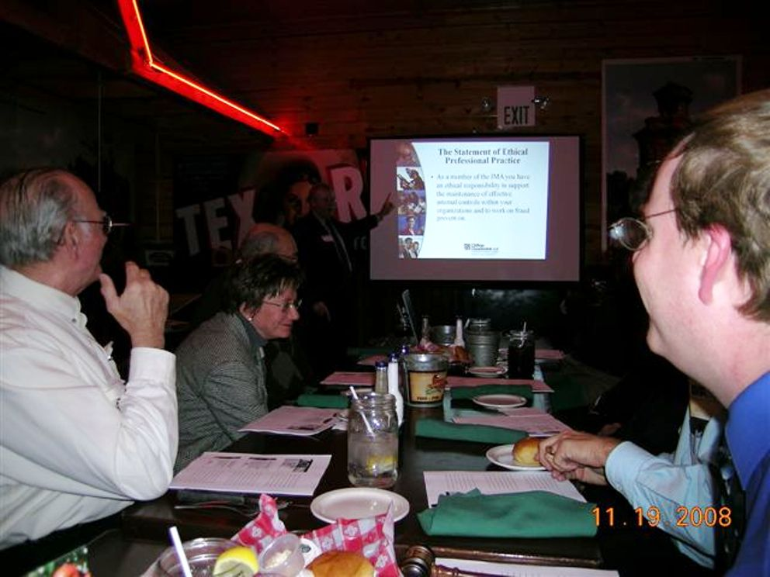

Tim also pointed out that when audit firms are switched the new audit firm is required to speak to the old audit firm so companies can not hide things. If you are interested in switching audit firms please consider Clifton Gunderson LLP you can reach Tim Anderson at 219.864.7300. We thank Tim for the presentation and certainly hope this is not the last we see of him.

J. Brian Hittinger of the law firm Krieg Devault presented the second hour of ethics. Brian earlier this year joined the chapter and we had him speak twice in 2008 first in February on Estate planning and now in November on ethics from a lawyer prospective. Both times he has been at the Amarillo Roadhouse as his office is located nearby.

Page 4

What Else you May Have Missed (continued)

Brian indicated that since he is licensed in both Indiana and Illinois there are numerous ethical laws that he must adhere too. Tim and Brian agreed that the ethical laws that lawyers are held to are much more than those in the accounting profession. Ethical laws can also very from state to state. There are different laws for Indiana and Illinois. It was very interesting to hear about what clients a lawyer or their firm could represent especially after leaving another firm. The ethical question was raised if a lawyer knows that he can not represent a party is it ethical that he recommends a competent lawyer but not necessarily the best lawyer? There were many other ethical questions raised throughout the night.

J. Brian Hittinger deals primarily with business law and estate planning. His firm Krieg Devault is a sponsor of the Calumet Chapter of the IMA and we ask that you support are sponsors so if you have any legal needs please contact J. Brian Hittinger at 219.227.6114. The Calumet Chapter thanks Brian for his presentation.

At this meeting the roster books for 2008-2009 were distributed. These roster books contain the Institute of Management Accountants Ethics policy. If you were unable to attend the November meeting and you are a member of the Calumet Chapter you should be receiving a roster book by the New Year. If you know that you are going to attend the January 20, 2009 meeting and have not received the roster book please let Warren Cebulko know as then we can save the postage if you can pick it up at the January meeting. You can contact Warren at wcebulko@yahoo.com The roster book also contains sponsors of the Calumet Chapter which we ask you to support.

The meeting concluded by 9:10 p.m. as promised and we hope that we achieved our goal of having an informative as well as fun meeting.

Effective January 1, 2009 New testing time window and schedule:
Effective January 1, 2009, the CMA exam will be offered according to the following schedule:
January and February: Parts 1, 2, and 3
March: no exam parts offered
April: Part 4 only
May and June: Parts 1, 2, and 3
July: no exam parts offered
August: Part 4 only
September and October: Parts 1, 2, and 3
November: no exam parts offered
December: Part 4 only

President’s Message
By Mark T. Camarena, CMA

Dear Readers:

HAPPY HOLIDAYS.

Mark T. Camarena, CMA
President (markt@550access.com or telephone 630.530.6707 (W) 219.864.8685(H)
Calumet Chapter of the IMA (an organization for anyone with an interest in accounting or finance serving Northwest Indiana and Southern Suburbs of Chicago)
Calumet Chapter
2008-2009
Officers and Directors

President Mark T. Camarena 630.530.6707 (W) markt@550access.com
Secretary Jim Spice 815.933.0491(W) jaspice@citykankakee-il.gov
Treasurer Deb Heim 630.378.6308 (W) debra.heim@patterson_medical.com
VP Administration Adolph Ferber 219.836.1476 (H) aferber@att.net
VP Communications Richard Mielcarz 708.799.6234(H) mycarz17@aol.com
VP Professional Education Bill Biller biller6625@comcast.net
VP Membership (Retention) Anthony Fontana 708.534.5000 ext 5434 (W) a-fontana@govst.edu
Academic Relations Wes Christensen weschristensen@comcast.net
New Members Richard Mielcarz 708.799.6234(H) mycarz17@aol.com
Director of Employment Al Zurawski 219.477.4488 ext 222 (W) al@okaya.com
Chapter Photographer Al Zurawski 219.477.4488 ext 222 (W) al@okaya.com
Director Program Rosters Warren Cebulko wcebulko@yahoo.com
Director of Manuscripts Bruce Flowers 219.322.2300 (W) bruceflowers@yahoo.com
Director at Large Brian Guse 219.362.1531(W) bguse@nyb.com

COMING IN 2009-2010 THE HISTORIC 65TH ANNIVERSARY ROSTER BOOK

Earlier this year many companies told me if the budgets had been set and if they had known pricing at budget time they would have considered advertising in our roster book. No payment is due until the books are printed (hopefully September) so if you are planning your budget now please consider the Calumet Chapter of the IMA as a low cost advertising option to reach a select group of individuals. The IMA Calumet Chapter is a not for profit organization.

The prices for ads in the 2009-2010 Roster Book are as follows:
Back Outside Cover $250.00
Front Inside Cover $200.00
Back Inside Cover $175.00
Full page ad $150.00
Half page ad $100.00
Business card ad $75.00
Sponsorship Listing (this is a listing in the roster book with no ad) $25.00

The ad sizes can be modified from just about any size; the final ad sizes appear in the book as 3 1/2"(w) by 8"(h) or smaller, depending on content and layout of the ad. For more information please feel free to contact myself imacalumet@yahoo.com or 630.530.6707 or 219.864.8685 or Warren Cebulko who has done a stupendous job on these roster books for the last several years wcebulko@yahoo.com.

2008-2009 SCHEDULE OF EVENTS (Subject to Change)

Tuesday January 20, 2009- Glenwood Oaks 106 N Main Street Glenwood Illinois- Annual Tax
Update with Howard Ellison

Tuesday February 17, 2009 – Angelino’s 9301 West 191st Street Mokena IL 60448. Topic: International Financial Reporting Standards (IFRS) presented by Denise Grivetti professor at Governor’s State University special guest Tony Fontana Governor’s State University. $30 MUST RSVP COLLEGE STUDENTS $10 MUST RSVP

Tuesday March 24, 2009- Zuni’s 5124 Pine Island Court Crown Point Indiana 46307. Member Appreciation Night and Student Night II The location has been confirmed and the Federal Reserve Bank of Chicago has confirmed one of their economists will be coming. Proposed Pricing $25.00 non members $20.00 IMA members and their guests $10.00 students

Wednesday April ??, 2009- Purdue University Calumet Hotel and Restaurant Management Club Dinner. As soon as the date is chosen it will be communicated. This is an invite your spouse/guest event and last year was sold out over a month in advance. This year we are hoping to get some representatives of the Purdue Finance and Accounting Club to talk about some of the club activities.

?? April or May??, 2009 Arrangements are being made to hold a joint meeting with the Governor’s State University Finance and Accounting Club. Last year this event was a smashing success. Each group was extremely pleased and we hope to make this a tradition.

Tuesday May 19, 2009- This will be the traditional bring your spouse/guest meeting. It will be the conclusion of the Chapter’s 64th year and time ready for the Chapter’s historic 65th year which we will celebrate through 2009-2010. The location is Gino’s Steakhouse 1259 W Joliet Street (US30) Dyer Indiana with nationally recognized speaker Leanne Hoagland-Smith whose has published thousands of articles and who is scheduled to have a nationally published book Unlocking Sales Results in April 2009. As long as everything goes according to plan, Leanne will be bringing along her book for members to purchase and she has agreed to sign her book that evening. The topic will be “Life is a Journey will you have a smooth ride or a Bumpy one” Look for her column every Monday in the Post-Tribune. For more information about Leanne Hoagland-Smith visit www.processsspecialist.com

Visit us online at www.geocities.com/imacalumet e-mail us anytime at imacalumet@yahoo.com

