GTA 17-2-15

THE CALL FOR FIRE
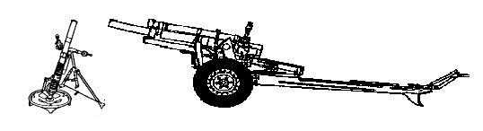

HEADQUARTERS, DEPARTMENT OF THE ARMY

October 1985

DISTRIBUTION RESTRICTION: (Refer to instructions on page 6)

- OBSERVER IDENTIFICATION: Use call signs for the CEOI.
- WARNING ORDER:
  - Type of Mission:
    - Adjust Fire
    - Fire for Effect
    - Suppress (Planned Target).
    - Immediate Suppression
  - Size of Element to Fire:
    - Omission indicates a request for one FA battery.
    - Larger units by stating size desired.
  - Method of Target Location:
    - Grid: No Announcement.
    - Polar Plot: Announce the word “POLAR”.
    - Shift from Known Point: Announce the word “SHIFT” followed immediately by the designation (TGT Number) of the known point
- TARGET LOCATION:
  - Grid: Two character six digit grid, i.e., NA123456
  - Polar: Direction and distance to target from observer’s position.
  - Shift: Direction to target.
    - Lateral Shift (left/right) in meters.
    - Range Shift (add/drop) in meters.
    - Vertical Shift (up/down) in meters if significant.
- TARGET DESCRIPTION: A word picture of the target (i.e., the number and type of vehicles/personnel observed).
- METHOD OF ENGAGEMENT:
  - Type Engagement:
    - Area Fire: Standard without request.
    - Precision Fire: Used only with destruction or registration missions.
  - Danger Close: Announce when applicable.
  - Trajectory:
    - Low Angle: Standard without request.
    - High Angle: Upon request of observer or when required due to masking.
  - Ammunition:
    - Type projectile desired in Fire for Effect phase.
    - Type of fuse action desired in Fire for Effect phase.
    - Volume of fire desired in Fire for Effect stated in rounds per howitzer.
    - Distribution: Type of Sheaf desired. Parallel is standard without request.
- METHOD OF FIRE CONTROL:
  - Method of Fire:
    - Center Platoon/Center Section (one weapon) is standard for adjustment phase.
    - Battery/Platoon right/left on request
    - Time Interval (5 seconds is standard when (2) above is used).
  - Method of Control:
    - 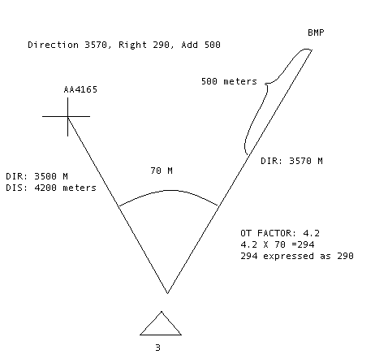Fire when Ready: Standard – no request required.
    - At my command: Weapons fire at observer’s command.
    - Cannot observe: Fire will not be observed.
    - Time on Target: Rounds land at a specific time.
    - Continuous Illumination: FDC will determine when to fire.
    - Coordinated Illumination: Observer determines when illumination is fired.
    - Cease Loading: Used on missions with two or more rounds in effect. Causes the firing unit to stop loading rounds.
    - Check Fire: Temporary Halt in firing.

DANGER CLOSE
The term DANGER CLOSE will be included in the Method of Engagement portion of the call for fire when the target is within 600 meters of any friendly troops for both mortars and field artillery. When adjusting naval gun fire the term DANGER CLOSE will be announced when the target location is located with in 750 meters when using 5 inch or smaller naval guns. For naval guns larger than 5 inch, DANGER CLOSE will be announced when the target is within 1000 meters.

The creeping method of adjustment will be used exclusively during DANGER CLOSE missions. The FO should make range changes by creeping the rounds to the target using corrections of no more than 100 meters.

TARGET LOCATION
- GRID:
  - Determine a two character, six digit grid for the target
  - Determine a grid direction to the target and send after the call for fire and before any subsequent corrections.
- POLAR:
  - Determine the grid direction to the target
  - Determine the distance from the observer to the target
  - Determine if any significant vertical interval exists.
- SHIFT:
  - Determine the grid direction to the target
  - Determine the lateral shift to the target from the known point
    - W = RM (mil relation formula)
    - W = Width of lateral shift (the unknown)
    - R = Distance to the known point divided by 1000 and rounded to one decimal place
    - M = Measured angel in mils from the known point to the target
  - Determine the range shift from the known point to the target
Complete Target Location:

MINIMUM BRACKETING GUIDE
If estimated range to the target is: | Then | Initial bracket is:
0-1000 meters |  | 100 meters
1000-2000 meters |  | 200 meters
2000 meters and beyond |  | 400 meters
NOTE: Estimated range to the TARGET is the basis used for choosing the initial bracket.

RANGE CORRECTIONS
In conducting an adjustment on a target, the observer should establish a range bracket as early in the adjustment in possible. When the first definite range spotting is made, the observer should make a range correction that will cause the net round to be spotted opposite that of the previous round. For example, if the first definite range spotting is SHORT, the observer should ADD a sufficient amount to obtain an OVER spotting on the next round. Likewise, if a spotting is OVER, he should DROP a sufficient amount to obtain a SHORT on the next round. The observer then cuts each range correction in half, successively moving each round closer to the target.

DEVIATION CORRECTIONS
The distance in meters that the burst is to be moved left or right is determined by multiplying the deviation in mils (the deviation spotting) by the OT distance in thousands of meters (the OT factor). Deviation corrections are expressed to the nearest 10 meters. A deviation correction of 20 meters or less is considered a minor deviation and will be ignored during the fire mission.

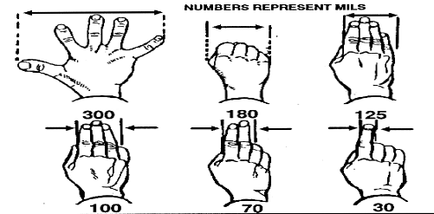The OT factor is determined by rounding your estimated range to the target to the nearest thousand and expressed in thousands.

OT distance greater than 1000 meters round to the nearest thousand meters | EX.1800=2000=2 OT factor of 2  1000 1000 1
OT distance less than 1000 meters round to the nearest 100 meters | EX. 800 = .8 OT factor

The computed deviation correction is announced to the FDC as LEFT(RIGHT) so much, the direction of the correction being opposite that of the spotting.

DETERMINING DIRECTION TO A TARGET
Determining direction is an essential skill for the FO. Direction is an integral part of terrain-map association, adjustment of fire, and target location. There are five methods of determining direction:
  - USING A COMPASS. Using an M2 or lensatic compass, the FO can measure direction. The FO will add/subtract the GM angle to determine the grid direction to send to the FDC.
  - SCALING FROM A MAP. Using a protractor or an OF fan (observed fire fan) the FO can scale direction from a map to an accuracy of 10 mils.
  - MEASURING FROM A REFERENCE POINT. Using a reference point with a known direction, the FO can measure the angle between the reference point and his target and ADD/SUBTRACT the measured angle TO/FROM the known direction to determine the direction to the target. The angle between the reference point and the target can be measured with bino’s or with the hand measurement technique as depicted below.
  - ESTIMATING. With a thorough terrain-map analysis, the FO can estimate direction by visualizing the eight cardinal directions (N, NE, E, SE, S, SW,W, and NW).
  - USING OTHER MEASURING DEVICES. The FO can use other measuring devices such as an aiming circle, battery commander’s scope, or a laser device, which can provide direction to the nearest mil.
The FO should try to be as accurate as possible and the use of mils is preferred. All measured directions sent to the FDC will be rounded to the nearest 10 mils.

ESTIMATING ANGLES IN MILS WITH THE HAND

SENDING CALL FOR FIRE
The standard call for fire is transmitted using field artillery radiotelephone procedures in three radio transmissions:
  - Observer’s identification and warning order
  - Target Location
  - Target Description, Method of Engagement, and Method of Fire and Control
The Simplified call for fire (used only with suppress and immediate suppression missions) is send in one radio call containing, at a minimum, the observer’s identification, warning order, and target location.

EXAMPLE: STANDARD CALL FOR FIRE
- T2F18 THIS IS T2F24, ADJUST FIRE OVER.  - GRID 123456, OVER  - 3 TANKS AND 3 BMPs IN THE OPEN DPICM IN EFFECT, AT MY COMMAND, OVER.  - I AUTHENTICATE CHARLIE, OUT.  EXAMPLE: Simplified Call for Fire  - T2F18 THIS IS T2F24, IMMEDIATE SUPPRESSION TGT AB 3001, OVER  - I AUTHENTICATE DELTA, OUT. | - T2F24 THIS IS T2F18, ADJUST FIRE OUT.  - GRID 123456, OUT  - 3 TANKS AND 3 BMPs IN THE OPEN DPICM IN EFFECT, AT MY COMMAND, AUTHENTICATE PAPA BRAVO, OVER.  - T2F24 THIS IS T2F18, IMMEDIATE SUPPRESSION TGT AB 3001, AUTHENTICATE TANGO FOXTROT, OVER.

DISTRIBUTION RESTRICTION: This publication contains technical or operational information that is for official government use only. Distribution is limited to US government agencies. Request from outside the US government for release of this publication under the Freedom of Information Act or Foreign Military Sales Program must be made to HQ TRADOC, Ft. Monroe, VA 23651-5000

DISTRIBUTION: US Army Training and Audio Visual Support Centers (TASC).

