Brian Cowden
Musconetcong Home Rivers Initiative Coordinator

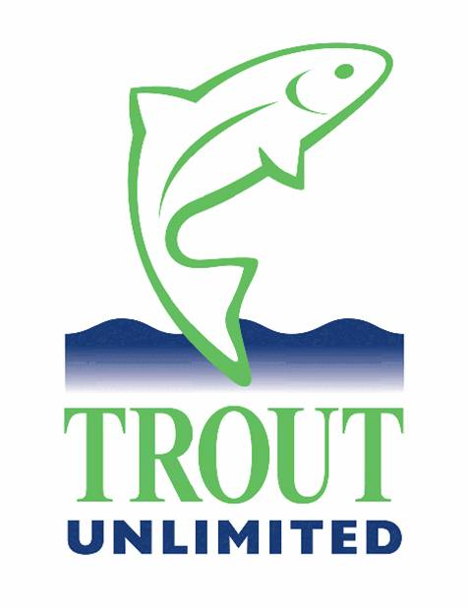
March 3, 2009

Well, it has been a very busy winter season for yours truly. Winter is time to identify work projects and to write grants to pay for those projects. This winter promises up to 13 riparian planting projects throughout the watershed, some on the Musky and some along the banks of several tributaries. I will attempt to get as much involvement from our TIC schools in the watershed as possible. Our growing partnership with the Holland Township School on the lower river where students planted 600 native trees and shrubs last Sept. will continue this year with a cattle stream crossing project and riparian buffer planting. We have also engaged the local communities in the watershed to increase our riparian buffer work. A section of Lubber’s Run in Byram Twp. will see its first riparian buffer along private property along that important Musky tributary with assistance from the Byram Environmental Commission and several local landowners.

In addition to riparian plantings, we have numerous “rock-rolling” projects lined up. One is to repair three riffles above the now removed Seber Grove Dam between Mount Olive and Hackettstown on the upper river. There are stone weirs built by hand over these riffles causing bank damage when the river flanks them. Work dates will be announced as the weather gets warmer. These are not the types of projects designed for student help, so I will be soliciting TU and other volunteers. I have found tremendous success in posting on some of the local trout fishing forums; many members of these forums had come out last year to help and most have since become active TU members. I have more support this winter by far than I did last year by discussing TU’s activities with the Musconetcong Home River Initiative on these forums. Part of my charter is to help grow our grassroots membership and along with half price offers placed at fly shops and at the Pequest Hatchery, I find the forums an excellent source of new blood.

Another rock rolling project still in the design phases is to improve the upstream banks above the former Gruendyke Dam. Some of the sediment dredged from the riverbed and used to build new banks has sloughed off back into the river. Designs are being worked on with approvals and permits to follow for TU volunteers to work on repairing those banks. We are adding fish habitat enhancement work to this so that large boulders or woody debris can be added at the same time as the bank stabilization work.

The Finesville Dam removal project continues to move along on schedule for removal in early 2010. This is the first dam upstream of the confluence with the Delaware River. I have meetings lined up with additional dam owners to discuss dam removals and preservation of some of these properties following any additional removals. Although it is too early to discuss in details more about these potential projects, there are some exciting things on the horizon for the Musky! I mentioned earlier that the Seber dam has been removed, that work completed in mid-February with follow up fish habitat enhancement to follow once the river channel has stabilized and more of the sediment upstream has washed through this site. This will be another opportunity for TU chapter involvement once we have plans in place. Large boulders that I was able to have donated by K. Hovnanian remain on site awaiting this work.

Working with partners, TU was helpful in getting over 350 acres into preservation immediately downstream of the Point Mountain TCA area and along the banks of the Musky. That deal is expected to close in the early summer months. Our preservation efforts are only in the early stages in this Home Rivers Initiative. TU and partners hope to make an exciting announcement shortly about preservation in the upper reaches of the South Branch watershed, a spin-off of our work in the Musky watershed. Stay tuned!
I also want to solicit help from all 9 of our chapters state wide for the annual Musconetcong River Clean-Up with our partners at the Musconetcong Watershed Association. Our Central Jersey chapter has been a long-time supporter of this effort and last year several additional NJTU chapters came out to help as well. This year I’ve already heard from our Jersey Shore chapter that they have at least 10 volunteers willing to come out on Sat., April 18th to help as well. They will join members of our E. Schweibert chapter to clean up the lower river down to the Delaware.

Lastly, I just learned today in my weekly Eastern Conservation staff conference calls that we have had two of our more major river restoration projects funded by the new federal stimulus bill. Details will be forthcoming in my next report, but we can expect at least one major public water stretch of the Musky to have a river restoration project that will include heavy machines working in the river to improve habitat degraded by poor land use practices. And I can promise you all better fishing in that area as a direct result! As we continue to ramp up our Musconetcong Home Rivers Initiative, I will be in constant need of volunteers from TU and the outside. Please consider lending a hand when and where you can to our many projects. I will contact our chapters and post on the state website (www.njtu.org) about upcoming volunteer related events. Thank you all for you continuing support of TU’s work in this wonderful watershed!

Tight lines - Brian

