University Of Aden

Faculty Of medicine And Health Sciences

Dentistry Section

Oral Pathology

4th Year

2007/2008

Tongue Cancer

Prepared By:

Marwan Salem Saleh Alamry C13

Tongue Cancer

Definition
Tongue cancer is a subgroup of head and neck cancer. In this disease, cancer develops from the squamous cells of the tongue leading to local tumor growth, and later metastatic spread.
Cancer occurs when cells in the body (in this case, tongue cells) divide without control or order. Normally, cells divide in a regulated manner. If cells keep dividing uncontrollably when new cells are not needed, a mass of tissue forms, called a growth or tumor. The term cancer refers to malignant tumors, which can invade nearby tissues and can spread to other parts of the body. A benign tumor usually does not invade or spread.
Tongue cancer is often grouped with other mouth cancers, such as cancer of the lips, hard palate, cheek lining, floor of the mouth (portion of the mouth underneath the front of the tongue), or gums. These cancers are collectively known as oral cavity cancer.

Cancer of the Tongue
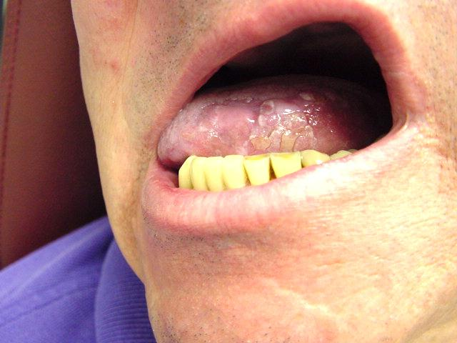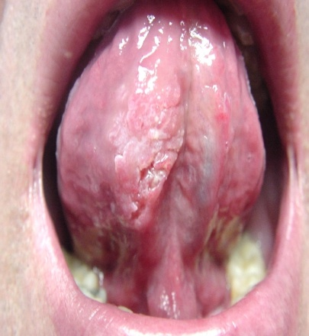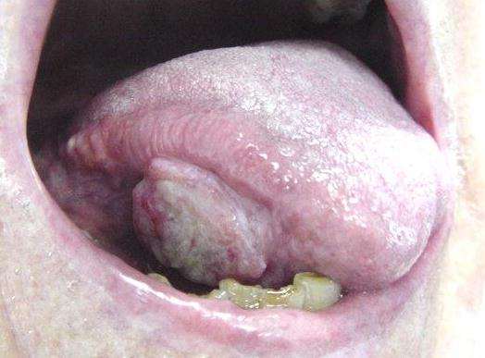

Causes
The exact cause of tongue cancer is unknown. However, the following lifestyle factors may be related:
- Smoking cigarettes, cigars, or a pipe
- Use of chewing tobacco, snuff, or other tobacco products
- Heavy alcohol consumption

Risk Factors
A risk factor is something that increases your chance of getting a disease or condition.
Risk factors include:
- Sex: Male
- Poor oral and dental hygiene
- Age: 40 and over
- Irritation of the mucous membranes in the mouth due to smoking and drinking
- History of mouth ulcers
- Family history due to genetic predisposition
- Dentures
Other definite risk factors include:
- Poor diet
- Having a weakened immune system
- Being exposed to some chemicals
- Viruses
- Acid reflux
- Sunlight

Types of tongue cancer
The most common type of tongue cancer is squamous cell carcinoma (SCCA). Squamous cells are the flat, skin-like cells that cover the lining of the mouth, nose, larynx, thyroid and throat. Squamous cell carcinoma is the name given to a cancer that starts in these cells.

Symptoms
The symptoms of tongue cancer may include
- A red or white patch on the tongue, that will not go away
- A sore throat that does not go away
- A sore spot on the tongue that does not go away
- Pain when swallowing
- Numbness in the mouth that will not go away
- Unexplained bleeding from the tongue (that is, not caused by biting your tongue or other injury)
- Pain in the ear (rare)

Diagnosis
Tongue cancer may be detected by your dentist during a routine dental cleaning, or by your doctor during a routine physical exam.
To confirm the diagnosis, your doctor will ask about your symptoms and medical history, and perform a physical exam. This may include:
- Examination of your tongue for lumps or masses
- Use of a fiberoptic scope—a thin tube with a tiny camera—to examine the base of the tongue
- A tongue biopsy—removal of a sample of tongue tissue to test for cancer cells
- CT scan—a type of x-ray that uses a computer to make pictures of the mouth
- Chest x-ray to determine if the cancer has spread to the lungs

Treatment
Once tongue cancer is found, staging tests are performed to find out if the cancer has spread and, if so, to what extent. Treatment depends on the stage of the cancer, as well as the size and location of the tumor. Treatment may include:

Surgery
This is surgical removal of the cancerous tumor and nearby tissues, and possibly nearby lymph nodes. This is often the preferred method of treatment when the tumor is on the visible side of the tongue, when it is quite small (less than 2 cm), and when it is lateralized to one side and does not involve the base of the tongue.

Radiation Therapy (or Radiotherapy)
This is the use of radiation to kill cancer cells and shrink tumors. This method is often used when the cancer is located at the back of the tongue. To cure cancer of the oral tongue with radiation, the patient must have both external beam and a brachytherapy implant. External beam therapy is not enough. Sometimes, chemotherapy is added to radiation, especially when the cancer has spread to the lymph nodes.

Chemotherapy
Chemotherapy is sometimes used in conjunction with radiation to destroy the cancerous growth, especially if surgery is not planned.

Rehabilitation and Follow-up
After treatment, your doctor may recommend the following:
- Therapy to improve tongue movement, chewing, and swallowing
- Speech therapy, if use of the tongue is affected
- Close monitoring of your mouth, throat, esophagus, and lungs for signs of cancer recurrence or spread

Prognosis
The prognosis (outlook) is generally good. The base of the tongue is the site of only one-third of all tongue cancers but these tumors tend to be far more advanced and aggressive than those on the front of the tongue.

Tongue Cancer Survival Rate
Overall tongue cancer survival rate ranges from 50-65%, with improved survival with early-stage disease. Even in the presence of advanced-stage disease, the mandible and larynx can be preserved in 80% of patients.
The overall survival and non-recurrence rates at 2 and 5 years were higher in cancer of oral tongue than in cancer of base of the tongue. Survival rates were better when neck nodes were clinically or histologically negatives and in early-stage carcinomas. Non-recurrence rates were better when nodes were clinically or histologically. The functional results were better in oral tongue cancer than in base of the tongue cancer.

Prevention
To help prevent tongue cancer:
- Don't smoke or use tobacco products. If you do smoke or use tobacco products, get help to quit.
- Avoid heavy alcohol consumption.
- See your doctor regularly for check-ups and cancer screening exams.

References

http://www.mayoclinic.org/oral-tongue-cancer/treatment.html

http://www.virtualcancercentre.com/default.asp

www.cancerhelp.org.uk/help/default.asp?page=19590

http://www.cancerhelp.org.uk/help/default.asp?page=9992#cause

