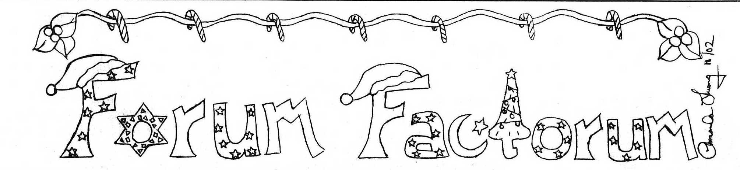

rum

The Official Newsletter of the Massachusetts Junior Classical League December 2002 Volume XXVIII, Issue 2

IN MEMORIAM
Mrs. Janet Rajotte was a Latin teacher from Pittsfield High School who died from breast cancer in 1999. This year, the Executive Board decided to name the new state trophy after Mrs. Rajotte to immortalize this icon of MassJCL and the legacy she left behind. Below, Jeff Roberts, a former student of Mrs. Rajotte and currently a MaSCLer at MIT, remembers his former magistra and the impact she made on all of her discipuli:

After learning of the Massac-husetts Junior Classical League's decision to honor Janet Rajotte, I was asked to write about her for the benefit of those who did not know her. It is a difficult thing to do, not only because of how sorely she has been missed, but because I know that my description could never do her justice. She is responsible for making Latin one of the most important parts of my and many others' high school ex-periences, and one would have to know her to understand why this is so. I will do my best here, but if you get the chance, talk to someone who knew her as well.
Mrs. Rajotte coordinated the entire Latin program at Pittsfield High
School and taught virtually all the classes. Latin was an elective, and her remarkable skills as a classroom teacher ensured that most students in the lower level classes continued into more advan-ced studies. Class was always comfor-table and informal, yet never out of her control. She spoke in a songlike voice that, while seldom forceful, always commanded the attention of the room. She lectured and translated with the attitude of a storyteller, often telling her
own stories as well-- though most students had heard her stories many
times before, they always encouraged her to tell them again. Most of all, she taught with an energy and passion that never failed to impress and inspire her students.
While her skill in the classroom was

unsurpassed by any teacher I have
known, it was her work outside the class period, and the way she blended academic and non-academic learning, that was most amazing. She was the motivation behind the Latin Club, which was surely one of the largest and most active extracurricular groups at Pittsfield High. The club consistently had over one hundred members in a school with an
enrollment a little over one thousand. The after-school activities of the club were always well attended, as were the frequent social events, community service programs, and trips. Students were dedicated to the club, even while most of them were also involved in
sports, theater or other activities. Even students who had only taken Latin in
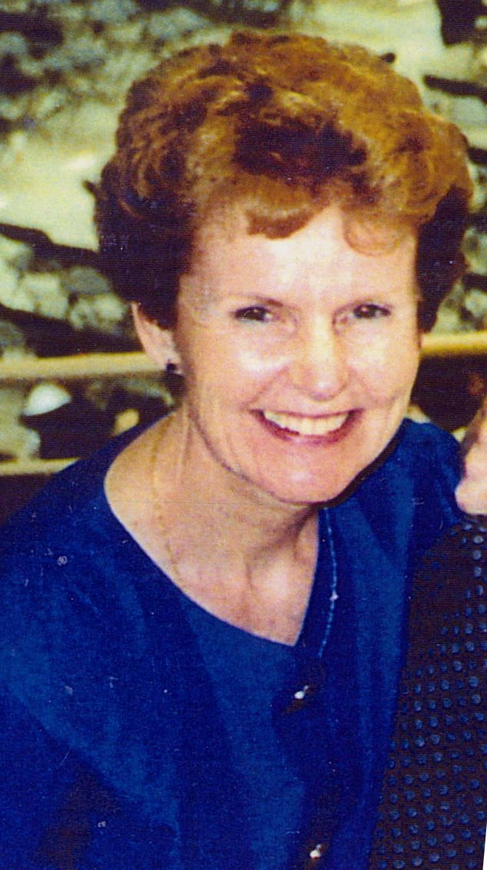

their freshman year remained in the club, partly to participate in its activities, partly to keep ties with friends, but
largely to continue to see Mrs. Rajotte.
The "Rajotte Dynasty", which refers to fourteen consecutive years in which Pittsfield won the overall championship at the Massachusetts JCL convention, is a testament to her abilities. I know that Pittsfield's perennial success at the state convention was due more than anything
to Mrs. Rajotte's phenomenal ability to encourage participation and inspire

students to do their best. She consistently convinced fifty or sixty people to get up at six in the morning to travel across the state, and she ensured that almost every event had participation from our club. The time she put into instruction for grammar, mythology and history tests, coaching for performance events and certamen, and oversight of the const-ruction of the club scrapbook-- her particular pride and joy-- not only
assured victory, but enriched the life and
education of everyone who participated. This is not to mention her strategic skills and competitive spirit, which played a part as well.
What was always most striking to me was how Mrs. Rajotte made the
Pittsfield High Latin program a family. She called us her "kids", and spoke of her students in the same way she spoke of her actual children and grandchildren. The Latin classroom was home-within-school for me and many of my peers. Mrs. Rajotte was the magistra and the
materfamilias. The beginning of class
would always find her seated at her desk sur-rounded by a crowd of students, discussing issues having to do with class, asking for help or advice, or just
chatting-- it was an effect that no other teacher I knew could produce. From time to time, alums of the program would drop in just to talk to Mrs. Rajotte and see how things were going. I had only known Mrs. Rajotte for one year when I had come to think of her as a friend as well as a teacher. Sadly, it was then that she was diagnosed with breast cancer. She spent the next half of the academic year away from school while undergoing treatment, but returned for the rest of the year and taught with the same love and energy as ever. It was her last year in the classroom.
Continued on pg. 2
Table of Contents
In Memoriam 1
Quid Novi 2
Chapter Tidbits 3
Interview 3
Book Review 4

Massachusetts Junior
Classical League
2002-2003

Publications Editor:
Ryan Manning
Ffeditor0203@msn.com

Artist:
Amanda Luong

President:
Mark Ivey
mjclprez@yahoo.com

Chairs:
Ms. Tamara Bauer
tambauer@aol.com

Ms. Janet Fillion
rockberries@mindspring.com

Ms. Marjorie Keeley
makeeley@rcn.com

EDITORIAL
Dear MassJCL,
I hope that you all enjoy reading this second issue of the Forum Factorum as much as I enjoyed making it. Making the MJCL newsletter is such a rewarding experience and I want to encourage any of you who are interested in newsletters and publishing to consider running for the office of MassJCL Publications Editor for the 2003-2004 term.
But before you start making state publications, you should all start by making a chapter newsletter of your own. Any chapter newsletter is eligible for entry in the Chapter Newsletter Contest, of which the winners receive overall points toward the school trophy at the 2-day State Convention at UMass Amherst on May 16 and 17, 2003.
Also, I am looking for artists who would be interested in making line drawings and title art for the Forum Factorum. I would like to thank everyone who helped me make this Forum Factorum more interesting by giving me news tidbits of chapter activities. Enjoy reading them and keep them coming!
-Ryan Manning

A LETTER FROM THE 1ST VICE PRESIDENT
Hey Everyone!

As your first Vice President, I'd like to first thank all who attended Classics Day this year. I hope you enjoyed the Armory as well as the Museum. For the schools that were not able to attend, let me tell you about a few of the features. The Higgins Armory presented to students wonderful pieces from the ancient world and also provided a short presentation. At the museum, students had lunch, talked to the MJCL officers, and saw some of the things that the Worcester Art museum has to offer, including some amazing mosaics. All in all, it was a great experience, fun and educational. Some lucky people even went home with a bag of prizes! So thank you to all those who attended and
I hope you enjoyed it as much as I did!
-Sarah Concannon
2002-2003 1st Vice President

IN MEMORIAM
Contined from pg. 1
I believe it is very fitting that the Junior Classical League will honor Mrs. Rajotte in this way, for I have always felt that she embodied the ideals of an education in the classics. As reflected in the JCL Creed, Mrs. Rajotte developed respon-sibility, fostered brotherhood, promoted enthusiasm, encouraged competition, inspired dedication, and enriched the total growth of all students fortunate enough to have studied with her.

QUID NOVI
Gratias Nobis Agunt
At this summer’s National Convention, members of MassJCL donated a total of $421.50 to the Sister Jeannette Plante Scholarship. Recently, the State Chairs received a letter thanking MassJCL for its generous contribution. Sister Jeanette was a Classic professor from New Hampshire. She was very active in NJCL and close to many of us in MassJCL. Last year, she died in a car accident and a scholarship fund was established by NJCL in her honor.

A Reminder from the Historian
Devika Gireesh, this year's Historian, needs materials for the state scrapbook. Every chapter must have a page in the book. Please begin saving photos, programs, announcements, awards, menus, agendas, etc. from your Latin club activities. Mail any scrapbook contributions to:
Devika Gireesh
21 Woodside Dr.
Milton, MA 02186
Website Contest
The MassJCL Website Contest will be judged during 4 during the school year. Sites will be judged using both Internet Explorer version 4 (or higher) and Netscape version 4 (or higher). Any current JCL chapter can enter. The website must be the sole work of the students in the chapter. N.B. Your website must be registered on www.njcl.org in order to apply for this contest.
In order to earn extra points toward the state trophy, you must add something new to your website and e-mail Technical Coordinator Amanda Luong (LiLOxPiNkbEbE@aol.com) in November, January, March, and May. The e-mail should contain the web address and the Webmaster(s)’s name.

*The new MassJCL website is up and running! Check it out at www.geocities.com/massjcl.

New Contest
A new contest that has been introduced this year is the Chapter Newsletter Contest. Below are the rules and judging criteria:

RULES:
- The chapter newsletter must be the sole work of JCL members only; i.e. not a JCL sponsor or non-JCL members.

- On every issue, the name of the newsletter’s editor(s) should appear somewhere in the newsletter.

- Every newsletter should have a title.

- Additional points will be awarded to any chapter who submits news tidbits for the Forum Factorum to the MassJCL Editor before the given deadline for each issue. Bonus points will also be awarded to any chapter who sends a copy of their newsletter to the MassJCL editor throughout the year.
- All entries will be judged as one unit.

JUDGING CRITERIA:
Design 25pts
Visual Appeal 25pts
Coverage 15pts
Chapter Involvement 15pts
Creativity [Name & Layout] 10pts
Spelling & Grammar 5pts

Please send 3 copies of at least 5 issues {if your chapter has published 4 or fewer issues send all of your pub-lished issues} postmarked by Friday, April 25, 2003 to:
Ryan Manning
136 Laurie Ave.
West Roxbury, MA 02132

Certamen Scrimmage
On January 29, 2003 Boston Latin Academy will host its annual certamen scrimmage at 3pm. All schools are welcome to attend as either competitors or spectators. For more information contact Janet Fillion by email or call Boston Latin Academy at 617- 635-9957. The deadline for registration is January 22.

New Officer
Hey y'all. My name is Stephanie Suillivan and I'm this year's Massa-chusetts Junior Classical League's Parliamentarian. Naturally I love Latin and my school's Latin club which I am also the historian for. Besides Latin I like watching and playing just about any sports, music - Bruce Springsteen and READING! I hope that all my fellow MJClers have as much fun as I am having this year. I'm honored to be part of such an awesome organization! See everyone at the State Convention! PS If anyone is interested in running for an office please contact me at Sulorbub @aol.com.

Catapult Contest
On Saturday November 16, ten MJCL chapters braved the harsh weather to compete in the annual catapult con-test. After the distances were calculated, the results are as follows:
Marshmallow Division
1st place: Mount Greylock’s
“Carnifex”
2nd place: Berkshire Country Day’s “Furor Volans”
3rd place: Boston Latin Academy’s “Potentissima”
Ballistae-8 lb. shooters
1st place: Mount Greylock’s
“Nomen Nullum”
2nd place: Westford Academy’s
“Mors Superne”
3rd place: Berkshire Country Day’s
“Ignis in Caelo”
Catapultae-Arrow shooters
1st place: Mount Greylock’s
“Saxum, Papyrum, Scissores”
2nd place: Coginchaug HS’s
“Senator Umbrosus”
3rd place: Tewksbury HS’s
“Feles Fatalis”

National News
If you’ve been on the NJCL Website lately, you may have noticed that the creative writing contest theme has been announced. This year’s topic is: “Olympian Survivor - The twelve Olym-pian gods are on an island. Who gets voted off, and why?”
This year’s costume contest characters have also been announced. These characters will be used at the MJCL convention as well, so it will help to know them. They are:
Male: Bacchus
Female: Aurora
Couple: Juno & Argus
For more info on both of these contests and so much more, check out www.njcl.org!

New Chapters
This year, MassJCL has five new chapters. Two of these chapters are our first two out-of-state chapters ever. Let’s give a big MassJCL welcome to:
- Berkshire Country Day School Lenox, MA
- Brattleboro Union High School Brattleboro, VT
- Dover Sherborn High School Dover, MA
- Eagle Hill High School Hardwick, MA
- Hartford Public High School Hartford, CT

NEWS TIDBITS
FROM MJCL CHAPTERS

Boston Latin Academy
This year, the members of the BLA-JCL started having weekly meetings run by their elected officers. The club is also planning a “Parent-Potluck” to show parents what JCL is all about. Plans are underway for BLA’s annual Certamen scrimmage in late-January as well as community service and community outreach activities. On November 16th, about 35 members of the BLA-JCL atten-ded the Catapult Contest. Everyone had fun; of course a certain President had a lot more fun than most.

Brattleboro Union High School
Brattleboro Union High School is MassJCL’s first out-of-state chapter from Vermont. Although their club is just getting started, the 30 Latin club mem-bers already have a board of 4 elected officers with monthly meetings. Bratt-leboro Union High School attended Clas-sics Day on October 22 and liked it very much. Future plans include fund-raising and a tutoring program for Latin students.

Milton High School
Milton High School is hoping to start up a certamen team for competition in the upcoming scrimmages and hopefully at the Certamen Prelims in April. Plans are also underway for publishing a chapter newsletter. Milton High is also planning on attending the State Convention on May 16th and 17th at UMass Amherst.

Mt. Greylock Regional HS
The Latin Club at Mt. Greylock Regional High School started off the year with their annual raffle. In October, the club set up booths at Williamstown Elemen-tary School’s “Words are Wonderful” fair to advertise taking Latin to the students. The club also held its annual induction ceremony on November 7. On November 16, the club hosted the MassJCL Catapult Contest.

Tewksbury High School
Tewksbury High School JCL upperclas-smen have been busy recruiting new freshmen for MJCL. The sophomores were busy constructing a catapult and transporting it to the Catapult Contest, where they had a wonderful time. Future activities include participating in a gift-giving program for the needy during the holiday season and the sale of hot cocoa during the morning to students in the school as a fundraiser!

Wakefield High School
Wakefield High School’s Latin Club presented its annual “Mr. WHS,” a mock beauty pageant for the junior and senior class guys. It took place on Saturday, December 7.

INTERVIEW WITH DR. COHEE
This year, a new position for MassJCL sponsors was introduced: the Certamen Coordinator. After reviewing all applications, the Executive Board appointed Dr. Peter Cohee of Boston Latin School to serve during the position’s trial term. I asked him some questions about himself and his plans for MassJCL Certamen, and here is what he said:

1. How long have you been a teacher? Where did you teach before coming to
Boston Latin School?
Including my grad student years in Colorado, I've been a teacher since
1987. I taught at universities and high schools in Virginia, and before coming to BLS, I was at Ohio University.
2. Can you speak any other languages besides Latin?
I can speak German fairly well, and enough Italian to get myself around
Rome. I can read French and Spanish with relative ease, and I studied Old
Norse and Old English as an under-graduate.
3. What made you want to become a Latin teacher?
Teaching's a calling, really; you just know you have to do it. After you've been in it a while and met some really great colleagues and really fine kids, then you begin to know why.
4. How did you become involved in JCL and Certamen?
At my first-ever JCL event, the Colorado State convention in 1988, I was asked to be a certamen moderator. Since then I've been a moderator, timer,
and scorekeeper at local and state certamen meets in Colorado, Virginia, and Massachusetts. I've also done open certamen moderating at several national
conventions.
5. How many NJCL conventions have you attended?
Hmmm. Six, I think. Or is it seven? It's all getting so blurry now…
6. Did you do certamen when you were in high school?
No, I took Spanish in high school!
7. Why did you suggest the creation of the MJCL Certamen Coordinator's
position to the Executive Board?
Massachusetts has the talent pool and the long Classics tradition to be one of the *big* certamen states at National convention, just as Virginia, Texas, Ohio, and Florida. What we need, and what I hope to further in this position, is the additional organization that's needed to recruit and train consistently successful state certamen teams, just as those states do.
8. Do you plan to work with the Executive Board throughout the year and involve the student officers in your planning?
Absolutely!
9. What are your plans for getting more certamen scrimmages?
Promotion of the game is my chief objective. To do that will mean informing all schools who are-or especially, who *might* be-interested in
certamen of upcoming events. After a little time, the state should have a more or less regular cycle of school-sponsored certamen meets. This will help develop skills, give teams goals to aim at, and give everyone the chance to see what talent is out there, with a view toward assembling great state teams for nationals.
10. Do you plan to make any changes to the format of the Certamen Prelims?
The format itself doesn't need any change right now, and the prelims situation is already improving, with a spot more or less convenient to member
schools from the whole state. That's something I want to work to continue.
11. Do you plan to make any changes to the format of the Certamen Finals at
the State Convention?
No, not right now. The MASCL does a wonderful job, and I want to make sure that relationship remains a fruitful one. I'll contact them to see what suggestions for improvement they might want to offer. I think we might also want to look at the points awarded for certamen wins at States, and making Oral Academic Finals into an open certamen format, but I'll certainly solicit everyone's opinion on such matters.
12. How do you plan to pick the certamen teams for the National Convention? Will you use certamen questions for this method? Who will write these questions?
I think this is one area where we can--and should--do much better as a state organization. My concept is that State certamen finals should continue to give the coaches right of first refusal; but my plan is to hold playoffs for national team *player* spots at Prelims. No matter which school team wins, individual players will play for a spot on the state team. Thus, the MA Nationals team will begin to form months before our state convention. We need to avoid a situation where good players are not invited to play on the national team simply because they didn't happen to be on the school team that won at the state convention. As far as questions go, I think the best thing
to do is to ask another, “big” state if we can get questions from them; that way we'll be choosing our teams on the same criteria. Virginia or Florida will be the best sources.
13. Who will write the certamen questions for Certamen Preliminaries and State Convention?
As I understand it now, our Prelim and State questions are written by cooperative agreement by teachers from Tennessee and/or Texas. Assuming that's right and as long as it works, there's no immediate need to change that relationship.

CATILINA’S RIDDLE BOOK REVIEW
By Michael Coughlin, Gr. 10, BLA
Have you ever wondered what life was really like in Ancient Rome, to be more precise, Etruria in 63BC? Steven Saylor takes you there in his mystery entitled Catilina’s Riddle. This book takes place in the midst of the cutthroat rivalry between Cicero the Consul, and can-didate Catilina. Catilina has been accused of plotting a revolution against the Republic, and of attempting to have Cicero assassinated. Our perspective in this book is that of bystander Gordianus The Finder. Whose side will Gordianus choose to be on in this election?
Normally, Gordianus would like to be as far away from the busy city life of Rome as possible, but he is caught in the middle of this election. This is so, because Cicero, who is a friend of Gor-dianus, asks him to harbor Catilina so that he doesn’t have to worry about his whereabouts. Is this a good move by Cicero, or has Gordianus befriended Catilina during his stay?
When Gordianus starts to find corpses on his secluded little farm, he does not know whom to trust-- and neither will you.
If cutthroat elections and confrontations of Ancient Rome do not interest you, this novel also shows the aspect of coming of age in this time period. Gordianus’ son, Meto, has just become a man in Roman society during the elections. This novel vividly portrays the ceremonies and traditions held for a young man upon entering manhood.
I highly recommend this book, especially if you are studying Cicero. This book gives you a great sense of what things were like back in Ancient Rome.

VENUM DATA
For Sale;
Patriots’ T-shirts: in Latin, red
“Ite, Amantes Patriae”
Sizes- L & XL
$8

Greeting Cards: drawn by MassJCL member; based on Greek vases.
A.) Ovid Series- 5 views
B.) Maenad Series- 5 views
$4 – 1 each of Ovid or Maenad
$7 – 2 each of Ovid or Maenad
Contact Ms. Fillion at rockberries@mindspring.com

