Facts & Figures on the Pharmaceutical Industry

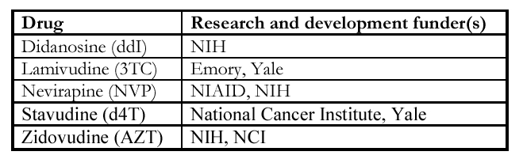
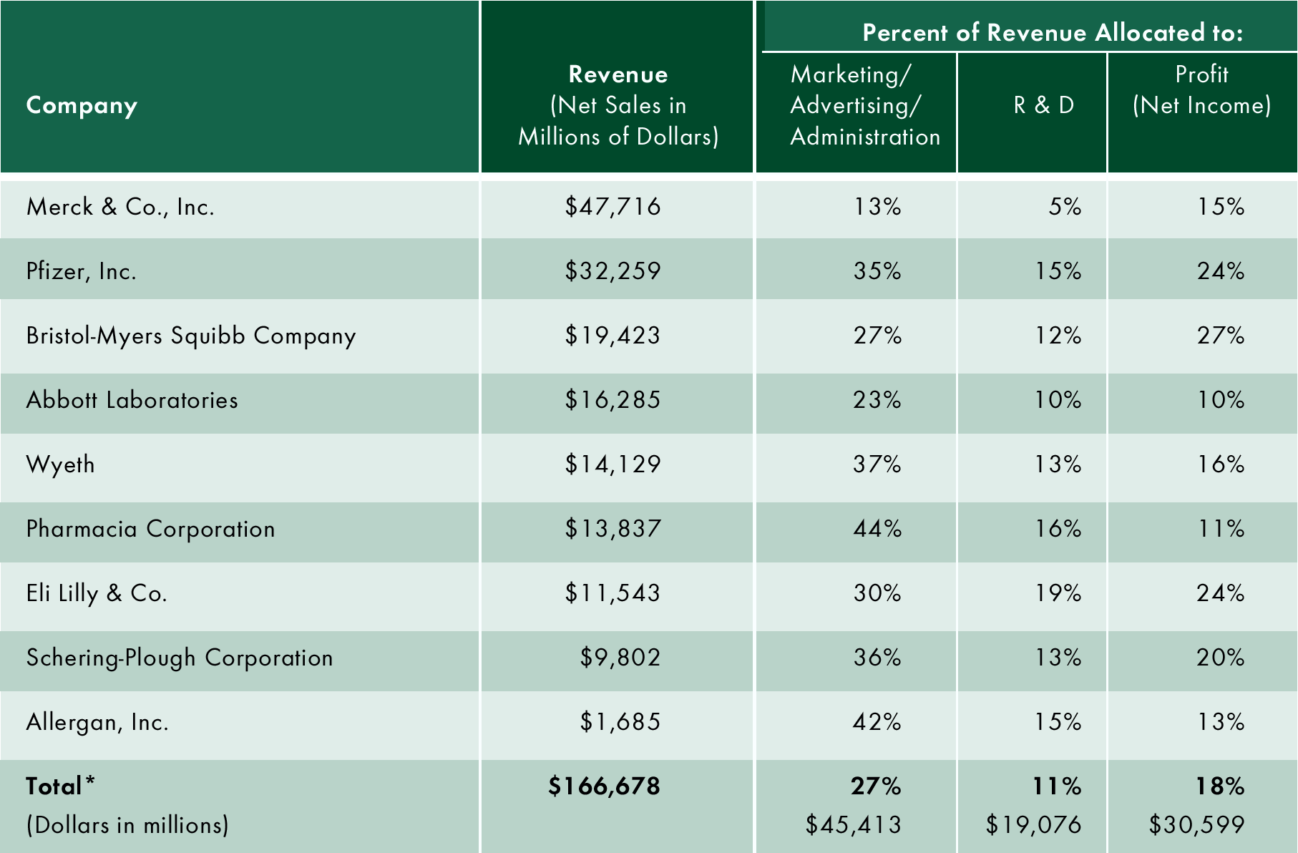
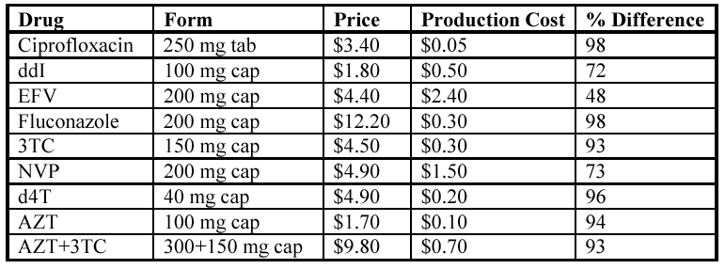
Figure 1: R&D funders for major AIDS drugs. NIH = National Institutes of Health. NIAID = National Institutes of Allergy and Infectious Disease. NCI = National Cancer Institute. All of the above were funded through public tax revenues (Source: J-Y Kim, Harvard Medical School, 2000).
Figure 2: Price versus production cost of major AIDS drugs as of 2001. Prices are dropping slowly for some drugs due to generic competition and selective price cuts (Source: MSF, 2001).
Figure 3: Marketing expenses versus R&D expenditures (Source: SEC, 2002).
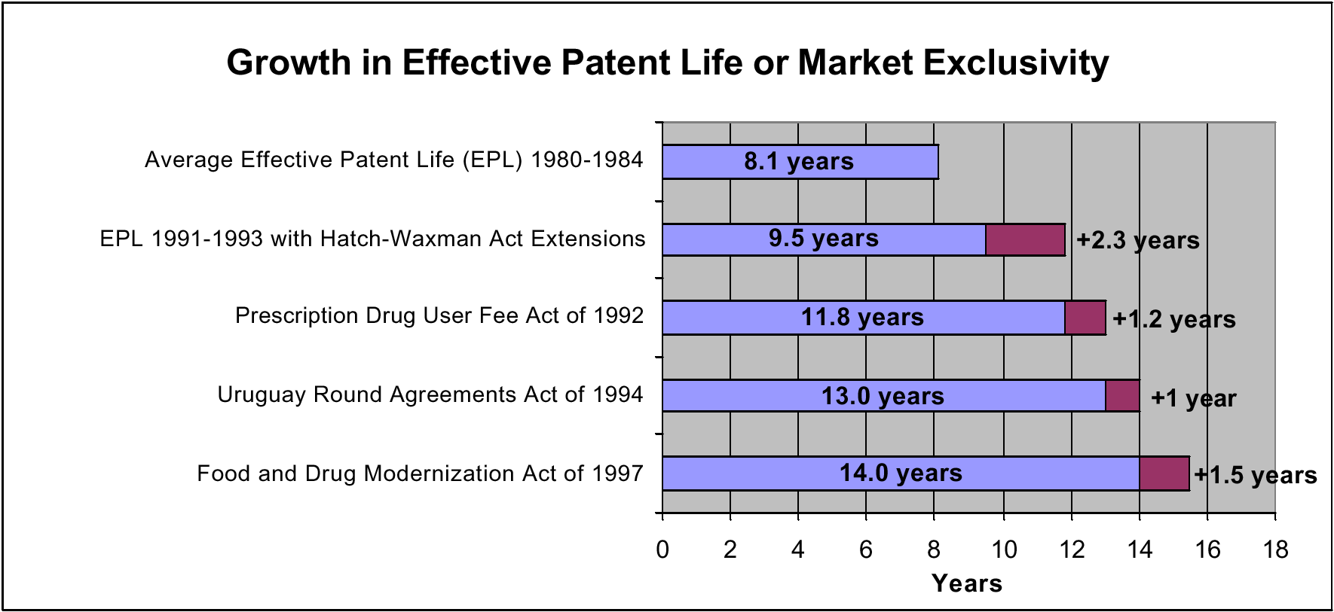

Figure 4: Patent life for prescription drugs. Purple indicates period of market exclusivity, effectively enhancing legal patent life (Source: National Institute for Health Care Management, 2000).

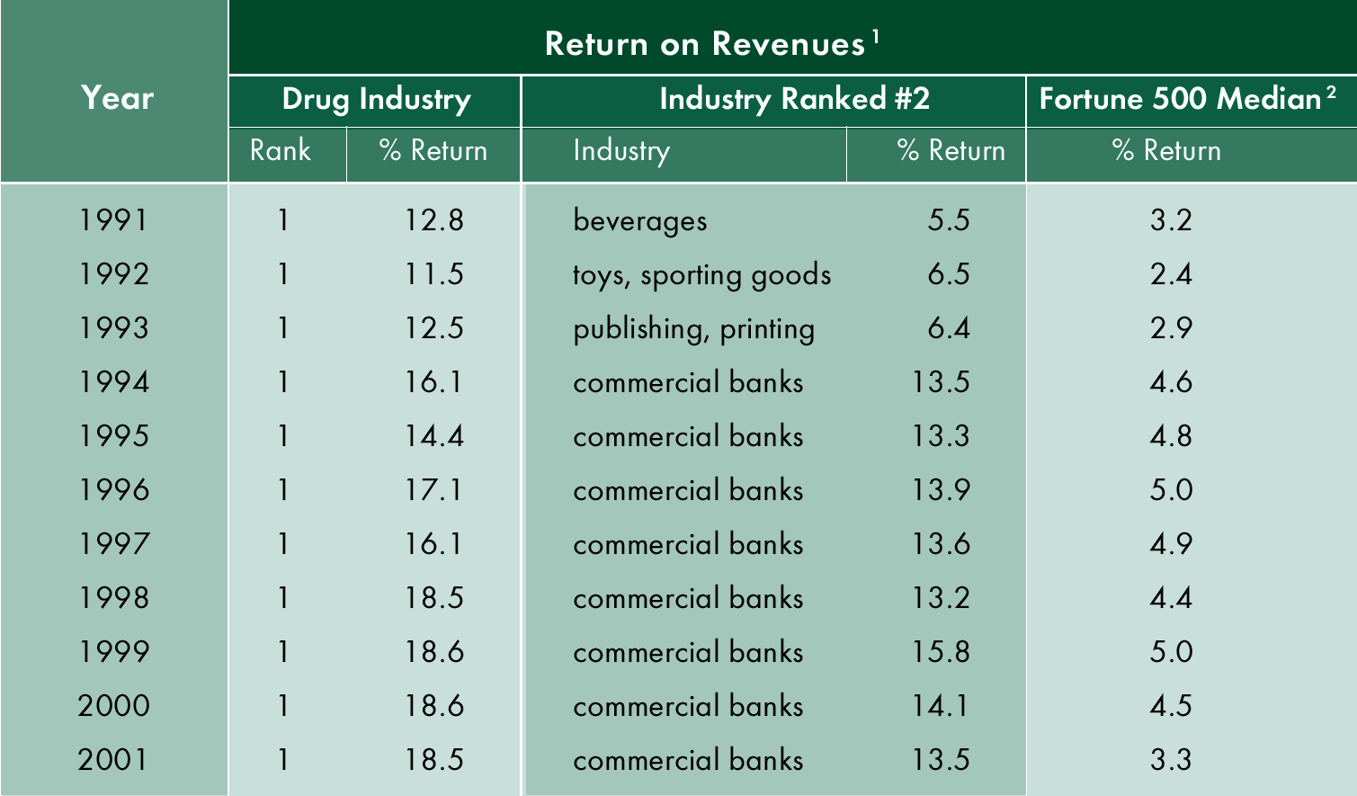
Figure 5: Pharmaceutical Industry Fortune 500 Ranking (Source: Fortune Magazine, 1992-2002).
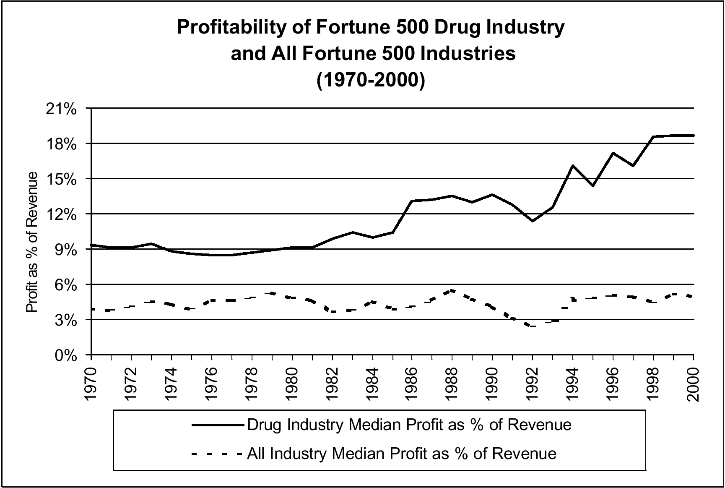
Figure 6: Pharmaceutical industry versus other Fortune 500 industries (Source: Public Citizen, 2001).

