Questioning the Assumptions About Generic Drugs…

The key argument against generic drugs:

Patent-based pharmaceutical companies need a high price and patents in order to obtain return on research and development costs.

Assumption #1: Pharma did all the R&D
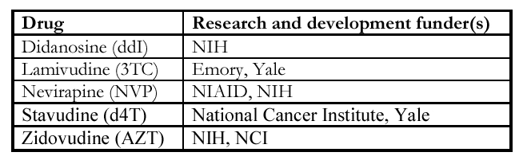

Source: Kim, Harvard Med, 2000

High profits…
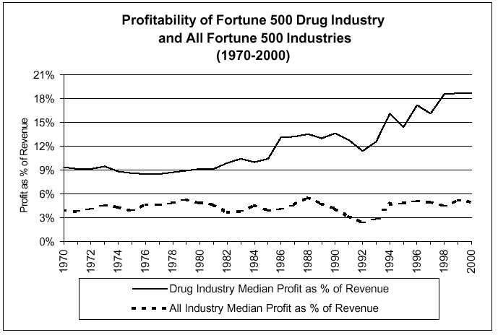

Source: University of Minnesota, 2000

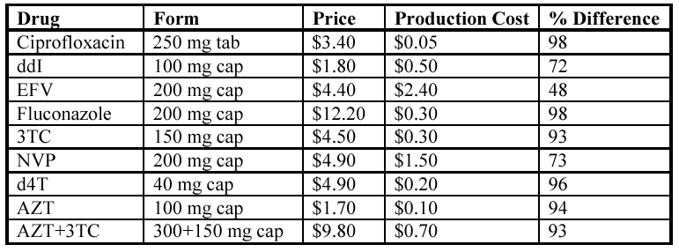
Assumption #2: The high price reflects high production cost (Source: MSF, 2000)

Assumption #3: Pharma needs the profit to pay for future R&D

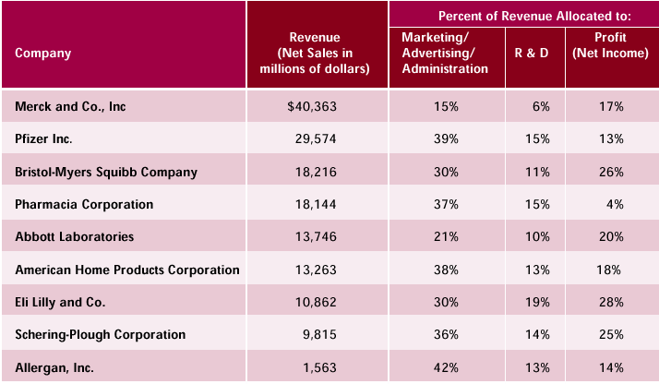
(Source: Families USA, 2001)

Assumption #4: Only Pharma has the money to pay for clinical trials

Pharma says that R&D costs total $500 million for each new drug (including failures; DiMasi, 1991)

But DiMasi’s calculation didn’t account for:

Tax cuts for the pharmaceutical industry

Taxpayer-funded research

Actual risk of failed research based on industry data

Percentage of profits made from “me-too” drugs (drugs with no new therapeutic efficacy)

The difference between R&D and marketing costs
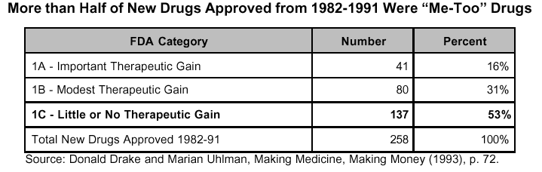

The importance of “me-too” drugs

Real expenditures:
From the Congressional Office of Technology Assessment (OTA), 2001

Actually, DiMasi predicted $231 million for the R&D of each drug

But industry reps upped it to $473 million based on how much money they would have made if they had invested that money, then rounded up to $500 million

Adding the pharmaceutical industry’s special tax deductions reduces DiMasi’s number to $65.5 million for R&D of each drug

Including industry’s data…

Adding in the industry’s actual data on risk and the data on research contributions from taxpayers, the final number becomes: $57 million per drug

Where did all those tax breaks come from?
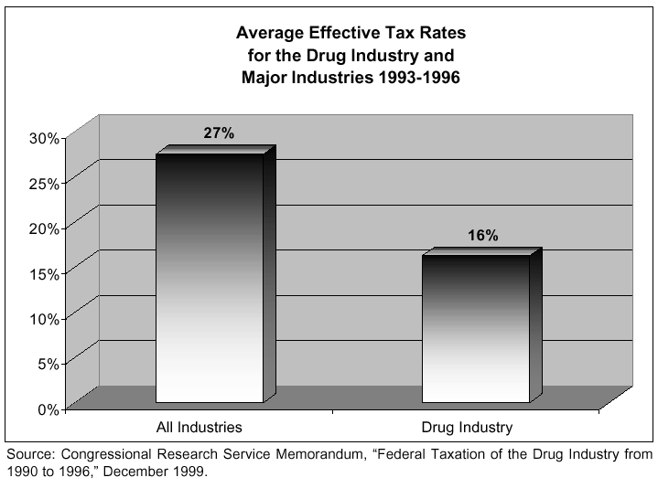

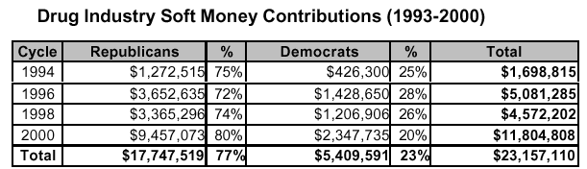
How much lobbying?

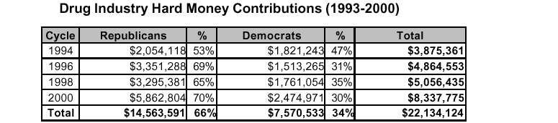
Source: Center for Responsible Politics

Campaign contributions…
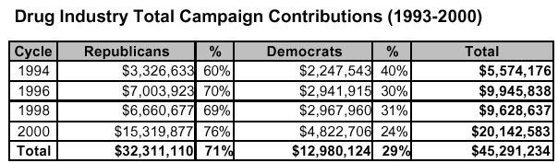
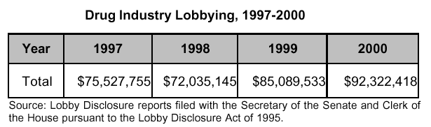

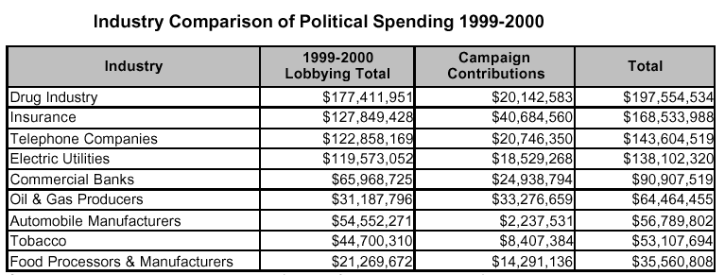

Isn’t everybody doing it? The drug industry does it most: Source: Cong Bud Office
The Revolving Door

