Preamble and Basic History
My first problem occurred Easter weekend in 1997 when the left eye filled with blood, which effectively blinded that eye. My understanding at the time was a “mass” behind the eye had ruptured the retina. I now believe that it was probably a form of Age Related Macular Degeneration that will be referred to as ARMD or just MD in the balance of the diary. I am of the opinion that I had the wet version of ARMD although that term was never mentioned specifically. I also now believe that the condition could have been escalating for up to 2 years and was not noticed as the brain began to ignore the left eye as the brain knew the images were faulty or flawed. Sometime in 1999 I had cataract surgery on the left eye and that eliminated a lot of glare and improved vision significantly as I recall. The effect to me of the 1997 problem was an eye with a scar to the right of the macula and extreme distortion in the balance of eye. The distortion is explained with links to pictures in the Jun 13, 2006 diary entries.
I began going to the optometrist on a yearly basis after that for what I considered to be a full range of tests and checks.
In Jan 2006 I made my annual visit and was advised that there was no required changes to my prescriptions and I remember being surprised by that as I was having problems seeing and recognizing people at a distance of 200 feet or so and thought my sight was changing. I know this was mentioned to my optometrist and I can’t remember if she had an answer to my query. She did suggest because of my prior problems that I should have my eyes photographed using their new camera as this would provide a benchmark for future visits. The photos cost $25 as they were not covered under OHIP (provincial medical insurance). I agreed this would be a useful thing.
By the end of March 2006, I was beginning to have severe worries about the state of my vision based on a series of apparently unrelated observations. I noticed I was having trouble cutting my nails as I couldn’t focus on them, peoples features were getting harder to distinguish, and worse in shade, going from sunlight to shadow caused the eyes to take up to 30 seconds to adjust to the different light, I was having trouble reading the newspaper, I couldn’t do the crossword any more as I couldn’t see my answers that I had written in dark pencil, text on the computer display was getting difficult to read and frequently had skewed words or lines coming from the left eye which had been ignored by the brain for 9 years at that point, night time vision was worsening and objects were harder to see, things I saw moving with peripheral vision disappeared from view when I attempted to focus on them, and in dusk or dawn outside light I was now seeing overlaid images and distortion where none had existed before. I believe I had more reasons on the list to the specialists, but this is all I remember at the time.
On or about April 3, 2006, I made an emergency appointment and the optometrist confirmed that there was a problem in the right eye. More hi-resolution pictures confirmed a circular shape in the lower right portion of the eye. An Amsler grid check showed wavy lines in the lower right quadrant. She sent the images to a couple of specialists and I sat and waited.
On or about April 10, 2006, I saw a retinal specialist who took a look and confirmed there was some type of problem and he ordered both a Fluorescein and OCT.
On or about April 20, 2006, I was at the Ivey Institute to have the Fluorescein done. In this test they take a series of very hi-resolution pictures of the eyes, then they inject you with a yellow dye and take more images. The yellow dye enables them to see and photograph the blood vessels in the eye and pinpoint the areas of seepage into the retina.
On Mat 4, 2006, I was back at the specialists office to have an OCT test (Optical Coherence Tomography) and this test takes a hi-resolution scan of the retina using hi-intensity light. It is similar to an Ultrasound which uses sound. The results of the OCT showed seepage into the retina causing a bubbled effect (the distortion) and subsequent problems for the optic receptors which now had blood between the receptors and the optic nerve. After the OCT had been analyzed and confirmed the diagnosis, I then had a Visudyne (Cold laser treatment) which was supposed to seal the blood vessel that was seeping into the retina. The nurse injected me with a drug that would cause a blood clot wherever light struck, and for the next 48 hours, I had to stay away from sunlight (outside or inside) and fluorescents, anything that emitted infra red rays.
This ends the preamble and the first diary entry starting May 5, 2006 is the ongoing continuation and ever evolving story. From this point on observations will refer to the right (was my good) eye unless the left is specifically mentioned in the observations or bench marks.

Early Indicators (Ignored)
In the ensuing months since I became aware of my problem I have had a lot of time to reflect on past events and I am now convinced that the early indicators of ARMD were noticed, and either ignored, or not acted on further as I didn’t realize the enormity of what was happening.

First Indicator
Sometime in the spring or summer of 2005 I began to notice I couldn’t identify people from a distance of approx 200 feet. I wasn’t sure when this started, but I had a nagging feeling that at one point I could. Trying to benchmark a sense is virtually impossible especially when the decline is very slow and gradual. I could only tell who it was by using an educated guess based on body size and shape, hair color and style, sometimes clothing, and the way the person moved, walked, or stood. If you are a people watcher, you know everybody has a distinct walk, gait and/or posture.
When I went for my annual checkup in Jan 2006, I mentioned this to the optometrist and was very surprised that there was no change to the prescription. I can not remember if she had an answer or just inferred it was an aging thing. Using hindsight, I now know I should have checked further and this was an indicator of central vision failing since I would have been focusing on the face when I tried to determine who was walking toward me and the focal point was blurred at a distance I thought I could see at some prior time.
This turned out to be serious mistake and probably caused me at least 4 months of damage.

Second Indicator
Last August we were in Gettysburg and it was after dark and I had just missed a turn. I was not familiar with the city and was looking for a safe spot to pull off the road and turn around. I remember my wife getting more agitated every time I missed seeing a safe spot that she had pointed out to me. I wasn’t turning into them because I couldn’t see the driveway or wide shoulder of the road. I hadn’t done much driving at night for years and when I was out, it was always in London where I was familiar with the roads and turns.
At the time I probably attributed the problem to the aging process.
The difficulty at night was not really apparent till until March 2006 and even then I had forgotten about the previous summer. I know that this was not told to the optometrist as it had long been forgotten and was not connected by me to the first indicator. Now I am certain that this was another indication that central vision was collapsing as the receptors were not getting enough light at night to see like they used to.
This also turned out to be a serious oversight and had the 2 problems been connected, and checked out, may have saved me a lot of vision loss.

Conclusion
I am not sure if the optometrist missed a connection, or maybe she wasn’t aware of the indicator either. I do believe however that the vision tests administered will not necessarily pick up ARMD in the early stages.
The eye tests are done under good lighting conditions and don’t test night vision.
I think there should be some tests performed and measured under dim or dark conditions.
I think people should test their own eyes in a darkened room with only residual or very low level lighting. They should check one eye, then the other, and compare what each eye saw. If one eye sees less or shows a dark circle, they have a problem and I believe this will show up before any distortion is noted using an Amsler grid and would be detected before an eye examination.
I think hindsight is a marvelous teacher but I don’t know how to impart this learned knowledge to anybody else including the eye care professionals.

The Dark or Gray Circle (Basic Description)
References are made frequently to the dark circle throughout the diary. The gray circle is caused by the blood seepage into the layers of the retina. It is used as a benchmark and is in my right eye only. I see it at night time in dim conditions and it masks the objects behind it. Under dim conditions it always appears as just dark with no tonal changes. I can also induce the gray circle in the evening and it works best inside a room that just has incandescent lighting. The room I use usually is the small bathroom with two 60 watt bulbs to my left, or behind me, and I am about 2 to 3 feet from the wall depending on which benchmark I am checking. I induce it by closing both eyes for approx 15 seconds, then I open the right eye. In my case and probably dependant where the seepage is, the dark circle appears to be in the upper left quadrant and the edge of the dark circle is at or to the right and below the macula (focal point). The various benchmark tests determine both the relative size as well as the opacity. Under these measured conditions I can watch as the shape morphs over weeks and weeks, I can see it change from oval to egg shape to circle, I can see the edge bulging with bumps or looking like it has a piece missing. The longer after the laser surgery I can go without another seepage determines the opacity. At the beginning it is a solid shade, and it slowly morphs into a shape with a dark border and gets paler in the center. As it fades, the paler center seems to move slightly. If I use an arbitrary size and say the circle is 10 units wide, the border is approx 1 unit on average. Sometimes the paler center is 1 unit from the left, ½ unit from the bottom and right, and 1.5 units from the top. There are a few crude images in the diary showing the effect. As it fades, I also see a change in the outer edge, and it appears as any or all of the following, streamers as from the sun’s corona, sparkly, spiky, lacy, or as if it was surrounded by cilia or eyelashes. I wish I could draw the edge as it is sometimes quite exquisite in its design.
I can also measure the potential damage based on how long the gray circle can be seen after I induce it. My flawed and failing memory tells me it was only a few seconds before the second seepage, and currently it is visible for up to 5 seconds before fading.

Northern Lights (Basic Description)
The northern lights is my descriptive term for an absolutely fascinating optical illusion that shows up in the right eye and has shown at various times since the first Visudyne laser treatment. I have never noticed this prior to the treatments and do not know why the treatments caused the eye to react in this fashion.
The illusion is only “seen” at night in the dark with my eyes closed as I try to go to sleep.
I call it the northern lights because of the shifting patterns as the light flares and ebbs just like the northern lights, but at a higher rate of change than the real thing. If you live in the southern hemisphere, then your southern lights are comparable.
The actual area of the eye where the illusion shows up was determined during a lightning storm on Aug 3rd, 2006 and the size was determined to be approx the inner 90% of the gray circle.
The illusion is hypnotic as the pattern morphs or shifts and you have to watch it even if you don’t want to because your eyes are already closed and there is no “off” button.
The illusion shows up shortly after closing my eyes. and continues for one to 10 minutes. It does not show up every night, only occasionally, and I have no idea what triggers it.
Normally the illusion starts at the left side of the eye, and flares brighter and then splits and moves across the eye, part at the top and part at the bottom. It leaves the center dark and the 2 moving flares meet at the right side, but never actually touch. The flares are similar in shape to the flames on a campfire, and constantly fade and brighten as the move.
The color of the flare is usually a very pale mint green, but sometimes will be a green tending to gold or orange. Sometimes the illusion starts as one color, and by the time it has reached the other side of the eye, it has gradually transformed to a different color.
The illusion is normally a repeating segment, it is on and visible for 2 seconds, and fades out for one second, then repeats. The time frame is estimated obviously. One night it took on a different aspect, and the flare started at the top and fell toward the bottom, then cascaded in both directions as it flowed upward before fading.
Normally there is no change in the repeated patterns, or if there is, it is too gradual to see or be aware of them. Other nights, the patterns change on every new flare and they are just different enough that you can almost trace the morphing effect.
One night I had the usual left to right flare and the color was a more unique orange or gold shade, and after the flares had traveled across the eye to meet at the right, the flare collapsed into the center which was normally black and took on the effect of a campfire except that the flames were leaping to the left from the right starting point. Then the flames morphed into bright shining pinpoints of reddish gold lights that reminded me of sparks from a fire. This particular effect also had a longer cycle and was maybe as long as 5 seconds before fading to black.
I really wish I had a means to capture these images or to even draw them as they are spectacular in their constantly changing shapes and colors. It is very difficult to even try and describe the illusions as they are almost other worldly and defy normal description.

I Don’t Know What To Call This Except Totally Bizarre
Last Sat, Sept 23rd, 2006, we were in the car driving to Hanover for a funeral. The day was dull, dismal, heavily overcast, and a misty rain was falling. In those conditions I have a problem seeing because the left eye becomes very active and is constantly overlaying the image from the right.
My eyes felt tired so I closed them.
Within a matter of a few seconds it was as if I was looking thru a round window. I will assume that this illusion was from the right eye and the image was in the gray circle.
I could see down the road, and the image changed in harmony with the speed we were traveling. I could see and feel myself going down the road and the fields, tree, houses, and buildings were visible on both sides. Sometimes it was as if I was looking out the corner of the windshield as all imagery was going by on the right side.
This happened on and off every time I closed my eyes while driving for about an hour on the way up there, it didn’t happen on the way home.
None of what I was “seeing” with my eyes closed bore any resemblance to the view with my eyes open, and none of the landscape, houses, building etc were the least bit familiar.
I have no idea why the brain manifested those images, or where the source came from but it was very strange to say the least.
The next time Barb is driving me somewhere I will have to try this again and see if this is another strange anomaly caused by the seepage.

May 6 2006, 07:51 PM
Cause – Bubble behind retina to the left of macula and slightly below a central horizontal line
newer info learned long after this date indicates the bubble is actually caused by blood seepage inside the layers of the retina, and not behind it.
Current condition – Can’t see as well as I could before the Laser procedure, however since I have been on the computer now I think I am almost back to Thursdays condition.
Mental condition – Depressed with occasional glimmers of hope however since the last 2 hours on the computer is getting a bit better, the optomism felt after discussing the OCT (Optical Coherence Tomography) with the specialist is beginning to return ........ cautiously
Thu May 4, 4:35pm
– saw results of OCT showing retina pushed in and seepage into the layers of the retina
Thu May 4, 6:35pm
– had 4:00pm procedure, 83 seconds of intense light
Thu May 4, 9:30pm
– TV blurred at the point of the bubble, no contrast or details just grayed out oval
Fri May 5, 1:15am
– Woke up and saw dancing brilliant green shapes in the center of eye. Sometimes there was 1, sometimes 3, sometimes in straight line horizontal, diagonal, or vertical, sometimes in a circle. Shapes were visible with eyes open and closed. Shapes looked like alphabetic characters from some foreign alphabet, Greek, Asian, Romulan, and Klingon. Etc. Slept poorly worrying about apparent vision loss. Wish I could draw what I saw, very bizarre.
Fri May 5, 8:00am
– discovered level of vision was far less than previous day and could not read what I had written previous day even with magnifying glass. Brilliant green dancing light still present most of time, would disappear and then come back
Fri May 5, 9:00am
– Called specialist in a state of panic, was told someone would call me sometime in morning.
Fri-May 5, 12:00pm
– Called again and got message that office closed till 1:30 for lunch.
Fri May 5, 1:30pm
– Called again, was told clinic was very busy, somebody would try to call me sometime. By now the gray oval had almost disappeared, and the green dancers were pale white or gray and only showing occasionally.
Fri May 5, 3:15pm
– Received call from nurse (first of 3) to advise vision loss was not uncommon, and she acted as an intermediary between specialist and me. Determined green dancers were not common and were unexpected. Even though gray blur has disappeared I am unable to focus with the eye and reading is impossible. She said she would call on Monday and suggested the eye had been extremely stressed by the PCT and Laser and vision may return to its state before the procedure. No time frame was given.
Fri May 5, 8:00pm
– Green dancers are back but not as vivid or as well defined, they now remind me of a cartoon bat as seen in Bugs Bunny cartoons set in Transylvania as far as motion and shape goes. TV is still blurry.
Sat May 6, 2:00am
– woke up to green blurry dancers again, still there with eyes closed. Also have new effect, can see a shape similar to solar eclipse corona with streamers, inside is not round but matching shape with streamers, colors varied from shades of gray/black, midnight blue, very dark green. This image would suddenly be there then fade out, then reappear in a different color. Watched these and the dancers till I fell asleep again.
Sat May 6, 6:00pm
– 48 hours is now up, opened the blinds and turned lights on and started to type this diary. Icons on desktop vanish in front of my eyes, difficulty reading the screen and many typos have had to be fixed.
Sat May 6, 7:45pm
– Have discovered that since being on the computer when I started to type the diary, the vision may have returned to a state that is close to "Pre Laser" condition. There are some blurry areas still just to left of macula but I can now see the icons that are in the Quick Launch and Taskbar areas which I couldn't see earlier.
I forgot to mention that the final results of the Laser Procedure may not be known for as long as 4 to 6 weeks and I have a followup appointment with him near the end of July.

May 8 2006, 03:23 PM
First thing I saw when I woke today was the green dancers in a circle. They disappeared within seconds and have not returned.
There is no other news, no change in status, and right eye continues to have a weak or dead area abiut the size of 4 characters, which seems to come and go,
No phone call from specialist nurse, will wait and if no call will come them tomorrow, I have questions and nobody to answer them

May 10 2006, 09:57 PM
I have noticed the green dancers again tonite on and off since about 5:30 tonight and briefly this morning after I woke, they are smaller and always in a circle now. They never stay long, and there is no discernible pattern as to when or what causes them to suddenly appear and disappear.
I don't think there is any change but every once in a while I think something was clearer than before, but since it doesn't stay, I think maybe it is just my imagination playing games with my mind. One of the problems is that it is impossible to benchmark my current vision for future comparisons due to variables.

May 12 2006, 09:49 AM
Today is very cloudy and overcast and is the normal lighting conditions that I will probably see for the 9 month fall/winter scenario that will come. Under this lighting from outside, I am not able to see clearly inside the house and think fall/winter is going to suck big time as well as costing me a small fortune keeping enough high output lights on so that I can do anything.

Jun 4 2006, 02:34 PM
Noticed something new last week and see it periodically now.
If I am outside and looking at something light colored, then look at something dark, I see a red circle which fades almost instantly, Sometimes the red is mid range red like a Geranium, sometimes very dark like a red maple, sometimes it is a full circle, sometimes it is more like a backwards C. It is always just an outline, never solid.

Jun 5 2006, 06:16 PM
A few weeks ago I noticed something else I hadn't noticed before. This phenomenon shows up best in dim light but with enough light to light the walls sufficiently to see with the bad right eye. This test is also done with the left eye patched. Or closed
I close his right eye for 5 to 15 seconds, and when I opens it there is a dark circle obscuring the image I am looking at. This dark circle fades in 2 to 5 seconds depending on how much light is available.
I am not sure if this dark circle is the one I sees in the darkened bedroom before going to bed but think it could be. If I was focusing on the TV when I open my eyes, the TV shines thru the center of the dark circle and looks strange. The shape I can induce by closing my eyes has changed from last week and I have tried to emulate last weeks shape and yesterday/today’s shape in the attached pictogram. If the dark area is shrinking then this might be a good thing. I need to see if it returns or keeps shrinking.
I also noted this morning I could read part of the newspaper standard text without my magnifier. I am treating that development with very cautious optimism due to the number of variables that could be in play.
I note the following could have an effect on my reading capability, angle of sun to earth, angle of sun to the room, amount of smog in air affecting light transmission, amount of cloud in sky affecting light intensity, quality of newsprint whiteness, quality of newspaper ink blackness, and the other immeasurable intangibles relating to my eye and how long has it been awake and warming up. (Note to self – This Weird Eye pic 01 is from # eye pics)

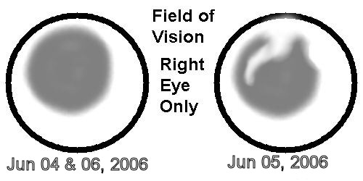

Jun 7 2006, 12:17 PM
Update
Q. I see a grey area and I can induce the effect, but it seems to move and/or change shape. Why?
A. It is caused by the seepage which is moving around in the vitreous fluid.
Q. Sometimes outside I see a red hollow circle or part of one.
A. Caused by the jelly like vitreous fluid pulling away from the retina, age related.
Q. If I am looking at the Amsler grid and it is flat on the desk at an angle to me, I see vertical distortion that is not there with the grid in the normal position.
A. Nature of the disease, strange things happen with Macular Degeneration.
Q. Today I have a new phenomona. If I look at the Amsler grid in the correct position, I see the same dip in the horizontal lines on the left side, but now for the first time I am seeing ghost gray lines in between the black horizontal lines
A. New to nurse, she will check with specialist this afternoon and get back to me.
Q. On Monday I could see better than I could on Tuesday, newspaper was clearer.
A. Caused by the moving seepage or blood in the vitrous fluid, it is something that just happens and must be dealt with.
Q. I am wearing a patch on the left eye almost all the time, is this good, bad, or no difference.
(had to remind her even tho the left eye was measured at 20-80 and is visually brighter, it has severe distortion and a blind spot)
A. The nurse thinks that wahtever helps overall would be OK.
She did add that the eye will tire more since the left eye is not contributing anything.
(Have noticed that and especially last night)
Q. Should I be making an appointment to have eyes retested and get new prescription since I seem to see better with the short range focus glasses.
A. No, not yet. Wait until the Jul appointment so that the examination can determine the current status of the problem.
I did get some new info and had assumed that the dark circle was caused by the receptors either dying off or not working correctly and was told that instead it is caused by the blood or seepage from the retina. This is probably exactly what happened to the left eye 9 years ago.
It is somewhat better news than I expected because if they can stop the seepage, the eye may purge itself of the foreign substance.

Jun 10 2006, 09:26 AM
Sometimes the circle or ellipse is full, most times it is just partial, but it is always hollow. The width of the red appears to vary apparently random, but I think there is probably a pattern I haven't discovered yet.
I have emulated a pic and pit in the webshots albums.

Jun 13 2006, 01:31 PM

Macular Degeneration – Get your eyes checked often

Lo-Res Images 750x500, all between 45 kb and 100 kb
Link to Lo-Res Album

Hi-Res Images 2160x1440, all between 300 mb and 700 mb
Link to Hi-Res Album

If the links don’t work, goto WWW.webshots.com and search for dreamwerxx,
And then look for the albums titles “What I See”

Background: Functionally blind in the left eye for 9 years, right eye is now acting up. The left eye has been basically ignored by the brain for the last 9 years except for peripheral vision. Currently the brain has no idea which image to use and it now varies depending on the light available.
Since most people will not be able to visualize what I have tried to explain in the past and in other threads, I have taken some photos and then modified them to show the effects as they exist in my eyes.
The current examples have been uploaded to 2 webshots albums, one is Hi-Res and one is Lo-Res for dialup connections. Even the Lo-Res should be adequate.
The pics all have the following naming scheme, ex NNN descriptor.jpg where ex is example, NNN is from 001 to 016 and descriptor is left, right, both, or real. Real is the actual untouched image as seen by camera and depending on light conditions and time of day will vary from light to dark.
The emulations for the left eye should show some elements higher than “real” and distorted. The distortion displayed got better as I learned how to apply the software formatting so that 001 is less accurate than higher numbers. Since I am not aware of peripheral objects when I focus at the center, I haven’t made any adjustments for distortion outside the central view.
The emulations for the right eye were a logistics problem as I am attempting to create an image that looks like what I see, but I am working on a monitor abnormally bright with an eye that already sees darker than normal and the left eye is patched as it is just in the way. I have no idea how close to reality the final versions are.
The benchmark photo would be 001 and the right eye image should be dark enough to just barely make out the pictures hanging on the wall. If you can’t see the pictures then I have over-compensated and if you can see the pictures easily, then the image should have been darker to match my actual vision.. The same darkening effect was used across the board on all other emulations.

ex 001 was taken at 11 PM with only one small lamp turned on.
ex 002 thru 005 – various daytime shots for left eye distortion
ex 006 & 007 – inside evening with interior lighting
ex 008 – an outside anomaly, the red circle vanishes within a split second.
ex 009 to 015 – a series taken at 5 minute intervals as it gets darker, Filenames indicate time taken, 9:00, 9:05, 9:10 etc, right eye examples of the dark curtain
ex 016 – yesterdays newspaper, I am focusing on the word Montreal in the byline.
This is the only emulation showing both eyes at once.

As an update only I added 3 more views of 4 more pics in Webshots.
Three are taken outside and the focus is 100' plus and the distortion takes on a different flavor than the inside shots.
One is taken inside and is the first example that really shows the difference between right and left views.
Have come to the conclusion that the brain does some amazing work when it blends the images. I have just noticed that the dead spot in the left eye changes depending on what the brain "thinks" should be there where it doesn't see anything. It fills the area with the most dominant colors or patterns found in the adjacent areas. In other words it builds a suitable image to blend seamlessly with the rest of the image the brain does see.
As Spock would say "Fascinating"
After modifying the images for the left view (I am getting better with the software) I wondered how many artists of old who painted with a distorted view, were in actual fact, painting exactly what the saw thru damaged eyes.
This is the house across the road, left eye only.
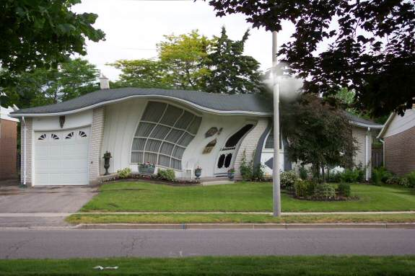

Jul 6 2006, 12:53 PM
I am having extreme problems since last nite. Waiting on a call back after 2pm with action needed. Nurse says it soumds like the right eye hemorraged
Diary entries in my Worc follow bia copy and paste.
=======================================
Wed 10:00 PM July 05
Could read keyvoard and display with no problems
Went outside to take dog out.
Had a coughing fit and my eyes started to water.
This has happened before, not unusual
Came inside and went bacj to computer.
Small icons in the quick launch and in system tray were gone.
Couldn’t follow the mouse, it kept disappearing.
Words looked like they were almost completely erased.
Went to bed, slept poorly.

Rough approximation of computer display after hemorrhage

Thur Jul 06, 3006
Can’t read newspaper even with light and . or magnifier
Computer display is still poor, icons hard to see, print I
could read yesterday I can’t today.
I tried writing, van’t see the numbers I have written.
Magnifier doesn’t help much.
Am using keyboard with difficulty /
TV is fuzzier. Pictures on wall have blank spots where the frame should be.
Amsler grid shows a vast reduction in contrast approx where the
bubble was, slightly left and below center.
Call in to specialist, waiting for a call back.
Induced gray circle may be darker today than yesterday.
Thur Jul 06, 3006 – 11:00 am
Got call from nurse who said it sounds like the right eye hemoraged
She won’t see doc rill 2 at earliest and will call back after that.
Thur Jul 06, 3006 – 12:30 pm
Just sitting outside with no patch. Left eue is feeing lots of info since the right has failed, lots of freaky images with overlays caused ny the left eye adding distortion and extra things to the pic. Vicycles are 3 wjeeled or one wheel in the air, cars have 3 wheels, one minute they are high, and then they are low.
Van’t read the keyboard worth a damn so have no idea how many typos there are.
Boring today because now I can’t surf, or watch TV.
Mouse keeps disappearing and I have to click when I think it is in the right spot.
These entries were made in my Word diary , font selected was 14 point and Word is set to display at 150% instead of the normal 100

Jul 6 2006, 06:08 PM
Emerg appointment to,orrow kate afternoon.
Noticed this afternoon I am now getting vertical shear in right eye at focal point. Top half of light standard is to the right of the bottom. This was not there yesterday.

Jul 10 2006, 11:44 PM
much worse today, this might be it.
went to specialist and sihned a form for the dye job pics at ivey (fast tracjed again)
that happens wed jul 12th
slot for laser has been reserved for jul 20 if he thinks it will do anything
asked about paying for it, thats never happened
now i sit and wait
5 days so far, no sleep, worse every day.
this is extremely hard to see.
later maybe, don't know what tomorrow will vring

Jul 13 2006, 12:53 PM
I am typing on a new keyboard for the visually impaired. It has big black letters on white and is color coded for the special keys like Ctrl Alt etc.

So while my typing may be better, I can't see the screen as well today and the text I am typing is hard to read.
My wife also picked up a trial version of Zoomtext which I will try to find someone to install tomorrow.

Jul 14 2006, 11:29 PM
It has been 9 days and every day the distortion and vision loss increases and as they increase, so does my deepening depression. At the speed the vision is vanishing, I’m not sure I’ll have any left by the time I get the laser treatment, IF I get the laser treatment.
No word from specialist so don’t even know if they will do the laser treatment or not. I had hoped I would get called in yesterday on an emergency basis . Tried calling all morning today, no answer so far.
Installed Zoomtext 9.0 and it seems to help the display however I am not sure how long this will work at the speed the vision is going.
This software also has speech included so I can hear the info I am typing as well as the info under the mouse as I move around the desktop. I am not sure what the total cost is. It is weird to listen to each word as it is typed.

Jul 20 2006, 01:18 PM
Visudyne Laser is set for this afternoon about 4:00
Vision is worse today than ever before. Distortion has reached new levels and the right eye has been so bad for the last week I can’t even use the software to draw it.

Looking at Garage siding (about 30 feet away) and focus on one horizontal line, the line above and below arc almost to the center line where I am focusing. The center line is apparent on both sides using peripheral vision, but at the point of focus, it is missing for about 20 inches.
The lamp standard across the street has the top sheared off to the right by approx ¾ of the diameter, and the one down the street about 170 feet away has the top above the focal point displaced by what might be 2 diameters.

Can’t read anything even with my magnifying glasses. Computer display is very hard to read and I have the Zoomtext software set to 2x.

My mental state has reached a new low, severe depression in all my thoughts, I now haven’t slept for most of the 15 days, and I have no appetite and must be losing weight as my pants are too loose now.

I think if the medical system worked the way it should, I should have been seen the moment I said I had the lost the vision in that 15 minute period, I should have had a Fluorescein the same day, that should have been looked at the same night, and I should have had the Visudyne the next day, that would have been day 2 and would have stopped the seepage and subsequent distortion at that level which was just barely noticeable.

Instead, nobody told me to get the consent forms signed on Fri Jul 7th, by the time they were done on the following Monday the earliest Fluorescein was Wednesday, the results weren’t analyzed until probably Friday and the Visudyne is only done on Thursdays which caused another 8 days of lost time and damage.

I don’t think the specialist either believed how fast the damage was occurring, or maybe they have never seen a case like mine.

An after the fact graphic is attached based on remembered bench marks. The lamp standard is 170 feet away, and the further away, the more the offset.
This accounts for distortion only, can’t remember enough to draw actual vision, however Day 15 would have been both darker and blurrier than the graphic would indicate.

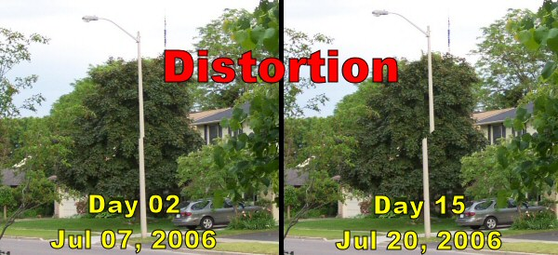

Jul 24 2006, 09:08 AM
Second treatment went faster than the first.
Now on day 4, no visible changes in the distortion.
New effect yesterday, left eye supplied the left side of
the visible images, right eye supplying the right side..
Not even sure I could describe that sensation, 2 different
types of distorted images blended, but not overlaid.
Bacl later sometime.

Jul 26 2006, 08:11 AM
Day 6 - July 26
Horizontal distortion appears less
Siding on garage has 3 rows bending upwards. Previous was top bending down, bottom bending up, and middle wasn't there.
Vertical distortion doesn't appear changed. as a benchmark, the vertical siding appears to be sharply cut and the upper portion is shifted 1/3 to the right of the bottom portion. This probably doesn't mean much to the reader and I don't know if I can draw it. May try later.
This is from a distance of about 30 feet.

Jul 26 2006, 10:09 AM
Day 6 additional
Induced gray circle is a pear shape fat end is at 11 pm.
has a small piece missing about 5 pm
Is solid medium gray with no apparent fading or sharply defined corona as before.
JPG is a rough simulation, best I can do.
It was subsequently determined that the lamp standards are at 75 feet and approx 170 feet, the downspout maybe 150 feet.
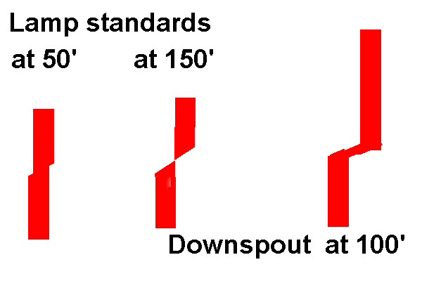

Jul 29 2006, 06:23 PM
Day 9 - July 29
Horizontal distortion appears less. Siding has 2 rows affected, one down and up like sideways S and one curving up.
Vertical appears shifted 1/4 to the right and appears less than 3 days ago.
Induced gray circle is still pear shaped in the same position. Can't determine if it is same shade or not. Edge is starting to look like corona with a 'sparkly' border. Can't adequately describe it in earthly terms.
Previous jpg image may be adjusted with the tops moving slightly left. Will wait 3 more days before checking again and drawing.
It is tough to determine accurately as the moment you change focus to try and measure mentally, you lose the last image and the distortion now is where you are currently looking. Frustrating.

Aug 1 2006, 07:02 PM
Day 12 - August 01
No apparent changes in distortion or vision, unless my imagination is playing tricks since the vertical distortion may be worse.
Earlier today I thought the gray pear shape was looking more like 2 overlaid circles or a figure eight but right now it is the same as day 9. Disappointing

Aug 2 2006, 12:32 PM
The only thing I have ever heard from the specialist’s office is to allow 4 to 6 weeks and I think that is a standard answer to all questions.
I just thought that since I saw increasing distortion for each and every one of the 15 days from hemorrhage #2 to the laser treatment #2 that I should be seeing some changes in the distortion every 3 days and I am not.

I determined from a trip to the office that everyone further away than 3 feet were not identifiable unless they spoke so I could match the voice and body size/shape to a name.
A number of the people say hi and then identify themselves by name which helps

Aug 3 2006, 08:58 AM
Last nights lightning showed a clearer view of the northern lights scenario I see frequently

Every time the lightning lit the room I could see the black circle/oval/pear shape clearly and vividly lit against the ceiling. My brain calculated this shape was 4 to 5 feet away or just below the ceiling.
The northern lights occur inside this area and shimmer for about 90% of the area leaving a sharply defined black corona around the lights, which shift around in ever changing patterns. The colors shifted slightly from pale ghostly green to a pale green shifting towards a pale orange or gold.

If I weren’t so depressed with the state of my vision it would have been beautiful to watch.
It really is too bad I don't have some way to capture it or recreate the illusion as it is beyond normal earthly description.

Aug 5 2006, 08:49 AM
Day 15 - August 04
No apparent changes in distortion or vision.
Gray circle is more circular than pear shaped and I can't tell if it is smaller or just wider.
Benchmark views on the garage siding have not changed, but there appears to be less in the evening than in the day when the sun is shining on it. Probably a trick of the light.

Aug 11 2006, 05:56 PM
Day 21 - August 10 - 3 weeks
Yesterdays observations posted today.
No apparent changes in distortion or vision.
Gray circle is more circular than pear shaped and it has a small bump at 4 o'clock.
For the first time since the laser procedure the inside is slightly paler and slightly more transparent appearing than the edge giving it a corona. The difference is so slight it is almost hard to see it. But it still doesn't seem to affect vision as I still can't read the newspaper and characters in the computer monitor are still hard to read at 2x magnification.
Benchmark views on the garage siding may have changed ever so slightly.

Aug 12 2006, 12:10 AM
Was just outside and noticed something new and don't know if this has always been there or if it is new.
While looking at the moon in the eastern sky, below that are 3 streetlights, and they are different colors. Using both eyes the furthest and nearest are yellow/orange and the one in the middle is blue/white. Using the left eye, all are the same color. Using the right eye, the blue/white just disappears.
That is just plain freaky.
NOTE: It took a week to realize that there is a bush in the way and the freaky left eye can see over it while the right eye can’t.
It is still freaky and I can’t figure out the dynamics that allows the left eye to see over the bush in the darkness to see the light when the right eye can’t see over the bush..
While looking up at the moon, the streetlights are in the lower part of the vision (eyeball) and the streetlights have streamers extending upward toward the moon. These are there with both eyes or the left eye only, and the right eye only has streamers from the closest yellow streetlight, not the furthest which is still missing.
Also noticed earlier this evening around 9:15 (getting dark) that the neighbor across the road had a lamp on in her living room. Using the right eye only, the lamp disappeared, and could only be seen in the extreme peripheral vision, maybe as little as 5 degrees in both sides meaning that gray circle which doesn't seem that big is really obstructing most of the visual area.

Aug 15 2006, 10:26 PM
I have decided to update the benchmarks weekly as the slowness of change is bugging me.
But 2 new observations, last night about 9PM and it was getting dark, Barb was only about 40 feet away with Utah and using the right eye only, I could not see her till she was between the streetlight and me. I don't like that
Today I picked up my binoculars (10x50 auto-focus) to have a look and see if they made any difference. I did not think they would help due to the receptors in the right not working well with the blood seepage inside the retinal layers.
I was blown away by the fact that I could see a neighbor about 100 feet away that I didn't notice with the naked eye. I was even more amazed that she was crystal clear and I could tell what colors she was wearing.
I went out front and scanned the street up and down as far as I could see and things I can no longer see, with the binoculars they are quite clear. The lamp posts are straight, not hanging off the edge, the neighbors window with the cross hairs was not deformed at all and looked just like it used to.
I can't reconcile this in my mind and spent most of the day trying to explain it from a logical point of view.
This is another question for the specialist.

Aug 17 2006, 08:53 PM
Day 28 - August 17 - 4 weeks
No apparent changes in distortion or vision and all benchmark checks appear unchanged.
No change to the Gray circle.
Benchmark views on the garage siding either is unchanged or may have changed ever so slightly, very difficult to tell.
Did make one other disturbing observation yesterday.
While at the hospital I was looking across the hall from inside the waiting room to another office. Lighting was indirect fluorescent and focus was about 25 feet. On a darkish wall were some tacked up papers and a circular sign about 4 inches in diameter in Day-Glo Red, a color which is highly visible. Because of the low lighting, the left eye images were being used by the brain to supplement the right eye. I discovered that the bright Day-Glo Red could not be seen at all using the right eye by itself, but the papers were still visible although dim.
Wonder if I am losing ability to see colors ??

Aug 20 2006, 07:01 PM
In actual fact, the light that disappeared was the farthest one, not the blue/white in the middle.
And a few days ago I noticed it really wasn't disappearing, it is another trick of the screwed up optics in the eyes and because it was night where I have trouble seeing, I didn't see the reason. In actual fact, the disappearing light is being hidden by bushes close to the building and for some strange reason the left eye can see the light because it distorts the view differently than the right eye does. The left eye shows the light above the bushes, the right eye doesn't see the light because it is below the bushes. And I am still confused as to how the distortion actually works.
I thought I had it figured out.

Aug 23 2006, 09:28 PM
Day 35 - August 24 - 5 weeks
Updated one day early as I won't be near a computer tomorrow.
No apparent changes in distortion or vision and all benchmark checks appear unchanged.
There is a marginal change to the induced Gray circle. It is now more circular and located in what appears to be the upper left portion of eye. The center is now lighter than a week ago but the darker border still comprises about 1/2 of the total diameter. The lightening is a good sign because it means the body is slowly removing the blood inside the retinal layers ………… I think.
Down side is the old gray circle prior to the 2nd hemorrage faded within 1 second of being induced, this gray circle stays visible for at least 3 seconds before fading.
Closing both eyes for at least 10 seconds, then opening the right eye only, induces the gray circle. It is best done in incandescent lighting and close to a wall. This benchmark is always done in the bathroom, 18" from the wall, and the two lights are 24" to my left.
Benchmark views on the garage siding either is unchanged or may have changed ever so slightly, very difficult to tell.
Today I noticed while going to CNIB that the red stop signs blended into the dark green foliage and I couldn't see them till I was within 100 feet. It was cloudy, and the stop signs were between me and the sun
Note: I wasn’t driving, Barb was
I still wonder if I am losing ability to see colors ??
Colored flowers in the shade are almost invisible at more than 50 feet using the right eye, left eye sees color better, but in the wrong places due to distortion.
CNIB has pegged my vision at 20/60 for the right eye and 20/120 for the left. The tests were done under optimum lighting so it stands to reason that if it was dark or dimmer, the right eye would be considerably less than 20/60 and in reality could be as bad as 20/100 or even worse.

Aug 28 2006, 03:46 PM
Went to Novacks today and picked up 2 Petzl hands free 3 LED headlamps to aid with vision in dark or dim areas. I had previously borrowed one from a girl at work.
It is a 3 LED light powered by 3 AAA batteries on an elastic strap that goes around your head and provides hands free lighting. The light is on a moveable mount allowing the light to be directed up or down as required. I tested the light quickly and is impressed enough to try and find one. The uses for a light like this are many and would be of equal value to the full sighted for small projects or hobbies. I was also advised by my co-worker to check out Lee Valley Tools as they have a ton of unique tools and toys.

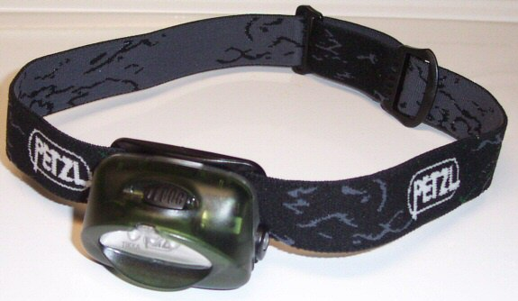

I took a pic inside the downstairs bath with the lights off, the door closed, and no flash active on the camera. The only illumination was from the 3 LED light and says the pic came out very well.

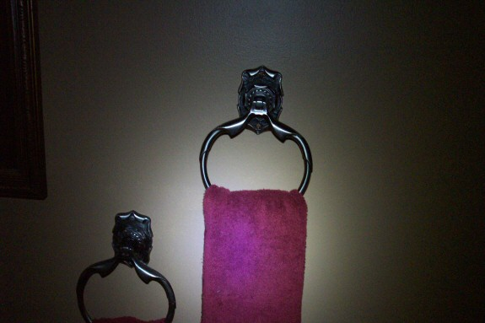

This morning, I received (from CNIB) 2 4x magnifiers with a single LED for illumination and a special 4x magnifier on a stand which provides hands free magnification.
Everything helps, but it is a pain to take 4 to 10 times longer to do the simplest things.

Sep 1 2006, 12:03 AM
Day 42 - August 31 - 6 weeks
There have been significant changes in distortion and vision and all benchmark checks appear changed.
There have been marginal change to the induced Gray circle. It is now more circular and located in what appears to be the upper left portion of eye. The center is now even lighter than a week ago but the darker border still comprises about 1/2 of the total diameter. The lightening is a good sign because it means the body is slowly removing the blood inside the retinal layers.I also think the gray circle is slightly smaller although I can not measure it against anything so it's just a perception.
Benchmark views on the garage siding has changed for the better, I think. Distortion on Horizontal lines has almost disappeared, just a slight upward arc. Distortion on vertical lines has changed and not sure what to make of it.
Prior perception was a 30-degree angle cut thru the line and the upper vertical offset to the right over the bottom, and both upper and lower appeared straight. Now it is a 40-degree cut, the offset appears slightly wider, and the lower portion, formerly straight, now appears to bend to the left. Perception is that further down may be more closely aligned to the upper, but impossible to measure using peripheral vision.
Lamp in window of house across road is behind sheer lace curtains and last week could not see lamp using right eye only. Last night the lamp was barely visible intermittently as if the optic receptors are now partially functional.
Peoples features seemed clearer today, my imagination ?? or maybe better lighting ???
Three weeks ago I was almost ready to change the Zoomtext software to 2.5x because I was having so much trouble reading. I decided to persevere until it became absolutely necessary. Last night I changed the setting from 2x down to 1.75x I tried 1.5x, but that is still too hard to see.
Frustrating thing at the moment is that the left eye is now almost always feeding info to the mix, and the resulting images are messed up because of the left eye distortion patterns.
I have quit patching the left eye (see note) as I am now trying to train myself to read with that eye and get used to the distorted and bent lines. I now just close the left eye to type, and use various combos to read, sometimes just the right, sometimes just the left, and some things I try to read with both eyes at the same time.
Note: I quit patching the left eye Jul 6 as I needed all the light input I can get, even distorted light from the left is better than nothing.
Ever since Jul 6, I have been reading with both eyes on and off. I read the computer usually with the left eye closed, but am experimenting with the left.
Printed material is read with either one or the other depending on which one sees the best.
Still waiting on a call from nurse and still have questions. The second hemorrage occurred at 7 weeks 6 days after the first laser treatment. I am at 6 weeks, and the closer I get to that 8 week mark, the more antsy I feel.

Sep 5 2006, 01:40 PM
An early update as both vertical and horizontal distortion have changed again.
Horizontal distortion appears to be morphing into a sharp short upward curve, can't draw it yet, but will try later.
Vertical appears (my perception) to be aligning the top more over the bottom and the diagonal connection angle is increasing, used to be less than 30 degrees, now is at least 40 degrees..

My perception is that the vertical offset increased each and every day moving to the right from Jul 5th until the laser treatment. Since then it appeared to come to the left, then went right again and now it seems as if the upper portion is moving up and to the left, almost as if it was unfolding. Very strange.

Sep 5 2006, 06:11 PM
I was asked by a forum member if I was seeing any better, and this is the answer to that and another question.

I replied that "seeing better" is hard to explain. I do not think I can read any better, but I am now seeing people moving at a distance of 300+ feet which I couldn't have seen a few weeks ago.
The car headlights are no longer at radically different heights but I think the remaining distortion will affect that. I haven't been anywhere in a car since last week so doesn't know how traffic lights appear at the moment.
There is still a major loss of visual acuity caused by the dark circle and it may be slightly paler inside. I think the focal point is still thru the edge of the dark circle which is still darker than the center. I bench marked the circle today and says if I stand 3 feet from a picture that is 13 inches wide on the wall, the dark circle is about 1 inch wider than the picture on both sides.
My perception of the gray circle, against a section of the bathroom wall which did not photograph well, but it will do.
The red “X” is where I perceive the focal point to be based on the circles position in my field of vision when I open my eyes, and I still have the feeling that the circle is in the upper left.
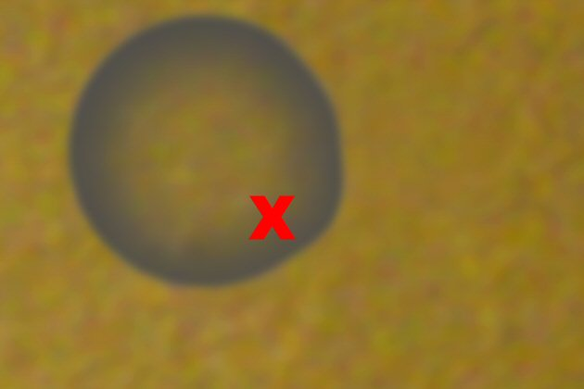

Sep 7 2006, 10:56 PM
Day 49 - September 07 - 7 weeks
There have been additional changes in distortion but not vision and all benchmark checks appear changed in some fashion.
Marginal change to the induced Gray circle. It is still circular and located in what appears to be the upper left portion of eye. The center may be lighter than a week ago but the darker border stiill comprises a little less than 1/2 of the total diameter.
The lightening is a good sign because it means the body is slowly removing the blood inside the retinal layers.
I also think the gray circle is slightly smaller altho I can not measure it against anything so it's just a perception.
Bench marked the circle today and if I stand 3 feet from a picture that is 13 inches wide on the wall , the dark circle is about 1 inch wider than the pic on both sides. This appears unchanged, but may be less.
Benchmark views on the garage siding has changed for the better, I think. Distortion on Horizontal lines has almost disappeared, just a slight short upward arc on a single line. Distortion on vertical lines has changed and appears to be more closely aligned.
Today’s perception is more closely aligned vertically, not possible to determine the percentage of offset using peripheral vision.
Lamp in window of house across road is behind sheer lace curtains and last week lamp was barely visible intermittently as if the optic receptors are now partially functional. Tonite the lamp is slow showing up, but perception is that the lamp is easier to see, altho considerably dimmer than the left eye sees it.
Previously Noted: Peoples features seemed clearer today, my imagination ?? or maybe better lighting ???
No apparent changes to this.
Last week I changed the Zoomtext setting from 2x down to 1.75x Today I tried 1.5x for the morning, then set it back to 1.75x.
Left eye is still feeding info to the mix, and the resulting images are messed up because of the left eye distortion patterns.
Still waiting on a call from nurse and still have questions. The second hemorrage occurred at 7 weeks 6 days after the first laser treatment. I am at 7 weeks, and the closer I get to that 8 week mark, the more antsy I feel.
Distortion on Vertical lines is measured on a few benchmarks and one is the lamp standards one of which is across the street 75' from where I observe it. The distortion at its worst had the top offset close to 3/4 at the 75' mark, today it appears to be offset by ¼ or less, tough to measure without a ruler.
Tonight I made another attempt at drawing the distortion in the right eye. I am using the window in the house across the street. In real life the bars are white and the glass appears dark grey. The window is approx 7' x 7' and is comprised of 16 panes approx 20" square with 2" vertical and horizontal framing. This window is approx 110 feet away and at that distance, it appears to my perception that the horizontal distortion covers a width of approx 30" and rises approx 4". The vertical distortion offset appears to be approx 2".
The window below is as close as I can get to how it appears, and this is the least amount of distortion and the most normal view I have seen in the last 9 weeks using the right eye only.
The focal point is on the center crosshairs and it is assumed that the distortion does not extend past what it drawn, peripheral vision does not seem to be distorted.

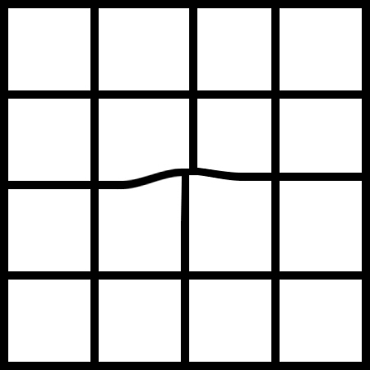

As a comparison, this a rough idea of what the left eye sees. I have determined that the distortion is actually less exaggerated than this image would suggest. I will try to redo it later.

Sep 15 2006, 01:31 PM
Day 56 - September 14 - 8 weeks
It was too dark to check the benchmarks yesterday.
There doe not appear to be any changes in distortion and all benchmark checks appear unchanged or if there are changes, they are so marginal that they aren't apparent or measurable.
Having said that my perception of my own vision makes me think it is marginally better.
Two days ago I noticed a marginal change to the induced Gray circle. It is still circular and located in what appears to be the upper left portion of eye.
The edges are now taking on a lacy or spiked appearance and the outline is not as sharply defined. The edge appears to be similar to the edge prior to Jul 5th. The circle is also mis-shapen on the top edge. (That has since changed and it is rounder again)
No apparent change in size.
The induced gray circle seems to float just above the surface of whatever is being used as a backdrop. Based on the bedroom window which is approx 7 feet wide and separated into 3 panes of 28" each, from the bed which is 5' from the window, the gray circle is approx 40 inches wide, and looking at the window from the doorway of the ensuite, approx 17 feet away, the circle is almost 7' wide.

Sep 21 2006, 01:25 PM
Day 63 - September 21 - 9 weeks

Now I'm confused again because I seem to be getting conflicting info from the benchmarks.

There appears to be changes in distortion and it seems to have increased over the past 4 days.
Garage siding – horizontal distortion spans 2 rows and one second both rows go up, and the next second the bottom arcs up and the upper arcs down.
Vertical offset appears greater but tough to measure.
The gray circle appears smaller on one check and unchanged on another. I believe it is paler all over and it now has a slight bulge at the 3 o'clock location.

Having said that my perception of my own vision makes me think it is marginally better again in spite of the apparent negative benchmark changes.

I changed the settings on Zoomtext yesterday to 1.5x from last weeks setting of 1.75x. Some letters seem to run together and skinny letters are hard to see. I find if I move closer to the display and use the reading portion of the bifocals, I can see if the letter is really there or if I've made a typo.

The gray circle is looking more like it did prior to July 5th, I previously said that it looked lacy or spiky around the outside edge. Yesterday I finally found the descriptive word I was looking for that was escaping me. It now looks as if the circle is surrounded by cilia, or like eyelashes if you prefer, faint but there, and I don't think I could draw it.

The lamp in the window across the street now shows up almost immediately after I open the right eye only. Occasionally the lamp is missing until I blink once or twice. Can't tell if it is any brighter but it is not cycling on and off as it was 3 to 4 weeks ago.

There is an imperfection in the paint on one wall I use for another benchmark and I am 2 feet from the wall for this test.
Using the right eye only the imperfection disappears behind the gray circle. Last week I had to focus on the wall about 1 foot to the left of the mark in order to be able to see it using peripheral vision. Today I only have to focus 4 inches to the left to see it.

I also used that imperfection to benchmark the screwed up left eye.
If I focus on the mark, I can see it with the left eye.
If I focus 1 to 2 inches to the left or below it, the imperfection vanishes behind the blind spot or scar that is close to the macula. As I mentioned earlier, the brain fills the blank area with the most prevalent color or pattern, and in this case, a nice perfect wall is used to fill the area where a normal eye would still see the imperfection.

The net effect of both eyes today is a combination.
If I use both eyes and focus on the imperfection, I can see it (left eye over-riding the right).
If I use both eyes and focus 1 inch to the left of the imperfection, I can't see it; it is hidden by both the gray circle from the right eye and the blind spot from the left eye.
If I use both eyes and focus 4 inches to the left of the imperfection, I can see it twice in peripheral vision, one faint from the right eye and one sharper but up and to the right from the left eye.

Sep 28 2006, 08:30 PM
Day 70 - September 28 - 10 weeks
Still confused and seem to be getting more distortion showing up from the benchmarks.
Changes in distortion over the past week and seems to be increasing as if there is another hemorrhage happening.
If there is, it is a slow one, not the gusher I had on July 5th.
Garage siding - horizontal spans 3 rows and keeps changing so difficult to draw it. Pattern seems to change depending on which row I am looking at and that makes no sense.
Vertical offset appears the same as last week maybe, but it seems as though the slice through the image is flattening and it looks like 30 degrees, previous I thought was around 40.
The gray circle appears unchanged in size and shape, but today’s benchmark test maybe is darker than before, tough to say. It still seems to have a slight bulge at the 3 o'clock location.
The crudely drawn pictogram below is an approximation of what I see on the garage siding. The horizontal is the most common of the recent views and the vertical is as close as I can determine. The light was poor yesterday (overcast) and may cause some of my weird observations.
The focal point of both views is on the center line and at the center of that line.



Note: Printed to here for Specialist Oct 2nd appointment.

Oct 2 2006, 06:01 PM
I went for a regularly scheduled appointment at 2:45 and it did confirm a 3rd hemorrhage, so now I will go for a Fluorescein Thursday morning and will have another Visudyne Laser treatment ASAP after the results are known.
I calculate that the laser won't be done 17 days at a minimum. After the laser seals the latest hemorrhage they will try a drug called Avastin that is not covered by any insurance or the Provincial Medical System (OHIP).
Now I am basically back to the drawing board again. At the moment this seepage is not as serious as the July 5th blowout, but still wonders how much damage will be done by the time the seepage is controlled.

Oct 2 2006, 10:25 PM
I have been thinking since I got home and have decided, based on what I heard, that it is all politics and an under funded medical system. I believe I heard the specialist say the government will not pay for the $2000 laser procedure unless a Fluorescein is done to prove the laser procedure was required. This imposes a government mandated roadblock in the way. The earliest Fluorescein possible is Thursday; the specialist will not have the results until Thursday night at the earliest, and probably not until Friday. The specialist only does lasers on Thursday, which now means the following week at the earliest, and it will only happen in the following week if he is not already fully booked.
I am now kicking myself since the eye probably started seeping on the 8 week mark when I had the feeling it would, and my inability to determine that fact was slowed by a lack of sun recently which is making the benchmark checks harder to do and analyze properly.
I checked my diary and it indicates that at the 6 week mark I was beginning to worry based on the earlier laser treatment and the fact that the major seepage occurred at the 7 week & 6 day mark after that treatment. I had called the specialists to find out whether they could determine in advance if a problem was developing and told they could not, they could only tell from the Fluorescein after the seepage occurred.

What is done is done; I can't change the last 2 weeks or the speed of the next 2 or 3.

The specialist told me that an analogy is that the Medical profession (eye care at least) is at the Model T stage and it has taken 30 years to determine how to block unwanted blood supply to areas of the eye like the macula where it is not wanted.

Oct 2 2006, 10:25 PM
Received a link to an article in the Globe and Mail on AMD and the link is this in Long form
http://www.theglobeandmail.com/servlet/story/LAC.20061003.HASK03/TPStory/?query=Ask+the+Doctor

I have also referred to the cold laser treatment as Visudyne throughout this diary. This is actually incorrect and the light sensitive drug that is injected is called Visudyne. The actual laser treatment is called PDT, which stands for PhotoDynamic Therapy, and from this point on I will use the correct name of PDT and all prior references to Visudyne should be read as PDT.

Oct 6 2006, 9:45 PM
I am back to the Ivey shortly for a Fluorescein set of images as a prerequisite for the PDT.

Since the eye has hemorrhaged again, the benchmarks show a regression or moving away from normal and that isn’t making me happy. Vision appears to be less as well and it is more difficult to read the web forums at 1.5x magnification. By default now the left eye has assumed dominance and things are brighter, but the line I am reading has a wave in it.
The distortion on vertical lines is not much different.
The distortion on horizontal lines has changed the most and the sharp waves are very distinct. Today while I was out, the shadows from the trees crossing the road at the focal point about 500 feet away showed very sharp upward curves in the center of the road.
Things in general are dimmer and blurrier because the gray circle is darkening and the defined edge that used to be about 10% of the circumference now appears to be 20%.
The TV is now also primarily viewed with the left eye by default and is difficult to see any details with the right eye only.
I went out today and bought a larger LCD TV that won’t be available till next Wednesday. In the store it seemed to be a better picture to watch so we will have to wait and see. The old TV was a 27” conventional and the new is a 40” in the new 16x9 ratio. It should have about twice the viewing area of the old and hopefully I will be able to see the characters and action with more clarity.

Oct 8 2006, 11:50 AM
Just sitting at computer at the time indicated and there was an instantaneous feeling of blur from the right side. I now have the computer system reset to 2x magnification, up from 1.5x, and still can hardly read with the right eye.

I went outside and looked around and there is a feeling of a power struggle between the left and right eyes. There is a white circular thermometer on the red brick wall and it is in the shade on a wall facing east that juts out on the north side of the condo. When I look at it, it is the left eye that is providing the image, as it looks higher than where the right eye sees things due to left eye distortion. If I close the left eye, I can see it but it seems dimmer or darker than before. If I open the left eye, it assumes dominance in a few seconds. Light conditions are bright and sun reflects off the south facing garage wall so light is presumably at its best right now.
I don’t see any changes in the benchmarks from yesterday and the gray circle still appears to be the same shape with the same amount of central fading and the hairy fuzzy appearance around the outside is still there.
The left eye with the distortion has apparently assumed dominance though and everything I look at is now seen with the distorted left and the right is not doing much at all.

After thoughts written at 1:30 PM: Upon further reflection, this is probably an accumulated effect since the seepage started again 3 weeks ago. It has been so slow that I over looked the fact that the left eye has been the dominant eye on the computer for weeks and I have become accustomed to reading the wavy line of print that I now see by default.
I have also become aware that it is the left eye seeing at least some of the keyboard even with the hi-intensity light and that is partially confirmed by the number of typos creeping in from hitting the key to the left (sometimes to the right) of where I thought I had struck. I just think I am more adept at spotting them with the left eye now.
Also upon reflecting, I am still certain that the right eye is worse and I still have the feeling that at least some of today’s new impressions and feeling occurred right at 11:50 am when I felt a blur as if something had suddenly dirtied my glasses or filmed over my eye.

Oct 12 2006, 10:00 PM
Benchmarks are still getting worse and distortion on Horizontal and vertical lines are increasing. The gray circle has changed marginally and may be somewhat darker in the center and the pale area may be a bit smaller than before.
I have also noticed over the past few days that when I come in from outside, I am now seeing a very bright black flashing area which appears to be in the upper right quadrant and doesn’t seem to relate to the gray circle or the location of the distortion. I seem to automatically try to focus on it and see what it is, and it moves away, then fades after maybe 10 seconds and is gone.
I had hoped that I would have the PDT today, but have heard nothing since my call yesterday.

Oct 14 2006, 9:00 PM
I purchased a Sony 40” LCD HDTV last weekend and it was delivered last Wednesday, Oct 11, and the picture quality and size is an improvement over the old 27” which was hard to see.
The characters faces are easier to see and I can follow the story lines easier.
Today I received the Cable systems HD box that will provide the High Definition side of the cable input. I don’t think I am seeing any difference so I may not have it hooked up correctly.
I am getting increasingly frustrated with my inability to read or even comprehend the new manuals and technology changes and have discovered that the remote controls are hard to read and understand. Attempting to read the manuals with a magnifying glass is just plain aggravating and the inability to scan quickly as I used to is really ticking me off.
Today I will attempt to read the manuals again. Using both eyes to read is preferable but the magnifying glass only works with one eye and I find myself flipping between the left eye that sees distorted with the blind spot and the right eye which is having trouble with the small print and a lack of contrast on the letters.

Oct 18 2006, 10:00 AM
It has been cloudy and overcast lately and not the best conditions for bench mark checks.
I think the distortion levels in the right eye are fairly close to where they were on July 20th, the date of the last PDT. Vertical offset may not be quite as bad, but horizontal distortion is very bad at the focal point. The distortion now covers 3 strips on the garage siding, the bottom strip ramps upward to just left of the focal point and then extremely sharply down, the top strip has a very narrow arc down to the center strip, and the center strip at the edges curves upward but in the center it disappears. This seems to change depending on which 3 strips I try to focus on.
There is little or no change to the gray circle for size or appearance.
The Northern Lights have been sporadic and don’t last as long, and the patterns generated are much more random in how they appear and morph from one flare to the next.
I just started noticing (actually about a week ago) that I am now tilting my head to the right to read this document, the forums, and printed materials. I also just became aware that the characters look like they are printed in Italic type font.
I reset the Zoomtext to 1.5x and decided to learn how to use that size and the left eye until hopefully the right eye improves.
I just received a call from the specialist’s office about ½ hour ago to schedule a PDT for tomorrow afternoon at 1:00pm. The eye has now been hemorrhaging for about 4 weeks or so and the gains made since the prior PDT to now have been lost again. Part of the problem is, in my humble and biased opinion, caused by slowness in the system, and the first 18 days or so was lost because I couldn’t tell immediately that the eye had hemorrhaged again.
The image below is the distortion levels today, The right eye is focused on the center of the 3 affected lines and is either the upper or the lower, not both at the same time as the eye can only focus at one point at a time..
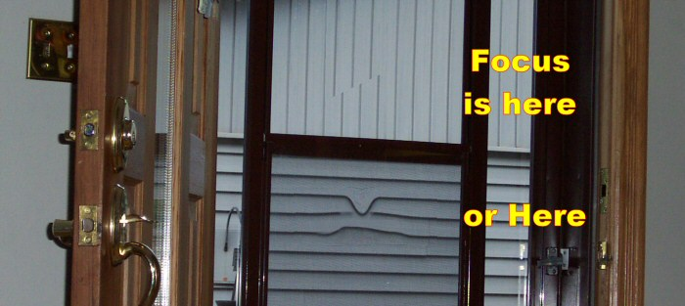

Note: Printed to here for Specialist Oct 19th appointment.

Oct 19 2006, 3:00 PM
This entry written Sat night when I could see better and get the lights on.
This laser PDT treatment was different than the last 2 sessions and the specialist said everything was the same. On the last 2 I saw a blinding white light and was not aware of anything else. I seem to vaguely remember that on at least the last one I was advised to look straight, left, down, etc but since I saw nothing but light, I did not have any points of reference.

I got the same type of instructions this time as well but this time I had a very strange view. I was looking at something that resembled the moons surface, it was pitted and cratered all over, there were a number of black lines wandering around similar to waterways on a map, the color was a medium Aqua, more green than blue, and very richly saturated. I could see a bright blue stick and there were some black circles as if the crater was filled with ink. As I was told to look left, right, down, etc, the view changed as if I was panning over the object or landscape and I could see the blue stick appeared to be directed towards the black pools. I assume that there was something outside the Aqua circle but I’m not aware of what it may have been, and the urge to focus on the craters and just look around was hard to control.

My next appointment is for Nov 19th when they will start the Avastin injections.
I sat in the waiting room from 1:45 to 2:30 waiting for my wife to come and get me. She was waiting in the parking lot from 1:43 to 2:30 waiting for me to come out.

Oct 19 2006, 9:00 PM
This entry written Sat night when I could see better and get the lights on.
The after effects of the PDT are similar to the last 2. The TV is washed out with some loss of contrast although the effect is not as severe as before because of the new LCD HDTV. The left eye is fully dominant and the words are skewed tonight since the right eye is not providing its customary input. The old TV in the bedroom seems to be a fuzzy as the last 2 PDT’s.

Oct 20 2006, 9:00 PM
This entry written Sat night when I could see better and get the lights on.
I tried using the computer in the dark. I was wearing a 3 LED headlamp to illuminate the keyboard for typing, there is one incandescent light in the corner, and the only other source of light was the LCD monitor display. Reading is awkward as the right eye supplies no input and the left eye seems to be having problems, possibly because of the low light conditions.
There would normally be two 2-tube 4-foot fluorescents and a hi-intensity lamp.
TV viewing is unchanged from yesterday.
Periodically I see a bright black circle and I have now determined that it is inside the borders of the gray circle and that is contrary to my previous feeling as to its location.
The size can only be determined relative to the gray circle and it appears the diameters of the black circles are about 15% of the gray circle.

Oct 21 2006, 2:00 PM
This entry written Sat night when I could see better and get the lights on.
My 48 hour incarceration has ended and I have opened the blinds, drapes, and turned on the fluorescents in the basement so I can see.
I just went outside for some fresh air and to look around. When I came back into the house where it was darker even though it is heavily overcast, I saw 3 shimmering black circles in a row and they are inside the gray circle confines. These shimmering shapes appear to have a gold border that also pulses and it gives the illusion or feeling that the shapes or the border are moving or rotating. It is impossible to focus on them and they disappear after a few seconds.

Oct 21 2006, 4:00 PM
This entry written Sat night when I could see better and get the lights on.
The outside light is at a minimum due to heavy overcast and this fact may be causing the benchmark variations that are too radical to be explained. I can’t get an accurate read on the distortion on vertical lines, but may be less. The distortion on horizontal lines has changed radically for the better and at no prior time has it ever changed as much in only 48 hours. The view of the garage siding is radically changed, as has one other benchmark that I use. I have a stained glass window hanging in front of a window and the stained glass is in a 2” wooden frame. This is a pictogram of the look on Thursday before the PDT and today, which is only 52 hours later.
Focal point should be at the center of the wood frame and if I was able to draw this properly the left side should only appear to have ½ the frame width at the focal point and the left side should reflect about 2/3 or so. This 2” frame is 12 feet from where I sit.

I hope the light is better tomorrow as I don’t believe what I am seeing based on months of checking the changes in bench marks.

Oct 21 2006, 10:00 PM
The shimmering black circles are going nuts tonight. I thought earlier that they were triggered by the change in light from relatively bright to inside darker. That may still be valid as they have been appearing all night and may be triggered by the bright LCD monitor on the computer.
Tonight the patterns have been too many to remember or mention.
Sometimes there is one, other times more than 7 but I have to count them in peripheral vision.
Sometimes they have a glowing gold border, sometimes the float over a pale corona.
Sometimes the gold border rotates or moves, sometimes it sparkles like the old moving light signs.
Sometimes the black circles are solid, sometimes filled with sparkling gold lights, sometimes the illusion is molten gold squirming wriggling worms.
Sometimes there is 3 in a row, or seven clustered in the top left corner, or 5 evenly spaced around the edge of the gray circle.
Sometimes they look circular and other times they are a flattened oval and may be wide or high.
Sometimes the gray circle contains a mix of round and ovals. The combinations and views are endless tonight.
Currently if I look at the wall I just saw 2, then a third showed up on the other side, then a 4th overlapping the third, then the 2 in the top left just went out and was replaced by 1 in the lower left.
They are also visible in my line of sight wherever I look, it is just harder to see them clearly when I am looking at the lit keyboard or monitor. They are always to the right and up from the actual focal point or line of sight and much more apparent when looking towards a darker area.
It will be interesting to see what I see tonight in the dark as I try to sleep.

Oct 22 2006, 9:00 AM
The shimmering black circles are losing their fascination and now they are beginning to bug me.
Since I have been up there has been a fairly constant number, usually about 4, and they seem to be more intrusive today. They are just above the focal point but seem to be interfering with my sight and concentration. They are either overlapping one another or they have changed to solid figure 8’s laying or standing at strange angles. I can’t focus on them as they move when I try.

The gray circle was checked just before bed last night and it is larger and darker than previous. The paler center section has shrunk to approx ¼ of the diameter. It is again egg shaped with the fat end at 11 o’clock and it seems to be flat at the other end instead of gently pointed. It still appears to have the fuzzy hairy outer edge although it is not as well defined as the earlier paler versions.

It is still too dark outside to get a better benchmark check.

Oct 23 2006, 2:00 PM
I was outside and it is still too dark to do benchmark checks but I did notice distortion that I have never seen before. I was looking at the house across the road and trying to check the distortion on the window that acts as an Amsler grid. In the present light conditions it appears that the distortion at the cross hairs is back to what it was about 3 or 4 weeks ago, but since vision is so low in these light conditions I can’t be sure.
However I also focused on the eave, and above and below it to see if I could see distortion where there was more contrast and discovered the following. Focal point is at the red X and the distortion is minor to the left of the focal point and at the curb level, where there has never been any noticed, it is fairly extreme. The center section has been blocked and modified to decrease the contrast, brightness, and increase the blur and is a fairly close example of what the right eye sees color wise.
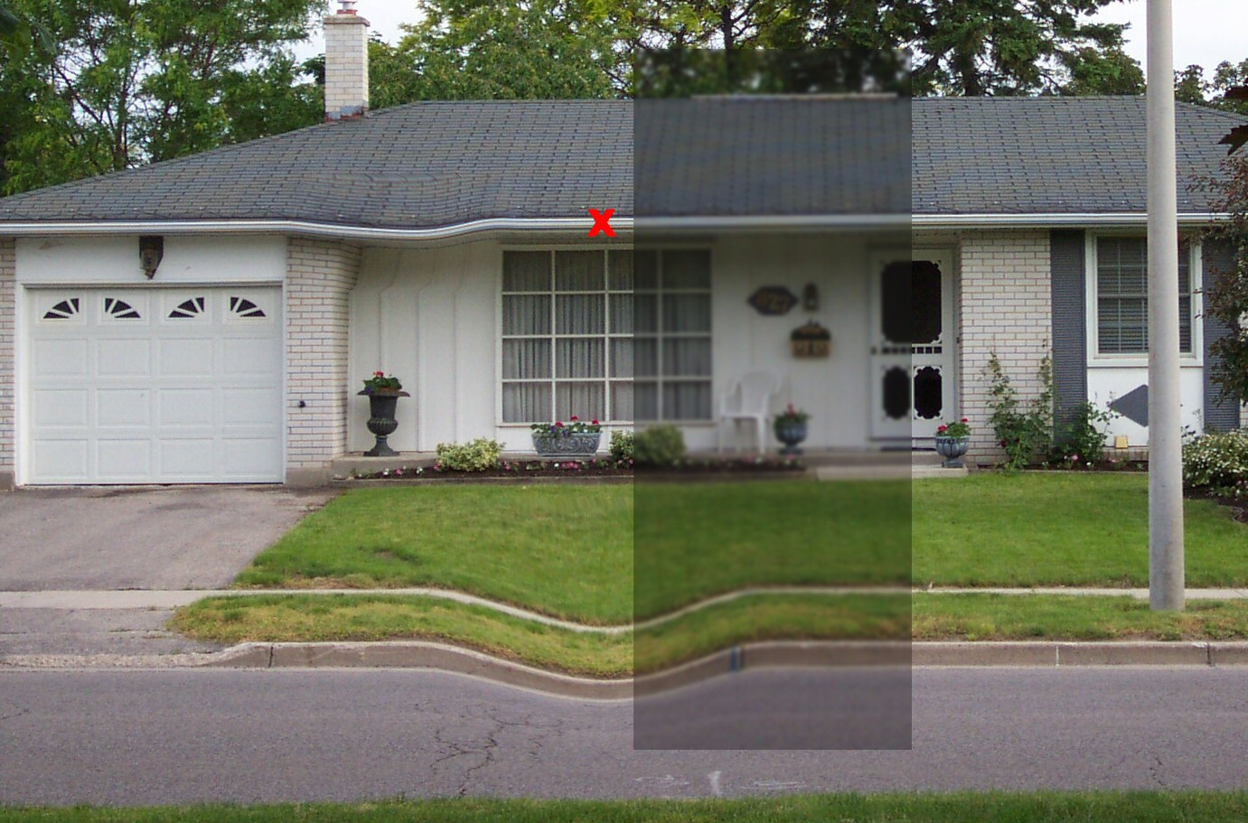

Nov 03 2006, 6:00 PM
I am confused by the distortion again. Maybe the changes noted earlier were caused or modified by the after effects of the PDT laser as the last few days indicates the distortion is either the same as, or worse than the distortion on the day of the treatment.

Distortion on horizontal lines and vertical lines is just as strong with the added distortion now showing up further away from the focal point. It has also been noted that distortion is much more noticeable and much more distorted in strong sunlight, and appears to be much less in dull or overcast conditions. I don’t know why that seems to happen.

The gray circle still appears as it has for 2 weeks and the paler gray shade in the center has not changed. The “black” circles have been further studied and now I think they appear dark only because of the flashing pale yellow coronas. These are beginning to be less intrusive than before and at their worst, there would be as many as 7 to 12 flashing very quickly. I cannot focus on them so I can’t tell if they flash in unison or each one is randomly independent. It is not unusual to have some of them disappear and be replaced by others, sometimes more, sometimes less.

The actual size and shape of the gray circle has changed slightly from the image included above and that image is actually from a week ago. Today, right now, it is slightly paler, is rounder, and appears to be slightly smaller.
The lamp in the window of the house across the road is barely visible, one week ago it was vible only as a delayed effect, roughly 5 to 15 seconds after I looked, it would slowly sputter and appear.

The graphic below shows the relationship of the gray circle to the focal point, the relationship of the flashing coronas to the gray circle, and how they appear on a wall. The example is a maximum number display and the background wall is usually the closet doors or the stairs going up.
It should be noted that the areas inside the coronas appear darker. They are not and that is an optical illusion caused by the light coronas surrounding the areas.
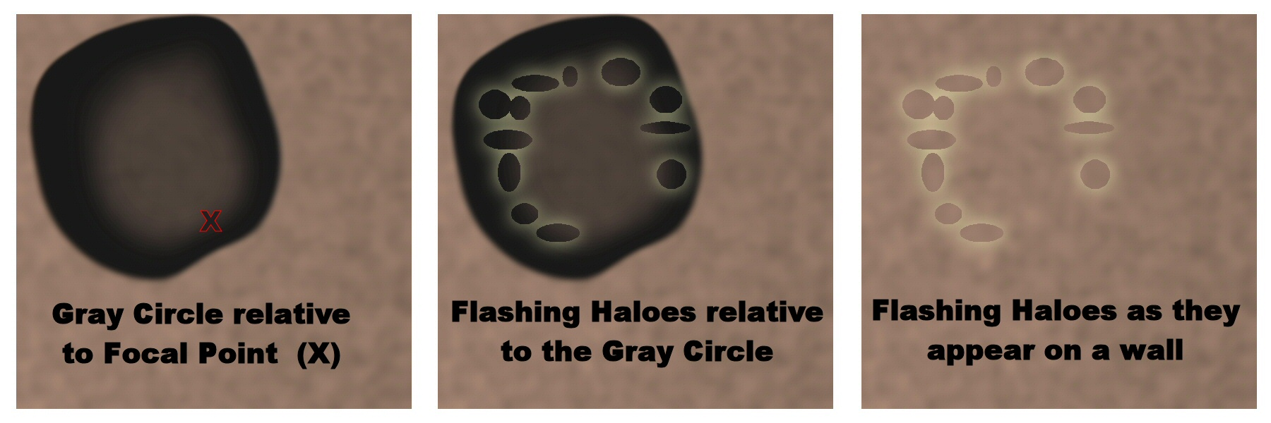
The following image is an animation attempting to show the speed and effect of flash. This is about as close as I can get since I can’t focus on them for a better read. The animation will only work inside this document as an HTML document and as uploaded to the web page. A printed hard copy will be static only.

