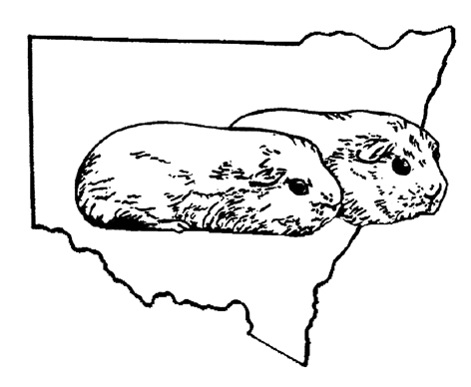
NSW Cavy Club Inc. Official Entry Form

Show: Date:
 | Ear Tag | Class No. | Class Name | Colour | Section | Name | Date of Birth
1
2
3
4
5
6
7
8
9
10
11
12
13
14
15

$5 for first entry = $5.00 + ______ additional entries @ $1.50 each = $ ________

Total Entry fee = $______

Name/s: Stud:

Address: Phone No/s:

________ for lunch please (this is not an order, just to help with catering if a canteen is available)

I agree to abide by the rules set down by the NSWCC inc. ___________________________

