Name, Period_____________________________

Virtual Lab – Vectors & Vector Operations
Setup
- Make sure your calculator is set to degrees and not radians.
- Go to http://phet.colorado.edu/simulations/index.php.
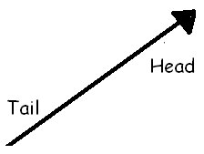
- From the menu at the left, click “Math Tools” and then select the Vector Addition simulation.
- Once you get to the Vector Addition page, there should be a green button below the picture that says “Run Now!” Click this button.
- In the basket at the top right, you can drag out a vector arrow. If you ever want to get rid of a vector, drag it to the trash can at the bottom right. If you want to start over, click “Clear All.”
- You can adjust the direction and length of the arrow by click-dragging the arrow head. Play with this until you are comfortable.
- Click the “Show Grid” button. This will make it easier to adjust the arrow lengths.

Part A: 3-4-5 Triangle
- Drag out a vector, and move it until the tail is located at the origin. Click on the head of the vector, and drag it until it is completely horizontal, points to the right, and has a magnitude ( |R| ) of 40.
- Look at the chart at the top of the page. Here is an explanation of what each number represents:
  - |R| represents the length of the arrow. This is usually called the magnitude of the vector.
  - θ represents the direction the arrow points. This is simply called the direction of the vector. The magnitude AND direction will completely define a vector.
  - R_{x} is called the X-component of the vector. This is the length of the vector in the X-direction only.
  - R_{y} is called the Y-component of the vector. This is the length of the vector in the Y-direction only.
|R| | θ | R_{x} | R_{y}
- For the first vector you dragged out, fill in the chart at right.

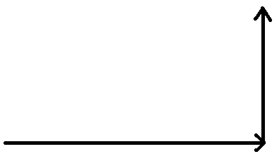
- Now, drag out a second vector and place its tail at the head of the first, as shown at right. Adjust this second vector until it points vertically upward and has a length of 30. Fill in the table for this vector here:
|R| | θ | R_{x} | R_{y}

- If you were to walk this path, at the end you would be 50 units away from the origin. You can show this by clicking the button that says Show Sum. A green vector should pop up. This represents the vector sum, or resultant, of the first two arrows.
- Drag this vector over so that the tail is at the origin, and use it to form the hypotenuse of a right triangle. Notice that the head of this vector ends exactly where the second vector ends. Click on the green vector and fill in the chart for this vector here:
|R| | θ | R_{x} | R_{y}

- Compare the R_{x} and R_{y} values for the green vector to the |R| values from the first two red vectors. What do you notice about these values?
Part B: Single Vector, Magnitude 50
- Hit the Clear All button to erase the screen. Next, create a vector with an R_{x} of 40 and an R_{y} of 30. Fill in the chart for this vector here:
|R| | θ | R_{x} | R_{y}

- Compare the chart values of this vector to those of the green resultant vector from #13. How do these values compare?

- Next, click the Style 2 button on the “Component Display” menu. This is a way to visualize any vector as a sum of horizontal and vertical components.

- Adjust this vector until it has an R_{x} value of 30 and an R_{y} value of 40. Fill in the chart for this vector:
|R| | θ | R_{x} | R_{y}

- Has the magnitude (that is, |R| ) of this vector changed, compared #15? If so, how?

- Has the direction (that is, θ) of this vector changed, compared to #15? If so, how?

- Figure out a way to adjust the magnitude and direction of this vector until it has a magnitude of 50, just like before, but points in a different direction (but with θ < 90º). Fill in the chart for this vector, and draw your vector below.

|R| | θ | R_{x} | R_{y}

- Looking at this vector, it is easy to imagine a right triangle, made from R_{x}, R_{y} and |R|. In this case, |R| would be the hypotenuse, and R_{x} & R_{y} would be the legs.
  - Show, using the Pythagorean Theorem, that |R|² = R_{x}² + R_{y}².

  - Show, using SOHCAHTOA, that R_{x} = |R| cos θ.

  - Show, using SOHCAHTOA, that R_{y} = |R| sin θ.

- Clear All. Imagine a vector with magnitude |R| = 28 and angle θ = 55 º.

  - Use SOHCAHTOA to determine the X- And Y- components (that is, find R_{x} and R_{y}). Show your work below.

  - Check your answer by constructing this vector.
Part C –Applications of Vector Components

Show your work!

- A plane is taking off with a speed of 70.0 m/s and climbing at an angle of 30.0°.

  - Using trigonometry, find the horizontal- or x-component and the vertical- or y-component of its velocity. Verify your results with the computer simulation. (Note – you can drag the corner of the window the simulation is in to make it bigger.)

horizontal-component _________

vertical-component _________

  - How long will it take the plane to reach an altitude of 800.0 m at this velocity? (Hint – 800.0 m is your vertical displacement. Which component of the velocity should you use in the formula v=Δx/t?)

  - How far will the plane go horizontally in the time it takes to get to the altitude in part b? (Hint – you are finding your horizontal displacement and you already have the time from part b.)

- The sun is directly overhead. The shadow of a plane is moving at 50.0 m/s along the ground (which is horizontal). The plane’s velocity is 56.0 m/s. Using trig, determine the angle at which the plane is climbing and the vertical- or y-component of its velocity. Verify your results with the computer simulation.

V=56.0 m/s
V_{x}=50.0 m/s
V_{y}= ? m/s
θ=?

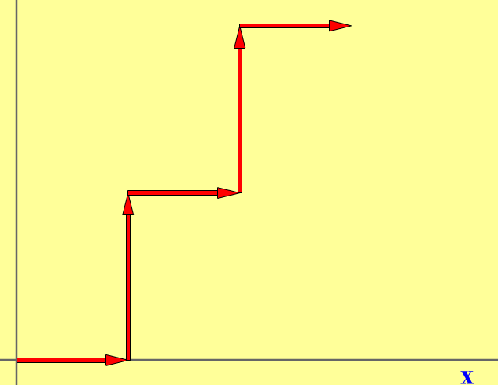
Part D– Several Vectors

- Create 5 vectors, as shown at right. The length of each of the horizontal vectors should be 10, and the length of the vertical vectors should be 15.

- Click on the “Show Sum” button. Fill in the chart for this resultant.
|R| | θ | R_{x} | R_{y}

- ۝ A useful way to keep track of vector sums is to create a chart. Complete the chart below, using the 5 vectors you’ve constructed, and then add the columns to get the sums.

Vector # | Rx | Ry
1 | 10 | 0
2
3
4
5
SUM

- How do the R_{x} and R_{y} sums from the previous chart compare to the R_{x} and R_{y} values from question #27?

- Using the Pythagorean Theorem, determine the resultant |R| value. Compare this number to the |R| value from #27.

- Using R_{x} and R_{y} and some trig, determine the direction or angle of the resultant. Compare this number to the θ value from #27.

