ATTN: On-Campus Students
HCCC Student PC Repair


AIM Screen name: hcccpcservice

Having Computer Problems? Live on-campus?

Put the headache on me!

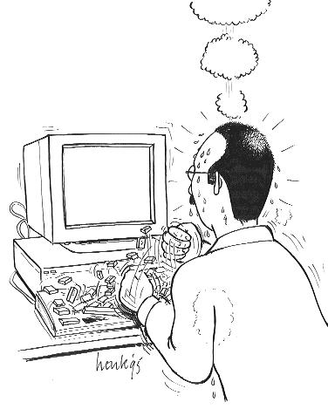
Basic Services:
- Spyware Removal
  - Sick of those pop-ups?
- System Tune-up
  - Unclutter your computer, optimize speed of system + start up speeds, and spy(ad)ware removal
- Video, Sound, Network Repair
  - Upgrade/Installing Drivers
  - Replacing/Upgrading Video, Sound, or Network Cards
- Memory Upgrades
- Windows Installation

Flat Low Rates.
Drop me a message online and you will hear from me within 24 Hours!

Questions? Comments?
Contact: xerxes@twcny.rr.com

