Derivatives and integrals

Derivatives of simple functions
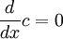
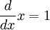
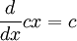
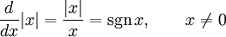
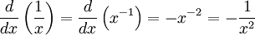
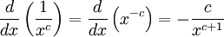
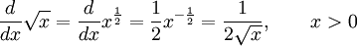

Derivatives of exponential and logarithmic functions
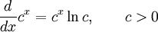
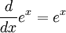
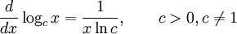
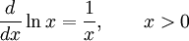
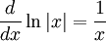
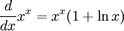

Table of integrals
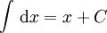
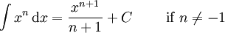
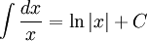
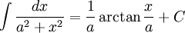

[edit] Irrational functions
more integrals: List of integrals of irrational functions
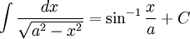
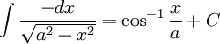
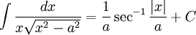

[edit] Logarithms
more integrals: List of integrals of logarithmic functions
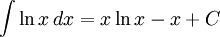
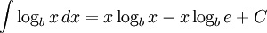

Exponential functions
more integrals: List of integrals of exponential functions
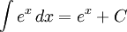

[edit] Trigonometric functions
more integrals: List of integrals of trigonometric functions and List of integrals of arc functions
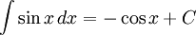
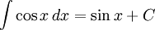
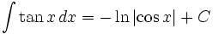
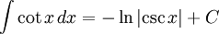
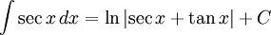
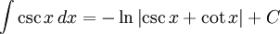
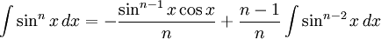
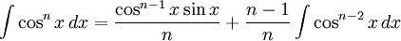

<!-- Start of NedStat Basic code -->

<a
href="http://usa.nedstatbasic.net/cgi-bin/viewstat?name=Boladura"><img
src="http://usa.nedstatbasic.net/cgi-bin/nedstat.gif?name=Boladura"
border=0 alt="" nosave width=35 height=35></a>

<!-- End of NedStat Basic code -->
<!-- Start of ReferStat -->

<script type="text/javascript" language="JavaScript">
<!--
d=document;
d.write("<img src=\"http://usa.nedstatbasic.net");
d.write("/cgi-bin/referstat.gif?");
d.write("name=Boladura&refer=");
d.write(escape(top.document.referrer));
d.write("\" width=1 height=1 align=\"right\">");
// -->
</script>

