Eastern State Hospital Mental Health Library

COLLEGE OF DIRECT SUPPORT DIRECTIONS

For help, please call Sandy Kochersperger at extension 5457.

1. Start Microsoft Explorer
2. Go to the following URL: www.collegeofdirectsupport.com/va
***Note: Make sure you are using the /va page. The forward slash (/) is next to the right SHIFT key.
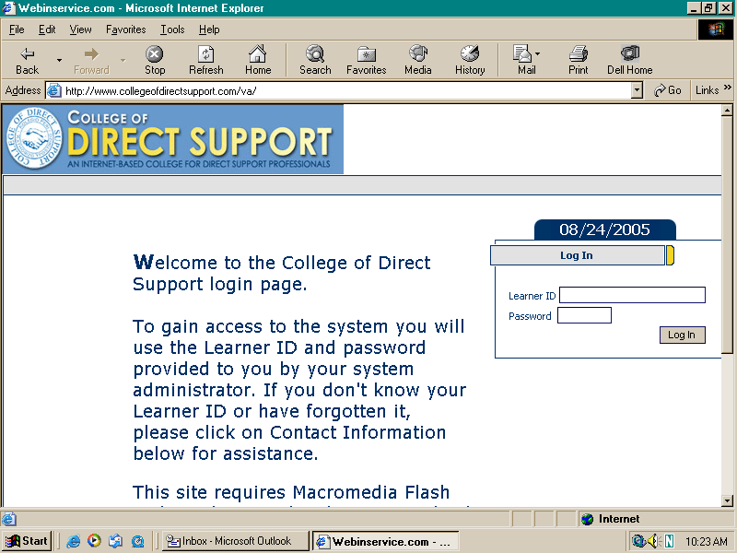
3. Enter your learner ID in the first box on the right. (First and last initial and last four numbers of social security number. Example: SK7878)

Then enter your secret password. (hello)

4. Click on the brown/tan “Log In” button.

5. The next page you will view will show an ACCEPTABLE USE POLICY.
Scroll down until you see the words “SEND MY RESPONSE” in bold blue letters.

Page 2 * ESH -CDS Directions

6. Click directly on the small white box to the right of the words “I agree to the terms and conditions listed above” and a small black check mark should appear inside the box.

7. Next, click on the brown/tan box that says “Send My Response”. See picture below.
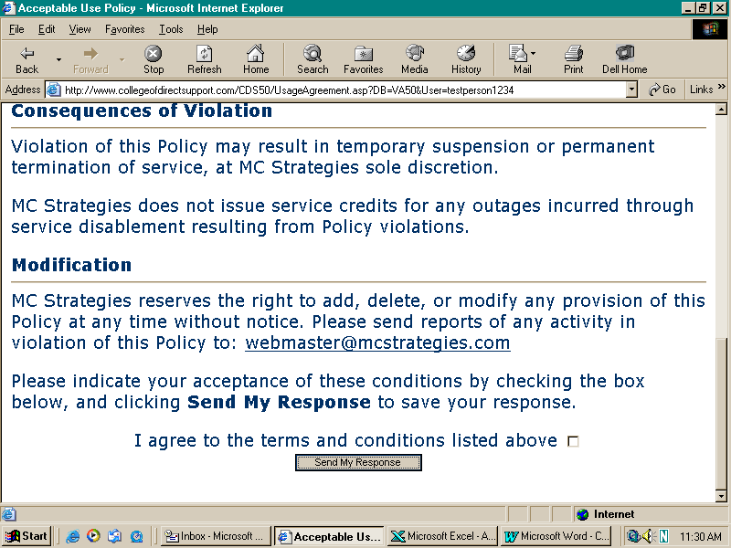

You should then come to a page that reads “webinservice personal page for: (YOUR NAME)”. * Click “edit my profile” under “What to do first” or “Tools” to change your password from the default “hello”.

There will also be a gray bar that gives you several different buttons (HOME, ONLINE LEARNING, LOGOUT, etc.) to use to access the features of the program.

Page 3 * ESH -CDS Directions

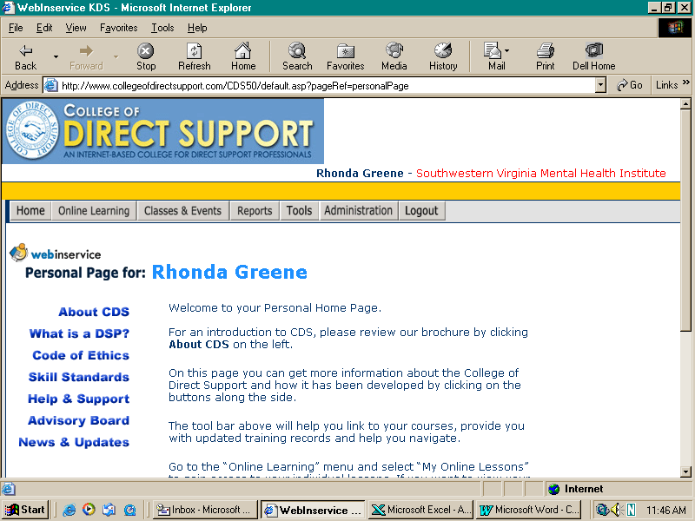

- You should then place your cursor on the gray button that reads “ONLINE LEARNING” and another menu will pop up underneath that button. You will see two choices that read “My Online Lessons” or “Enroll in a course”

- Select the words “Enroll in a Course”. When you select those words with your mouse they should be highlighted in the color navy. When those words are highlighted in navy, click left mouse key.

Page 4 * ESH -CDS Directions

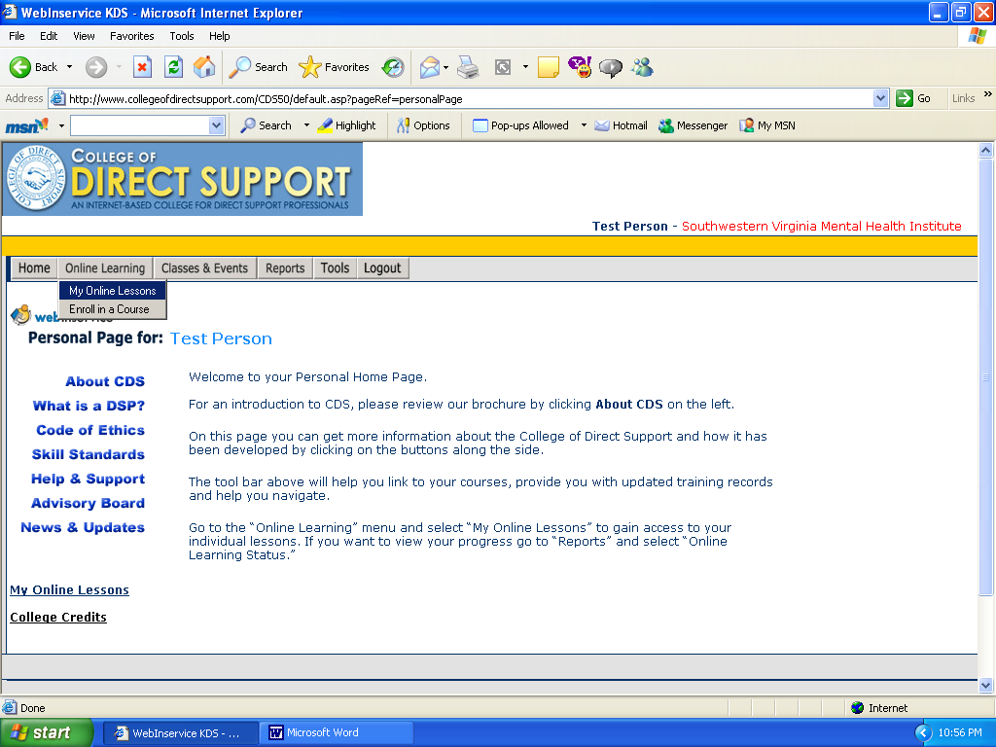

Once you have clicked on those words, you will come to a list of courses that are available for self registration. The page will show your name, our facility in red font type and then show the list of courses available for self-registration.
10. Click “Signup Now” to register for a course.

Self Enroll Signup

Online training available for Self Registration
Lessons you add yourself can be deleted if desired. When you look in your Online Learning Status under your Training Plan you will see a image beside lessons you add yourself. To remove a lesson, simply click the graphic. Completed lessons cannot be removed. Also, lessons you add will be highlighted using this background color .
Entire Organization
Eastern State Hospital
Department
Group
Yourself

Courses available everyone at your facility (Eastern State Hospital)
Courses (click to see details)

Top of Form
Course (click to see details)
ESH Culture Compendence
ESH Developing Intervention Plan
ESH Direct Support Professionalism
ESH Documentation
ESH Medication Support
ESH Positive Behavior Supports
ESH Supervision/Management |  |  | Bottom of Form

Step 10

Self Enroll Signup

Top of Form
Add lessons from ESH Culture Compendence to your lesson plan
Adding this module will add 8 lessons, or about 2 hours of training to your lesson plan. Click Add Module to add the lessons, or click the Back button in your browser to return to the self-enrollment page.
Note: If lessons in the module you are adding are the same as lessons you already have in your lesson plan, the duplicate lessons are ignored. Only new lessons will be added to your lesson plan.
Bottom of Form

Step 11

- Click “Add Module” to add course to your lesson plan. Repeat for
each course you want to add.

Each lesson should take anywhere from 20 minutes to an hour depending on our internet speed, your speed of reading/typing, how quickly you complete activities and tests and how many pages are within the lesson. You do not get credit for completing the Introduction courses but it is wise to take a look at these courses to see what you’ll be expected to know once you have completed the course (just in case you were wondering, we will be able to tell whether you’ve been to all of the lessons or not). It is helpful to look at the introduction so that you’ll know what is in store for the lesson.

Page 5 * ESH -CDS Directions

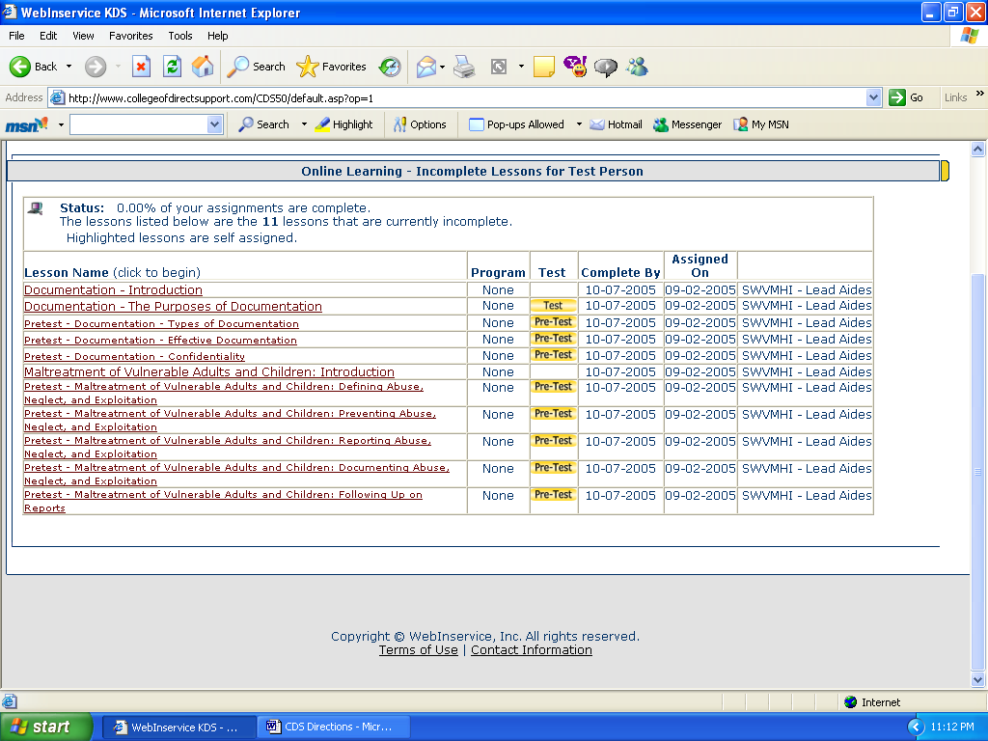

This page shows lessons you have been registered for and when you should have them complete. It does not matter what course (maltreatment or documentation) you choose to take first but you should do the lessons in each course in order because they build on each other. Make sure you go through the lesson and complete all activities, and then take the test in order to get full credit and complete lesson. (Pre-Test are not authorized for ESH)

12. The lesson names are in red/maroon font and are underlined. Click directly on the introduction with the left mouse key to start the course.

Page 6 * ESH -CDS Directions

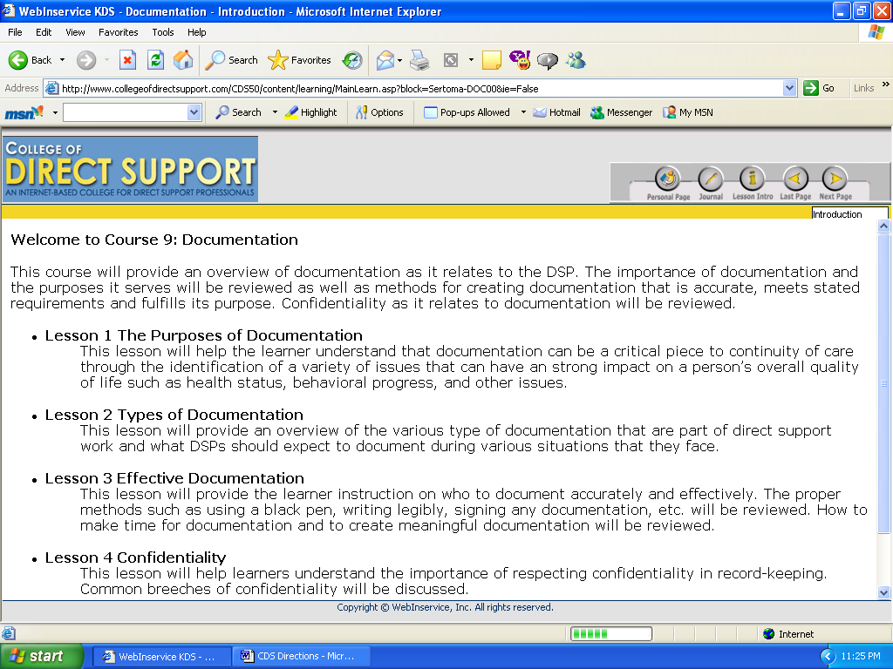

This page will tell you about the course and a general description of each lesson. Notice the buttons at the top. These buttons help move you around the website.

Personal Page button  takes you all the way to the beginning page you came to when you logged in.

Journal button  is like your online notebook. You may be asked to answer questions by typing in the journal or you may just want to record your notes and thoughts to remember later. **Remember to save your notes before exiting out.

Lesson Intro button 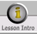 allows you to go back to the introduction page that gives you a description of the lesson.

Page 7 * ESH -CDS Directions

  These buttons allow you to move backward and forward throughout the lesson pages.

Take Test button  would be to jump ahead to the test. Most of the lessons will not let you go to the test without completing the lesson first.

***Note: most introduction lessons do not have a test. When you have completed the introduction, you must click on the to go back to the next course. Once you are there, you can go back to steps 9, 10, 11, and 12 to begin the next lesson.

13. On lessons that require a test, you must click on the begin test button in the navy bar above the yellow line. **Note: you do not have to take the test right away but you will not have completed the lesson until you have taken the test.

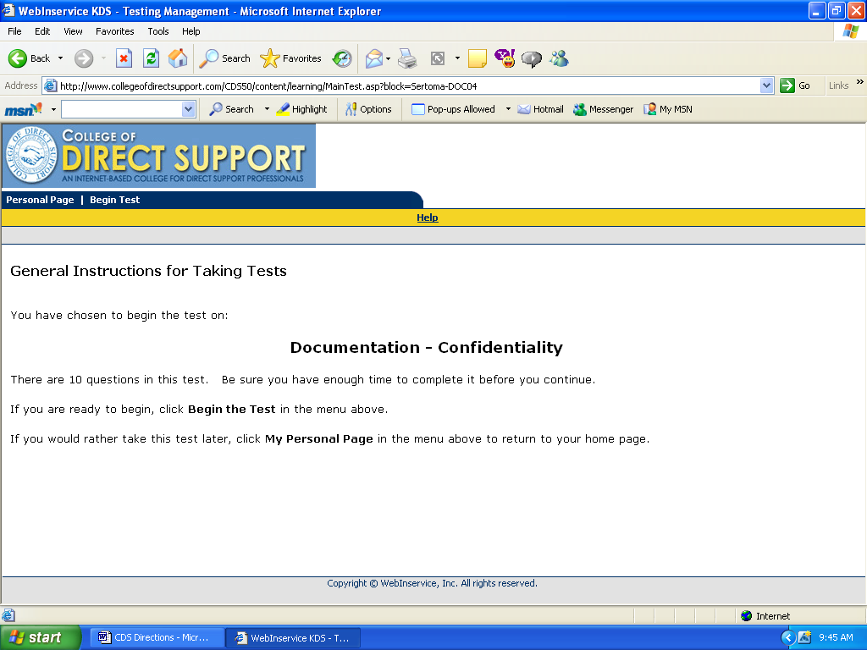

Page 8 * ESH -CDS Directions

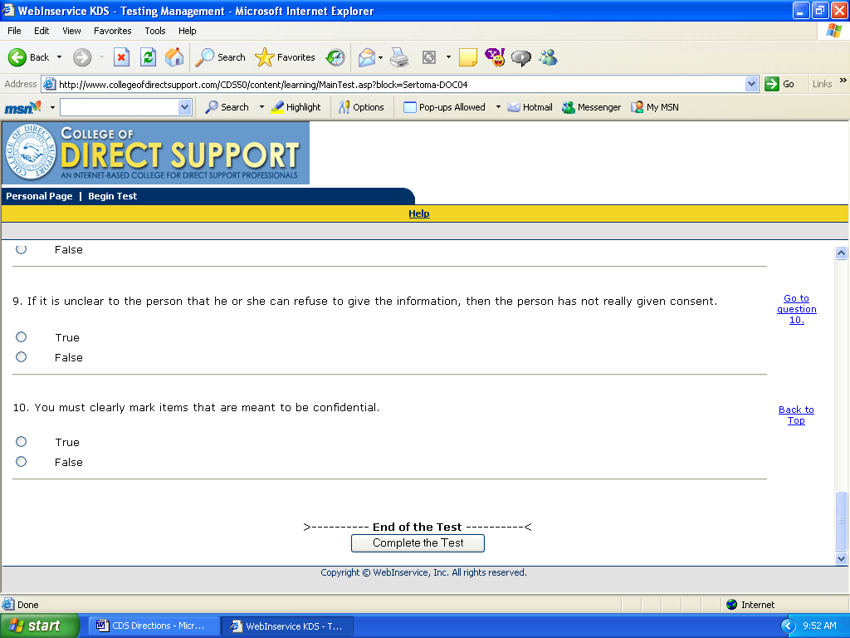

- Pick the correct answer by clicking on the circle/dot next to the answer. You should see it filled with a black color when it is selected.
15. After you have all questions marked with one answer, click on the “Complete the Test” button. You’ll then see your score/grade for the test and which answers were answered correctly or incorrectly. It will not tell you what the correct answer should have been. Only what you picked that was incorrect will be shown. You must get a score of 80% to pass the lesson. If there are only 10 questions, then you can not miss more than two questions to pass. Test can be retaken in 24 hrs., there is no limit to how many times you can retake the test.

GENERAL TIPS

Sometimes we will not be able to see the video clips or hear the sound for the characters. They say a little more than what you can read on the screen. If for some reason, you can not see the video or read the sound, you may click on the closed caption button to read a script of what the video would say.

Page 9 * ESH -CDS Directions

TO CHANGE PASSWORD (please do this when you log-in because everyone has the same password at this point).

- Click on the gray button that says and make sure the words EDIT PROFILE are highlighted in navy (see picture below).
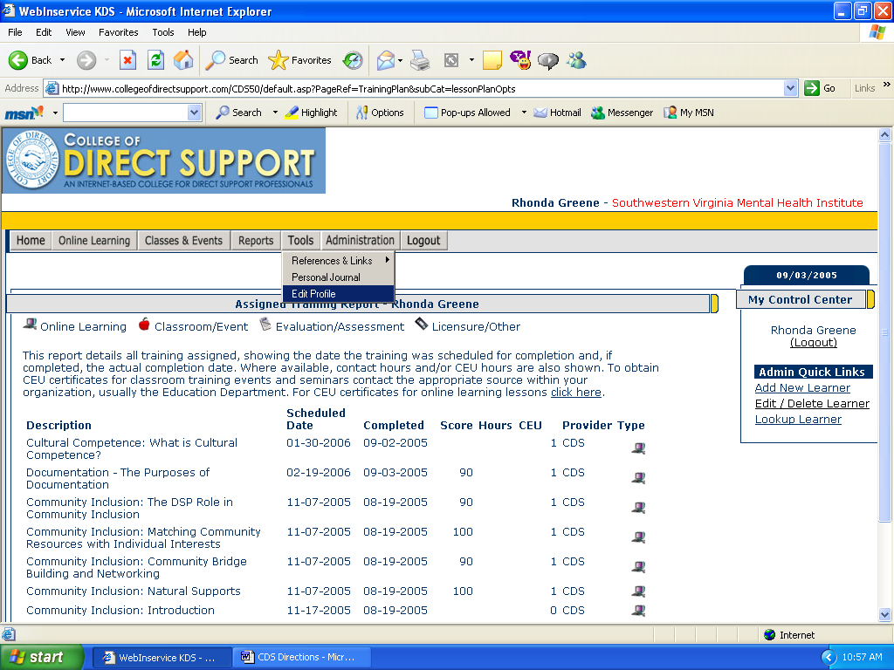

Once you click on the words EDIT PROFILE, you will be directed to a page that you can change your password. You must type in the same thing in both boxes. It is case sensitive in the fact that if you use capital letters, you’ll have to type in capital letters upon logging in. (see illustration on the next page).

***Note: If you forget your password, call me (Sandy Kochersperger) at ext. 5457 and I’ll let you know what your password is.

Page 10 * ESH -CDS Directions

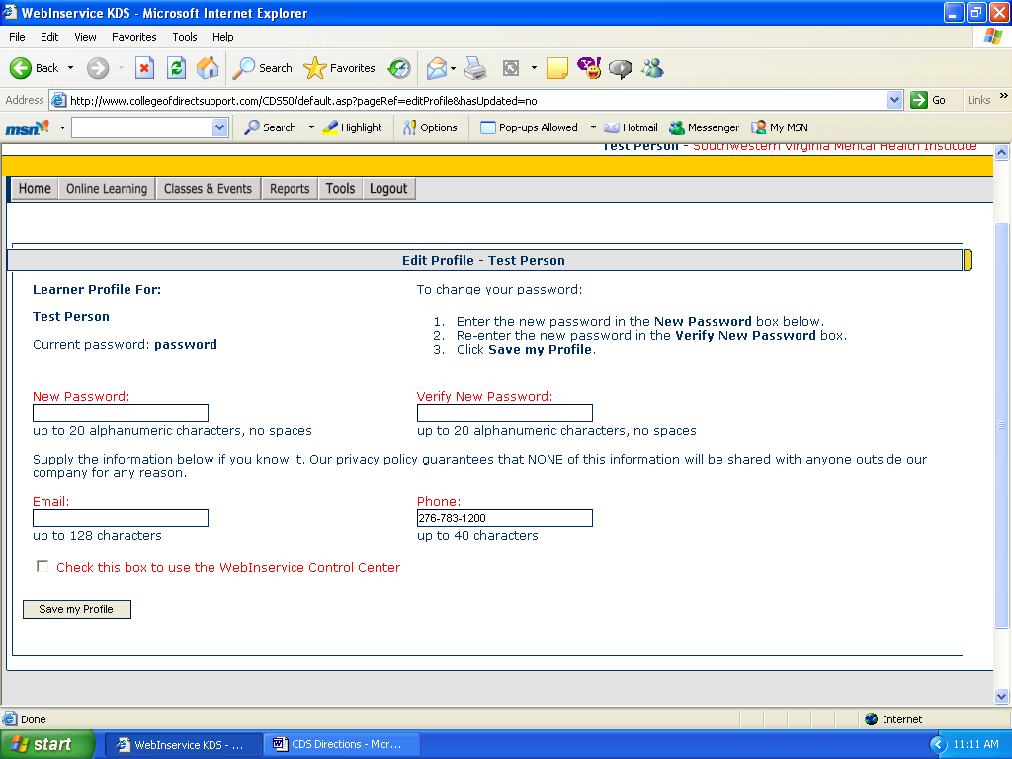
STEP TWO: Type the exact same thing in both boxes.
This shows what your current password is now.

- On this page, you will see what your current password is (most of you will have the word “hello” as your password) and then see directions on the right of the screen on how to change your password. MAKE SURE YOU DO NOT SHARE YOUR PASSWORD WITH ANYONE!
- You can enter your email address and work phone if you so choose but it is not necessary. Be sure to click on the tan button that says “Save my profile”.

Page 11 * ESH -CDS Directions

LOGGING OUT OF THE PROGRAM

- Go to your personal page and click on the gray LOGOUT button.
- Highlight the words “Exit the system”
- A menu will pop up to ask you if you are sure you’d like to leave. Click on the word yes.
- Exit out of Microsoft Explorer

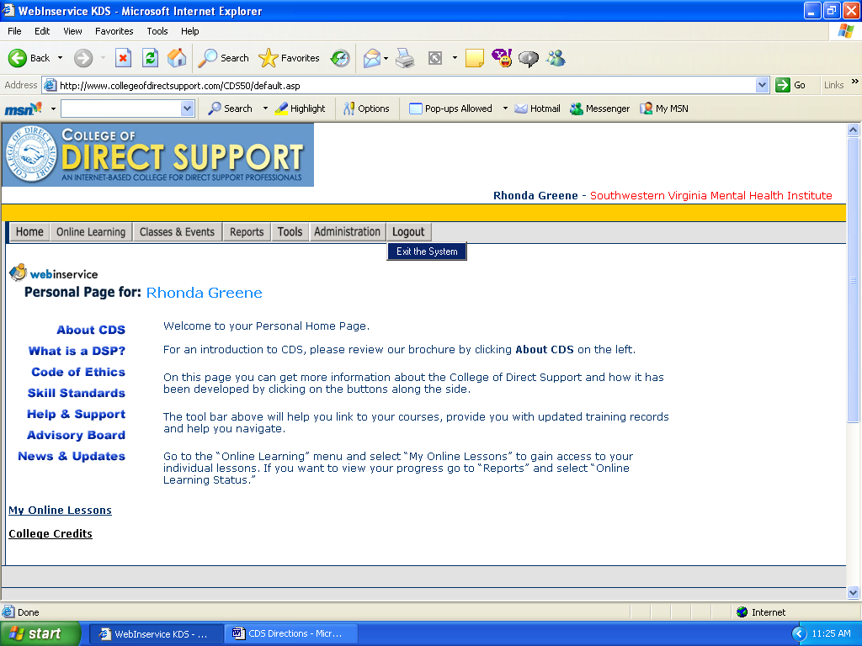

Please do not hesitate to call me at any time with questions or comments. Since this is on the internet, you can access your courses from any computer that has internet access.
Thank you so much for your cooperation. Your input is invaluable to us.

