CHEMO EXAM II NOTES/STUDY GUIDE
Yellow = on his study guide
Red = underlined in his notes, not on study guide
Blue = he didn’t say to learn everything about it

Antiviral Drugs
Virus: The Problem
- Viruses resisted therapy/ prophylaxis more than any other life form
- Totally depend on host cell for multiplication/survival
- Development of effective antiviral chemotherapeutic agents is very difficult.
- Recently specialized cell culture techniques required for the screening of potential antiviral drugs have been developed.
-The comparative biochemical simplicity of viruses & few targets for potential attack by
chemotherapy.
- The success of immunization procedures for prevention of certain viral diseases,
- The delay of clinical symptoms until the infection is well established & the immune response begun to mount a successful challenge in certain mild viral diseases, e.g., influenza
- This made chemotherapy is not the appropriate choice in viral infections.
- Hence, only few antiviral drugs are available compared with antibiotics versus bacteria,
despite many drug candidates which are now under extensive clinical trials.

Virus: History & Definition
- Virus word = poison= venom = slime = virulent = bitter feeling=stench= offensive odor

- 1800s "virus": new class of pathogens, smaller than the bacteria studied by Louis Pasteur & others
- 1907 "virus": poison of an infectious disease in secretion or tissues of individual/animal suffering an infection
- 1920’s virus: filterable/ invisible in the light microscope which distinguish them from most familiar microbes
- Today: Non-cellular infectious agent, vary in size, morphology, complexity, host range,
infection way

Viral Characteristics
a) A virus consists of a genome, either RNA or DNA core surrounded by a protective protein shell, this shell is enclosed inside an envelope (capsid) that contains both proteins & lipids.
b) A virus can be replicated after its genetic material entered a host cell, absolutely dependent on the host cells’ energy-yielding/ protein synthesizing machinery; parasitic at the genetic level.
c) Multiplication cycle: separation of genomes from their protective shells as an initial step.

Viral Replication:
1. Virus chemically recognizes/attaches to a host cell specific virus sites will bind to
appropriate cellular receptors (glycoproteins). Spikes or polypeptide binding sites are
attachment organs
2. Whole virus or its genetic material alone (DNA or RNA) enter the cell’s cytoplasm
(penetration). Virus particles transported along the network of cytoplasmic
microtubules to a specific site, where new replication takes place.
- Uncoating = liberation of viral nucleic acids into the cell, which makes them sensitive to nucleases.
3. Information contained in the viral DNA or RNA directs the host cell to replicate viral
nucleic acids & synthesize viral enzymes, capsid proteins, proteins which are
incorporated into the host plasma membrane.
4. These viral materials assembled into new viral particles with their associated
RNA/DNA polymerase
5. The newly formed viral particles are released from the infected cell.

Apoptosis in Viral Infections
- Homeostasis of cell numbers in multicellular organisms is maintained by a balance between cell proliferation & physiologic (programmed) cell death.
- Apoptosis is a process by which cells undergo physiologic death in response to a stimulus & it is a predictable series of morphologically defined events.
- Many viruses can induce apoptosis in infected cells. Many other viruses, especially transforming viruses, can inhibit apoptosis & allow for cell transformation.

Viral Classification
1. Bacteriophages
- A class of viruses that infects bacterial cells.
2. Plant Viruses:
~1000 infectious diseases to plants
- Mostly RNA viruses e.g. Tobacco mosaic virus.
- Few DNA viruses e.g. Geminivirus (Maize).
3. Animal Viruses:
- DNA Viruses: Herpes viruses, H. simplex I (Oral herpes, cold sores, HSV-1), H. simplex II (Genital herpes, HSV-2), Poxyviruses: Smallpox, cowpox
- RNA Viruses: Picornaviruses: Enteroviruses; Polio, hepatitis A, Rhinoviruses: Common cold
- Paramyxoviruses: measles, mumps, Orthomyxoviruses: Influenza - Retroviruses: HIV-1 & 2 (AIDS), Filoviruses: Ebola virus (Ebola
hemorrhagic fever)
4. Viroids:
- Category of plant pathogens which consists of naked strands or circles of RNA, without protein coat.
5. Unconventional Agents:
- Some unidentified infectious agents cause some rare fatal diseases of the nervous system, e.g., Scrapie in sheep & Kuru & Crutzfeldt-Jacob (mad cow) disease in humans. Probably these diseases are caused by infectious protein
particles, tentatively named prions. Prions might be synthesized according to information in mutated genes. Researchers studying scrapie, have isolated the gene coding for altered forms of a protein in infected cells.

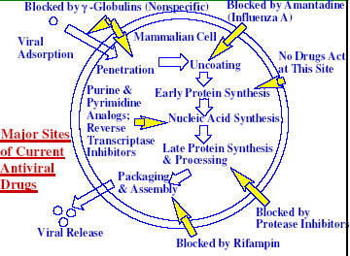

Proposed Targets of Antiviral Chemotherapy
1. Attachment (adsorption) of viral particle to host cell.
2. Penetration of host cell by infectious viral particles.
3. Particles uncoating, release & transport of viral nucleic acid & core proteins.
4. Nucleic acid polymerase release &/or activation.
5. Translation of m-RNA to polypeptides (early proteins)
6. Transcription of m-RNA.
7. Replication of nucleic acids.
8. Protein synthesis (late proteins).
9. Viral polypeptides cleavage into useful polypeptides for maturation.
10. Morphogenesis & assemblage of viral capsids & precursors.
11. Encapsidation of nucleic acid.
12. Envelopment.
13. Release.

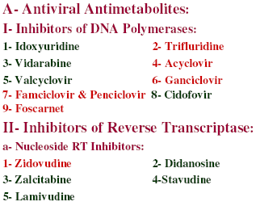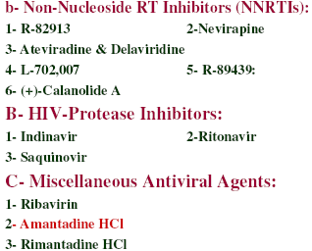

Antiviral Drugs:
A. Antiviral Antimetabolites:
I. Inhibitors of DNA Polymerases:
1. Idoxyuridine (2’-Deoxy-5-iodouridine, Herplex)
- Antiviral chemotherapy started ~1950’s when the search for anticancer drugs revealed new compounds that inhibit viral DNA synthesis, e.g., idoxuridine.
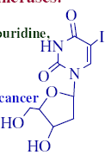
- I or F often means that compound is light sensitive/stability problems—must store in amber container
- Idoxuridine was approved as a topical treatment for herpes simplex keratitis in 1963
- The drug is active only against DNA viruses as herpes & vaccinia.
- Idoxyuridine is phosphorylated by viral thymidylate kinase to the
monophosphoate.
- The latter is bioactivated to the triphosphate, which used as a substrate &
inhibit viral DNA polymerase, causing inhibition of viral DNA synthesis & production of viral DNA-containing iodinated pyrimidine, which is more susceptible to strand breakage & miscoded errors in viral RNA & protein synthesis.

2. Trifluridine (2’-Deoxy-5-(trifluoromethyl)-uridine, Viroptic)
- Similar in mechanism & activity spectrum to idoxyuridine.
- Used as 1% sterile ophthalmic solution for keratoconjunctivitis caused by HSV & idoxyuridine-resistant HSV.
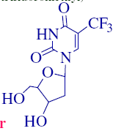

- Trifluridine is also in vitro active against vaccinia virus (VV) & some adenoviruses.
- Incorporation of trifluridine phosphate into both viral & cellular DNA prevents its systemic use but not its topical use.
- The drug is unstable & requires refrigeration before & after dispensing.
- The product will lose 10% of its potency after one month storing at room temperature.

3. Vidarabine (9-b-D-Arabinofuranosyladenine, Ara-A, Vira-A)
- Originally synthesized in 1960 as anticancer & found to have
broad spectrum activity against DNA visuses, e.g., HSV, VZV & CMV
- Marketed in 1977 as alternative to idoxyuridine for HSV keratitis &
later approved by the FDA for IV. administration for HSV encephalitis.
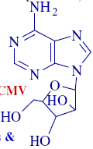

- Commercial vidarabine is obtained from Streptomyces antibioticus.
- Ara-A is phosphorylated intracellularly by host enzymes to form ara- ATP which inhibits viral DNA polymerase.
- It is rapidly deaminated in vivo to the much less active ara-H.
- Poor water solubility leaded to withdrawal of its parenteral form from the U.S. market.

4. Acyclovir (Acycloguanosine, ACV, Zovirax)
- Acyclic guanosine derivative, effective against HSV-1, -2 & Varicella- zoster virus (VZV).
- It also shows activities against Epstein-barr virus (EBV), cytomegalovirus (CMV) & human herpes virus (HHV)-6.
- Structure similarity of deoxyguanosine & acyclovir
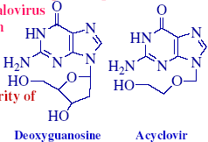

- Acyclovir requires 3 phosphorylation steps for activation:
1. First converted by the virus-specific thymidine kinase to monophosphate derivative (hence it is selective to the infected cells).
2. Acyclovir monophosphate is then converted by the host’s cellular enzymes to di- followed by triphosphate derivatives.
- Acyclovir triphosphate inhibits viral DNA synthesis by competitive inhibition of GTP incorporation into the viral DNA polymerase, irreversibly binding to DNA template & chain termination after incorporation into the viral DNA.
- Acyclovir is the drug of choice for genital herpes.
- The drug is chemically stable, soluble in acid & alkali due to its amphoteric nature.
- Available forms of acyclovir:
1. Orally (initial control of genital herpes & mild recurrent episodes)
2. Parenterally: slow i.v. for initial & recurrent infections in immunocompromised patients & for prevention of severe recurrent episodes.
3. Topically: 5% ointment in PEG base, for initial treatment of mild herpes episodes. Not effective in preventing recurrent episodes
- Side effects:
- Few: GI upset, dizziness, headache, lethargy, joint pain, thrombophlebitis (after i.v. injections).
- Resistance to acyclovir can be developed in HSV & VZV through alteration of viral thymidine kinase or DNA polymerase.

5. Valacyclovir (Valtrex):
- L-Valyl ester of acyclovir, immediately transform after ingestion to acyclovir.
- Improved bioavailability.

6. Ganciclovir (Cytovene):
- Structurally related to acyclovir.
- Ganciclovir also requires triphosphorylation activation prior to inhibiting the viral DNA polymerase, hence inhibits DNA elongation.
- Monophosphorylation is catalyzed by virusspecific protein kinase phosphotransferase UL97 in CMV & thymidine kinase in HSV-infected cells
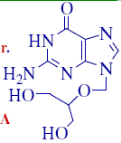
- Ganciclovir is active against CMV, HSV, VZV & EBV.
- Its activity against CMV is 100 fold higher than acyclovir.

- Toxicity:
- Limits its use, especially in immunocompromised patients.
- Toxicity includes: Myelosupression, inhbition of γ-DNA polymerase, neutropenia, thrombocytopenia, anemia, behavioral changes, convulsions, GI intolerance & phlebitis.

7. Famciclovir (Famvir) & Penciclovir (Denvir):
- Famciclovir is the diacetyl ester prodrug of 6-deoxy penciclovir, an acyclic guanosine analog.
- Famciclover is rapidly converted to its prodrug after oral ingestion

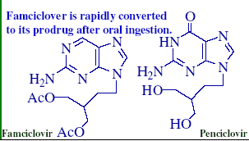
- Penciclovir is similar to acyclovir in the margin of activity.
- It is also active in vitro against HSV-1, 2, VZV, EBV & hepatitis B virus (HBV).
- Activation by phosphorylation, by the virusspecific thymidine kinase.
- Penciclovir doesn’t induce DNA chain termination.
- Cross resistance between acyclovir & penciclovir.
- Used orally or topically.

8. Cidofovir (Vistide, HPMPC):
- Cytosine nucleotide acyclic analog with broad-spectrum activity against several DNA visuses, e.g., CMV, HSV-1, -2, VZV, EBV, adenovirus & human papillomavirus.
- Unlike other nucleotides, cidofovir is a phosphonic acid derivative, which is not hydrolyzed by phosphatase in vivo.
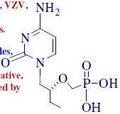
- Cidofovir is phosphorylated by cellular kinases to the di-phosphate, which acts as antimetabolite for deoxycytosine triphosphate (CTP).
- Inhibits viral DNA polymerase & incorporated in viral DNA to induce chain termination.
- Used i.v. for CMV-retinitis in AIDS patients
- Toxicity:
- Renal impairment.
- Pretreatment with probenecid & prehydration with i.v. normal saline can reduce the nephrotoxicity.

9. Foscarnet (Foscavir)
- Inorganic trisodium phosphonoformate that inhibits viral DNA by binding to the
pyrophosphate-binding sites of viral DNA polymerase, RNA polymerases & HIV reverse transcriptase (RT) directly without the need of any activation steps.
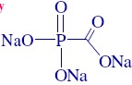
- It prevents the incorporation of nucleoside triphosphates into DNA & concomitant release of pyrophosphate.
- It is in vitro active against HSV, VZV, CMV, EBV, HHV-6, HBV & HIV.
- Since the inhibition is non-competitive, concerning nucleoside triphosphate binding, foscarnet can synergize the effect of nucleoside triphosphate antimetabolites, e.g., zidovudine & didanosine triphosphate.
- Foscarnet is used in resistant viral strains and as a second-line drug against CMV-induced retinitis in AIDS patients.
- Resistance is developed due to mutation in the DNA polymerase gene.
- Toxicity:
- Nephrotoxicity, electrolyte imbalance including hypocalcemia, hypokalemia, hypomagnesemia & hypo or hyperphosphataemia.
- Also may induce parathesias, tetany, seizures & cardiac arrhythmias.
- Enhances other nephrotoxic drugs as amphotericin B & pentamidine.
- Chemically incompatible with drugs administered as acid salts such as vancomycin, midazolam, prochlorperazine.

II. Inhibitors of Reverse Transcriptase:
a. Nucleoside RT Inhibitors:

1. Zidovudine (Azidothymidine, AZT, Retrovir):
- Deoxythymidine analogue, containing an azide (N3) moiety.
- It requires anabolic phosphorylation for activation, by retroviral thymidylate kinase.
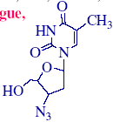
- Competitively inhibits deoxythymidine triphosphate for the RT.
- Zidovudine also acts as a chain terminator in the synthesis of proviral DNA.
- Cellular a-DNA polymerase also inhibited but only at a concentration of 100 times greater than those required by viral DNA polymerase.
- It is active against retroviruses: HIV-1, HIV-2 & the human T cell lymphotropic viruses.
- Recommended for AIDS patients with confirmed Pneumocystis carinii pneumonia infection.
- Resistance develops by long-term use due to mutation in RT gene & reduced bioactivation of the nucleoside by viral &/or cellular kinases.
- Toxicity:
- Anemia & granulocytopenia.
- Administration forms:
- Orally: 100 mg capsule or syrup.
- Injectable: 10 mg/ml solution for i.v. infusion.

2. Didanosine (2’,3’ -Dideoxyinosine, Videx, ddI):
- Synthetic analogue of deoxyadenosine.
- It is anabolically activated to 2’,3’-dideoxyadenosine-5’-triphosphate by cellular
enzymes, inhibiting RT, incorporating into viral DNA, causing chain termination,
which inhibits viral replication.
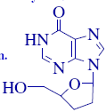
- Used to treat patients with advanced HIV who have received prolonged
zidovudine therapy & became intolerant or immunosuppressed. AZT/ddI combination is synergistic.
- Administered orally with buffers to avoid acid instability.
- Toxicity:
- Causes less myelosuppression than AZT, hyperuricemia, pancreatitis (resulting in nausea, abdominal pain, elevated amylase), peripheral neuropathy (tingling & numbness).

3. Zalcitabine (2’,3’ -Dideoxycytidine, Hivid, ddC):
- Pyrimidine nucleoside that inhibits RT & replication of HIV-1 in a similar mechanism to ddI (as triphosphate).
- Phosphorylation is catalyzed by cellular deoxycytidine kinase.
- It also inhibits mitochondrial DNA synthesis, which causes clinical toxicity.
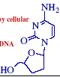
- Toxicity: Peripheral neuropathy (in ~30% of patients), rarely cause fatal pancreatitis
- Approved for advanced HIV patients who are intolerant to AZT
- Mutation at codon 65 induces resistance, which is associated with the decrease in susceptibility to AZT & ddI.

4. Stavudine (Zerit, 2’,3’ -Didehydro-2’-deoxythymidine)
- Stavudine (d4T) is a thymidine analogue that also requires a metabolic activation and its mechanism of action is similar to that of AZT.
- Active against HIV-1.
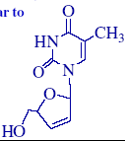
- Toxicity:
- As ddC, the main dose-limiting toxic effect is peripheral neuropathy
(15-20% of cases).
- Used for advanced HIV cases who have experienced clinical or immunological deterioration while receiving other therapy.

5. Lamivudine (3TC, (-)-SddC, (-)-2’,3’ -Dideoxy-3’-thiacytidine):
- Nucleoside analogue structurally similar to zalcitabine (ddC), with replacement of one methylene group with sulfur atom.
- Its mechanism of action is similar to AZT & requires similar metabolic
phosphorylation.
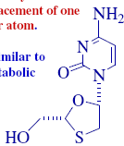
(Stereochemistry)
- Inhibits HIV-RT, shows synergistic effect with AZT against HIV-1. Also active against HBV.
- (-)-enantiomer shows greater antiviral activity & less toxicity compared with (+)-enatiomer, which inhibits more potently the cellular DNA polymerases.
- Cellular 3’,5’ -exonuclease was found to cleave terminal (+)-lamivudine monophosphate (MP) incorporation into viral DNA 6 times faster than
(-)-lamivudineMP from the viral terminus.
- Rapid resistance is developed by mutation at codon 184 when lamivudine monotherapy is used, which encodes HIV-RT.
- Mutation that causes lamivudine resistance suppresses AZT resistance, making the virus more susceptible.
- Combination with AZT in HIV-patients caused tremendous increase in CD4+ cell counts.

Summary
1. Virus definition & replication.
2. Apoptosis definition& virus effects, apoptosis versus necrosis.
3. Unconventional viral agents, Crutzfeldt-Jacob (mad cow) disease in humans, prions.
4. Proposed targets of antiviral chemotherapy
5. Name, structure & activity range of nucleoside inhibitors of DNA polymerase & RT,
protease inhbitors & other antiviral agents.
6. Toxicity of cidofovir & foscarnet.
7. Toxicity zalcitabine & effect of stereochemistry on the activity of lamivudine.

b. Non-Nucleoside RT Inhibitors (NNRTIs):
- Unlike the nucleoside antimetabolites, NNRTs do not require bioactivation.
- They bind to an allosteric site distinct from the substrate (nucleoside- triphosphate)-binding site of RT to cause non-competitive inhibition of the
enzyme.
- NNRTs are active in vitro in nanomolar concentrations against HIV-1.
- They do not inhibit RT of HIV-2 or simian immuno-deficiency virus (SIV) enzymes.
- They have high therapeutic indexes, unlike nucleosides.
- Do not inhibit mammalian DNA polymerases.
- Used as additive or synergistic with nucleosides.
Examples are:

1. R-82913:
- A tetrahydroimidazobenzodiazepenone (TIBO) analogue.
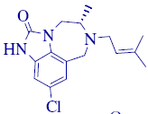
2. Nevirapine (Viramune):
- Tricyclic compound
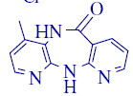

3. Ateviradine & Delaviridine (Rescriptor):
- Bis(heteroaryl)-piperazine (BHAP) derivatives.
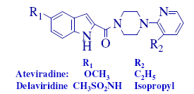

4. L-702,007:
- A pyridinone derivative.
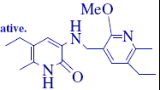

5. R-89439:
- An a-anilinophenylacetamide analogue.
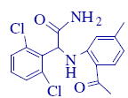

6. (+)-Calanolide A:
- A C22 coumarin isolated from the Malaysian rainforest tree, Calophyllum langigerum by the U.S. NCI.
- It shows a potent HIV-RT & HIV-1 inhibitory activity (IC50 <0.03 mM) including AZT & other non-nucleoside RT inhibitors-resistant strains
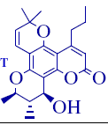
- (+)-Calanolide A also shows synergistic anti-HIV activity when combined with nucleoside RT inhibitors.
- (+)-calanolide A successfully passed a single-center 7-month U.S. phase Ia clinical trial to assess its safety/ tolerability.
- It is now under clinical trial phase II.

B. HIV-Protease Inhibitors:

1. Indinavir
- Indinavir is a specific inhibitor of HIV-1 protease, which is essential for the production of mature & infectious virions.
- It is clinically approved for treatment of HIV-1 infections
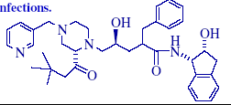

2. Ritonavir
- Inhibitor of HIV protease with high bioavailability.
- It is metabolized by the hepatic P450 cytochrome oxidase system & hence suffers from several drug interactions.
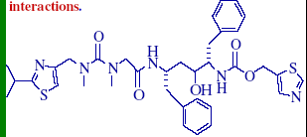

3. Saquinovir
- Synthetic peptide-like analog that inhibits the activity of HIV-1 protease & prevents the cleavage of viral polyproteins.
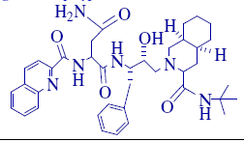

C. Miscellaneous Antiviral Agents:

1. Ribavirin (Virazole, 1b-D-Ribofuranosyl-1H-1,2,4-triazole-3-carboxamide:
- Synthetic nucleoside active against wide variety of DNA & RNA viruses, e.g., HSV, VV, adenovirus, myxoma, influenza, parainfluenza viruses, &
rhinovirus.
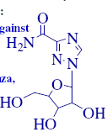
- Despite this broad spectrum of activity, ribavirin is approved only for treatment of severe lower respiratory RSV infections in infants & young children.
- The broad activity spectrum suggests multiple modes of actions.
- The drug is bioactivated by viral & cellular phosphorylating enzymes to the mono, di & then the triphosphate (RTP).
- RTP inhibits inosine monophosphate (IMP) dehydrogenase, preventing the conversion of IMP to xanthine monophosphate (XMP).
- XMP is required for GMP synthesis.
- RTP also inhibits viral RNA polymerases & prevents capping of viral m-RNA by inhibiting guanyl N-methyl-transferase.
- Ribavirin is administered as an aerosol.
- Toxicity:
- Anemia, headache, abdominal pain, lethargy.
- Unlabeled uses of ribavirin include:
- aerosol treatment of influenza A & b, hepatitis, genital herpes, measles & Lassa fever.
- It doesn’t protect cells against cytotoxicity of the AIDS virus.

2. Amantadine Hydrochloride (Symmetrel, Symadine):
- Useful synthetic drug in prevention & treatment of influenza A virus, but not
effective in influenza B or other viruses.
- It is 80% effective in prevention of illness when administered 1-2 days after the onset of illness
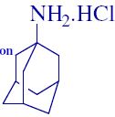
- It also reduces the fever duration & other symptoms by preventing infection of additional cells.
- Generally used in high-risk patients in close household or hospital contacts of patients with severe influenza A.
- Adjunctly used for treatment of Parkinson’s disease for patients who do not tolerate full therapeutic levodopa doses.

- Toxicity:
- Increase the release of dopamine from dopaminergic neurons, depression, dizziness, urine retention, hallucinations, GI upset &
anxiety.

3. Rimantadine Hydrochloride (Flumadine):
- Branched homologue of amantadine with similar spectrum of antiviral activity.
- Unlike amantadine which is excreted largely unchanged, rimantadine is extensively metabolized by liver after oral administration.
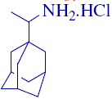
- Less CNS side effects observed, providing an important advantage over amantadine therapy in some patients.

4. Interferones (INFs)
- They are a family of multifunctional endogenous polypeptides that exerts non-specific antiviral activities through cellular metabolic processes
involving the synthesis of both RNA & proteins.
- There are four known varieties of INFs:
- INF-α, INF- ω, INF-β & INF-γ.
- They act as a potent complex antiviral, immunomodulatory& antiproliferative agent.
- INFs are not direct antiviral agents but they act by causing elaboration of effector proteins in infected cells, which inhibits viral penetration, uncoating, mRNA synthesis& translation or virion assembly & release.
- Their immunomodulatory effect may also be additive to their antiviral effect.
- Three known enzymes are induced by INFs:
1. Protein kinase, which leads to phosphorylation of elongation factor 2, inhibiting peptide initiation.
2. Oligoisoadenylate synthase, which leads to activation of RNAase& degradation of viral mRNA.
3. Phosphodiesterase, which degrades the terminal nucleotides of tRNA& inhibits peptide elongation.
- Systemic INF-α is currently approved in the US for the treatment of
chronic HBV & HBC infections.
- It is also clinically approved for the treatment of AIDS-associated Kaposi’s sarcoma & laryngeal papillomatosis.

Antimicrobial Chemotherapy
Bacteria
- Prokaryote microorganisms which cell is characterized by:
1. Lack of nucleus.
2. Lack of organelles (membrane-bound compartments including mitochondria, lysosomes, Golgi bodies, endoplasmic reticulum).
3. Bacterial ribosomes (RNA protein bodies) are free in the cytoplasm & not bound to membranes, unlike the eukaryotic cells.
4. Its DNA is a single closed loop, naked strand with no protein.
5. Cell wall present & of complex structure.
6. Reproduction is usually by fission, no evidence of mitosis.
- Bacteria (staff or rod) are the most abundant organisms on earth.
- They have major roles in nature:
1. Digest sewage into simple chemicals.
2. Extract nitrogen from air & make it available to plants for conversion to amino acids & proteins.
3. Break down the remains of all organism that die & recycle the carbon.
4. Produce food, products, e.g., cheese, wine, etc. & antibiotics.
- Bacteria inhabit air, soil, water, surfaces of plants & animals.

Bacterial Cell Wall
- Composed of multiple layers of peptidoglycan, a large molecule consists of alternating
units of N-acetylglucosamine (NAG), N-acetylmuramic acid (NAM), joined by side chains of the amino acids D-Alanine, L-Lysine, Glycine, L-Alanine& D-Glutamic acid
- In Gram (+) bacteria, the peptidoglycan layer is ~25 nm wide& contains an additional
polysaccharide called teichoic acid.
- In Gram (-) bacteria, peptidoglycan layer is only 3 nm wide without any teichoic acid, that is why Gram (-) bacteria lose the crystal violet-iodine complex on Gram staining.
- Gram-negative bacteria, however, contain a lipopolysaccharide layer outside the
peptidoglycan & multiple layers of phospholipids & lipoprotein, which provide additional protection to the cell from chemicals, antibiotics & dyes.
- Penicillins prevent construction of cell wall, the bacteria then become elongated & burst, due to the high pressure inside the cell which contain high concentration of inorganic salts, carbohydrates & amino acids.
- Lysozyme is an enzyme in human tears & saliva, it also attacks the cell wall linkage between carbohydrates & peptidoglycan layer, affecting the bacterial cells especially Gram(-).
- Generally, bacterial cell walls are different from those of mammalian cells.
- This provides selective targets for antibacterial chemotherapy.
- Bacterial cell wall provides a semi-permeable barrier interfacing with the environment allowing only to the desirable molecules to pass.
- It also provides bacterial cells with protection against osmotic pressure changes of its
environment.
- Cell wall also prevents bacterial digestion by host enzymes.
- Initial constructing units of cell wall are made within the cell.
- Final assembly occurs outside the inner membrane.
- This makes the enzymes involved in this process more vulnerable to inhibition.
- Individual species differ in details.

Antibiotics & antimicrobial agents:
- Antibiotics are microbial metabolites or synthetic analogs inspired by them. In small doses, they inhibit the growth (static) & survival (cidal) of one or more microbes (pathogens) without serious toxicity to the host, e.g., penicillins& tetracyclines.
- Antimicrobial agents: Synthetic compounds that inhibit the growth or survival of pathogens at a low concentration, e.g., sulfa drugs, isoniazide, trimethoprim, nitrofurantoin, acyclovir, etc.
- Methanol, ethanol, isopropanol are obtained naturally by fermentation but not considered antibiotics because their effectiveness is at large doses & might harm the host.
- Antibiotic misuse led to resistance threatening the continued efficacy of antibiotics.
- Our body parts contacting the environment support microbial life. Our internal fluids, organs & body structures are normally sterile & presence of microbes there is evidence of
infection.
- Mild infections can be overcame by healthy immune system, which if was not enough to protect us antimicrobial agents are indicated.
- Fermented beans & corn were used to treat infections, which means there are microbes when they grew they produce antibiotics.
- Robert Fleming, 1929:
- Accidental observation of a clear zone of inhibition (lysis) in a bacterial colony surrounding a colony of contaminating airborne Penicillium mold.
- Florey, Chain, Abraham & Heatly, Late 1930’s & early 1940’s: Purification of penicillin & successful clinical trials.
- R. Dubos, 1939: Directed people to look at soil antibiotic-producing organisms & discovered tyrothricin.

Era of Miracle Drugs
- Streptomycin, 1943
- Chloramephenicol, 1947
- Chlortetracycline, 1948
- Neomycin, 1949
- Erythromycin, 1952
- These antibiotics were fully natural & had serious disadvantages, e.g.,
- Penicillin G: can’t be given orally
- Chlortetracycline: Only 20% absorbed & the rest will cause diarrhea
- Semisynthetic antibiotics were developed to overcome these problems, e.g.,
- Amoxicillin is a semisynthetic penicillin analog that can be given orally.
- Doxicycline is a derivative of tetracylcine with 99% absorption rate.

Sources of antibiotics
1. Bacteria:
~ 8% of antibiotics are produced by bacteria.
- They produce peptide antibiotics,e.g., lincomycin, which are not orally active & nephrotoxic& monobactams (not nephrotoxic), e.g., azactam.
2. Fungi:
- Produce ~35% of antibiotics, e.g., penicillins, cephalosporins, gresiofulvin.

3. Actinomycetes:
- Fungus-like bacteria with filamentous structures & bacterial cell wall possessing murein.
- They grow at room temperature & produce bulk of clinically useful antibiotics (~57-60%), e.g., chloramephenicol by Streptomyces venzuelae.

Classification of Antimicrobial Agents

1. Sulfonamides
- In 1932, the German Gerhard Domagk discovered the in vivo antibacterial effect of prontosil in mice.
- Prontosil was inactive in vitro
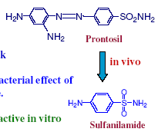
- Trefouel& Bovet in 1935 opened the modern chemotherapy era by identifying sulfanilamide as the bacteriostatic metabolite of prontosil.
- Several sulfanilamide analogs were later synthesized.
- Current sulfonamides possess the same general skeleton:
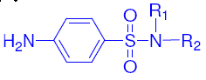
2. β-Lactams
- All of them possess the unique functional group
- Examples:
penicillins
Cephalosporins
Monobactams: azethreonam (azactam)
Carbopenems: Imipenem, Meropenem
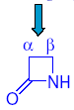

3. Aminoglycosides
- All have NH2& glycosidic linkage e.g., streptomycin & kanamycins
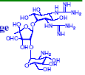

4. Tetracyclines
- They have a tetracyclic skeleton, e.g., Tetracyclines
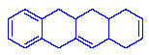

5. Macrolide Antibiotics
- Contain large ring system (macrocycle). The suffix “ide”= lactone= cyclic ester group
- Examples:
erythromycin, clarithromycin, oleandomycin, telithromycin, azithromycin, dirithromycin.
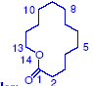

6. Polypeptide Antibiotics
- Used topically & rarely systemically due to toxicity.

- Examples:
bacitracin, polymyxin& vancomycin.

7. Antifungal polyenes
- Examples: Amphotericin B, nystatin

8. Miscellaneous antibiotics
e.g., chloramephenicol, rifampin, griseofulvin

9. Fluoroquinolones
- Synthetic drugs, e.g. nalidixic acid, moxifloxacin, gatifloxacin, levofloxacin,
trovafloxacin& ciprofloxacin
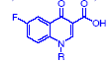

10. Oxazolidinones
- Linezolid (Zyvox) is the 1st of new synthetic antibacterial class to treat community-acquired pneumonia (CAP) & methicillin resistant staph
(MRS), approved April 2000.
- Other member in clinical trials Eperezolid with the side chain replacing morpholine in Linezolide
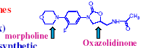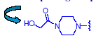

1. Sulfonamides
- The red dye prontosil rubrum was studied by Domagk in belief that it might be selectively picked up by pathogenic bacteria in a similar way to Gram-stain & hence will kill these bacteria.
- Prontosil was active in mice against streptococcal infections but was inactive in vitro.
- Trefouel& Bovet isolated the active metabolite p-aminobenzenesulfonic acid amide
(sulfanilamide)
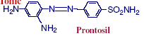
- Although sulfanilamide itself has been synthesized since 1908, it has not been tested before as anti-infective because there was no reason at that time to suppose that it would be active.
- Sulfonamides’s popularity tremendously decreased with the emergence of more effective antibiotics.
- Yet, their comparative cheapness is one of their most attractive features that accounts for the persistence of few sulfonamides in the market.
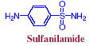
Sulfonamides Chemistry
- Sulfonamides are substituted aniline analogs with the general skeleton
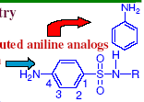
- Sometimes they are prodrugs like prontosil or sulfasalazine which are commonly used orally for ulcerative colitis & Crohns disease, not orally absorbed & most drug dose is delivered to the distal bowel where reductive metabolism by gut bacteria converts
the drug to:
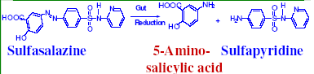
- Sulfapyridine& 5-aminosalicylic acid (mesalamine) which has potent antiinflammatory
activity required in these cases.
- Direct salicylate administration will irritate the gastric mucosa.
- Other non-antibacterial sulfonamides includes:
- Tolbutamide: oral hypoglycemic
- Furosemide& Chlorthalidone: diuretics
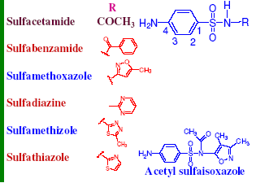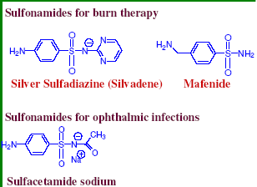

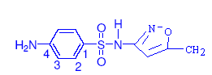
Sulfmamethoxazole

Therapeutic Applications
1. Treatment of primary uncomplicated urinary tract infections (cotrimoxazole) & as a
back up to other preferred agents in certain situations (sulfisoxazole).
2. Treatment & prophylaxis of Pneumocystis carinii (cotrimoxazole) & cerebral
toxoplasmosis (sulfadiazine/pyrimethamine).
3. Prevention & treatment of bacterial infections of burn (silver sulfadiazine)
4. Conjunctivitis& ocular infections (sodium sulfacetamide).
5. Chloroquine-resistant malaria in combination with quinine & other antimalarials
(sulfadoxine, sulfalene).
6. Less commonly used for nocardiosis& severe traveler’s diarrhea (cotrimoxazole).

Not Useful in:
- Streptococcal & meningococcal infections
- Prophylaxis of rheumatic fever recurrences
- Vaginal infections & Ulcerative colitis.

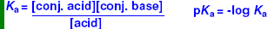
- Aniline is a base.
- PKb values are not used in pharmaceutical chemistry to compare compounds.
- If the pKa value of aniline is 4.6, it refers to
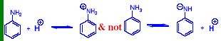
- If a pKa value of a base is given, it refers to its salt acting as the conjugate acid.
- The negative charge on nitrogen atom is normally not very stable unless the charge is greatly delocalized by resonance as the case of sulfanilamides.
- Hence, the pKa value of 10.4 is given to sulfanilamide, it refers to the loss of an amide
proton (H+) and formation of a salt.
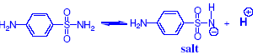
- Similarly, a pKa value of 5.0 in case of sulfisoxazole indactes that it is a slightly weaker
acid than acetic acid (pKa=4.8)
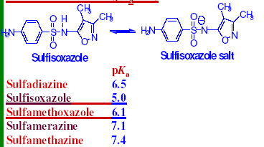

Sulfonamide Crystalluria
- Sulfanilamide caused several severe kidney damage in 1930’s by forming crystals in kidney.
- Sulfonamides usually metabolized by acetylation of C-4 NH2 group & glucouronidation& excreted entirely in urine.
- Sulfonamides are not water soluble unless the pH is above the pKa value (10.4 for sulfanilamide).
- Urine pH is typically ~6 & slightly lower during bacterial infections, hence sulfonamides are relatively insoluble, nonionized at this pH.
- At pH= pKa, there will be a 1:1 mixture of nonionized& salt forms.
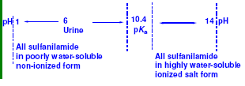
How can sulfonamides be more soluble in the urine?
1. Improve & increase urine flow: during early use of sulfonamides, patients are warned to “force fluids”.
2. Raise the urine pH to make it closer or higher than pKa value. This will increase their water-soluble form. Oral NaHCO3 was & still indicated
to raise urine pH.
3. Use sulfonamides which have lower pKa value, e.g., sulfisoxazole (pKa=5) & sulfamethoxazole (pKa=6.1).
4. Use sulfonamide mixtures to reach the targeted total dose & solubility of sulfonamides is independent, hence more mixtures of sulfonamides can stay water soluble at a particular pH than a single sulfonamide can.
- That is why “triple sulfas”(trisulfapyrimidines, USP) contain a mixture of sulfadiazine, sulfamerazine& sulfamethazine. All these sulfonamides have low pKa values
- Patients still must be cautioned to maintain a good fluid intake even if they do not feel like drinking during illness.

Why do modern sulfonamides have low pKa values?
- Heterocyclic rings attached to C-1 nitrogen are electron withdrawing, which adds more stability for the salt form.
- Nonionized forms can give up an H+ more easily & hence the pKavalues are lower.
- Why simpler electron withdrawing groups, like p-nitrophenyl, are not used?
- Such analogs were investigated & were either too toxic or less active or both.

- Other side occasional effects of sulfonamides, which decreased their use includes:
- Kidney & liver damage
- Hemolytic anemia & other blood problems
- Steven-Johnson syndrome is the most severe side effect of sulfonamides, characterized by sometimes-fatal erythrema multiforme& ulceration of mucous membranes of the eye, mouth & urethra.
- Stevens-Johnson syndrome (SJS) is an immunecomplex–mediated hypersensitivity complex that is a severe expression of erythema multiforme. It
is now known also as erythema multiforme major. SJS typically involves the skin and the mucous membranes. While minor presentations may occur, significant involvement of oral, nasal, eye, vaginal, urethral, GI, and lower respiratory
tract mucous membranes may develop in the course of the illness. GI and respiratory involvement may progress to necrosis. SJS is a serious systemic disorder with the potential for severe morbidity and even death.

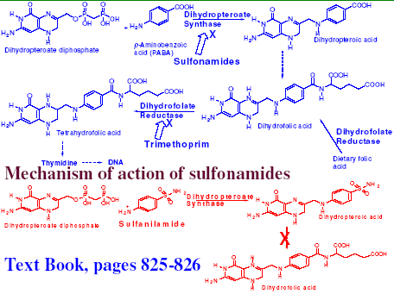
Resistance to Sulfonamides
- Wide use of sulfonamides led to the emergence of many drug-resistant strains of bacteria probably by increased production of PABA or by other mechanisms.
- If a microbe is resistant to one sulfonamides, it is generally resistant to all.
- Sulfonamide resistance can be transferred a resistant species to a previously sulfonamidesensitive species through the transfer of Rfactors.

Trimethoprim, 2,4-Diamino-5-(3,4,5-tri-methoxybenzyl) pyrimidine
- Developed by Hitchings& Gertrude & approved by the FDA in 1980.
- Bacteriostatic, inhibits tetrahydrofolic acid synthesis. Selectivity is attributed to significant architectural difference between bacterial & mammalian dihydrofolate
reductase.
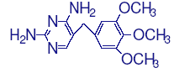
- Bacterial enzyme is sensitive to trimethoprim inhibition by up to 40,000 times lower
concentrations than mammalian enzyme.

Therapeutic applications include:
1. Oral treatment of uncomplicated urinary tract infections caused by susceptible bacteria (E coli & Gm (-) rods).
2. Commonly used in a 1:5 fixed synergistic combination with sulfamethoxazole (Bactrim, Septra, etc.) as antibacterial agent. Blocking sequentially two different steps in the same folate reductase essential pathway, it is less likely to develop bacterial resistance than either agents alone. Unlikely an organism will mutate to resistance at both enzymes during therapy.
3. Trimethoprim is also useful in other bacterial infections, e.g., shigellosis, otitis media, traveler’s diarrhea, MRSA, legionella& bronchitis.
4. Used also in combination or separate as injection for pneumocystis carnii & malaria.

Side Effects
1. Rash, nausea, vomiting
2 . Blood dyscrasias& pseudomembranous colitis caused by non-antibiotic sensitive opportunistic gut anaerobes Clostridium difficile.
3. Severe diarrhea, like many antibiotics, this side effect must be carefully monitored. Nonresolving diarrhea could be fatal, which justify withdrawing existing therapy in favor of antianaerobic antibiotics. So far, No structurally related analogs to trimethoprim have been developed despite the extensive efforts.

Summary
1 . Different pharmacophores of antibiotics.
2. Sulfonamide chemistry & therapeutic applications
3. Prodrug sulfonamides: Prontosil & Sulfasalazine
4. Sulfonamide-induced crystalluria& how to avoid it.
5. Synergism of trimethoprim with sulfa drugs & dapsone& its therapeutic applications.

Gram (+) Cell Wall
- Simpler than Gram (-) with external characteristic carbohydrates & proteins, making
antigenic determinants characteristic to each species.
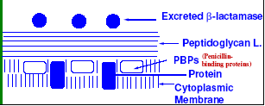

- Peptidoglycan spongy, gel-forming layer is the second layer
- It consists of alternating NAG & NAM, linked in 1-4 b glycisidic linkages.
- To the free lactic acid carboxyl moiety of NAM, a series of amino acids is attached.
- These include: D-& L-alanine, L-lysine, D-glutamate & D-glycine.
- D-glutamate & terminal D-alanine protect the peptidoglycan layer from host’s GI peptidase hydrolysis.
- Cell wall transamidase (one of the penicillin binding proteins, PBP) catalyzes displacement of a terminal D-alanine in B-strand with a terminal glycine of A-strand.
- The overall result of this cross linking is the formation of a thickened 3-dimensional cell wall, which strengthen the cell against osmotic stress & retain characteristic morpholgy of Gram (+) bacterial cell.
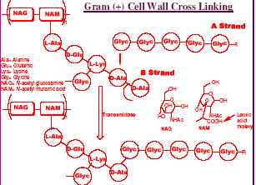
- Crosslinking is highly sensitive to β-lactam antibiotics.
- Peptidoglycan layer is traversed by teichoic & teichuronic acids.
- Next layer is lipoidal cytoplasmic membrane which contains up to 7 types of b-lactam receptor proteins, penicillin-binding proteins (PBPs).
- They’re important in construction & repair of cell wall.
- β-lactam antibiotics bind to PBPs, which kill the bacteria by preventing the biosynthesis of functional cell wall, growth & repair especially young bacterial cells.
- Inhibition of PBPs creates serious problems for growing bacteria.
- Cell wall not only protects the bacterium from its environment but also provide confining case that must be repaired when damaged or be remodeled so that cell can grow.
- The β-lactamases are secreted outside the Gram (+) cell & must be reloaded frequently.

Gram (-) Cell Wall
- More complex, more lipoidal with additional outer membrane containing complex
lipopolysaccharides which encode antigenic responses, causing septic shock & affecting morphology.
- Outer layer contains porins which are transmembranal super molecules made of 2 or 3
monomeric proteins.
- Size, shape, & lipophilicity control porin passage.
- They act as transmembranal pores, allowing many kinds of small molecules to pass, while others contain specific receptors that allow certain molecules to enter.
- Antibiotics hardly penetrate Gram (-) bacteria. Peptidoglycan layer is much smaller than those of Gram (+) bacteria.
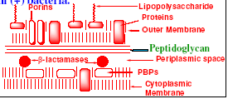
- This is followed by periplasmic space which possesses the b-lactamases.
- A phospholipid-rich cytoplasmic membrane comes next with many characteristic proteins including the β-lactam receptors (PBPs).
- Binding of β-lactam antibiotics to PBP-1A & B (transpeptidase) of E coli causes its cell lysis.
- Binding to PBP-2 (transpeptidase) leads to decreased cell rigidity & inhibition of cell
division.
- While binding to PBP-3 gives abnormally long filamentous shapes by failure to produce a septum.
- Binding to PBP-4-6 (carboxypeptidases) has no lethal effects.
- 8% of a benzyl penicillin dose binds to PBP-1, 0.7% to PBP-2, 2% to PBP-3, 4% to PBP-4, 65% to PBP-5 & 21% to PBP-6.
- Hence, most of the dose cause no lethal effect on Gram (-) bacteria.
- Amoxicillin & cephalosporins bind more avidly to PBP-1.
- Methicillin& cefotaxime to PBP-2.
- Mezocillin& cefuroxime to PBP-3.
- β−lactamases located within the cell (periplasmic space) & hence no need to be produced in large characteristic amount like Gram (+) bacteria.
- Inner membrane proteins involved in transport, biosynthesis & energy.
- In Gram (-) cells, there are many proteins that actively pump out antibiotics & other substances at the expense of energy, which may require simultaneous entrance of
oppositely charged compounds to keep the electrostatic balance.

2. β-Lactams
- All of them possess the unique β-lactam functional group.
- Lactam = cyclic amide
- Nitrogen of β-lactam is neutral & not basic any more because its lone pair of electrons
are delocalizing
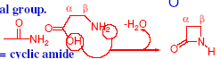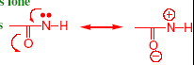
− β-lactams are cyclic amides with 4 atoms in its ring, sometimes called azetidinone.
- Penicillins characterized by the presence of 5-membered thiazoldine ring fused with the β-lactam ring,
- This fusion & the chirality of β-lactam ring results in a V shaped- molecule.
- This interferes with the planarity of lactam bond & resonance of lactam nitrogen with its carbonyl group.
- Hence, β-lactam ring is much more sensitive to hydrolysis, compared with normal planar amides.
1. Penicillins
- In 1929 Robert Fleming was growing the bacterium Staph aureus in a petri dish, but he
was not careful enough so contamination occured by a fungus & he then observed
a clear (no growth) zone in the bacterial colony around the fungus, This indicated that the fungus produced a substance that kill or prevent the growth of bacterial colonies.
- This fungus is identified as Penicillium notatum & the isolated substance (antibiotic was found to be penicillin F=British penicillin=penicillin I).
- Used for military purpose during World War II (1939-1945)

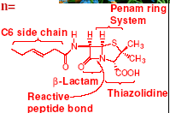
- It is very effective against Gm(+) bacteria like S. aureus.
- Very safe, however it was very expensive, 600 mg cost ~ $200, because the yield was so low.
- Later on, Uncontrolled fermentation of the fungus Penicillium chrysogenum produced a
mixture of penicillins with different side chains.
- When the fermentation media is enriched with a sufficient supply of phenylacetic acid, the main fermentation product was benzyl penicillin (penicillin G)

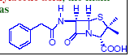

- Enrichment of media with phenoxyacetic acid the main product was phenoxymethyl penicillin (penicillin V).
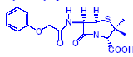
- Complete exclusion of side chain precursor acids from the media resulted in the main penicillin nucleus, 6-aminopenicillanic acid (6-APA) which has only a weak antibiotic activity.
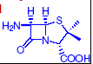

- When the NH2 of 6-APA was substituted, the antibacterial activity greatly enhanced.
- Hence isolation of 6-APA opened semisynthetic studies of penicillins.
- Currently, 6-APA is obtained by using natural fungal enzymes which selectively hydrolyze away the side chain of natural penicillins without cleaving the β-lactam bond.
- These enzymes are found in Gram (-) bacteria but they have no relation to the resistance of these bacteria to β-lactam antibiotics.
- The Na & K salts of penicillins are crystalline, hygroscopic & water soluble.
They’re stable for long time when dry but rapidly hydrolyze in solution. Their best stability is noted at pH 6-7.2.
- Procaine & benzathine salts of benzylpenicillin are water insoluble & hence used when long-term blood level is required.
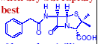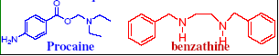

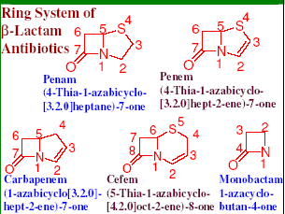

Degradation Reactions of Penicillins
- The reactive β-lactam amide bond is the most strained & unstable bond in penicillin molecule.
- It cleaves moderately slowly unless heated, but cleaves much rapidly in alkaline solutions to produce penicilloic acid (irreversibly), which readily decarboxylates to penilloic acid.
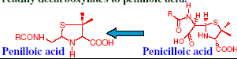
- Since the β-lactam ring is essential for activity, this reaction deactivates penicillins.
- A similar reaction is catalyzed by the bacterial enzyme β-lactamase (penicillinase), causing clinical bacterial resistance.
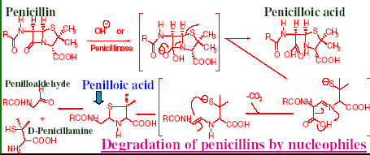
- Significant hydrolysis of penicillins takes place in liver.
- Alcohols & amines cause the same cleavage but with corresponding esters & amides.
- This is why aminoglycosides (with guanidine free amino groups in amino sugars) can inactivated penicillins & cephalosporins& hence they should not used concomitantly in the same compartment.
- When proteins act as the nucleophile in this hydrolysis, the antigenic conjugate formed can produce penicillin allergies.
- Small molecules that are not inherently antigenic but react with proteins to produce antigens in this way are called haptens.
- Commercial penicillin salts may be contaminated with small amounts of these antigenic penicilloyl proteins derived from reaction with proteins encountered in their fermentation production or by high molecular weight self-condensation derived polymers when penicillins are concentrated & react with themselves.
- Both impurities are antigenic & can sensitize some patients.
- Parenteral penicillin solutions should be refrigerated, used promptly & never stored.
- In acid solution, Penicillin side chain amide oxygen contributes to its degradation.
- The main acid hydrolysis products are penilloic acid, D-penicillamine & penilloaldehyde
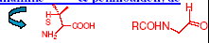
- The intermediate penicillenic acid is highly unstable & quickly hydrolyze to corresponding penicilloic acids.
- Sulfur could be ejected to the product & form penicilloic acid too.
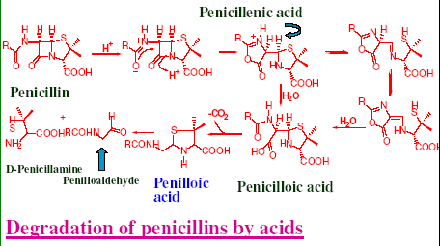
- Penicilloic acid readily decarboxylates to penilloic acid, which later hydrolyzed to penilloaldehydes & penicillamine.
- Penicillamine is used clinically to chelate heavy metals & iron.
- Hence, at gastric pH (ca. 2) & temperature 37oC, benzyl penicillin has a t_{½} of few minutes.
- Less water soluble amine salts are more stable.
- Electron withdrawing side chain R decreases the electron density on its carbonyl & partly protects penicillins from acid degradation.
- This was used clinically to formulate acid resistant penicillins which survive stomach
acidity & hence orally active.
~15-30% of an oral benzyl penicillin dose survives passage through stomach under fasting conditions, compared with ~60-73% of an oral dose of phenoxymethyl penicillin.
- The latter reaches blood peak in 0.5-1 hr & has t1/2 ~5 hrs.
- In vitro penicillin degradation can be retarded by keeping the pH of solution ~6-6.8 & refrigeration.
- Metal ions, e.g., Cu, Zn, Hg, etc. catalyze penicillins degradation & hence lids of
formulations containers are routinely made of inert plastic to minimize this problem.

Protein Binding
- The more lipophilic the side chain of a penicillin, the higher is its serum protein binding.
- Lipophilicity of side chain reduces the degradation of penicillins& also its effective
bactericidal concentration.
- The degree of serum protein binding has comparatively little effect on their t1/2.
- Penicillins are actively excreted into urine through active transport of their anions & this is mainly controlled by kidney secretion rate.
- The serum t1/2 of penicillin G is ~0.4-0.9 hrs & of phenoxymethyl penicillin is ~0.5 hr. - Both drugs are excreted into urine by tubular excretion.

Mechanism of Penicillin Action
− β-lactam antibiotics are selective & irreversible inhibitors of the enzymes processing the developing of peptidoglycan layer.
- Just before cross linking, peptide pendant from lactate carboxy of NAM terminates in D-ala-D-ala unit.
- Hydrolysis of these 2 amino acid units is catalyzed by the cell wall transamidase.
- Transamidase is one of PBPs (also include carboxypeptidase, endopeptidase& transpeptidase).
- These are located in the inner membrane & responsible for construction, repair &
housekeeping cell wall & play vital role in cell growth & division.
- PBPs significantly differ from bacterium to another, which rationalize different potency & morphologic outcomes after β-lactam antibiotics attack different bacteria.
- Cell wall transamidase uses a serine hydroxyl group to attack the penultimate D-ala unit, forming a covalent bond while the terminal D-ala is released & diffuse
away.

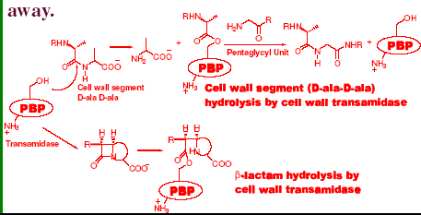
- The enzyme-peptidoglycan complex is attacked by the free amino end of a pentaglycyl unit of an adjacent strand regenerating the transamidase’s active site for further catalysis & producing a new amide bond, which glues 2 adjacent strands together.
- The enzyme is highly selective to the critical substrate residues, not even attack other bacterial peptides.
− β-lactam antibiotics closely resemble the geometry of acylated D-ala-D-ala & hence the
enzyme mistakenly accepts it as a normal substrate.
- The highly strained b-lactam ring is much more reactive than normal amide, specially when fused into the appropriate bicyclic system.
- Hydrolysis doesn’t break penicillins into 2 pieces as normal substrate.
- Penicillin’s heterocyclic residue is still covalently bonded & can’t diffuse away as natural terminal D-ala.
- This presents a steric barrier to approach by the pentaglycyl unit & prevents regeneration of the enzyme’s active site & cell wall precursors cross-linking.
- The resulting cell wall is structurally weak & subjected to osmotic stress, leading to cell lysis & death.
- Cell lysis is even assisted by the bacterial autolysins (peptidoglycan hydrolases) which
original function is to clear cellular debris.
- Autolysins enhance the bactericidal action of penicillins through cleavage of NAM-peptide bond to L-ala (not D-ala), which lead to the fall away of the whole amino acid side chain & bacterial cell death.
− β-lactam-enzyme complex is strong enough to resist water hydrolysis.
- Cell wall transamidase is stoichiometrically inactivated.

Resistance
- Increasingly common, unfortunately.
- Can be intrinsic & involve decreasing of cellular uptake of penicillin or lower binding affinity to PBPs.
- This is typical in methicillin-resistant Staphycoccus aureus (MRS) whose PBP-2 has
been mutated so that it doesn’t bind methicillin effectively any more.
- Elaboration of b-lactamase resistance is even more common.
- β-lactamases are enzymes (serine proteases) generated by microbes that catalyze hydrolysis of the β-lactam bond, which inactivate penicillins to penicilloic acids before they can reach PBPs.
- β-lactamases resemble cell wall transamidase but they released distally from inner membrane.
- Hydrolytic regeneration of β-lactamases’ active site is much more facile than transamidase & a small amount of these enzymes can destroy a large amount of penicillins.
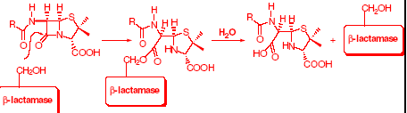
- With Gram (+) bacteria as Staph, β-lactamases usually continuously shed into the medium & meet the drug outside the cell wall.
- In Gram (-) bacteria, β-lactamases are secreted into the periplasmic space between the inner & outer membrane so, while still distal to the PBPs, β-lactamases don’t escape into medium & need not be resynthesized as often.
- Elaboration of β-lactamases is often R-factor mediated & even induced by the presence of β-lactam antibiotics.

Summary
- Penicillins are natural product-based antibiotics that act by inhibition of cell wall synthesis.
- Mainly active against Gram (+) bacteria.
- Many penicillins are unstable in acid or basic pH’s, or aqueous solutions, hence, they must never be stored in solution & for long time.
- Many penicillins are sensitive to β-lactamases.
- To avoid this problem, penicillins sometimes are mixed with β-lactamase inhibitors like clavulanic acid or sulbactams.

Allergenicity
~ 6-8% of US population is allergic to β-lactam antibiotics.
- This allergenicity is commonly expressed as drug rash, itching, delayed onset reactions & less commonly reaction is immediate & profound as cardiovascular collapse, shock & death.
- These are common with injections.
- Patient medication history with hypersensitivity is usually helpful in anticipating allergenicity.
- Food & pollen allergy are also indicative.
- Prior penicillin allergy contraindicate the use of all β-lactams.
- Topical wheal & flare tests are indicated when there is doubt.
- Drug must be discontinued immediately once allergic reaction develops. Cross sensitivity is expected between all β-lactam antibiotics.
- Erythromycin & clindamycin are useful alternates in penicillin allergy.
- Patient may have become sensitized without knowing due to prior passive exposure through contaminated food or cross-contaminated medications.
- It is required that penicillins be manufactured in isolated facilities away from other drugs manufacturing facilities to prevent cross contamination & possible sensitization.
- Animals treated with penicillins are required to be drug free for long time before products prepared from them can be marketed.
- Pharmacists must never override these protective measures & must never fail to cleanse their pill counters properly between prescriptions.
- It is unlikely to use molecular manipulation to overcome β-lactam allergy because the allergy is haptenic reaction with host proteins & the β-lactam pharmacophore.
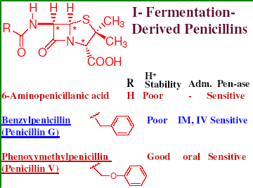
Benzyl Penicillin
- Useful against Gram (+) cocci, except Neisseria gonorrhoeae& Haemophilus influenza.
- Widely used because it is cheap & lacks serious side effects, except acute allergy.
- Particularly useful in the infections of upper & lower respiratory tract & genitourinary tract.
- Also useful for group A β-hemolytic streptococci (pharyngitis, scarlet fever, cellulitis, pelvic infections & septicemia).
- Also usually useful for group B β-hemolytic streptococci infections specially of neonates (acute respiratory distress, pneumonia, meningitis, septic shock & septicemia).

- Its activity margin also includes:
- Pneumococcal pneumonia, H. influenza pneumonia of children, Strep. pneumonia, Strep. pyogenes-caused otitis media & sinusitis, meningococcal meningitis & brain abscess, meningococcal & pneumococcal septicemia, Strep.
viridans endocarditis
- Pelvic inflammation caused by Neisseria gonorrhoeae& Strep. pyogenes, uncomplicated gonorrhea, meningitis, syphilis (Treponema pallidium),
Lyme disease (Borrelia burgdorferi), gas gangrene (Clostredium perfringens), & tetanus
(Cl. tetani).
- Nonpenicillinase producing Staph. aureus& Staph. epidermidis.
- Bacillus anthracis (anthrax)& diphtheria
- Because it is an economic & safe antibiotic, mild infections with susceptible organisms can be treated with comparatively large doses.
- Its activity is much less orally & it is better used parenterally, which affords 5-times higher blood level than oral route.
- The main defects of benzyl penicillin are still under investigation & include comparative instability specially in acids, poor oral absorption, allergenicity, sensitivity to β-lactamases & relatively narrow antimicrobial spectrum.

Phenoxymethyl Penicillin (Penicillin V)
-Penicillin V is acid stable due to the presence of electronegative oxygen atom in C-7 amide side chain which inhibits the participation of amide carbonyl in β-lactam hydrolysis.
-Penicillin V is the first oral penicillin which affords higher & prolonged blood levels.
Its antimicrobial spectrum is roughly similar to benzyl penicillin, somewhat less potent & hence not used for acute infections.
-It is also sensitive to β-lactamases& allergenic.
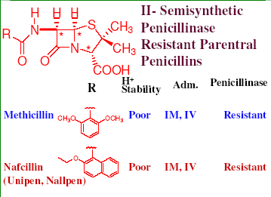
Penicillinase-Resistant Parentral Penicillins
- Fortunately β-lactamases are much less tolerant to the presence of steric hindrance near the sidechain amide bond than PBPs.
- Stable penicillinase resistant penicillins are afforded when the aromatic ring is directly
attached to the side chain carbonyl & both orthopositions are substituted by methoxy groups.
- Methicillin is unstable at gastric pH, t1/2 5 min at pH 2, hence it has to be used via injection.
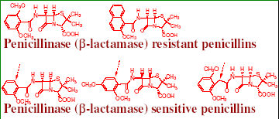
- Moving of methoxy groups to the para or replacing them by a hydrogen will result
penicillinase-sensitive analogs & the same is true if we inserted a CH2 group between phenyl & 6-APA amide carbonyl.
-Hence resistance to penicillinase degradation is based on differential steric hindrance.
- The potency & antimicrobial spectrum of methicillin is narrower than penicillin G &
hence it is mainly used clinically as injections for β-lactamase producing Staph aureus, e.g. Staph. caused cellulitis.
- Penicillins G or V are preferred if the strain is sensitive to them.
- Methicillin-resistant Staphylococcus aureus (MRSA) strains recently became more common.
- The mode of resistance in MRSA appeared to be reduced uptake & alterations in PBPs, especially formation of altered PBP-II, which has a very low affinity for β-lactams.
- Vancomycin is the current favorite alternative for MRSA followed by co-trimoxazole, clindamycin, & rifampin.
- Since methicillin is an efficient inducer of penicillinase, its use should be restricted to
sensitive infections only.
- The related nafcillin is more acid stable but clinically identical to methicillin
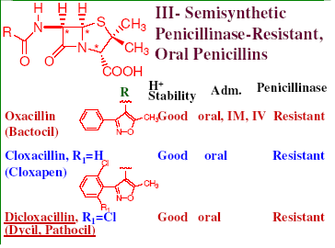
III. Penicillinase-Resistant Oral Penicillins
- Using an isoxazolyl ring as bioisosteric replacement of benzene with one
methyl on one side & a substituted benzene ring on the other side instead of methoxyls of
methicillin produced an orally active isoxazolyl penicillins; oxacillin, cloxacillin & dicloxacillin.
- Why?
- Generally less potent than penicillin G against non penicillinase producing Gram (+) bacteria.
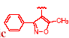
- Because they are high serum protein bound penicillins (>90%), hence they do not considered as a good choice for septicemia.
- Methicillin resistant bacteria are usually resistant to isoxazoloyl penicillins.
- Mainly used against Staph. Aureus in osteomyeltis, endocarditis& CNS infections.
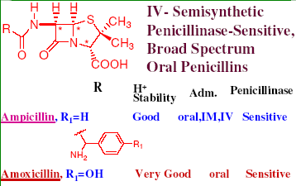
Penicillinase-Sensitive, Broad-Spectrum Oral Penicillins
- Ampicillin is α−aminobenzylpenicillin & hence is orally active.
- Protonated NH2 group’s electron withdrawing effect contributed to acid stability & reduced hydrolysis of the β-lactam bond.
- The antimicrobial activity is broadened to include some Gram (-) pathogens due to improved penetration ability of ampicillin.
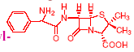
- Ampicillin has apparent t1/2 12-20 hours at pH 2 & 35ºC.
- Very widely prescribed but lacks stability towards β-lactamases.
- To deal with this problem, several additive coadministrations have been developed.
- Clavulanic acid is a mold product that has a weak intrinsic antibacterial activity.
- It has excellent irreversible inhibitory effect on β-lactamases
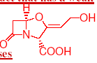
- It acylates the active site serine by mimicking the normal substrate.
- While hydrolysis occurs with some β-lactamases, subsequent reactions occur which irreversibly inhibit the enzyme.
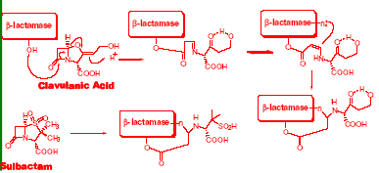
- Clavulanic acid is classified as a mechanism-based inhibitor (suicide substrate).
- Addition of clavulanic acid to ampicillin preparations the potency against β-lactamase-producing strains is greatly enhanced.
- Sulbactam is another β-lactamase inhibitor which is prepared by partial synthesis from penicillins.
- Oxidation of sulfur to sulfone greatly enhances its potency.
- Both clavulanic acid & sulbactamare unable to overcome penetration barrier or chromosomal mediated β-lactamases.
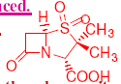
- Ampicillin’s oral efficacy (30-55%) tremendously improved by preparation of its
prodrugs, like bacampicillin.
- Bacampicillin is a weak base (no longer amphoteric like ampicillin) & very well absorbed in duodenum (80-98%).
- In gut, ester hydrolyzed& liberate CO2& ethanol, followed by spontaneous loss of
acetaldehyde which oxidatively metabolized by alcohol dehydrogenase & production of
ampicillin.
Bacampicillin
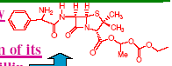

- In addition to allergenicity, concentrated ampicillin preparations can self condense & form high molecular weight aggregates through reaction of its NH2 group with b-lactam bond of another molecule.
- These aggregates could be antigenic & are responsible for ampicillin allergy which is
different in details from that of penicillin hypersensitivity.
- Ampicillin& amoxycillin are the penicillins most commonly associated with drug induced rash.
- Avoiding use of old preparations could potentially deal with this problem.
- Ampicillin is similar in activity to benzyl penicillin against pneumococcal, streptococcal & meningococcal infections.
- It is also active against Gram (-) Salmonella, Shigella, Proteus mirabilis& Escherichia coli.
- Oral ampicillin is also effective against H. influenza, N. gonorrhoea& uncomplicated
community-acquired UT infections.
- Insertion of p-hydroxyphenolic group in amoxycillin adjusts its isoelectric point to more
acidic value which enhances its blood level, compared with ampicillin.
- It also improves oral absorption (74-92%), which decreases disturbance to normal GI flora & hence less drug-induced diarrhea.
- Amoxicillin’s spectrum of activity is similar to ampicillin.
- Addition of clavulanic acid to amoxicillin (Augmentin) improves its stability against β-lactamases.
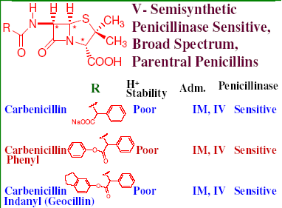
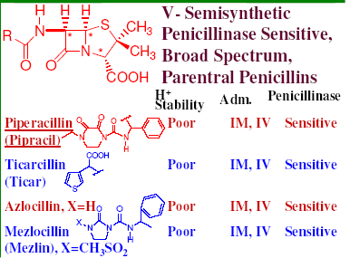
V. Penicillinase-Sensitive, Broad-Spectrum Parentral Penicillins
- Azlocillin, mezlocillin& piperacillin, known as acylureidopenicillins, are ampicillin analogs in which the D-side chain NH2 group is converted chemically to ureas.
- They have anti-Gram (+) & (-) activity, including some strains of Pseudomonas aeruginosa.
- The added side chain mimics a longer segment of peptidoglycan chain more than ampicillin, which gives more attachment points to PBPs, activity.
- They’re used parenterally especially for Gram (-) bacteria, e.g. Klebsiella pneumonia& anaerobe, Bacteroides fragilis.
- Resistance due to β-lactamases is common, so disk testing & combination with other antibiotics, like aminoglycosides are indicated for their use in severe infections.
- Tazobactam is co-administered with piperacillin (Zosyn) because tazobactam effectively inhibits β-lactamases.
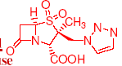
- Carbenicillin is a penicillin G analog in which one of the methylene hydrogens of the side chain is replaced with a carboxy group.
- Stereochemistry of this COOH group is not important as the product is a mixture of epimers.
- Introduction of new free COOH group enhances anti-Gram (-) activity. Clinical use is restricted primarly to high dose therapy of P. aeruginosa, Proteus vulgaris, some enterobacter& Serratia infections.
- Carbenicillin is less potent than acylureidopenicillins
- Carbenicillin is acid & penicillinase sensitive & must be administered parentrally&
usually used in conjunction with aminoglycosides (never mixed in the same solution due to chemical incompatibility).
- Carbenicillin can decarboxylate readily to produce penicillin G. While still an antibiotic, this degradation product has no activity against the organisms for which carbenicillin is indicated & hence it is still considered degradation or inactivation.
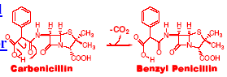
- Large doses of carbenicillin Na (multi gm/day) results in ingestion of significant amount of Na+ which could be a consideration in heart patients.
- This can be avoided with the oral use of the prodrug indanyl ester carbenicillin.
- Unfortunately the potency of this preparation doesn’t allow to be used as a full substitute for carbenicillin & hence it is primarily used for oral treatment of
UT infections.
- Ticracillin is a sulfur-based bioisostere of carbenicillin that can’t decarboxylate.
- It is more potent against Pseudomonas infections & specially effective when laced with sulbactam.
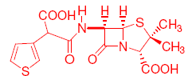

Summary
- Penicillins are natural product-based antibiotics that act by inhibition of cell wall synthesis.
- Mainly active against Gram (+) bacteria.
- Many penicillins are unstable in acid or basic pH’s, or aqueous solutions, hence, they must never be stored in solution & for long time.
- Many penicillins are sensitive to β-lactamases. To avoid this problem, penicillins sometimes are mixed with β-lactamase inhibitors like clavulanic acid or sulbactams.

I. Fermentation-derived penicillins
6-Aminopenicillanic acid
Benzylpenicillin (Penicillin G)
Phenoxymethylpenicillin (Penicillin V)
II. Semisynthetic penicillinase resistant parenteral penicillins
Methicillin
Nafcillin (Unipen, Nallpen)
III. Semisynthetic penicillinase-resistant, oral penicillins
Oxacillin (Bactocil)
Cloxacillin (Cloxapen)
Dicloxacillin (Dycil, Pathocil)
IV. Semisynthetic penicillinase-sensitive, broad spectrum oral penicillins
Ampicillin
Amoxicillin
V. Semisynthetic penicillinase sensitive, broad spectrum, parenteral penicillins
Carbenicillin
Carbenicillin Phenyl
Carbenicillin Indanyl (Geocillin)
Piperacillin (Pipracil)
Azlocillin
Mezlocillin (Mezlin)
Ticarcillin (Ticar)

2. Cephalosporins
- Original cephalosporin-producing culture Cephalosporium acremonium was discovered by Brotsu off the Sardinian coast.
- In England, one cephalosporin (cephalosporin C) was active against penicillin-resistant cultures due to its stability to β-lactamases.
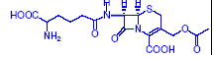
- Cephalosporin C was not potent enough to be used as antibiotic but chemical removal of its natural side chain produced 7-amino-cephalosporanic acid (7-ACA), analogus to 6-APA in penicillins.
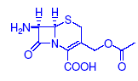
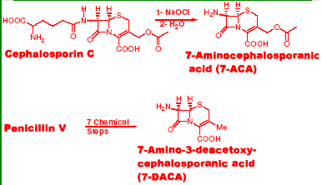
- 7-ACA could be chemically fitted with unnatural side chains, producing diverse antibiotics.
- Conversion of Penicillin V to 7-amino-3-deacetoxycephalosporanic acid (7-ADCA) was achieved by Robert Morin, through 7-steps chemical reactions.
- This was an economically important progress because penicillin is much more efficient than cephalosporin fermentation.
- Derivatization of 7-ACA &7-ADCA resulted in thousands of cephalosporin analogs.
- Cephalosporins have a 6-membered dihydrothiazine ring instead of the b-lactam 5-membered thiazolidine ring of penicillins.
- This ring system is much less strained & also less reactive/potent.
- However, the new double bond at C-2,3 & methylene acetoxy group at C-3 make up
for the reactivity loss.
- When the β-lactam ring opens by hydrolysis, acetoxy group can be ejected carrying away the developing negative charge, which reduces the energy required for this process.
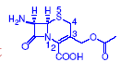
- This is modulated by the nature of C-3 & C-7 substituents, similar to penicillins & the ability of C-3 side chain to carry away a negative charge.
- Isomerization of C-2,3 double bond to C-3,4 leads to loss of antibiotic activity.
- Most cephalosporins are comparatively unstable in aqueous solutions.
- Pharmacist is directed to keep their injectable preparations frozen before use.
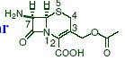
- Cephalosporin free acids are water insoluble whereas their Na salts are water soluble.
- Injectable cephalosporin preparations usually contains NaHCO3 to facilitate dissolution of free acids.
- Mechanism of cephalosporin action is similar to penicillins.
- They bind to PBPs followed by cell lysis.
- Cephalosporins are bactericidal in clinical terms.

Resistance
- Analogus to penicillin, susceptible cephalosporins can be hydrolyzed by b-lactamases before they reach the PBPs.
- Certain β-lactamases are constitutive (chromosomally encoded) in certain strains of
Gram (-) bacteria, e.g., Citrobacter, Enterobacter, Pseudomonas, Serratia & normally repressed.
- These are induced by certain β-lactam antibiotics, e.g., cefoxitin, cefotetam, imipenem.
- As with penicillins, resistance to β-lactamase hydrolysis can be improved using steric bulk side chain near the amide linkage.
- Chromosomally & plasmid-derived metallo-blactamases are recently discovered in Gram (-) bacteria.
- These enzymes are dependent upon divalent metal ions, commonly Zn.
- They attack penicillins, some cephalosporins & carbapenems.
- Penetration barriers to cephalosporins are also well known.

Allergenicity
- Less common & less severe compared with penicillins.
- Cephalosporins can be administered to patients who had a mild or delayed penicillin reaction.
- Cross allergenicity is common. Patients with allergy history must be cautioned.
- Patients with rapid & severe penicillin reactions should not be treated with cephalosporins.

Nomenclature & Classification
- Most cephalosporins have the generic names beginning with “cef-” or “ceph-”.
- The first-generation cephalosporins are in vitro active against Gram (+) cocci (penicillinase positive & negative Staph. aureus& Staph. epidermis). Not effective against MRSA. Not significantly active against Gram (-) bacteria although some strains of E. coli, Klebsiella pneumonia, Pseudomonas Mirabilis& Shigella may be sensitive.
- The second-generation cephalosporins are also active against
- Gram (+) bacteria
- Gram (-) strains of H. influenzae, Cinetobacter, Citrobacter, Enterobacter, E. coli, Klebsiella, Neisseria, Proteus, Providencia & Serratia.
- Cefotetan, cefmetazole & cefoxitin are also active against some anaerobic bacteria.
- The third-generation cephalosporins are less active against Staphylococci than first-generation but much more active against Gram (-) bacteria than either the first or the second-generation drugs.
- They are useful against multidrug-resistant hospital-acquired strains.
- Also active against Morganella, Bacteroides fragilis& Pseudomonas aeruginosa.
- Third generation drugs are more expensive.
- The fourth-generation cephalosporins are similar in their antibacterial spectrum to the
third-generation, in addition to Pseudomonas aeruginosa& some enterobacteria that are resistant to the third-generation cephalosporins.
- They’re also active against Gram (+) bacteria.

Therapeutic Applications
- Infections of the upper & lower respiratory tract, skin & related soft tissue, UT, bones, joints & septicemia & endocarditis.
- Also intra-abdominal & bile tract infections caused by susceptible Gram (+) bacteria.
- When a Gram (+) infection is involved, a first-generation drug is preferred.
- When the pathogen is Gram (-) & the infection is serious, parenteral third-generation is indicated.
- For pelvic inflammatory disease (PID), the leading cause of sterility in young women,
- 3rd or 4th-generation cephalosporins are combined with doxycycline because most likely this infection includes Chlamydia trachomitis anaerobes & other organisms that are not sensitive to cephalosporins, along with penicillinase-producing Neisseria gonorrheae.

Side Effects
- In addition to mild or severe allergic reactions, mild & temporary nausea, vomiting, diarrhea & disturbance of normal GI flora.
- Rarely may cause a life-threatening pseudomembraneous colitis diarrhea, which is
associated with opportunistic & toxin-producing anaerobic bacteria Clostridium difficile.
- Rarely can cause aplastic anemia, prolonged bleeding times & an antabuse-like acute alcohol intolerance.

Degredation Reactions
- Mainly β-lactam bond hydrolysis.
- C-7 & C-3 side chains play important role.
- The tetrazolethiomethyl moiety found in C-3 of some cephalosporins is easily eliminated, enhancing instability & reactivity.
- This moiety is also responsible in part for clotting difficulties & acute alcohol intolerance in certain patients.
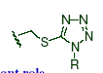
Metabolism
- Cephalosporins having C-3 acetyl side chain are subjected to in vivo enzymatic hydrolysis.
- The resulting molecule with C-3 hydroxymethyl group (which is not a good leaving functionality) is much less active metabolite. It will also lead to facile lactonization with the C-2 carboxy group, which is completely inactive.
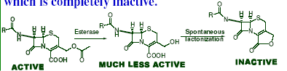
- This is because PBPs have an absolute need for free COOH group to mimic that of terminal carboxy of D-ala-D-ala in their normal substrate.
- Lactonization masks this docking functional group & blocks the affinity of enzyme inhibition.
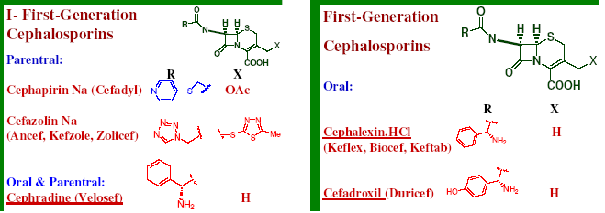

Cephapirin (Cefadyl)
- Has a C-7 pyridylthiomethylene side chain.
- Comparatively resistant to staphylococcal β-lactamase but sensitive to other β-lactamases.
- The drug is also sensitive to host hepatic, kidney, & plasma deacetylation which reduces its potency to half.
- Significantly used as IM injections as a substitute to methicillin& isoxazolyl penicillins for MRS.
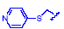
- Orally inactive.
- Comparatively painful in IM injection.
- Excreted in urine partly by glomerular filtration & partly by tubular secretion.
- Doses must be reduced in presence of renal impairment.

Cefazolin (Ancef, Kefzole, Zolicef)
- It has the natural acetyl side chain at C-3 replaced with a thio-linked thiadiazole ring.
- This group is an activating leaving group & is not subject to the inactivating host hydrolysis reaction, like cephapirin.
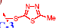
- C-7 possesses a tetrazoylmethylene moiety.
- Comparatively unstable & light sensitive
- It is less irritating on injection & has a longer t1/2.
- Its dosing should be reduced in renal impaired patients.
Cephalexin (Keflex, Biocef, Keftab)
- Orally active cephalosporin with an ampicillin-like side chain.
- No activating side chains at C-3, which decreased its potency a little bit.
- No metabolic inactivation, thus maintains potency.
- Rapidly & completely absorbed from GIT.
- Active against Gram (+) aerobic cocci but of limited anti-Gram (-) activity.
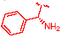
- Widely used particularly against mild UT Gram (-) infections, Gram (+) infections of soft tissues including S. aureus, Strept. pneumoniae& Strept. pyogenes.

Cefadroxil (Duricef)
- Orally active with amoxicillin-like side chain.
- Has immunostimulant effect through T-cell activation, helping to fight infections.
- Once a day usage, prolonged t1/2.
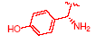

Cephradine (Velosef)
- Orally (acid stable) & parenterally active, so IM parenteral therapy starts & then patient sent home with oral form, avoiding the risk of having to establish a different antibiotic.
- Ampicillin-like aromatic side chain has be partially hydrogenated using Birch reduction
resulting in a planar molecule with excessive pi electron.
- Used for uncomplicated UT & upper respiratory tract infections.
- Rapidly & completely absorbed from GIT.
- IM & IV forms are no longer available in the US.
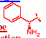
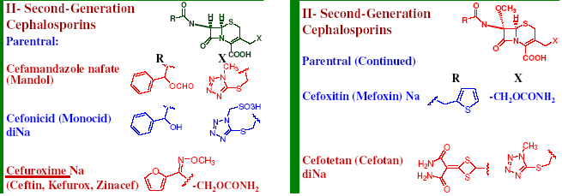
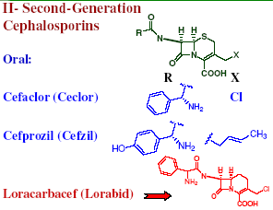
Cefamandazole nafate (Mandol)
- Parenterally used drug with C-7 side chain formate ester derived from D-mandelic acid.
- Formate ester cleaves rapidly in the host releasing the more active cefamandole.
- Esterification also increased the dry storage stability of cefamandole.
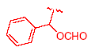
- Mandol has higher activity against H. influenzae & other Gram (-) bacilli compared with 1st generation cephalosporins.
- So it is used for lower respiratory tract, skin, bone & joint infections,
septicemia & UT infections.
- C-3 side chain (5-thio-1-methyl-1-H-tetrazole, NMTT) is associated prothrombin
deficiency, bleeding problems & antabuse-like acute alcohol intolerance.
- NMTT enhances potency & prevents metabolism by deacetylation.
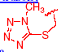
Cefonicid (Monocid)
- It has a C-7 unesterified mandelic acid moiety & NMTT sulfonate at C-3.
- Unlike Mandol, C-3 side chain has no clotting & alcohol antabuse side effects.
- It also adds another acidic group & hence injectable formulation of the drug is a di Na salt.
- Pain & discomfort as well as phlebitis & burning sensation are encountered when administered intramuscularly or intravenously, respectively.
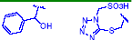
- Has a longer t1/2 than other members but achieves this at the price of somewhat lower potency against Gram (+) bacteria & anerobes.
- Slightly unstable & must be protected from light & heat.
- Kirby-Bauer disk testing may overestimate the sensitivity of β-lactamase producing bacteria & hence extra caution in laboratory interpretation should be taken.

Cefuroxime (Ceftin, Kefurox, Zinacef)
- It has a syn-oriented C-7 methoxyimino side chain which adds a considerable resistance to β-lactamases by steric effect.
- The anti-analog is attacked by the β-lactamases
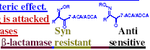
- Resistance by P. aerouginosa is due to lack of drug penetration rather than β-lactamases
hydrolysis.
- C-3 carbamoyl moiety is intermediate between acetyl & thiotetrazoles in metabolic stability.
- Cefuroxime penetrates CSF & hence useful in cases of H. influenzae meningitis.
- Cefuroxime axetil (1-[acetyloxy]ethyl ester) is a more lipophilic prodrug, which gives good blood level on oral administration.
- The ester is cleaved metabolically to give an intermediate which loses acetaldehyde to produce cefuroxime.
- More stable (for 24 hours) in solutions
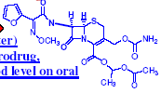
Cefoxitin (Mefoxin)
- It contains an α-oriented methoxy group at C-7 instead of H.
- This increases the steric bulk & hence the drug is significantly stable against β-lactamases.
- This pattern was inspired by the natural product antibiotic cephamycin C (from Streptomyces lactamdurans).
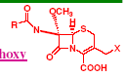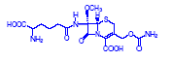
- Cephamycin C was not clinically used but provided structural clue that led to cefoxitin.
- Synthetic chemists introduce this methoxy now to cephalosporins lacking this feature.
- Cefoxitin is more useful against gonorrhea & anaerobic infections but has the capacity to induce broad-spectrum β-lactamases.

Cefotetan (Cefotan)
- It is also cephamycin inspired (C-7 methoxy) & contains a unique S-containing side chain amide.
- Contains two carboxyls, hence marketed as di Na salt.
- Contains C- NMTT, hence caution in monitoring prothrombin levels & bleeding times & alcohol intake.
- Has a better activity against anaerobes than the rest of 2nd generation drugs.
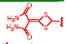
- Comparatively stable for 24 hours after reconstitution at room temperature.
- Chemically incompatible (form precipitate) with tetracyclines, aminoglycosides &
heparin.
- The drug has a special affinity to PBPs 3 of Gram (-) bacteria. It also binds well with PBPs 1A & 1B, causing cell lysis& death.
- Stable to a wide range of β-lactamases but also considered a potent inducer in some bacteria.

Cefaclor
- Differs from cephalexinin the bioisosteric replacement of C-3 methyl by chlorine.
- It is orally & metabolically stable.
- Less active against Gram (-) bacteria than other 2nd generation drugs but still more active against Gram (-) bacteria than 1st generation cephalosporins.

Cefprozil
- Has amoxicillin-like side chain at C-7 & C-3 1-isopropenyl group conjugated with C-2-C-3 double bond of the 6-membered ring.
- Both geometric isomers of double bond are active.
- The predominant trans isomer is much more active against Gram (-) bacteria.
- Very similar to cefaclor but little more potent.
- 90% bioavailable after oral dose & no effect for food on its peak level.
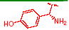

Loracarbef
- Synthetic C-5 “ carba” (instead of “S”) analog of cefaclor. Smaller C-5 methylene makes the drug more potent & reactive.
- It is more chemically stable.
- Causes diarrhea, specially in children, hence it is not preferred under the age of 12-years
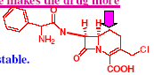
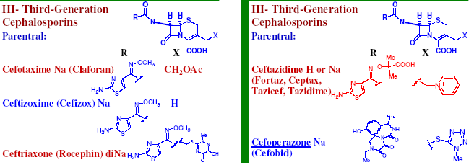

Cefotaxime (Claforan)
- Has a C-7 syn-methoxyimino group attached to aminothiazole ring, which gives significant β-lactamase resistance.
- Bacteria which produce chromosomal mediated β-lactamase usually resistant following mutation to depression of these enzymes.
- Excellent anti-Gram (-) activity & less anti-Gram (+) activity, like all 3rd generation drugs.
- Metabolic hydrolysis of C-3 vulnerable acetoxy group loses 90% of activity. Light & heat sensitive
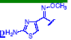

Ceftizoxime (Cefizox)
- C-3 side chain omitted to prevent hydrolytic metabolic inactivation.
- Resembles cefotaxime in properties, except metabolism & with much less complex
pharmacokinetic properties.

Ceftriaxone (Rocephin)
- Same C-7 side chain as cefotaxime& ceftizoxime.
- Thiotriazinedione C-3 side chain is metabolically stable & sufficiently acidic to form enolic Na salt at acidic pH, hence the commercial form is di Na salt.
- Useful in severe meningitis Gram (-) infections.
- Quite stable to many β-lactamases but sensitive to some inducible chromosomal β-lactamses.
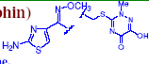

Ceftazidime (Fortaz, Ceptax)
- Oxime moiety is more complex
- With a free carboxylic acid, which conveys pronounced β-lactamases stability, better anti-Pseudomonas aeruginosa& anti-Gram (+) activities.
- Broad-spectrum of activity.
- The charged pyridinum C-3 side chain enhances water-solubility& activates β-lactam bond towards cleavage.
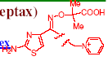
- Light & heat sensitive, must be protected from them.
- Aminoglycoside, vancomycin & NaHCO₃ chemically incompatible.
- Resistance
- by chromosomally β-lactamases & by lack of penetration.

Cefoperazone (Cefobid)
- C-7 side chain is similar to those of piperacillin & C-3 NMTT side chain which is associated with bleeding & alcohol intolerance problems.
- Active against Pseudomonas, but not potent enough to be used individually against this
difficult pathogen.
- Combination with clavulanic acid or sulbactam help to reduce its sensitivity to β-lactamases.
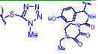
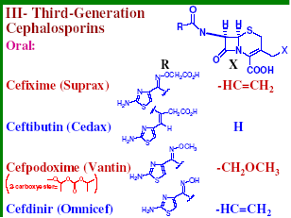

Cefixime (Suprax)
- C-7 β-lactamases stabilizing syn-oximino acidic ether moiety.
- C-3 vinyl group similar to cefprozil’s vinyl group contributes to oral stability.
- Intermediate anti-Gram (-) activity (between 2nd & 3rd generation drugs).
- Poorly active against staphylococci, low binding affinity to PBPs-2.
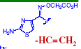

Ceftibutin (Cedax)
- C-7: cis ethylidinecarboxyl which enhances β-lactamase stability & contributes to oral activity.
- No C-3 group, metabolically stable, despite in vivo double bond isomerization.
- 75-90% oral absorption, which greatly decreased by food.
- Significantly bind to serum protein (highly lipophilic& acidic).
- Used for UT, respiratory tract, otitis media, pharyngitis& tonsilitis infections.
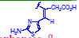

Cefpodoxime Proxetil (Vantin)
- Prodrug which cleaved metabolically to cefopodoxime in gut wall.
- Has a better anti-Staphylococcus aureus activity than cefixime.
- Used for UT, gonorrhea, upper & lower respiratory tract, otitis media, pharyngitis , skin
& soft tissue infections.
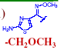

Cefdinir (Omnicef)
- C-7 unsubstituted syn-oxime, enhancing anti-Gram (+) activity/penicillinase resistance.
- The C-3 vinyl moiety is associated with oral activity.
- 20-25% oral absorption unless taken with fatty food which reduces its blood level.
- Reasonable β-lactamase resistance.
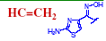

IV. Fourth-Generation Cephalosporins

Cefepime
- Semisynthetic cephalosporin containing C-7 syn-methoxyimine& aminothiazolyl moiety, which broadens its activity spectrum, its antistaphylococcus activity & its β-lactamase stability.
- C-3 Quaternary N-methylpyrrolidine group improves Gram (-) bacteria penetration.
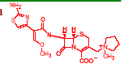
- The 4th-generation drugs characterized by enhanced anti-staphylococcal & broader anti-
Gram (-) activities, compared with the 3rd generation cephalosporins.
- Cefepime is used as IM or IV injections for UT, skin, pneumonia & intra abdominal infections.

3. Carbopenems:
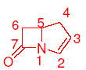
1. Thienamycin& imipenem
- Thienamycin is a natural product from Streptomyces cattleya.
- Extreme intense & broad-spectrum antimicrobial activity & ability to inhibit β-lactamases.
- One of the best β-lactam antibiotics.
- Methylene carbon replaced C-4 sulfur atom.
- C has ~½ molecular size of S, carbapenem ring is highly strained & susceptible to β-lactam bond cleaving reactions.
- This is even worse with the presence of C-2,3 double bond.
- S-atom is attached to the C-3 functionalized side chain.
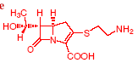
- Terminal NH2 is a nuclophile & can attack the β-lactam bond & hence the drug is less stable as it concentrated.
- Semisynthetic replacing of the free NH2 group in thienamycin with a less nucleophilic moiety N-formylimino, solved the stability problem & produced imipenem.
- C-6 has a-hydroxyethyl group & the drug has 5R,6S,8S absolute stereochemistry.
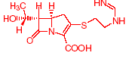
- Drugs bind to PBP-2 in a different way, which tremendously improves their activity compared with penicillins & cephalosporins.
- Thienamycin& imipenem penetrate well through porins.
- Imipenem is very stable to many β-lactamases but not orally active.
- When used in UT infections, renal dehydropeptidase-1 hydrolyzes & deactivates imipenem.
- Cilastatin is an inhibitor of dehydropeptidase-1, which co-administered with imipenem to increase its efficacy.
- Inhibition of dehydropeptidase-1 is not harmful to patients.
- Imipenem/cilastatin injection combination (Primaxin) 25% bound to serum-protein, well penetrating tissues but not CSF & excreted in urine.
- It is broader in spectrum than any other antibiotic presently available in the US
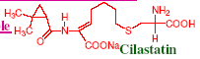
- This potent combination is very useful in for treatment of serious Gram (-) bacilli, anaerobes & Staph. aureus infections.
- It is clinically used for severe infections of adult gut, bone, skin & endocardia.
- Allergic reactions are the main risk factor, in addition to induction of β-lactamases.
- Hence, Imipenem/cilastatin is rarely the drug of first choice & must be reserved for use in special cases.

2. Meropenem
- Synthetic carbapenem with more complex C-3 side chain & chiral C-5 methyl group, which conveys intrinsic resistance to hydrolysis by dehydropeptidase-1.
- The drug is administered as a single agent for severe bacterial infections.
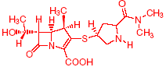

4. Monobactams:
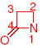

Aztreonam
- Fermentation of unusual microorganisms led to the discovery of the monocyclic β-lactam antibiotics, which inspired the synthesis of aztreonam.
- Aztreonam is a synthetic parenteral antibacterial which is exclusively devoted to Gram
(-) bacteria.
- It is capable of inactivating some β-lactamases.
- Mode of action is closely similar to penicillins with strong affinity to PBPs-3 producing
filamentous cells.
- While the principal side chain resembles that of ceftazidime, the sulfamic acid moiety
attached to β-lactam is unprecedented.
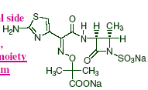
- The bulky sulfur atoms may spatially resemble the C-2 COOH group of β-lactam antibiotics to confuse PBPs.
- The C-2 a-methyl group is associated with its stability.
- Monobactams demonstrates that a fused ring is not essential for antibiotic activity.
- Serum protein binding of monobactams is 50% & nearly unchanged by metabolism & excreted in urine.
- Aztreonam is mainly used for Gram (-) bacterial infections, especially those acquired in the hospital, e.g., UT, upper respiratory tract, bone, cartilage, abdominal, obstetric & gynecologic infections & septicemias.
- Aztreonam is well tolerated & has infrequent side effects, including allergy.
- Cross allergenicity with penicillins & cephalosporins has not been reported.
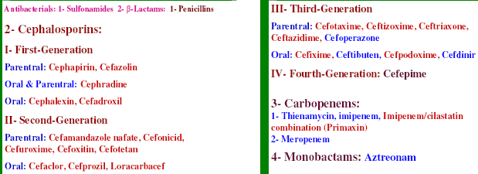

- Antibiotics that inhibit protein synthesis in prokaryote microorganisms’ 70S ribosome are selective to binding sites & not bind the 80S mammalian ribosome.
- E coli’s 70S ribosomal particle is composed of RNA & 55 different proteins, e.g., 21 on the 30S & 34 on the 50S subparticle.
- Aminoglycosides bind to a site on mRNAs of the 30S subparticle.
- Macrolides, lincosaminides& chloramphenicol bind to a different site on the 50S subparticle.
- Teracyclines bind to both 30S & 50S subparticles. - At normal therapeutic doses, these antibiotics do not interfere with mammalian 80S ribosomal subparticles.
- Interference with bacterial protein biosynthesis prevents repair, cellular growth & reproduction which produces bacteristatic or bactericidal effects.

3. Aminoglycosides& Aminocyclitols
- Antibiotics containing the pharmacophore aminoinositols:
- streptamine, deoxystreptamine or Spectinamine.
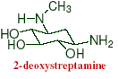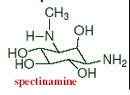
- Some OH groups of 1,3-diaminoinositol are glycosidically substituted with aminosugars to form pseudo-oligosaccharides.
- Diaminoinositol unit directly affect the spectrum, potency, toxicity & pharmacokinetics of aminoglycosides.
- Aminoglycosides are highly polar, hence they are freely water soluble.
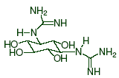
- They are basic, forming acid salts (NH2 groups).
- Aminoglycosides are not significantly absorbed from GIT, yet they used orally for some GIT infections with their effects confined to GIT.
- After IM or perfusion injection, they are well distributed & have low protein binding level.
- They excreted in urine in high concentration & in active form.
- Hence dose adjustment is indicated in cases of renal impairment to avoid accumulation of toxic levels.
- Antimicrobial spectrum of aminoglycosides is very wide but their toxicity potential limits their use to severe Gram (-) infections.
- Toxicity includes:
1. Ototoxicity to functions mediated by 8th cranial nerve, resulting hearing loss & vertigo.
2. Kidney tubular necrosis& decrease in glomerular function. These effects may have a delayed onset, as the patient can be significantly injured before symptoms appear.
3. Curare-like neuromuscular blockade (less common) through competitive inhibition of Ca++-dependent acetylcholine release. This can exaggerate the muscle weakness of myasthenia gravis & Parkinsonism patients.
- Creatinine function should be monitored & the dose is adjusted downward accordingly.
- To reduce its toxicity, tobramycin is used as a spray for P. aeruginosa lung infections in cystic fibrosis patients.

Mechanism of Action
- Aminoglycosides are bactericides.
- At less than toxic dose, they bind to the 16S ribosomal DNA portion of the 30S ribosomal subparticle impairing the proofreading function of the ribosme.
- This leads to mistranslation of RNA templates & consequent selection of wrong amino acids & formation of nonsense (unnatural) proteins, which disturbs semipermeability of bacterial membrane function.
- This damage will also lead to admission of large quantities of aminoglycosides.
- Accumulation of high concentration of aminoglycosides inside the bacterial cell will lead block of all protein biosynthesis. Both effects are devastating to bacterial cells.
- Aminoglycosides initially bind to external lipopolysaccharides& diffuse into the cells in
small amounts.
- This uptake is inhibited by Ca++ & Mg++ ions which are therapeutically incompatible with aminoglycosides.
- Permeability through cytoplasmic membrane is dependent on electron transport & energy generation.
- At high concentrations, aminoglycosides can also inhibit protein biosynthesis in eukaryotic cells, which induce toxicities.
- Resistance to aminoglycosides is common due to bacterial elaboration of R-factor mediated enzymes that N-acetylate (AAC-aminoglycoside acetylase), O-phosphorylate (APH-aminoglycoside phosphorylase) & O-adenylate (ANT-aminoglycoside nucleotide transferase) specific functional groups, preventing subsequent ribosomal binding.
- Semisynthetic modification can be used to delete or replace inactivation targeted groups in aminoglycosides with novel functional groups that would be poorer substrates for inactivating R-factor enzymes.
- Resistance due to decreased uptake of aminocyclitol/ aminoglycosies is also encountered.
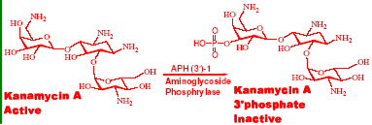

Therapeutic Applications
- Aminoglycosides have broad antibiotic spectra against aerobic Gram (+) & Gram (-) bacteria.
- They usually reserved for serious Gram (-) infections due to their serious toxicity.
- Examples of these Gram (-) aerobes are:
- Acenetobacter sp., Citrobacter sp., Enterobacter sp., E. coli, Klebsiella, Provedentia, Pseudomonas, Salmonella, Shigella& Serratia species.
- Streptomycin is a first-line antituberculosis drug
- Spectinomycin is used for gonorrhea.
- The similarity of clinical antibiotic spectrum of aminoglycoside with that of quinolones
decreased the popularity of clinical aminoglycosides use & increased the use of
quinolones.

1. Kanamycin
- Isolated from Streptomyces kanamyceticus in 1957. This actinomycete produces 3 kanamycins: A-C.
- The commercially available kanamycin is almost pure kanamycin A, the least toxic form.
- One of the most chemically stable aminoglycosides (along with gentamicin,
neomycin & paromomycin).
- They can resist heating with acids & alkali for long time & autoclaving temperature.
- Kanamycin is unstable to R-factor enzymes, can be C-3’ O-phosphorylated by enzymes APH(3’-I & APH(3’)-II & can also be inactivated by N-acetylated of the C-6’ amino group.
- Kanamycin is used parenterally (with local anesthetics to avoid pain) for Gram (-) bacteria but Pseudomonas aeroginosa& anerobes are usually resistant.
- It can be used a 2nd line-drug for mycobacteria, e.g., M. kansasii, M. intracellulare , M. marinum & M. tuberculosis.

2. Amikacin
- Semisynthetic analog of kanamycin.
- Interestingly, N-3 substitution with L-hydroxylaminobuteryl amide (HABA), inhibits adenylation & phosphorylation in the distant sugar ring at C-2’ & C-3’ although it is not
where the enzymatic reaction occurs.
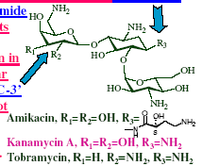
- This is due to decreased binding to the R-factor mediated enzyme.
- With HABA substituent, potency & spectrum are strongly enhanced & amikacin is used
competitively with gentamicin for treatment of sensitive strains of Mycobacterium tuberculosis, Yersinia tularensis & severe P. aeruginosa infections resistant to other
agents.

3. Tobramycin
- It is 1/6 of a mixture of fermentation products of Streptomyces tenebrarius.
- It lacks C-3’ OH group, hence tobramycin is not a substrate to APH93’)-I & -II.
- This increased its spectrum of activity compared with kanamycin.
- It is however a substrate for C-2’ adenylation & acetylation as well as C-3 acetylation.
- Used specifically for gentamicin-resistant P. aeroginosa infections & considered less toxic than gentamicin.

4. Gentamicin
- Mixture of several antibiotics produced by the fermentation of Micromonospora purpurea & other related soil microorganism.
- It is spelled with ‘i” instead of “y” to recognize it is not derived from Streptomyces
origin like other aminoglycosides.
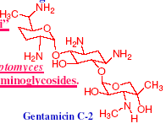
- It is the most important aminoglycoside antibiotics in current clinical use.
- It is one of the early antibiotics that showed significant activity against P. aeruginosa, which is an opportunistic pathogen usually encountered in burns, pneumonia & UT infections.
- Some R-factor enzyme targets are missing in the structure of gentamicin, which enhances their antibiotic spectrum.
- However it is inactivated by C-2’ adenylation & acetylation at C-1, C-2’ & C-6’.
- It is chemically incompatible with β-lactam antibiotics which induce C-1 N-acylation of
gentamicin, thus inactivating each other.
- Both antibiotics should never be administered in the same compartment, usually one in each arm.
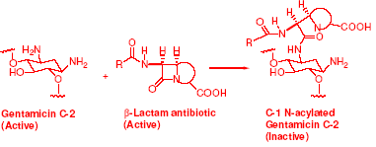
- Gentamicin is used for Gram (-) UTIs, burns (topically as dressing), pneumonia, bone & joint infections.
- Also used to prevent contact lenses fouling & sepsis of orthopedic surgery polymer matrices.

5. Neomycin
- Mixture of 3 neomycins A-C, obtained by fermentation of Streptomyces fradiae.
- Neomycin B is the major.
- Too toxic for parenteral use.
- Used in preoperative bowel sanitation & for enteropathogenic E. coli infections.
- Topically used for wounds.
- Lowers serum cholestrol& have antiangiogenic activities.
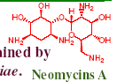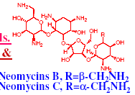

6. Netilmicin
- Semisynthetic product of addition of C-3 N-ethyl substituent onto sisomicin, produced by Micromonospora inyoensis& related soil microbes.
- They’re chemically unique by possessing unsaturation in sugar moiety.
- Clinically similar to gentamicin& tobramycin with a broader spectrum against R-factor
producing strains.

7. Oral Aminoglycosides
- Paromomycin, neomycin & kanamycin are orally used to suppress gut flora, prophylactically before gut surgery to reduce the possibility of post surgical peritonitis.
- Paromomycin also used for treatment of amoebic dysentery.

8. Streptomycin
- Broad spectrum aminoglycoside antibiotic isolated from the fungus Streptomyces griseus.
- It contains two highly basic guanido groups at C-1 & C-3 of the diaminoinositol unit
which is streptamine.
- 1st-Line antituberculosis drug
- Useful against bubonic plague & leprosy
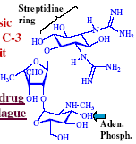
- α-Hydroxyaldehyde function causes molecule instability, hence it can’t be sterilized by
autoclaving but only by ultrafilteration of its water soluble sulfate salt.
- Resistance to streptomycin through N-acetylation, O-phosphorylation& O-adenylation
of specific functional groups.
- Streptomycin is not useful against MAC & other unusual opportunistic mycobacteria.
- Long-term use disturbs normal flora & can cause overgrowth of thrush & vaginal Candida albicans.

9. Spectinomycin
- Unusual aminoglycoside from Streptomyces spectabilis.
- The diaminoinositol unit (spectamine) contains 2 mono-N-methyl groups & the stereochemistry of the OH between them is opposite to that of streptomycin.
- The glycosidically attached sugar also contains 3 consecutive carbonyls, either masked or overt & fused to spectinamine by 2 adjacent linkages.
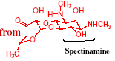
- Spectinomycin is bacteriostatic& exclusively used as a single IM bolus injection for Neisseria gonorrhea, especially penicillinase-producing strains (PPNG) in oral or urogenital gonorrhea.
- This single shot doesn’t produce any ototoxicity or nephrotoxicity.
- It is particularly useful in penicillin-allergic patients.
- Not active against syphilis & chlamydia.
- Resistance is known.

Summary: Aminoglycosides& Aminocyclitols
1. Kanamycin
2. Amikacin
3. Tobramycin
4. Gentamicin
5. Neomycin
6. Netilmicin
7. Paromomycin
8. Streptomycin
9. Spectinomycin

Macrolide Antibiotics
- Contain a large ring system (macrocycle).
- The suffix “ide”= lactone= cyclic ester
- Macrolide antibiotics have 2 or more characteristic sugars attached to the 14-
membered ring.
- One of these sugars bears substituted NH2 group, making the molecule weak basic (pKa = 8).
- Free bases are not freely water soluble, which increase with salt formation with for example glucoheptonic or lactobionic acids
- Other salts like laurylsulfate& stearic acid decrease water solubility.
- The 14-membered ring macrolides are biosynthesized from propionic acid units, hence
every second carbon of erythromycin for example bears a methyl group & the rest of carbons (except C-7) are oxygenated.

Macrolides Biosynthesis
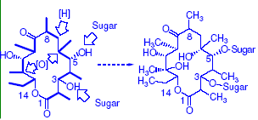
- Two carbons (C-6 & C-12) are oxygenated later during the biosynthesis to bear “extra” oxygens, i.e., oxygens not originally from propionic acid.
- C-3 & C-5 are also later glycosylated.

Mechanism of Action
- Macrolides interfere with programmed ribosomal protein biosynthesis by inhibiting translocation of aminoacyl t-RNA after binding to the 50S subparticle.
- They also bind to domain V of bacterial 23S rRNA making contact with adenosine 2058
(A2058) & bind to domain II hairpin 35 in the same rRNA.

Resistance
- Develops quickly by bacteria possessing R-factor enzymes which methylate a specific guanine residue on their own ribosomal RNA making them less efficient at protein biosynthesis & comparatively poor macrolide binders.
- Resistance also develops by mutation of adenine to guanine at A2058, which results 10,000 fold reduction of binding capacity of erythromycin & clarithromycin to the 23S rRNA.
- This mutation is less likely to occur with ketolide derivatives.
- Some bacteria are resistant due to their ability to actively efflux macrolides, expelling the drug out of cell at the cost of energy.
- Intrinsic resistance of Gram (-) bacteria is due to the lack of penetration.

Stability
- Macrolides are chemically unstable in acid due to quick internal ketal formation & inactivation.
- Many macrolides have unpleasant taste, so formulation of water-insoluble dosage forms & enteric coated tablets will reduce unpleasant taste, acid instability & gut cramps
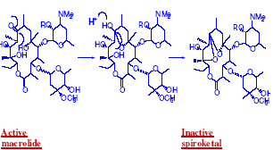

Drug-Drug Interactions
- Common & involve competition for oxidative liver cytochrome P450 oxidase (CYP3A4).
- Examples of these are: ergotamine, theophylline, carbamazepine, bromocryptine, warfarin, digoxine, oral contraceptives, terfenadine, astemizole, cyclosporin, midazolam, triazolam& Me prednisone.
- They can extend the t1/2 & enhance potential toxicity & induce serious cardiovascular effects.
- N-demethylated analog is the main liver metabolite of erythromycin.

Therapeutic Applications
1. Treatment of Gram (+) upper & lower respiratory tract, otitis media & soft tissue
infections by Strep. Pyogenes, Strep. Pneumonia& H. influenzae (with
sulfonamides)& for mycoplasma pneumonia.
2. Prophylaxis against Strep. Pyogenes endocarditis in Legionnaire’s disease.
3. Combined with rifabutin for M. avium complex infections in AIDS patients.
4. Sexually transmitted diseases, e.g., gonorrhea & pelvic inflammatory disease caused
by cell-wall free bacteria as Chlamydia trachomitis.
5. Clarithromycin is used a component of multidrug cocktail for H. pylori gastric ulcers.

- Macrolides have low toxicity (gastrin stimulation & hyperperistalsis/GI cramps) BUT they do not cause β-lactam allergy.
- They are used orally & their GI absorption is irregularly affected by food.
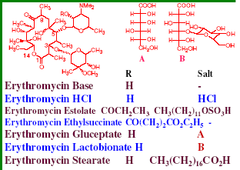

Erythromycin Estolate
- One of the most common erythromycin prodrugs, where C-2’’ is propionyl ester & used as an N-laurylsulfate salt (CH3(CH2)11OSO3H).
- Erythromycin released by metabolism, producing high blood level.
- Occasionally (partly allergic & partly dose related) bile become granular in bile ducts,
impeding its flow & backing up bile salts to circulation, which cause cholestatic jaundice.
- The drug can damage hepatocytes, releasing antigenic proteins.
- In both cases, the drug must be replaced with non-macrolide antibiotics like cephalosporins or penicillins.

Erythromycin Ethyl Succinate (EryPed)
- Another erythromycin prodrug where its C-2’’ is esterified with ethyl succinate CO(CH₂)₂CO₂C₂H₅
- Frequently used as an oral pediatric suspension to mask erythromycin’s the bitter taste.

Clarithromycin
- Semisynthetic C-6 Me ether analog of erythromycin.
- Blocking of free C-6 OH group is important since C-6 is involved in acid-induced ketal formation in erythromycin. The ketal product is less active & causes GI cramps.
- This conversion results in a more lipophilic molecule & prevents internal ketal formation giving better stability (in acid) & blood level.
- Lipophilicity increase allows using of lower doses.
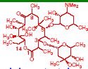

Azithromycin
- Semisynthetic insertion of an N-methyl group between C-9 & C-10, transforming the ring to “azalide” & removing C-9 carbonyl.
- The new 15-membered azalide is more acid stable, better penetration & has a longer t1/2, hence used once/day.
- The drug should be taken on an empty stomach & can cause metallic taste.
- Has greater anti-Gram (-) activity& has a cross resistance with other macrolides.
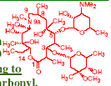

Oleandomycin/Troleandomycin
- Oleandomycin is obtained by fermentation of Streptomyces antibioticus.
- Troleandomycin is the C-2’ semisynthetic analog & a prodrug of oleandomycin.
- Less active than erythromycin, frequent cross resistance is encountered, not currently
commonly used.
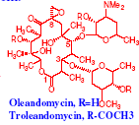

Dirithromycin
- Semisynthetic macrolide prodrug hydrolyzed in vivo to the active erythromycyclamine, which is more stable than erythromycin.
- It is also less active against anaerobes but not metabolized by cytochrome P450, hence much less drug-drug interactions encountered.
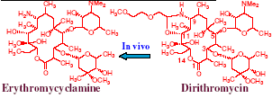

Telithromycin (Ketek)
- First ketolide antibiotic marketed in 2002.
- Used in 800 mg/day dose for community-acquired pneumonia, acute sinusitis, chronic bronchitis.
- Can cause nausea, vomiting, diarrhea & dizziness.
- Drug interactions include itraconazole, ketoconazole, digoxin& cisparide.
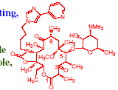

Lincosaminides
- Lincomycin (Lincocin) is a natural product obtained from Streptomyces lincolnensis var. lincolnensis.
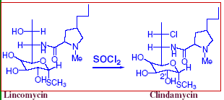
- It contains an unusual 8-carbons sugar, a thiomethyl aminooctoside (O-thio-lincosamide), linked by an amide bond to an n-propyl susbstituted N-methylpyrrolidylcarboxylic acid (N-methyl-n-propyl-trans-hygric acid).
- Reaction of thionyl chloride with lincomycin affords clindamycin (Cleocin), inverting the C-7R hydroxy to C-7 chloride S-stereochemistry.
- Clindamycin is more active & lipophilic than lincomycin & better orally absorbed (90%
absorption).
- Lincosamides bind to 50S ribosomal subparticles at a site partly overlapping with the macrolides side, hence cross resistance is expected.
- Clindamycin is formulated for injections as C-2’ phosphate ester prodrug which is much less painful than erythromycin.
- Its palmitate hydrochloride is another available non-bitter orally active water insoluble
preparation.
- Clindamycin’s clinical spectrum of activity is very similar to macrolides & better distributed into bones.
- Hence it used for Gram (+) coccal infections especially allergic patients to β-lactams, good alternative for MRSA.
- Clindamycin also has better anti-anerobes activity.
- Clindamycin is also effective against Propionobacterium acnes when applied topically
to comedones. Because it is white in color, it can be cosmetically tinted to match flesh tones much better than the yellow tetracyclines.
- Lincosaminides hepatically metabolized through N-demethylation. The N-desmethyl analog is still biologically active.
- Lincosamides are associated with GI complains, nausea, vomiting, ramps, diarrhea.
- They can also cause pseudomembraneous colitis by releasing glycoproteinaceous endotoxin produced by the lysis of Clostridium difficile, an opportunistic anaerobe which overgrow by suppression of normal gut flora.
- Clindamycin can cause Stevens-Johnson syndrome.

Tetracyclines
- Tetracyclines are common antibiotics initially isolated from Streptomyces sp.
- They are characterized by highly functionalized partially reduced naphthacene
ring system where 4 linearly fused 6-membered rings.
- Tetracyclines are amphoteric, have 3 pKa values & isoelectric point at pH 5.
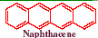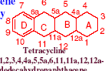
- Commercial tetracyclines HCl salts are water soluble.
- The C-4 a-dimethylamino is the basic moiety.
- The conjugated C-10 phenol is associated with the pKa 7.5, due to phenol-enone system
extending from C-10 to C-12.
- The conjugated trione C-1/C-3 system is nearly as acidic as acetic acid with pKa ~3.
- These resonating systems can be translated to a
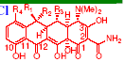
- Chelation is a clinically important issue in tetracyclines
- The acidic functions of tetracyclines can form chelate metal & polyvalent ion salts (e.g., Fe2+, Al3+, Ca2+, Mg2+) which are completely water insoluble at neutral pH.
- This insolubility interferes with GI absorption, blood levels & creates formulation problems.
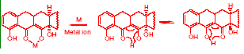
- Hence, tetracyclines are incompatible with coadministration of multivalent ion-rich antacids, hematinics& concomitant use of Ca2+ rich food.
- Bones & teeth are Ca2+-rich structures, which accumulate tetracyclines in proportion to the amount & duration of therapy when being formed.
- This lead to progressive & permanent discoloration (brown, tetracyclines are yellow in
color).
- Color intensification is a photochemical process which is cosmetically unacceptable but not deleterious except in extreme cases where bone is mechanically weakened.
- Hence tetracyclines are not indicated for children forming their permanent teeth (age 6-12) & during pregnancy.
- When oral tetracycline therapy is indicated, Ca2+ & iron rich food must be taken 1 hr before or 2 hrs after tetracyclines administration.
- Tetracycline im injection is painful due to formation of insoluble Ca complexes.
- Hence, their injectable formulations contain EDTA & their solutions are buffered at acidic pH, reducing chelation& increasing solubility.
- Tetracycline can cause thrombophlebitis upon iv injection.
- Oral route is much preferred as it has better GI absorption in absence of metal ion-rich gut content.

Chemical Instability
1. Epimerization
- The C-4 a-dimethylamino group is essential for tetracycline activity.
- The presence of tricarbonyl system in ring A facilitates enolization with the loss C-4 H.
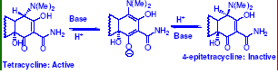
- Reprotonation can occur either from top, regenerating tetracycline or from bottom, regenerating the inactive 4-epitetracycline.
- At equilibrium, the mixture is 1:1 mixture of both diastereoisomers.
- Old tetracycline preparation lose their ½ potency in this way.
- Overfilling the capsule by ~15% during manufacture will allow longer shelf life at labeled potency.
- Epimerization is most faster at pH 4 & relatively slower at dry solid state.

2. Dehydration
- C-6 b-benzylic 3ry OH is easily acid catalyzed dehydrated with involvement of C-5a a-oriented.
- This is also facilitated by their Antiperiplanar (trans) orientation
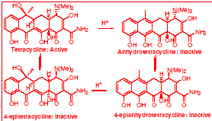
- The product (C-5a,6-anhydrotetracycline is much deeper in color & inactive.
- This compound can further epimerize at C-4 to give the inactive 4- epianhydrotetracycline, which is renal toxic producing Fanconi-like syndrome &
can even be fatal.
- Old discolored tetracyclines must be suspected & discarded.
- Commercial tetracyclines are closely monitored for 4-epianhydro products.
- Tetracyclines without 6-hydroxy group, like minocycline& doxycycline
can’t undergo dehydration & hence they have the advantage of being
completely free of such toxicity.

3. Base-catalyzed degradation
- C-6 OH group is also cleaved in alkaline solutions (>pH 8.5) to produce the lactonic inactive product isotetracycline.
- Clinical impact of this degradation is still uncertain
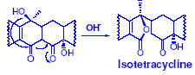
Phototoxicity
- Tetracycline, especially C-7 chlorinated, absorb light in the visible region leading to free radical generation & causing potentially severe erythryma to sensitive patients on exposure to sun light.
- Patients should be cautioned about this especially during their first few doses.

Mechanism of action
- Tetracyclines interfere with protein biosynthesis at the ribosomal level.
- They bind to the 30S & possibly 50S subparticles. - Bound tetracycline inhibits subsequent binding of aminoacyltranfer-RNA to the ribosomes resulting in termination of the peptide chain growth.
- Lipophilic tetracyclines like minocycline can disrupt cytoplasmic membrane function causing leakage of nucleotides & essential components causing bactericidal effect.

Resistance
- Unusual ribosomal protection with elaboration of bacterial protein TET (M), TET (O) & TET (Q) results in resistance.
- These proteins associate with ribosomes, allowing protein biosynthesis to proceed even in presence of bound tetracyclines.
- R-factor-mediated, energy-requiring, active efflux of Mg-chelated tetracyclines from cells in exchange for H’s. This is common in Gram (-).
- Mycoplasma & Neisseria modify their membranes that either they accumulate less tetracyclines or have porins which do not pass tetracyclines.
- Tetracyclines imperfectly differentiate between bacterial 70S & mammalian 80S ribosomes & hence high doses (specially iv) can lead to severe liver & kidney damages.
- Diuretics & metabolism inducers (e.g., hydantoins, barbiturates, carbamazepine) are
contraindicated with tetracyclines because they potentiate tetracycline toxicity.

Therapeutic Applications
- Due to widespread resistance & comparative frequency of troublesome phenomenon,
tetracyclines are no longer commonly used.
- Tetracyclines are bacteriostatic antibiotics that used for:
1. Low dose oral & topical acne therapy
2. First course community acquired UTIs, mainly E. coli., brucellosis, upper respiratory tract & ophthalmic infections.
3. Sexually transmitted diseases.
4. Mycoplasma pneumonia, bacteroides & rickettsial infections.
5. Malaria & traveler’s diarrhea prophylaxis.
6. Enterobacter& Helicobacter cocktails.
7. Shigellosis, cholera & scrub typhus.
8. Agriculturally used in tonnage amounts in the form of feed supplements.
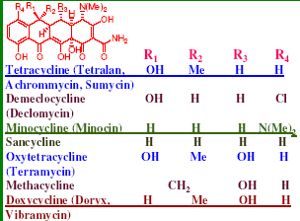

Tetracycline
- Produced by fermentation of Streptomyces aureofaciens or catalytic reduction
of chlortetracycline.
- Comparatively cheap.
- Oral blood level comparatively irregular as food & milk reduce absorption by 50%.
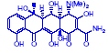

Minocycline
- Produced by semisynthesis from demeclocycline.
- Removing C-6 OH & C-7 Cl by catalytic reduction to give sancycline.
- Sancycline is then nitrated in strong acid media to give C-7 nitro & C-9 nitro analogs.
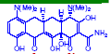
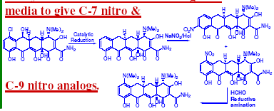
- The former is subjected to reductive amination/HCHO to give minocycline.
- Minocycline is much more lipophilic than its precursor, giving better (90-100%) oral
absorption & can be given once/day.
- Its absorption is lowered ~20% by food.
- It is less painful im or iv injection, however it can induce vestibular toxicities (e.g., vertigo, ataxia, nausea) which are not produced by other tetracyclines.
- It has broad spectrum of activity specially against Gram (+) pathogens Staphylococci & Streptococci.

Doxycycline
- The most important & common current tetracycline because it causes fewer GI disturbances & can’t participate in C-6 involving degradations.
- Well absorbed on oral administration (90-100%) & reduced by 20% by food. Long t1/2 allowing once/day use.
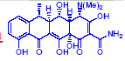

- Glycylcyclines are recent tetracyclines including 9-nitrodemethyldeoxytetracycline & 9-nitrominocycline that are especially reserved for tetracycline-resistant strains.

Macrolides:
Erythromycin Base Erythromycin HCl
Erythromycin Estolate Erythromycin Stearate
Erythromycin Ethylsuccinate
Erythromycin Gluceptate
Erythromycin Lactobionate
Lincosaminides
Lincomycin
Clindamycin

Tetracyclines
Tetracycline Demeclocycline Minocycline
Sancycline Oxytetracycline Methacycline
Doxycycline Glycylcyclines

- Macrolides, licosaminides, & teracyclines are bacteriostatic antibiotics that target ribosomal bacterial protein synthesis.
- Macrolides have low toxicity profile but suffer several oxidative cytochrome P450 interactions.
- Lincosaminides are aminooctosides that act by the same mechanism of macrolides.
- Clindamycin is a semisynthetic product which effective for MRS & other wide uses.
- Tetracyclines suffers many chelation, dehydration, epimerization reactions that can
affect their activity & can even cause toxicity.

6. Cyclic Peptides:
- Several bacteria produce mixtures of cyclic peptides which differ from the regular
physiological linear peptides
- These cyclic peptides occasionaly contain unusual amino acids or with common D-amino acids & usually have terminal fatty acid chains.
- This unique structure feature affords compounds which are not readilyly metabolized.
- Cyclic peptides are highly water soluble, unstable in solution, light & pH sensitive.
- They are highly toxic to susceptible bacteria through intereference with their membrane
permeability, leading to leak out of essential ions.
- Cyclic peptides are also toxic to humans, hence they’re reserved for topical use or for serious life-threatening infections where there are few alternatives.

1. Vancomycin& Teicoplanin
- Vancomycin is obtained by fermentation of Nocardia orientalis.
- It is one of 2 clinically used, out of 200 known related glycopeptide antibiotics.
- Used since 40 years ago but gained recent interest due to its useful spectrum against Gram (+) multiply resistant coagulase negative staphylococcus & MRSA which cause speticemia, endocarditis, skin & soft tissue infections.
- Life-saving orally for Clostridium difficile infections despite it is not GI absorbed.
- It is instilled slowly in iv infusion to prevent thrombophlebitis.
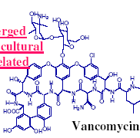
- Recently, resistance emerged due to the extensive agricultural use of the structurally related antibiotic avoparcin.
- Avoparcin is not for human use in the US.
- Resistance is due to alteration of the D-ala-D-ala units on the peptidoglycan precursor to D-ala-Dlactate, reducing the affinity to the antibiotic.
- It is feared that this form of resistance can create clinically untreatable resistant strains.
- Vancomycin is a glycosylated hexapeptide with unusual aromatic amino acids.
- It has a specific binding peptide receptor in the bacterial cell wall.
- Its mechanism of action is different from that of β-lactams, covering the substrate for cell wall transamidase, preventing its cross linking & resulting in osmotically defective cell walls.
- High dose of vancomycin can cause nephrotoxicity& audit ory nerve damage.
- Red man syndrome, which is a significant drug rash can occur with the use of vancomycin mediated by histamine release.

Teicoplanin
- Teicoplanin is a mixture of 5 vancomycin-related fermentation products.
- It is more lipid soluble, so it distributes better.
- Used as IM or IV injection once/day.
- Better tolerated, no significant histamine release on iv injection, much less irritating than vancomycin

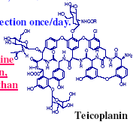
Streptogramins
- Quinupristin/dalfopristin (3:7, Synercide) combination is recently approved for iv use for vancomycin-resistant Enterococcus faecium & skin infections by MRSA & Streptococcus pyogenes.
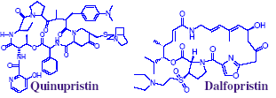
- It is then one of few choices for resistant E. faecium strains, that is why its use should be limited to avoid emergence of resistant strains
- Both drugs are bacteriostatic individually but act synergistically in combination, inhibiting protein synthesis by binding to the 70S ribosome.
- Synercide effectively inhibits cytochrome P450 which results in potential drug-drug interactions.

Bacitracin
- Mixture of similar peptides (mainly bacitracin A) produced by the fermentation of the bacterium Bacillus subtilis.
- The first part of the name “baci” is derived from Bacillus, its source bacteria while “tracin” is derived from “Tracy”, the family name of the first patient to be treated with this antibiotic, a little girl.
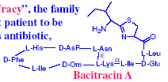
- It is effective against Gram (+) bacteria, specially MRSA, used topically or intramuscularly.
- Also useful orally for enteropathogenic diarrhea, especially against Clostridium difficile & for preoperative bowel sanitization.
- Used with caution as it may cause neurotoxicity & nephrotoxicity.
- Zn²⁺ enhances its activity.
- Inhibits peptidoglycan biosynthesis & causes disruption of plasma membrane integrity.

Polymyxin B (Aerosporin)
- Produced by fermentation of Bacillus polymyxa & used as a mixture of related peptides.
- Active against Gram (-) microorganisms by binding to phosphate groups in bacterial cytoplasmic membranes & disrupts their integrity
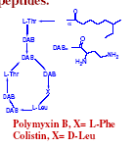
- Used IM or IV for serious UTIs, meningitis & septicemia caused by Pseudomonas aeruginosa.
- Also used orally for enteropathogenic E. coli & Shigella sp. Diarrhea.
- Used to irrigate & reduce urinary bladder infection after installation of catheters.
- Injections can cause neuro-& nephrotoxicity, hence only used if other drugs failed.

Colistin (Coly-Mycin S)
- Cyclic polypeptide produced by fermentation of Bacillus polymyxa var. colistinus, mainly colisitin A.
- Bactericidal to Gram (-) bacteria, targeting the integrity of their plasma membranes.
- Rarely used (only in life-threatening Gram (-) infections) because it is neuro-& nephrotoxic.
- Used orally for E. coli& Shigella diarrhea.

Capreomycin
- Mixture of 4 cyclic peptide, mainly 1A & 1B) produced by fermentation of Streptomyces capreolus.
- Bacteriostatic against mycobacterial strains, e.g., M. tuberculosis, M. kansasii, M. bovis & M. avium.
- Ototoxic & nephrotoxic,
- Used with caution
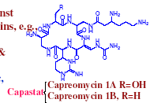

7. Special Purpose Antibiotics:

1. Chloramphenicol (Chloromycetin)
- Originally produced by the fermentation of Streptomyces venezuelae but later chemically synthesized due to its simple structure.
- Posses 2 chiral centers, i.e., has 4 diastereomers, only the 1R, 2R diastereomer is the most active.
- Inactive synthetic isomers must be removed before use
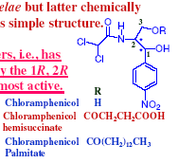
- Chloramphenicol is neutral, its 2 nitrogens are not basic, moderately soluble in water.
- It was the 1st broad spectrum antibiotic marketed in the US.
- Its severe blood dyscrasia decreased its use in North America despite it is still commonly used worldwide because of its cheapness & efficacy.
- It is rapidly metabolized as C-3 glucouronide & deamidated & dehalogenated products to give inactive metabolites.
- Its NO₂ group is also reduced, mainly by human bacterial gut flora.
- Chloramphenicol used orally or parenterally. It is ~60% serum protein bound, diffuse into soft tissue & inflamed CSF, hence used in meningitis.
- Also penetrates lymph & ganglions, hence very useful in typhoid & paratyphoid fevers.
- Chloramphenicol is also excellent (along with ampicillin) for Haemophilis infections, e.g., epiglotitis & meningitis.
- Also very useful in pneumococcal/meningococcal meningitis in β-lactam allergic patients, anaerobic bacteroides infections & as a backup to tetracyclines in rickettsial infections.

Mechanism of Action
- Bacteriostatic by inhibition of protein synthesis through binding to 50S subparticle, near the macrolide’s region.
- Resistance mediated by R-factor enzymes, catalyzing acetylation of C-2 & C-3 OH’s,
reducing its affinity to ribosomes.
- E. coli decrease its intercellular accumulation of the drug.
- The most serious side effect of chloramphenicol is pancytopenia (aplastic anemia), 70% lethality rate.
- It occurs once/25,000-40,000 courses of therapy.
- Most likely it is produced by one of the aromatic nitro group reduction products.
- Genetic predisposition is possible.
- It can even occur through ophthalmic use.
- Dose-related reversible hematopoiesis inhibition is another less severe & more common side effect, especially in renal insufficiency patients.
- Drug withdrawal recovers marrow function.
- Careless administration of chloramphenicol in neonates (<48 hours-old), where hepatic
glucouronidation is yet undeveloped, can cause successive accumulation of drug due to impaired metabolism, leading to “ gray syndrome”, which is a form of cardiovascular collapse. This is associated with anemia & ashen gray pallor, vomiting, appetite loss, cyanosis, & death.
- Since chloramphenicol is intensively bitter, prodrugs that mask this bitterness are common, especially pediatric formulations.
- Its C-3 palmitate usually cleaved in duodenum to liberate free drug.
- The C-3 hemisuccinate Na salt formulation is intended to overcome chloramphenicol’s poor water solubility, cleaved in vivo to generate active free drug. Its cleavage in muscle tissue is very slow, hence this formulation is intended for iv use only & not used IM
- Chloramphenicol is a known inducer of the activity of other hepatically-metabolized drugs, e.g., anticoagulant coumarins, sulfonamides, oral hypoglycemics& phenytoin.

2. Novobiocin (Albamycin)
- Coumarmycin antibiotic produced by Streptomyces niveus.
- Inhibits the function of DNA gyrase, binding to a different subunit than the furoquinolones which synergize its effect.
- Novobiocin binding interferes with ATP metabolism which otherwise provides needed
energy for the enzyme’s conformational work.
- Orally active against Gram (+) & (-) microbes.
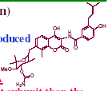
- Common side effects including rash, blood dyscrasias, liver damage & Resistance emergence limited its significant use.
- Its C-4 OH is vinylogous, hence acts as an acid, forming Na & Ca salts.
- Na salts used for injections.

3. Mupirocin (Bactroban)
- Lipid acid produced by Pseudomonas fluorescens.
- Only used topically because of its rapid in vivo hydrolysis inactivation.
- Used primarily for topical staphylococcal & streptococcal skin infections.
- It binds to bacterial isoleucyl transfer-RNA synthase preventing incorporation of isoleucine into bacterial proteins.
- Resistance due to alterations of the synthase target.
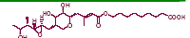

8. Oxazolidinones

Linezolid (Zyvox)
- It is the 1st of new synthetic approved April 2000 antibacterial class to treat
community-acquired pneumonia (CAP) & methicillin resistant Staph. aureus (MRSA),
nosocomial pneumonia, complicated & uncomplicated skin infections & vancomycin-resistant Enterococcus faecium infections.
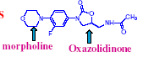
- Linezolid is available as tablet, injections & oral suspensions.
- Linezolid inhibits protein synthesis at a stage different from other protein synthesis inhibitors.
- It inhibits protein synthesis initiation, preventing the formation of ternary complex
between N-formylmethionyl-tRNA-mRNA-70S (or 30S) subunit.
- It distorts binding site for the initiator-tRNA which overlaps both 30S & 50S ribosomal
subunits.

