DISEASE EXAM ONE—DOESN’T INCLUDE LYNCH

Metabolic Crises--Diabetic Ketoacidosis; Hyperglycemic Hyperosmolar Nonketotic Syndrome
Definitions
♦ DKA
– Absolute insulin deficiency
– Hyperglycemia
- Hyperglycemia progresses over time → hyperosmolarity
– Increased lipolysis, increased ketone production and hyperketonemia
- Insulin usually functions to store fat
- treat by giving insulin; it will stop lipolysis
– Acidosis
♦ HHS, HNC, HHNS
– Relative insulin deficiency
– Severe hyperglycemia
– Elevated serum osmolality
Insulin deficiency
♦ Decreased cellular uptake of glucose
– Hyperglycemia
– Osmotic diuresis
- since glucose is osmotically active, it pulls water with it → will also pull other electrolytes
– Hypotonic losses
♦ Increased protein catabolism
– Increased amino acids – gluconeogenesis
– Increased nitrogen loss
♦ Increased lipolysis
– Increased glycerol – gluconeogenesis
– Ketogenesis, ketonemia, ketonuria

Pathophysiology
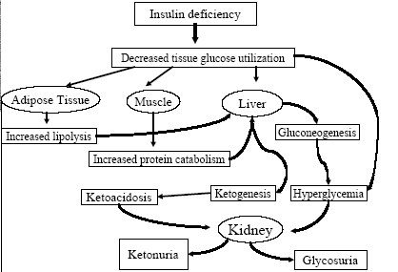

Diabetic Ketoacidosis (DKA)
♦ More common in type I diabetes
♦ Inadequate glycemic control
♦ Stress – release of counter-regulatory horomones
– Glucagon
– Cortisol
– Catecholamines
– Growth hormone
- Patient often has what they may believe is pneumonia or flu → increased counter-regulatory hormones
- exercise: increases counter-regulatory hormones
♦ Failure to take insulin
- adolescent females may decrease their insulin because they know they will lose weight
- some patients/kids like the sick role
- there are also rebellious adolescents
♦ Acute presentation – less than 24 hours.

DKA
♦ Relative insulin deficiency – 50%
♦ Undiagnosed patient – 25%
- many patients present as undiagnosed T1DM
♦ Excess counterregulatory homones
– Dehydration
– Infection-illness – 25%
– Surgery
♦ Psychological stress
♦ Sustained strenuous exertion
♦ Pregnancy
♦ Pancreatitis
♦ Hyperthyroidism
♦ Hyperthermia
♦ Acute MI
♦ CVA
♦ Alcohol abuse
♦ Drugs that can cause DKA
- corticosteroids
- sympathomimetics
- e.g., giving terbutaline to DM patient going into premature labor
- thiazides

Hyperglyemic Hyperosmolar Nonketotic Syndrome (HHNS)
♦ Usually elderly
♦ Life threatening – 5-10% mortality
- more life-threatening than DKA (<5%; <1% in centers used to treat DKA)
♦ Hyperglycemia - >800 mg/dL
♦ Absence of ketoacidosis
♦ Profound dehydration
♦ Evolves over several days to weeks

DKA and HHS clinical presentation
♦ Polyuria
♦ Polydipsia
♦ Polyphagia
♦ Weight loss
♦ Vomiting
♦ Many patients believe they should drink sugary drinks when they have N/V or they stop insulin
♦ Abdominal pain (DKA)
♦ many patients look like they have an acute abdomen
♦ Dehydration
♦ Weakness
♦ Mental changes
♦ tend to go more with changes in osmolality
♦ Poor skin turgor (skin tenting)
♦ babies are affected more by dehydration because they are composed of more fluid
♦ Kussmaul respirations (DKA)
♦ Tachycardia
♦ Hypotension
♦ Altered mental status
♦ Coffee-ground emesis (GI bleed)

DKA/HHS laboratory evaluation
♦ Body temperature may not be elevated because of peripheral vasodilation (this concerns patients with an infection)

♦Chem 7:
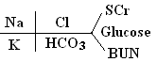
♦ Glucose
♦ BUN
♦ Creatinine
♦ Serum ketones
♦ Electrolytes – calculated anion gap
♦ Osmolality
♦ Urinalysis
♦ Urine ketones
♦ CBC with differential
♦ WBC can increase with DKA, even with no infection
♦ looking for presence of bands: if >10% → infection

♦ ECG
- picks up on K⁺ changes; presence of MI
- Low K⁺: U waves are present; peaked T waves; wide QRS
♦ Cultures
♦ Chest x-ray
♦ Amylase
♦ may be increased due to saliva
♦ lipase
♦ if normal and amylase is high: saliva
♦ if high and amylase is high: pancreatitis

Differential Diagnosis
♦ Starvation ketosis
♦ Alcoholic ketoacidosis
♦ High-anion gap metabolic acidosis
– Lactic acidosis
– Salicylate
– Methanol
– Ethylene glycol
– Paraldehyde
– Chronic renal failure
Diagnostic Criteria

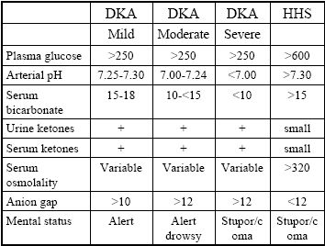
♦ plasma glucose is usually through the roof in HHS
♦ pH is not terribly abnormal
♦ Bicarbonate is higher (?)
♦ body produces bicarbonate to buffer H⁺ in normal situations
♦ bicarbonate is depleted, trying to neutralize H⁺ → low serum bicarbonate
♦ not much of anion gap → not much acidosis

Fluid and electrolyte losses

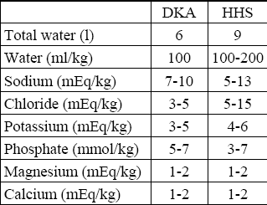
♦ DKA: usually about 6 L down
♦ want to be sure serum K⁺ isn’t low
♦ K⁺, water, Na⁺ are major determinants of replacement (Na: determines what replacement to use)
♦ if patients are extremely compliant, they may be able to treat themselves as outpatients (only less severe cases of DKA)
♦Don’t have to have astronomical glucose levels to be DKA

DKA/HHS – Treatment
♦Three treatment components:
1. Fluid
2. Insulin
3. Electrolytes
♦ Fluid Replacement
- Hct: percentage of blood that is RBC → willb e high if fluid is low
– Increases urine flow and glucose excretion
– Decreases counterregulatory hormones
– Corrected serum sodium
• Serum sodium + 1.6 mEq/100mg/dl of glucose above 100 mg/dl
- must correct Na because excess glucose affects level
– 0.9% saline 1L/hr for 1 hour
– 0.45% after stabilization of vascular status
– D5 1/2NS after glucose reaches 250 mg/dL
- CV status is poor: want isotonic NS because it will stay in vascular space
- ½ NS is ½ free water
- don’t want to bottom out glucose or overtreat
♦ Insulin
– 0.15 unit/kg IV bolus
– 0.1 units/kg/hr IV infusion
– Double if glucose does not drop 50 mg/dl in first hour
– Goal –steady fall of glucose of 50-75 mg/dl
– Decrease to 0.05-0.1 units/kg IV infusion when glucose is less than 250 mg/dl
– Continue IV for 1-2 hours after initiation of split-mixed regimen
- split-mix: mixing intermediate and short acting insulin
- must give SC insulin time to get into system → keep IV up for 1-2 hours after administration of SC insulin
- must preflux tubing before administering insulin because insulin will complex to tubing
- want to correct the estimated deficit within 24 to 48 hours
♦ Potassium
- may be low, normal, or high

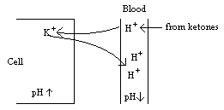
- if you treat with insulin, you decrease H⁺ in blood, and situation is reversed: H⁺ moves back to blood and K⁺ moves back to cell

– May drop due to
• Rehydration
• Continued loss in urine
• Correction of acidosis
• Insulin-mediated cellular uptake
– Monitor hourly
– < 3.3 mEq/L – HOLD insulin, give 40 mEq of potassium 40 mEq/hr
- insulin would force glucose into muscle, which will take K with it
– > 5.5 – HOLD potassium
- don’t put any in the bag until some fluid has been given
– 3.3-5.5 – 20-30 mEq/L of IV fluid – 2/3 KCL and 1/3 KPO4
- in elderly, you worry about muscles becoming fatigued due to PO₄ deficiency (especially the heart and diaphragm)
– Goal – potassium of 4.5 mEq/L

DKA - Treatment
♦ Sodium bicarbonate
– NONE if pH > 7.0
– If pH < 7.0 – recheck after 1 hour of rehydration
– 2 mEq/kg in NaCl
– Less than 155 mEq/L over 1 hour
- only give when pH is severely low: will cause a decrease in K⁺
♦ Ketonemia
– Resolves more slowly than glucose
– Direct measurement of beta-hydroxy butyric acid preferred method
- urine ketones may linger for up to 48 hours
- if hospital can measure ketones directly, it can be used
- nitroprusside is good for diagnosis, but don’t use it to monitor ketones

Venous Thromboembolism and Anticoagulation – Chapter 17

Venous Thromboembolism

Deep Vein Thrombosis (DVT)
- A thrombus, which is composed of cellular material bound together with fibrin strands, forms in the venous portion of the vasculature
- many times in the calves of legs
- kills ~60,000/year
Pulmonary Embolism (PE)
- A thrombus or foreign substance causing either complete or partial obstruction of pulmonary blood flow by lodging in the pulmonary artery or one of its branches

Risk Factors for Venous Thrombosis

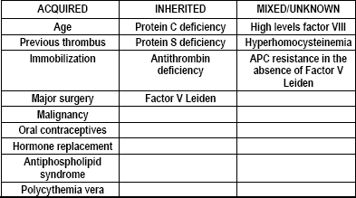
- Protein C and Protein S are the body’s natural anticoagulation proteins
- Immobilization could result from things such as surgery
- Antiphospholipid syndrome:
- presence of antibodies
- Polycythemia vera
- Decreased tendency of blood to blow
- Increased blood cell count

Virchow’s Triad
1. Hypercoagulable state
- Protein C or S deficiency
- positive for antiphospholipid antibodies

2. Circulatory stasis
- Atrial fibrillation, immobilization, CHF with a low ejection fraction
3. Endothelial injury
- trauma, blood clots
- If a patient has any one of these, they are likely to have a DVT

DVT versus PE
- Most venous thrombi involve the veins of the lower extremities (DVT)
- Complications – postphlebitic syndrome, compromised venous blood flow return, and embolization of thrombus to the lungs (PE)
- 15 – 20% of DVTs become PEs
- Can lead to alveolar dead space, pneumoconstriction, hypoxemia
- Increases pulmonary vascular resistance and risk of right ventricular failure
- Don’t want to give a thrombolytic because it can cause thrombus to move to lung

Clinical Presentation and Diagnosis

DVT (must be at least several symptoms present)
- Pain tenderness (tender to the touch)
- Unilateral swelling in calf and lower extremities
- Erythematous
- Palpable
- Warm to the touch
- + Homan’s sign
- if patient experiences pain when patient sits with feet elevated and toes are pushed back
PE
- Sudden onset of unexplained dyspnea
- Tachypnea – rapid breathing
- Pleuritic chest pain – crushing chest pain
- Anxiety
- Associated tachycardia
- Hemoptysis – coughing up blood
- Circulatory collapse

- Doppler ultrasonography
- gold standard
- V/Q scan
- Doppler
- Pulmonary angiography

Antithrombotic Agents: Mechanism of Action
- Anticoagulants: prevent clot formation and extension
- Antiplatelet drugs: interfere with platelet activity
- ASA, Plavix, Ticlid

- Thrombolytic agents: dissolve existing thrombi
- streptokinase, TPA
- never for DVT patients!
Anticoagulation
- Heparin
- Warfarin
- Low Molecular Weight Heparins
- Direct Thrombin Inhibitors

Heparin
- Drug of choice when rapid anticoagulation is required
- Can be given IV infusion or SQ injection
- IM will cause hematoma
- Only 1/3 of administered dose is responsible for effect
- Binds to Antithrombin III and forms complex
- Antithrombin III inhibits thrombin
- Inhibits several coagulation enzymes, but mostly factor Xa and factor IIa (thrombin)
- Inactivates thrombin and thus inhibits thrombin-induced activation of factors V and VIII
- Large molecular weight molecule
- Indicated for the treatment of DVT and PE
- also MI, UA, CABG, vascular surgery
- Halts further growth of the thrombus and promotes resolution of the thrombus by the body
- 3 to 6 months (up to 9 months)
- Contraindicated in patients with hypersensitivity, hemophilia, active bleeding, thrombocytopenia, intracranial hemorrhaging, severe ulcers of the GI tract

Initial Treatment of DVT or PE
- Start heparin bolus 80 U/kg IV and begin a maintenance infusion at 18 U/kg of total body weight
- Check APTT at 6 hours and adjust infusion until APTT is in the therapeutic range of 1.5 to 2.3 x normal (46 – 70 seconds)
- APTT: test for heparin; INR is test for warfarin
- activated partial thromboplastin time
- measure of intrinsic and common pathways
- 24 – 36 is normal
- Check APTT and platelet count daily (stop heparin if <100,000)
- Start warfarin on day 1 at 5 mg per day (unless otherwise indicated) and adjust according to INR (checked daily)
- Stop heparin after 4-5 days of combination therapy when INR is within therapeutic range x 2 consecutive days
- Discharge patient to anticoagulation clinic or primary care

Weight Based Nomogram
- don’t have to memorize, so it’s not in here

Monitoring
- Signs and symptoms of PE monitored with each shift
- If PE: monitor daily for change in clinical status with regards to dyspnea, chest pain, cough, hemoptysis
- If DVT: monitor for changes in pain, swelling, tenderness, and erythema
- **APTT most commonly monitored, but measurements not necessarily parallel to clinical progress

Heparin Adverse Effects
- Hemorrhage
- Major bleeding risk 2 – 5%
- Protamine sulfate – reverses heparin, 1 mg for every 100 units of heparin given in the past 4 hours
- Thrombocytopenia – decreased platelet count
- Occurs in 1 – 30%
- Seen at days 5 to 14 (immunologic reaction)
- there is also one that can occur in the 1st 5 days, but it’s usually transient and self-limiting
- Monitor platelets and stop heparin if < 100,000
- Osteoporosis
- Rare, but has been seen in patients on prolonged use

Other Clinical Uses
- Venous thromboembolism
- Prophylaxis of DVT and PE
- Treatment of DVT
- Coronary heart disease
- Unstable angina or acute MI without thrombolytic therapy
- Acute MI after thrombolytic therapy

Clotting Cascade
- 2 pathways to activate the coagulation process, extrinsic and intrinsic
- 3 Main Pathways:
1. Intrinsic
2. Extrinsic
3. Common—Xa on to fibrin
- Common pathway: Factor X to Fibrin
- Factor Xa changes prothrombin into thrombin
- Thrombin causes fibrinogen to become fibrin, which becomes the actual clot
- Factors II, VII, IX, and X known as the vitamin-K dependent clotting factors
- Know half-lives of vitamin K-dependent clotting factors:
- II (Thrombin): 60 hours
- VII: 4-6 hours
- IX: 24 hours
- X: 48 hours

Vitamin-K Dependent Clotting Factors
- Synthesized in the liver
- Factor II – longest half-life (60 hours)
- Factor VII – shortest half-life (4-6 hours)
- Takes a long time for warfarin to inhibit all of these; typically 5-7 days
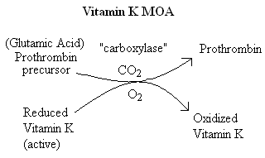

Warfarin Mechanism of Action
- Antagonism of Vitamin K
- Doesn’t stop vitamin K production, but inhibits ability of vitamin K to become activated
Warfarin: Indications
- Prophylaxis and/or treatment of:
- Venous thrombosis and its extension
- Pulmonary embolism
- Thromboembolic complications associated with AF and cardiac valve replacement
- Post MI, to reduce the risk of death, recurrent MI, and thromboembolic events such as stroke or systemic embolization
- Prevention and treatment of cardiac embolism
- if patient has ongoing atrial fibrillation, they need to be on warfarin for life

Warfarin: Major Adverse Effect—Hemorrhage
- Factors that may influence bleeding risk:
- Intensity of anticoagulation
- Concomitant clinical disorders
- Concomitant use of other medications
- Quality of management
- warfarin has a narrow therapeutic index

Special Considerations in the Elderly (>65 yo)—Bleeding
- Increased age associated with increased sensitivity at usual doses
- Comorbidity
- Increased drug interactions
- ? Increased bleeding risk independent of the above
- starting dose is usually 2.5 mg/day, not 5 mg
- patients with stroke in the past—try to keep low levels to prevent hemorrhagic stroke

Warfarin Dosing in Elderly Patients
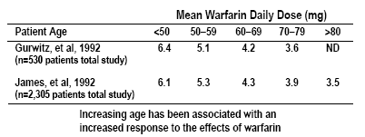

Prothrombin Time (PT)
- Historically, a most reliable and “relied upon” clinical test
- However:
- Proliferation of thromboplastin reagents (processing agents in the lab) with widely varying sensitivities to reduced levels of vitamin K-dependent clotting factors has occurred
- Concept of correct “intensity” of anticoagulant therapy has changed significantly (low intensity)
- Problem addressed by use of INR (International Normalized Ratio)
- measures II, VII, and X
- Thromboplastin reagents: sensitive to how well II, VII and X are reduced/inhibited by warfarin
- different ones are used—they vary from lab to lab—reason for INR

INR: International Normalized Ratio
- A mathematical “correction” (of the PT ratio) for differences in the sensitivity of thromboplastin reagents
- Relies upon “reference” thromboplastins with known sensitivity to antithrombotic effects of oral anticoagulants
- INR is the PT ratio one would have obtained if the “reference” thromboplastin had been used
- Allows for comparison of results between labs and standardizes reporting of the prothrombin time

INR Equation
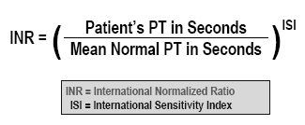

- mean normal PT: in any given lab, of any 50-100 patients not on warfarin with a normal PT
- ISI: assigns a number to the sensitivity of the thromboplastin reagent
- more sensitive: approaches 1

How Different Thromboplastins Influence the PT Ratio and INR
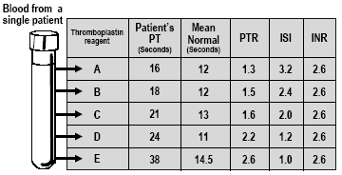

Relationship Between PT Ratio and INR
- there is a nomogram using PTR and ISI

Potential Problems with the INR

Limitations
- Unreliable during induction
- Loss of accuracy with high ISI thromboplastins
- Incorrect ISI assignment by manufacturer
- Incorrect calculation of INR due to failure to use proper mean normal plasma value to derive PT ratio

Solutions
- Use thromboplastin reagents with low ISI values (less than 1.5)
- Use thromboplastin reagents with low ISI values
- Use thromboplastin reagents with low ISI values and use plasma calibrants with certified INR values
- Use “mean normal” PT derived from normal plasma samples for every new batch of thromboplastin reagent
- starting to come out wit handheld PT monitors

Warfarin: Dosing Information
- Individualize dose according to patient response (as indicated by INR)
- Use of large loading dose not recommended
- May increase hemorrhagic complications
- Does not offer more rapid protection
- Low initiation doses are recommended for elderly/frail/liverdiseased/malnourished patients
- elderly: 2-2.5 mg/day; these patients are typically more sensitive
- liver-diseased: can’t make vitamin K dependent clotting factors as well
- malnourished: low albumin levels; warfarin is highly protein bound

Loading Dose and Maintenance Dose
- NEVER GIVE A LOADING DOSE OF WARFARIN
- Inhibition of Protein C can theoretically cause a transient thrombotic state
- Starting with a maintenance dose only avoids the rapid fall in factor VII and decreases chance of skin necrosis
- Same steady state level is achieved, but there is no large dip inVII, as with loading dose
- warfarin also immediately inhibits proteins C and S → Loading dose could actually lead to clotting problems

Conversion from Heparin to Warfarin
- May begin concomitantly with heparin therapy
- Heparin should be continued for a minimum of four days
- Time to peak antithrombotic effect of warfarin is delayed 96 hours (despite INR)
- When INR reaches desired therapeutic range, discontinue heparin (after a minimum of four days)
- usually wait until patient has 2 consecutive normal INR levels → discontinue heparin and send home
- INR should progress evenly (~0.2/day)
- Reason that immediate follow-up is so important

Warfarin: Dosing & Monitoring
- Start low
- Initiate 5 mg daily*
* Elderly, frail, liver disease, malnourished: 2 mg/day
- Educate patient
- Stabilize
- Titrate to appropriate INR (indication dictates the range)
- Monitor INR frequently (daily then weekly)
- Adjust as necessary
- Monitor INR regularly (every 1–4 weeks) and adjust
- at first, once every week for ~4 weeks, then once every 4 weeks

Relative Contraindications to Warfarin Therapy
- Pregnancy – Category X
- Situations where the risk of hemorrhage is greater than the potential clinical benefits of therapy
- recent history of peptic ulcer/GI bleed
- Uncontrolled alcohol/drug abuse
- EtOH increases iNR; liver will always metabolize EtOH before anything else
- Really binge drinking
- If patient is very consistent with EtOH intake, may still be able to monitor
- Unsupervised dementia/psychosis
- with no good caregiver

Signs of Warfarin Overdosage
- Any unusual bleeding:
- Blood in stools or urine
- type of blood is important: dark, tarry, sticky stools (“melena”
- Excessive menstrual bleeding
- Bruising – usually not a problem, unless it is unexplainable
- Excessive nose bleeds/bleeding gums
- Persistent oozing from superficial injuries
- Bleeding from tumor, ulcer, or other lesion

Managing Patients with High INR Values/Minor or No Bleeding (Vitamin K Guidelines)
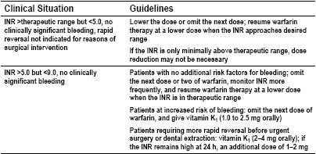
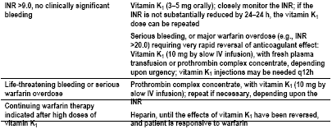
- >5.0 but < 9.0 with bleeding: vitamin K, 2.5 mg PO
- If INR is high at all—get a repeat lab
- “warfarin resistance”

Relationship Between INR and Efficacy/Safety
- Low-intensity treatment:
- Efficacy rapidly diminishes below INR 2.0*
* Effective below 2.5
- No efficacy below INR 1.5
- High-intensity treatment:
- Safety compromised above INR 4
- In studies, usually don’t show bleeding until INR > 5

Risk of Intracranial Hemorrhage in Outpatients
- Hylek, et al, studied the risk of intracranial hemorrhage in outpatients treated with warfarin. They determined that an intensity of anticoagulation expressed as a rothrombin time ratio (PTR) above 2.0 (roughly corresponding to an INR of 3.7 to 4.3) resulted in an increase in the risk of bleeding

Lowest Effective Intensity for Warfarin Therapy for Stroke Prevention in Atrial Fibrillation
- INR below 2.0 results in a higher risk of stroke

Warfarin: Current Indications/Intensity

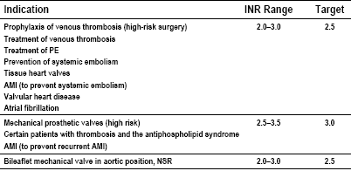
- tissue heart valves: 3-6 months, then ASA
- prevention of systemic embolism: 3-6 months, life if 2 or more
- Atrial fibrillation: for as long as they have AF
- Intermittent AF: chck AF yearly, try to remove warfarin if AF isn’t present
- bileaflet mechanical valve in aortic position is less thrombogenic than mitral valve
- Hint: remember when INR range isn’t 2-3

Mechanical Prosthetic Heart Valves
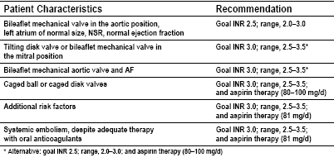

Examples of Low & High Risk Invasive Procedures & Clinical Conditions
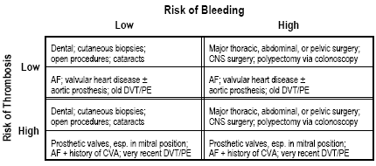

- Bridge therapy: using heparin around a procedure when a patient must be on warfarin
- Should not discontinue warfarin before going to DDS if they have valves, AF + CVA history, or recent DVT/PE

Management of Warfarin for Invasive Procedures
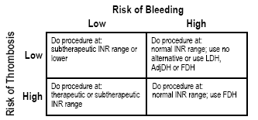

LDH = Low dose heparin
AdjDH = Adjusted dose heparin
FDH = Full dose heparin

Management of Warfarin During Invasive Procedures
- For subtherapeutic or normal INR: Hold warfarin for 3–5 days pre-procedure
- Low Dose Heparin (LDH): Low-dose heparin (5,000 IU SQ BID); hold warfarin 3–5 days pre-procedure and begin LDH therapy 1–2 days pre-procedure
- Adjusted Dose Heparin (AdjDH): Same as LDH but higher doses of heparin (between 8,000–10,000 IU BID or TID) to achieve an aPTT in upper range of normal or slightly higher midway between doses
- Full Dose Heparin (FDH): full doses of heparin, IV continuous infusion, to achieve a therapeutic aPTT (~1.5–2x control); implement as for LDH
- Restart heparin or warfarin post-op when considered safe to do so

Warfarin Dosing Schedule
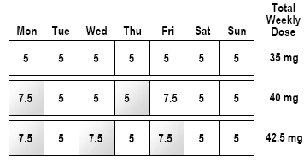
- increases: 5-15% (I think—was falling asleep)

Dosage Adjustment Algorithm
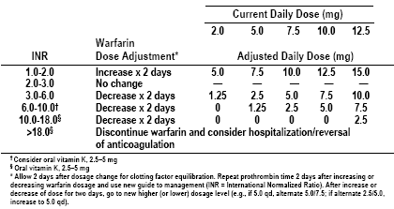

Drug Interactions with Warfarin: Potentiation
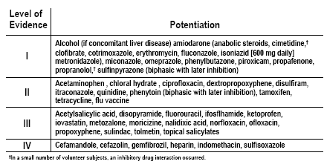
- APAP: high doses that affect liver
- amiodarone: long half-life; inhibit P450
- 2nd generation cephalosporins: usually suggest Keflex
- cimetidine and omeprzole don’t typically have an increased effect—they inhibit the r-isomer, the less active isomer of warfarin

Drug Interactions with Warfarin: Inhibition
- cause decreased INR
- inhibition of P450
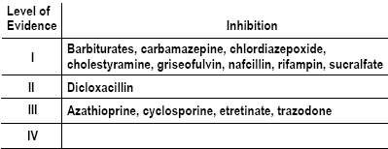

Drug Interactions with Warfarin: No Effect

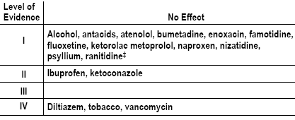

Effective Patient Education
- Teach basic concepts of safe, effective anticoagulation
- Discuss importance of regular INR monitoring
- Counsel on use of other medications, alcohol, vitamin K foods
- green leafy vegetables (spinach, cabbage, lettuce, broccoli)
- tell patient to be consistent with consumption
- Develop creative strategies for improving compliance

Factors Influencing Variability
- Patient / Disease State
- Process of Care (Education and Monitoring)
- Warfarin: drug with a narrow therapeutic index

Low Molecular Weight Heparins (LMWH)
- Advantages of LMWH
- Can be given in-patient and out-patient
- Can be given subcutaneously
- Monitoring is generally not necessary
- Appropriate to give if anticoagulation is needed during pregnancy or with warfarin failure (heparin is also not contraindicated in pregnancy)

LMWH Pharmacology
- Mean molecular weight of 4,000 to 5,000 daltons
- Excellent bioavailability and longer t ½ than UFH
- Less ability than UFH to inactivate thrombin but can inactivate factor Xa almost as well as UFH
- Result is fewer effects on the platelets
- Each drug has a different anti – Xa potency

LMWH Monitoring
- No effect on aPTT, so monitoring of anticoagulant effect can only be done by monitoring plasma anti-Xa
- Not routinely done, mostly in patients who have renal impairment or require treatment beyond 14 days
- Drawn 4 hours after injection
- Therapeutic range is 0.5 to 1.0 units/mL
- Baseline – PT/INR, aPTT, CBC (PLT), SCR
- Periodic monitoring of PLT, occult fecal blood
- Problem: cannot monitor well

Adverse Effects
- Bleeding
- Protamine sulfate – help reverse bleeding
- Thrombocytopenia
- Much lower than with heparin
- Osteoporosis
- Much lower than with heparin

Low Molecular Weight Heparins
- Enoxaparin sodium (Lovenox)
- Dalteparin (Fragmin)
- Tinzaparin (Innohep)
- Ardeparin (Normiflo)
- Nadroparin calcium (Fraxiparin)
- Reviparin (Clivarine)

FDA-Approved Indications for LMWH
(Px = prevention)
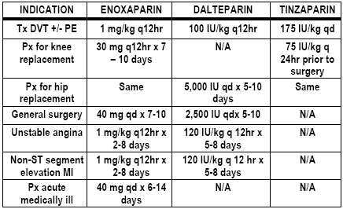

Other Agents for DVT/PE Prophylaxis
- Danaparoid - heparinoid
- FDA indication in 1996
- Similar in mechanism to heparin
- Alternative if patient experiences HIT
- Effects not reversed with protamine
- CI in children or those with sulfite allergies

- Dextran
- Impairs platelet function and decreases aggregation
- Disadvantages
- Not as effective
- Very expensive
- Must be given IV

Direct Thrombin Inhibitors
- Interact with and inhibit thrombin directly
- Can inhibit both circulating and clot-bound thrombin
- Will not cause immune-mediated thrombocytopenia
- Hirudin – prototype of this new class – derived from leech
- Adverse effects:
- Bleeding
- No known agent will reverse action of direct thrombin inhibitors

Direct Thrombin Inhibitors
- Lepirudin – irreversible inhibitor – management of HIT; IV
- Argatroban – management of HIT; IV
- Bivalirudin – with ASA for unstable angina or PCTA; IV
- Ximelgatran – BID dosing; oral dosing (60 mg BID)
- not studied in patients with mechanical valves

- Monitoring
- PT/INR, aPTT (range 1.5 – 3.0 x mean normal control), Ecarin clotting time
- none have turned out to be good methods of monitoring
- CBC at baseline and periodically after
- No known drug interactions
- Advantages
- less monitoring

Stroke

Overview
• Epidemiology
• Risk Factors and Pathophysiology
• Acute Treatment of Ischemic and Cardiogenic Stroke
• Secondary Prevention of Ischemic and Cardiogenic Stroke

Readings
• DePiro 5th Edition; Stroke 375 - 394
• Read pp. 375 - 385
• Study pp. 386- 391

• Concentrate on efficacy of agents for
treatment and prevention of stroke

Stroke
• Stroke refers to the sudden onset of a focal neurologic deficit. It is usually due to a
vascular pathological events which may impede or interrupt cerebral vascular blood
flow including:
• arteritis, aneurysm, hypertensive disease, vasconstriction, atherosclerosis, thrombosis,
emboli, ischemia, infarct, or hemorrhage
- these are all related and can complicate each other
- arteritis → stasis
- thrombus: stable
- emboli: moving (loose)
- often the only pain that really occurs is a terrible headache

Epidemiology
• Incidence of stroke
• Approximately 600,000 new strokes/yr (decreasing: awareness; better control)
• Males outnumber females—compliance issues
• Incidence doubles per decade over 55
• Most common in patients over 65

Morbidity and Mortality
• Third leading cause of death in U.S (What do you think are No. 1 and No. 2—CAD and cancer; both of these are risk factors for stroke)
• Leading cause of disability (costs of almost 40 billion dollars per year)
• Blacks/Hispanics > Caucasians (economic)

Risk Factors for Stroke--Non-treatable
• Age
• Gender (males)
• Race
• Heredity
• Obesity (if life long tendency)

Risk Factors for Stroke--Treatable
• Hypertension
• Cardiac Impairments - CAD, CHF, LVH, A. Fib.
- increase heart rate→blood pools → clots
• Transient Ischemic Attack (TIA)
- reduction in flow to arteries in brain
- only lasts a few minutes—often ignored
- RPh should refer patient with these symptoms to ER—increased number will have 1st stroke within a month
• Hyperlipidemia
• Smoking – lowers HDL; increases fibrogen
• Diabetes – bacterial plaques—break off or can deform valves

Multiple Risk Factors
• Framingham study determined 5 Risk Factors:
• Elevated systolic blood pressure (>140)
• Elevated serum cholesterol
• Glucose intolerance
• Cigarette smoking
• Left ventricular hypertrophy (LVH)
• These factors can be used to determine 10% of all patients who will have 1/3 of the all
strokes

Types of Stroke
• 85% of Ischemic Origin
• Atherosclerotic (hypoperfusion or emboli)
• Lacunar Infarcts –deep-seated in brain (circle of Willis)
• Cardiogenic emboli (a. fib., valvular thrombi and other c.v. events)—usually small → can go into brain
• Cryptogenic or unusual causes
• 15% Primary Hemorrhagic Origin
• Intraparechymal (intracerebral)
• Subarachnoid – concussion causing a bleed
Pathophysiology of Stroke Types
• The large majority of strokes result from inadequate blood flow (85%) while 15%
occur from intracranial hemorrhage
• Inadequate Blood Flow Types include:
• Atherosclerotic plaques
• Cerebral Ischemia
• Lacunar Infarcts
• Transient Ischemic Attacks (TIAs)

Patients at Highest Risk for Stroke
• Atrial Fibrillation – treat with amiodaone: doubles effect of warfarin
• Asymptomatic stenosis of carotid artery as evidenced by a cervical bruit – fluttering you can feel in carotid artery
• Amaurosis Fugax
• A TIA
• Previous stroke

Amaurosis Fugax
• Transient monocular blindness secondary to retinal ischemia
• Symptoms:
• Fog
• Scum
• Haze
• May also present as sparkles, shimmering, or bright lights

Atherosclerotic Plaques
• Arterial plaque formation which in turn promotes platelet aggregation
• Platelets aggregating within a narrowing vessel may lead to clot formation
• Clot may occlude vessel or may break off to become an emboli
• What is the origin of these atherosclerotic plaques?

Cerebral Ischemia
• Can be divided into focal or global
• Global Ischemia is associated with the lack of collateral blood flow. Irreversible brain
damage usually results within 4 - 8 minutes
- massive emboli break loose
• Focal Ischemia has a degree of collateral circulation associated with it and offers
hope of some reversal of neuronal damage after a period of ischemia
- collateral circulation: tissue extends other vessels that go around blockage

Lacunar Infarcts
• Strokes that occur in the small arteries that penetrate deep into the brain tissue
• When these strokes occur they leave small cavities or lacunae after necrotic tissue is
removed
• Major risk factor for this type of infarct is uncontrolled hypertension

• Process is one of lipohyalinosis of the arterial structure leading to occlusion
- lipohyalinosis: a waxy, greasy fluid ends up in arteries → blockage

Transient Ischemic Attacks
• Typically temporary focal cerebral dysfunction of vascular origin
• Onset is rapid
• Duration is variable, but lasts from a few seconds or minutes up to 24 hours
• TIAs have great significance in that they herald an impeding major stroke
• Cerebral or cerebellar artery thrombosis are most commonly responsible for TIAs

Cerebral Embolism
• Embolism may result from fragments of an arterial thrombus that have broken off or
from a heart valve vegetation
• Cerebral embolism secondary to thrombotic disease is usually rapid in onset and not
preceded by a TIA. Because it is rapid, collateral circulation has not usually developed and these strokes are usually functionally devastating

Cardiogenic Embolism
• Approximately 20% of all strokes of infarction are due to cardiogenic embolism
• Cardiogenic embolism has been associated with many types of heart disease:
* Atrial Fib. 50%
• CHD 20%
• Valvular HD 15%
• Prosthetic Valves 10%
• Infective Endocarditis 5%

Mechanism of Cerebral Embolism
• Fragment breaks off from thrombus or heart valve vegetation
• Circulates until too large to traverse arterial lumen
• Arterial occlusion occurs
• Rapid onset of infarct
• Usually not preceded by a TIA

Intracranial Hemorrhage
• Remember only accounts for 15% of strokes
• Either Intracerebral or Subarachnoid
• Pathophysiology:
• Underlying causes - arterial hypertension
• Leads to rupture of an artery
• Extravasation of blood into tissue
• Brain Damage
• Impaired function

Importance of Early Diagnosis of Stroke and Neural Deficits
• Rule out tumors

• Typically will see use of:
• CT Scan
• MRI
• EKG
• X-Rays
• Cerebral arteriography
• Lumbar puncture

Stroke – Therapeutic Interventions

An Ounce of Prevention is Worth a Ton of Cure
• Prevention of cerebrovascular disease is the most important aspect of therapeutic
management. Eliminate or reduce risk factors for stroke:
• Control Hypertension
• Control Hyperlipidemia
• Obesity - lose weight
• Eliminate smoking and alcohol use

Goals in Ischemic Cerebrovascular Disease
• Remove or limit blood vessel obstructions to flow
• Protect neural brain tissues beyond the circulatory obstructions from hypoxia
• Improving blood flow is possible with thrombolytics, however protection of brain
tissue from hypoxia is still in research

Thrombolytic Inclusion Criteria for Stroke
• Age 18 years or older
• Clinical diagnosis of ischemic stroke causing a measurable neurological deficit
• Time of symptom onset established to be less than 180 minutes before treatment
would begin
- this is what rules out most patients—they wait to long to go to ER
- MRI ordered by neurologist
- ~$2000/dose

Exclusion Criteria for Thrombolytic Stroke Therapy
• None of the following:
• Evidence of intracranial hemorrhage
- this is a side effect of thrombolytics
• Only minor or rapidly improving symptoms
• Clinical suspicion of subarachnoid bleed
• Active internal bleeding within 21 days
• Known bleeding diatheses
- condition that causes bleeding; e.g., hemophilia, bleeding ulcer, etc.
• Heparin administration with high APTT
• Use of anticoagulant with elevated PT/INR
• Brain surgery, head trauma, or stroke within the last 3 months

• Major surgery or trauma within 14 days
- especially orthopedic surgery because it generally immobilizes the patient—likely to throw a clot
• Recent arterial puncture at noncompressible site (trauma)
• Lumbar puncture within 7 days (e.g., withdrawal of CSF)
• Hx of intracranial hemorrhage, arteriovenous malformation, or aneurysm
• Witnessed seizure at stroke onset
• Recent acute myocardial infarction
• SBP>185 mm Hg or DBP > 110 Hg at time of treatment

Acute Treatment of Ischemic Stroke
• Thrombolytics -
• t-PA (Alteplase) tissue plasminogen activation
• rtPA (reteplase) - deletion mutant of tPA
• TNK-t-PA (tenecteplase) - single bolus deletion mutant of tPA
• SK (Streptokinase) not recommended increased mortality
• Urokinase: not recommended

Stroke t-PA Trial (NINDS)
• In text - only positive trial using IV thrombolytics (620 patients)
• IV t-PA 0.9 mg/kg (max 90 mg) vs placebo
• Treatment must begin within 3 hours of symptom onset
• No mortality difference between groups
• 33% increase in pts returning with minimal or no deficits at 3 months vs placebo

Dosing of t-PA
• 0.9 mg/kg (max 90)
• - 10% of total dose - bolus
• - infuse remainder over 1 hour
• Adverse effects
• Hemorrhage
• Cerebral Edema
• Hypersensitivity reaction
• Urticaria (hives)

Monitoring Patients following Thrombolytic Therapy
• Monitoring Parameters: Vital Signs, LOC, Motor Function, overall improvement in
symptoms
- LOC = loss of consciousness
- drop in blood pressure → indicative of internal bleeding
• Bleeding
•Monitoring Parameters listed above:
• q 15 min x 2 hrs
• q 30 min x 6 hrs
• q 1 hr x 24 hrs
• No anticoagulants or antiplatelet therapy for 24 hrs. following thrombolytic therapy for
stroke

Heparin Use in Stroke
• The use of heparin in a variety of trials (IST, Nadroparin, Toast Trial) have not shown significant benefit. It is still used with progressive stroke as an alternative to thrombolytics.
- e.g., in patient who doesn’t meet inclusion criteria
• Heparin has been used in treating cerebral embolism of cardiac origin

Secondary Prevention of Ischemia
• Antiplatelet Therapy including:
• - aspirin
• - Ticlopidine (Ticlid)
• - Clopidogrel (Plavix)
• - Dipyridamole (Persantine)

High Dose vs Low Dose Aspirin in Ischemic Stroke
• No definitive studies that demonstrate that one dosing regimen is better than the other
• Mini-dose 30 mg - 80 mg
• Low dose 165 - 325 mg
• High dose 650 - 1300 mg

ASA Mechanism of Action
• Aspirin inhibits platelet aggregation by irreversible inactivation of the enzyme
cycloxygenase. In platelets it prevents the conversion of arachidonic acid to
thromboxane A2 (TXA2).
• Higher doses of ASA also inhibit prostacyclin (PGI₂) activity in the smooth
muscle of the vascular wall and also inhibits platelet aggregation
• PGI₂ inhibits platelet aggregation → good

Ticlopidine (Ticlid)
• Ticlopidine inhibits the adenosine diphosphate pathway in platelet aggregation
• By blocking this pathway, fibrinogen can not bind to platelets which is a necessary
step in platelet aggregation
• May be used in pts who fail ASA therapy or who can not tolerate ASA
• Why it is not typically recommended over ASA
• Adverse effects include:
• thrombocytopenia
• neutropenia
• diarrhea
• cost
• Monitoring parameters:
• CBC q 2 weeks for 1st 3 months therapy
• Watch for s/s of bleeding
• LFT and alkaline phosphatase during 1st
• four months of therapy if known liver
• dysfunction exists or suspected

Clopidogrel (Plavix)
• Mechanism of action identical to ticlopidine
• Major advantages:
• Several times more potent that Ticlid
• Much higher safety profile than Ticlid
• CHEST guidelines recommend clopidogrel over ticlopidine in pts who can not tolerate ASA or who have failed ASA therapy
• guidelines are a standard of care

Dipyridamole (Persantine)
• Inhibits adenosine deaminase and phosphodiesterase which cause platelet aggregation
• Place in Stroke Therapy
• No benefit of dipyridamole alone vs ASA
• Dipyridamole+ASA has been shown to be more effective in reducing the number of strokes than either agent alone
• Dose at 200 mg BID
• At this juncture, recommend that it be used in combination with ASA
• Adverse effects
• Dizziness
• Hypotension/Hypertension/Tachycardia
• Abdominal Discomfort

Promising Interventions in Acute Stroke Treatment
• Merci Retrieval System
• Extraction Screw System for removing clots from occluded cranial arteries
• Awaiting FDA approval

