Circuit Analysis –number 1 (2 marzo 2006)
by Reinaldo Baretti Machín
www.geocities.com/serienumerica
www.geocities.com/reibaretti2004

e-mail: reibaretti2004@yahoo.com

Reference : Jimmie J Cathey and Syed A. Nasar, Basic Electrical Engineering, Schaum’s Outlines , page 92 (problem 6.10)

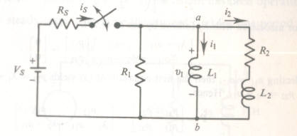
For the given circuit i1 and i2 are sought. Let i1=x1 , i2=x2
The governing ODE are

dx1/dt= vx1(i)= -(rs/(2.*L1))*(x1(i)+x2(i)-Vs/Rs)
dx2/dt= vx2(i)=(-.5*Rs/L2)*x1(i)-(.5*rs/L2 +R2/L2)*x2(i) +(.5/L2)*Vs
and the initial conditionas are i1=i2=0.

The code given below solves them by the finite difference method,
where

x1(n) = x1(n-1)+ dt* vx1(n-1)
x2(n) = x2(n-1)+ dt* vx2(n-1)

FORTRAN CODE
c Circuit analysis problem 6.10 basic EE Scahum' Outlines
c Cathey page 92
dimension x1(0:10000) , x2(0:10000)
real L1 , L2
data Vs,R1,R2, Rs , L1,L2/1.,2.,1.,2.,1.,2./
vx1(i)= -(rs/(2.*L1))*(x1(i)+x2(i)-Vs/Rs)
vx2(i)=(-.5*Rs/L2)*x1(i)-(.5*rs/L2 +R2/L2)*x2(i) +(.5/L2)*Vs
t1=Rs/l2
t2=r2/l2
t3=rs/l1
tscale=amin1(t1,t2,t3)
dt=tscale/20.
tf=3.5*amax1(t1,t2,t3)
nstep=int(tf/dt)
kount=int(float(nstep)/50.)
kprint=kount
x1(0)=0.
x2(0)=0.
print 100 ,0, x1(0),x2(0)
do 10 i=1,nstep
t=dt*float(i)
x1(i)=x1(i-1)+ dt*vx1(i-1)
x2(i)=x2(i-1)+ dt*vx2(i-1)
if(i-kount)10,17,17
17 kprint=kprint+kount
print 100,t , x1(i),x2(i)
10 continue
100 format(2x,'t,x1,x2=',3(3x,e11.4))
stop
end

