Coupled Circuits 17 oct. 2006
by Reinaldo Baretti Machín
www.geocities.com/serienumerica
e-amil : reibaretti2004@yahoo.com

Reference :
1. Applied mathematics for engineers and physicists by L. A. Pipes , page 174.

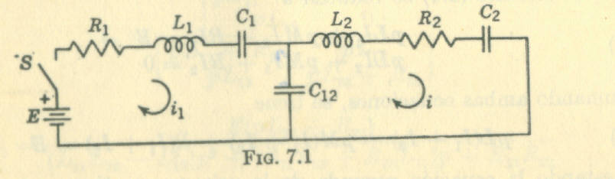

The Kirchoff equations are

L1 * d I1/dt + R1*I1 + q1/C1 + (q1-q2)/C12 = E

L2 * dI2/dt + R2*I2 +q2/C1 + (q2-q1)/C12 =0

The finite difference solution is

i1one=i1zero+(dt/L1)*a1(i1zero,q1zero,q2zero)
i2one=i2zero + (dt/L2)*a2(i2zero,q1zero,q2zero)
q1one=q1zero+dt*i1one
q2one=q2zero+dt*i2one

where a1(i1,q1,q2)= -r1*i1-q1/c1 -(q1-q2)/c12 + V
a2(i2,q1,q2) = -r2*i2-q2/c2 - (q2 -q1)/c12 .

c surge prob 9 oct 2006 resuelto por dif finitas
c the i0 , i1 represent values of the current on the LHS mesh
c the amp0,amp1 are values of the current on the RHS mesh
real L1,L2 ,i1zero,i1one,i2zero,i2one ,i1,i2
data c1,c2,c12,r1,r2,V/1.E-6,1.E-6,1.E-6,100.,100.,12./
a1(i1,q1,q2)= -r1*i1-q1/c1 -(q1-q2)/c12 + V
a2(i2,q1,q2) = -r2*i2-q2/c2 - (q2 -q1)/c12
l1=r1*(r1*c12)
L2=r2*(r2*c12)
t1= L1/r1
t2= sqrt(L1*c1)
t3= sqrt(L1*c12)
t4=L2/r2
t5=sqrt(L2*c2)
t6=sqrt(L2*c12)
tscale=amin1(t1,t2,t3,t4,t5,t6)
print*,'l1,l2,tscale=',l1,l2,tscale
c ADJUST FINAL TIME ACCORDING TO THE GRAPH YOU WANT TO PLOT COMPARE
c TFINAL with t1,t2,t3
tlarge=amax1(t1,t2,t3,t4,t5,t6)
timeratio=tlarge/tscale
tfinal=7.*tlarge
print*,'tscale,tlarge,timeratio,tfinal=',tscale,tlarge,timeratio,
$ tfinal
dt=tscale/100.
nstep=int(tfinal/dt)
i1zero=0.
i2zero=0.
q1zero=0.
q2zero=0.
print*,'dt,tscale,tfinal,nstep =', dt,tscale,tfinal,nstep
print*,' '
kp=int(float(nstep)/80.)
kount=kp
print 100,0., i1zero, i2zero
do 10 i=1,nstep
t=dt*float(i)
i1one=i1zero+(dt/L1)*a1(i1zero,q1zero,q2zero)
i2one=i2zero + (dt/L2)*a2(i2zero,q1zero,q2zero)
q1one=q1zero+dt*i1one
q2one=q2zero+dt*i2one
if(i.eq.kount)then
print 100 ,t, i1one, i2one
kount=kount+kp
endif
i1zero=i1one
i2zero=i2one
q1zero=q1one
q2zero=q2one
10 continue
100 format(1x,'t,i1,i2=',3(3x,e10.3))
stop
end

