Morse Potential- H₂ vibrational energy levels

by Reinaldo Baretti Machín
www.geocities.com/serienumerica
e-mail: reibaretti2004@yahoo.com

Reference:
1. Y.K. Syrkin , M. E. Dyatkina , The Structure of Molecules and the Chemical Bond, Dover Publications (1964), pages 147-151.

We calculate numerically the vibrational energy levels of H_{2.}

Schrodinger’s equation for the vibrational energy levels is

{ - (1/(2 m _{reduced} )) d² / dx ² + V(x) } Ψ = ε Ψ (1)

The equation is replaced with a finite difference equation in the Fortran code shown below.

m(reduced)= 918 (see below) and V(x) is the Morse potential

V(x) = d*(1.-exp(-beta*(x-xe)) )**2 (2)

We take
d=109.4 kcals beta =1. and xe= 0.74 A

Units and conversion factors

m₀ = 9.1e-31 kg , L = 0.529e-10 m

h(bar) = 1.05e-34j-s

ε₀ = h(bar)**2/( m₀ L**2) = 4.33e-18 J

1 kilocal/mol= 6.94E-21 J

ε₀ = 624 kcal

μ (reduced mass oh H2) =(1/2) ( m _{proton} / m₀ ) = 918

f ₀ (unit of frequency) =ε₀/ h = 4.33e-18 J/6.63E-34 = 6.53E15 hz

f(experimental ) = c/λ = (3E10 m/s)(4.405E5 /m) = 1.32E14hz

f(au) = 1.32E14hz /6.53E15 hz = 2.02E-2

E _{n} ≈ (n+1/2) f(au)
The ground state is approximately

E ₀ ≈ (0+1/2) f(au)=.5*2.02E-2=1.01E-2=6.30 kcal
as can be seen in figure 1.

Morse potential ,in kcal vs angstrom- Fig. 1.
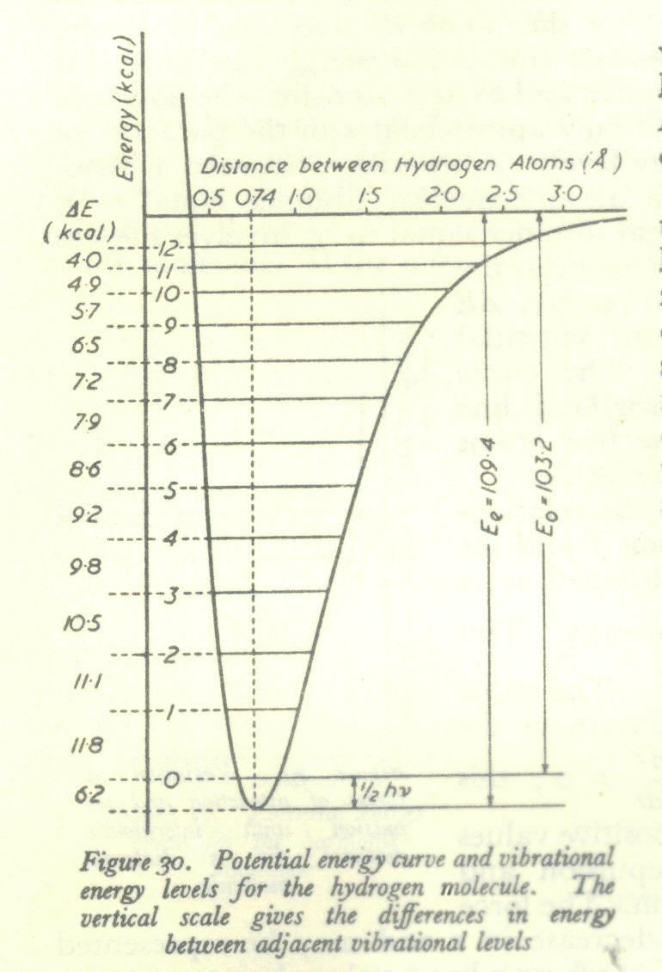

According to fig1, the first four levels have energies, reading from the bottom-up of 6.2 kcal , 18 kcal, 29.1 kcal and 39.6 kcal.

Ground state (n=0) ε = .958E-2 au= 6.03 kcal
e(au),e(kcal/mol), psinf= 0.9582E-02 0.6026E+01 0.1361E+03
e(au),e(kcal/mol), psinf= 0.9612E-02 0.6045E+01 -0.1846E+02

State (n=1) ε = 0.279E-1 = 17.5 kcal
e(au),e(kcal/mol), psinf= 0.2790E-01 0.1755E+02 -0.1152E+02
e(au),e(kcal/mol), psinf= 0.2799E-01 0.1760E+02 0.1831E+01

State (n=2) ε = 0.452E-1 = 28.5 kcal
e(au),e(kcal/mol), psinf= 0.4525E-01 0.2846E+02 0.9729E+00
e(au),e(kcal/mol), psinf= 0.4539E-01 0.2855E+02 -0.7330E+01

State n=3 ε = 0.614E-1 = 38.6 kcal
e(au),e(kcal/mol), psinf= 0.6139E-01 0.3861E+02 -0.5361E+00
e(au),e(kcal/mol), psinf= 0.6158E-01 0.3873E+02 0.5933E+00

FORTRAN CODE
c vibrational energy levels for the hydrogen molecule
dimension psi(0:10000) ,psinf(300),energy(300)
V(x) = d*(1.-exp(-beta*(x-xe)) )**2
g(x,i)=-2.*918.*(e- v(x))*psi(i)
d=109.4*1.59e-3
beta=1.
xe=0.74/(.529)
escale=1./(1.59E-3)
e0=18.*1.59e-3
print*,'e0=',e0
print*,' '
ei=.90*e0
ef= 1.2*e0
nstep=5000
niter=100
de=(ef-ei)/float(niter)
e=ei
do 20 it=1,niter
energy(it)=e
c xi and xf are the limits of integrations chosen by looking
c at the Morse curve and some trial and error
xi=0.35/.529
xf=1.4/.529
dx=(xf-xi)/float(nstep)
psi(0) =0.
psi(1)=psi(0)+dx
do 10 i=2,nstep
x=xi + dx*float(i)
psi(i)=dx**2*g(x-dx,i-1)+ 2.*psi(i-1)-psi(i-2)
c print*,'x,g,psi=',x , g(x-dx,i-1) , psi(i)
10 continue
psinf(it)=psi(nstep)
e=e+de
20 continue
do 100 i=1,niter
print 120,energy(i),energy(i)*escale,psinf(i)
100 continue
120 format(3x,'e(au),e(kcal/mol), psinf=',3(4x,e11.4))
c if(niter.eq.1)call plotwave(psi,x1,x2,dx,nstep,60)
stop
end

subroutine plotwave(psi,x1,x2,dx,nstep,ns)
dimension psi(0:10000)
print*,'x1,x2=',x1 , x2
print*,' '
do 10 i=0,nstep,ns
x=x1+dx*float(i)
print 100, x , psi(i)
10 continue
100 format(2x,'x,psi=',2(3x,e11.4))
return
end

