Schaum’s BEE problem 6.11
by Reinaldo Baretti Machín
www.geocities.com/serienumerica
e-mail: reibaretti2004@yahoo.com

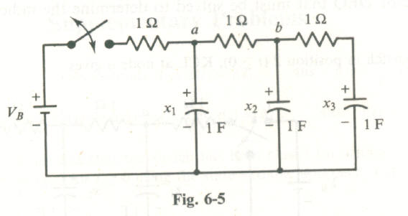

The switch is closed at t=0. Initial conditions are x1=0, x2=0,x3=0. The equations for the capacitor voltages are

dx1/dt= -2x1+x2+VB

dx2/dt= x1-2x2 + x3

dx3/dt=x2-x3

The analytical solutions are worked out in the above reference

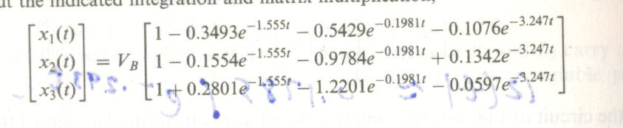
Fig 2.

We print below our numerical solution x1(num.) vs the analytical solution x1(t) given in fig 2.

c Schaum's Outlines BEE prob. 6.11
dimension x1(0:10000) , x2(0:10000), x3(0:10000)
v1exact(t)=VB*(1.-.349*exp(-1.555*t) -.5429*exp(-.1981*t)
$ -.1076*exp(-3.247*t) )
f1(i)=-2.*x1(i) + x2(i) +VB
f2(i)=x1(i)-2.*x2(i)+x3(i)
f3(i)=x2(i)-x3(i)
Vb=1.
tscale =1./2.
tfinal=5.*tscale
nstep =6000
dt=tfinal/float(nstep)
kount=30
x1(0)=0.
x2(0)=0.
x3(0)=0.
do 10 i=1,nstep
x1(i)=x1(i-1)+dt*f1(i-1)
x2(i)=x2(i-1)+dt*f2(i-1)
x3(i)=x3(i-1)+dt*f3(i-1)
10 continue
do 20 i=0,nstep,kount
t=dt*float(i)
print 100, t ,x1(i), v1exact(t)
c print 200, t ,x2,v2exact(t)
c print 300, t ,x3,v3exact(t)
20 continue
100 format(1x,'t,x1,v1exact=',3(3x,e11.4))
stop
end
t,x1,v1exact= 0.0000E+00 0.0000E+00 0.5000E-03
t,x1,v1exact= 0.1250E-01 0.1235E-01 0.1284E-01
t,x1,v1exact= 0.2500E-01 0.2440E-01 0.2488E-01
t,x1,v1exact= 0.3750E-01 0.3615E-01 0.3662E-01
t,x1,v1exact= 0.5000E-01 0.4762E-01 0.4808E-01
t,x1,v1exact= 0.6250E-01 0.5881E-01 0.5927E-01
t,x1,v1exact= 0.7500E-01 0.6973E-01 0.7018E-01
t,x1,v1exact= 0.8750E-01 0.8040E-01 0.8084E-01
t,x1,v1exact= 0.1000E+00 0.9081E-01 0.9124E-01
t,x1,v1exact= 0.1125E+00 0.1010E+00 0.1014E+00
t,x1,v1exact= 0.1250E+00 0.1109E+00 0.1113E+00
t,x1,v1exact= 0.1375E+00 0.1206E+00 0.1210E+00
t,x1,v1exact= 0.1500E+00 0.1301E+00 0.1305E+00
t,x1,v1exact= 0.1625E+00 0.1393E+00 0.1397E+00
t,x1,v1exact= 0.1750E+00 0.1484E+00 0.1488E+00
t,x1,v1exact= 0.1875E+00 0.1572E+00 0.1576E+00
t,x1,v1exact= 0.2000E+00 0.1659E+00 0.1663E+00
t,x1,v1exact= 0.2125E+00 0.1743E+00 0.1747E+00
t,x1,v1exact= 0.2250E+00 0.1826E+00 0.1830E+00
t,x1,v1exact= 0.2375E+00 0.1907E+00 0.1911E+00
t,x1,v1exact= 0.2500E+00 0.1986E+00 0.1990E+00
t,x1,v1exact= 0.2625E+00 0.2063E+00 0.2067E+00
t,x1,v1exact= 0.2750E+00 0.2139E+00 0.2143E+00
t,x1,v1exact= 0.2875E+00 0.2213E+00 0.2217E+00
t,x1,v1exact= 0.3000E+00 0.2286E+00 0.2289E+00
t,x1,v1exact= 0.3125E+00 0.2357E+00 0.2360E+00
t,x1,v1exact= 0.3250E+00 0.2426E+00 0.2430E+00
t,x1,v1exact= 0.3375E+00 0.2494E+00 0.2498E+00
t,x1,v1exact= 0.3500E+00 0.2561E+00 0.2564E+00
t,x1,v1exact= 0.3625E+00 0.2626E+00 0.2629E+00
t,x1,v1exact= 0.3750E+00 0.2690E+00 0.2693E+00
t,x1,v1exact= 0.3875E+00 0.2753E+00 0.2756E+00
t,x1,v1exact= 0.4000E+00 0.2814E+00 0.2817E+00
t,x1,v1exact= 0.4125E+00 0.2874E+00 0.2877E+00
t,x1,v1exact= 0.4250E+00 0.2933E+00 0.2936E+00
t,x1,v1exact= 0.4375E+00 0.2991E+00 0.2994E+00
t,x1,v1exact= 0.4500E+00 0.3048E+00 0.3051E+00
t,x1,v1exact= 0.4625E+00 0.3104E+00 0.3106E+00
t,x1,v1exact= 0.4750E+00 0.3158E+00 0.3161E+00
t,x1,v1exact= 0.4875E+00 0.3212E+00 0.3214E+00
t,x1,v1exact= 0.5000E+00 0.3264E+00 0.3267E+00
t,x1,v1exact= 0.5125E+00 0.3316E+00 0.3318E+00
t,x1,v1exact= 0.5250E+00 0.3366E+00 0.3369E+00
t,x1,v1exact= 0.5375E+00 0.3416E+00 0.3418E+00
t,x1,v1exact= 0.5500E+00 0.3464E+00 0.3467E+00
t,x1,v1exact= 0.5625E+00 0.3512E+00 0.3515E+00
t,x1,v1exact= 0.5750E+00 0.3559E+00 0.3562E+00
t,x1,v1exact= 0.5875E+00 0.3605E+00 0.3608E+00
t,x1,v1exact= 0.6000E+00 0.3650E+00 0.3653E+00
t,x1,v1exact= 0.6125E+00 0.3695E+00 0.3698E+00
t,x1,v1exact= 0.6250E+00 0.3739E+00 0.3741E+00
t,x1,v1exact= 0.6375E+00 0.3782E+00 0.3784E+00
t,x1,v1exact= 0.6500E+00 0.3824E+00 0.3826E+00
t,x1,v1exact= 0.6625E+00 0.3865E+00 0.3868E+00
t,x1,v1exact= 0.6750E+00 0.3906E+00 0.3909E+00
t,x1,v1exact= 0.6875E+00 0.3946E+00 0.3949E+00
t,x1,v1exact= 0.7000E+00 0.3985E+00 0.3988E+00
t,x1,v1exact= 0.7125E+00 0.4024E+00 0.4027E+00
t,x1,v1exact= 0.7250E+00 0.4062E+00 0.4065E+00
t,x1,v1exact= 0.7375E+00 0.4100E+00 0.4102E+00
t,x1,v1exact= 0.7500E+00 0.4137E+00 0.4139E+00
t,x1,v1exact= 0.7625E+00 0.4173E+00 0.4175E+00
t,x1,v1exact= 0.7750E+00 0.4209E+00 0.4211E+00
t,x1,v1exact= 0.7875E+00 0.4244E+00 0.4246E+00
t,x1,v1exact= 0.8000E+00 0.4278E+00 0.4281E+00
t,x1,v1exact= 0.8125E+00 0.4312E+00 0.4315E+00
t,x1,v1exact= 0.8250E+00 0.4346E+00 0.4348E+00
t,x1,v1exact= 0.8375E+00 0.4379E+00 0.4381E+00
t,x1,v1exact= 0.8500E+00 0.4411E+00 0.4414E+00
t,x1,v1exact= 0.8625E+00 0.4443E+00 0.4446E+00
t,x1,v1exact= 0.8750E+00 0.4475E+00 0.4477E+00

