Trajectory of a light ray in the Schwarschild Field
(a numerical integration)
by Reinaldo Baretti Machín

www.geocities.com/serienumerica2
www.geocities.com/serienumerica
reibaretti2004@yahoo.com

Reference :
1. Adler , Bazin and Schiffer, Introduction to General Relativity, pages 188-193

The equation of motion –in general relativity-for a particle of mass m in the presence of an attractor M is

d ²u/dφ² = - u + G M (m/I )² + 3(GM/c²) u ² (1)

If we let m=0 ,we obtain the equation of a particle with zero rest mass like for example a photon ,

d ²u/dφ² = - u + b u ² . (2)

With G =6.67E-11 Nm^2/kg^2 M= 1.99E30 kg ,c =3.00e8
the constant b= 3(GM/c²)= 4.40E3 meters.

Equation (2) will be solved using the finite difference method.
The initial conditions are ( see drawing)

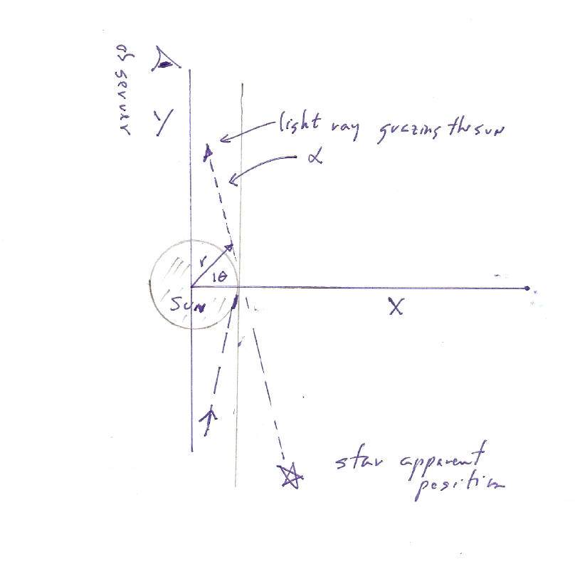

u₀ = 1/R _{sun} = (6.95E8 m) ⁻¹ = 1.44E-9 m⁻¹ (3)

( d u/dφ )₀ =0. . (4)
The order of magnitude of the deflection angle α ( in radians) is
≈ R_{Schwarzschild} / R_{sun} = 2GM/(c² R_{sun} )
= 4.24E-6 radians (5)

but 1 rad=(180.d0/pi)*(3.6D3)= 2.06E5 seconds of arc ,

hence the deflection is of the order of 0.873 seconds or twice this

1.75 seconds of arc.

theta(deg),x,y,alpha(sec)= 0.886E+02 0.695E+09 0.277E+11 0.864E+00

When θ reaches approximately 89 degrees , α = 0.864 sec of arc.
The total apparent deflection is twice that 1.728 sec of arc.

The two Taylor series employed are
u1=u0+dtheta*d1u0+.5d0*dtheta**2*d2(u0)+(1.d0/6.d0)*dtheta**3*
$d3(u0)
d1u=d1u0+dtheta*d2(u0)+.5d0*dtheta**2*d3(u0)
and the equtaion of motion is
d2(u)= -u + b*u**2.
Initial conditions are
u₀ = 1/R _{sun} = (6.95E8 m) ⁻¹ = 1.44E-9 m⁻¹

( d u/dφ )₀ =0.

FORTRAN CODE
c Einstein equation d^2u/dtheta^2 = -u + b u ^2 - 10 april 2006
c G =6.67E-11 Nm^2/kg^2 M= 1.99E30 kg ,rsun=6.95E8 m
c u = 1/r , c= 3.E8* sqrt(rsun/(G*m))
c r (sun)= 6.95D8 meters // the lightray travels along +Y axis,
c initial position is (x0,y0)=(rsun, 0.d0)
implicit real*8(a-h,o-z)
double precision m
data m, c, G, rsun/1.99D30, 3.D8, 6.67D-11, 6.95d8 /
d2(u)= -u + b*u**2
d3(u)=-d1u0 + 2.d0*b*u*d1u0
c initial conditions u0=1./r0 , du/dtheta =0.
pi=2.d0*dasin(1.d0)
conv=(180.d0/pi)*3.6D3
b=(3.d0*G*M)/(c**2)
r0=rsun
u0=1.d0/r0
c final angle thetaf ...almost pi/2.
thetaf= .99d0*(pi/2.d0)
nstep=10000
kp=int(dfloat(nstep)/70.d0)
kount=kp
dtheta=thetaf/dfloat(nstep)
rx=(1.d0/u0)*dcos(0.d0)
ry=(1.d0/u0)*dsin(0.d0)
d1u0=0.d0
print 100,0.d0,rx, ry,0.d0
c a third Order Taylor series is employed to obtain u( theta)
do 10 i=1,nstep
theta=dtheta*dfloat(i)
u1=u0+dtheta*d1u0+.5d0*dtheta**2*d2(u0)+(1.d0/6.d0)*dtheta**3*
$d3(u0)
d1u=d1u0+dtheta*d2(u0)+.5d0*dtheta**2*d3(u0)
if(i.eq.kount)then
rx=(1.d0/u1)*dcos(theta)
ry=(1.d0/u1)*dsin(theta)
alpha=(rsun-rx)/ry
kount= kount + kp
c print*,'rs,rx,ry=',rsun,rx,ry
print 100,theta*180.d0/pi, rx, ry, alpha*conv
endif
u0=u1
d1u0=d1u
10 continue
100 format('theta(deg),x,y,alpha(sec)=',4(3x,d10.3))
stop
end

