Duffing Equation
by Reinaldo Baretti Machín
www.geocities.com/serienumerica2
www.geocities.com/serienumerica
reibaretti2004@yahoo.com

Reference:
1. Introduction to Nonlinear Differential and Integral Equations by Harold T. Davis , page 180.

The Duffing equation represents a forced oscillator with a non linear ( cubic term )

m d² x/dt² = -k x – delta*( dx/dt) –beta* x³ + F cos( ω t) . (1)

We investigate through numerical integration the effect of varying beta.An increase in beta means an added attraction force which will decrease the amplitude of the transient state oscillations.

There are three time scales in the problem coming from the parameters mass,
k (spring force constant) ,delta (damping term) and beta. They are

tscale(1)=sqrt(mass/kspring) ; tscale(2)=mass/delta; (2)
tscale(3)=1/omega;

∆t , the integration interval, must be less than the smallest time scale.

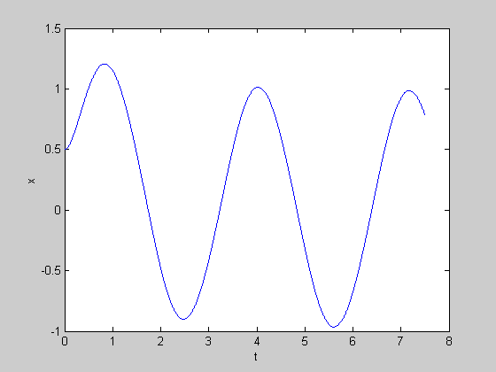
Example #1
mass=1; delta=5; kspring=1; beta=1; f=10; omega=2*sqrt(kspring/mass);
x(1)=.5 ; x(2)=x(1) ; v(1)=0; v(2)=0;
beta =1

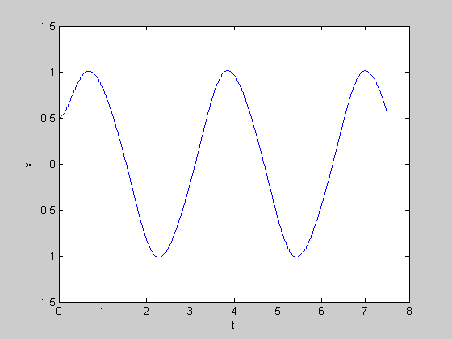
Example #2
mass=1; delta=5; kspring=1; beta=5; f=10; omega=2*sqrt(kspring/mass);
x(1)=.5 ; x(2)=x(1) ; v(1)=0; v(2)=0;
beta=5

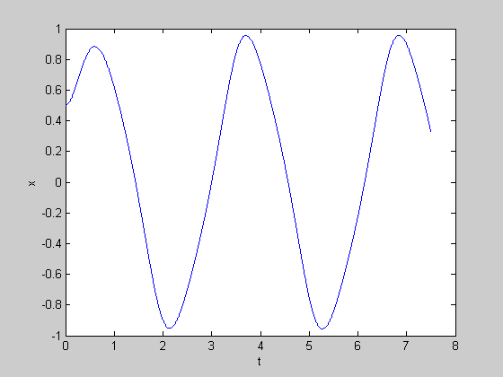
Example 3
beta = 10

MATLAB CODE

% ax(x0,x1,t)= (1./mass)*(-delta*(x1-x0)/dt -k*x1-beta*x1**3+
% f*cos(omega*t) )
mass=1; delta=5; kspring=1; beta=1; f=10; omega=2*sqrt(kspring/mass);
x(1)=.5 ; x(2)=x(1) ; v(1)=0; v(2)=0;
tscale(1)=sqrt(mass/kspring) ; tscale(2)=mass/delta;
tscale(3)=1/omega;
tf=15*tscale(3); dt=tf/4000;

k=1 ;
for t=[2*dt:dt:tf];
k=k+1;
ax= (1./mass)*(-delta*(x(k)-x(k-1))/dt -kspring*x(k)-beta*x(k).^3);
ax=ax+(1./mass)*f*cos(omega*(t-dt));
x(k+1)=2*x(k)-x(k-1)+(dt^2)*ax ;
%x(k+1)=f*cos(omega*(t-dt));
v(k+1)=(x(k+1)-x(k))/dt ;
end

t=[0:dt:tf];
plot(t,x),xlabel('t'),ylabel('x')
%plot(x,v) , xlabel('x'), ylabel('v')

