Power at the load using Complex Fortran
by Reinaldo Baretti Machín , Alfonso Baretti Huertas

www.geocities.com/serienumerica2
www.geocities.com/serienumerica
reibaretti2004@yahoo.com

The power at the load RL =100ohms on the diagram is sought.
In another page (http://www.geocities.com/serienumerica2/Averagepoweroct6.doc
)
we applied the finite difference method to solve two coupled differential equations for the currents I1 and I2.
The results,I1,I2 and I2**2*Rload , are plotted and the FORTRAN code employed is given.

In complex notation the results follow simply from the equations,

zpar=1./(1./z1+1./z2)
zt=r1+zpar
I=v/zt
i1=(v-I*r1)/z1
i2=I-I1
pload=i2**2*rload

In the example worked below C=3e-3 F , the inductance L= 0.2H , and the two resistance are R=20ohms , Rload =100 ohms.
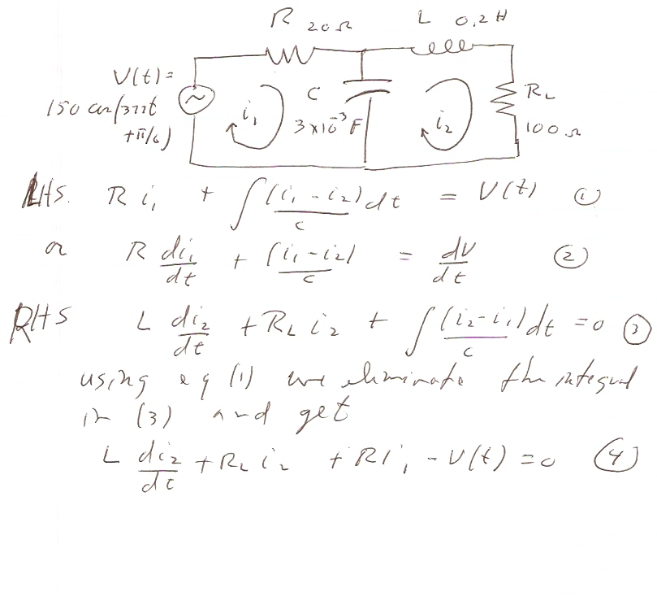

abs(i), anglei= 7.49074125 2.5413928

abs(i1), anglei1= 7.52259398 2.86566758

abs(i2), anglei2= 0.0530997179 55.8432732

abs(pload),Real(pload), aimag(pload),angle= 0.281958014 -0.104191564
0.262000829 -68.313446

c example power at the load ...
real L
complex V , I , I1, I2 , z1 , z2, zpar, zt ,Pload
data r1,rload,c,L, omega/ 20.,100.,3.e-3, 0.2,377./
pi=2.*asin(1.)
rtodeg=180./pi
degtor=1./rtodeg
v=cmplx(150.,0.*degtor)
z1=cmplx(0.,-1./(omega*c))
z2=cmplx(rload,omega*L)
zpar=1./(1./z1+1./z2)
zt=r1+zpar
I=v/zt
i1=(v-I*r1)/z1
i2=I-I1
pload=i2**2*rload
print*,'abs(i), anglei=',abs(i),rtodeg*atan(aimag(i)/real(i))
print*,' '
print*,'abs(i1), anglei1=',abs(i1),
$ rtodeg*atan(aimag(i1)/real(i1))
print*,' '
print*,'abs(i2), anglei2=',abs(i2),
$ rtodeg*atan(aimag(i2)/real(i2))
print*,' '
print*,'abs(pload),Rael(pload), aimag(pload),angle=',abs(pload),
$real(pload),aimag(pload),
$ rtodeg*atan(aimag(pload)/real(pload))
stop
end

