Schaum’s Basic Electrical Engineering , problem 3.8
by Reinaldo Baretti Machín , Alfonso Baretti Huertas
www.geocities.com/serienumerica2
www.geocities.com/serienumerica
reibaretti2004@yahoo.com

Reference:
1.Basic Electrical Engineering, Jimmy Cathey , Syed Nasar, Schaum’ Outlines , prob 3.8 .

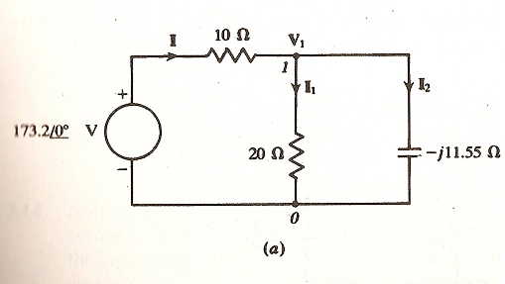

The following problem from steady state analysis is solved using FORTRAN complex number code (given below).

Let r1=10 ohm , r2=20 ohms
The total impedance is
Z_{t} = r1 + Z_{p} where

Z_{p} = ( 1/r2+1/Z_{c} )⁻¹ , Z_{c} = -11.55 j (ohms).

I = V / Z_{t} , I1=(V-I*r1)/r2 , I2= I- I1 .The Fortran code transcribes this formulation exactly as it is written.

FORTRAN CODE
c example 3.8 Schaum BEE using Fortran complex numbers code
complex V , I , I1, I2 , zc , zp , zt
data r1,r2/ 10.,20./
pi=2.*asin(1.)
rtodeg=180./pi
degtor=1./rtodeg
v=cmplx(173.2,0.*degtor)
zc=cmplx(0.,-11.55)
zp= R2*zc/(r2+zc)
zt=r1+zp
I=v/zt
i1=(v-I*r1)/r2
i2=I-I1
print*,'abs(i), anglei=',abs(i),rtodeg*atan(aimag(i)/real(i))
print*,' '
print*,'abs(i1), anglei1=',abs(i1),
$ rtodeg*atan(aimag(i1)/real(i1))
print*,' '
print*,'abs(i2), anglei2=',abs(i2),
$ rtodeg*atan(aimag(i2)/real(i2))
stop
end

ANSWERS
abs(i), anglei= 9.99841022 29.9999962

abs(i1), anglei1= 5.00017738 -29.9935646

abs(i2), anglei2= 8.65831566 60.006424

