Reflection by a potential barrier
by Reinaldo Baretti Machín
www.geocities.com/serienumerica
www.geocities.com/serienumerica2
reibaretti2004@yahoo.com

References:
1.Fundamentals of Modern Physics by Robert Martin Eisberg , Chapter 8
2. Quantum Mechanics: Non-Relativistic Theory, Volume 3, (Quantum Mechanics) by L. D. Landau and L. M. Lifshitz

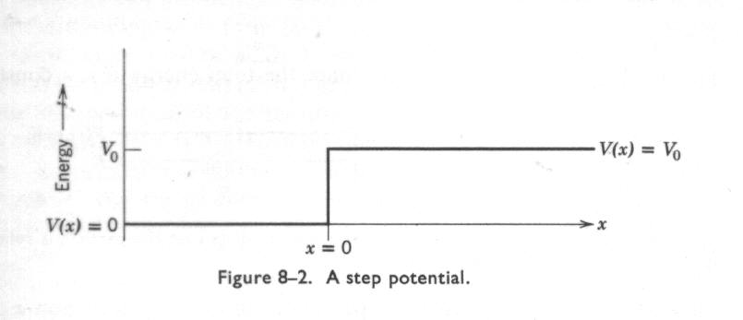

A standard problem in quantum mechanics is that of the step potential. A flux of particles is incident from the left( x<0) and are reflected when the energy E < V₀ . However there is some wave penetration into the classically forbidden region (x>0).
The analytical solution consists in postulating the nature of the “wave ” in the two regions and by matching conditions at the boundary ψ _{I}( 0) ( 0) = ψ _{II}( 0) and

( d ψ _{I} /dx )₀ = (d ψ _{II} /dx ) ₀ the coefficients are found.
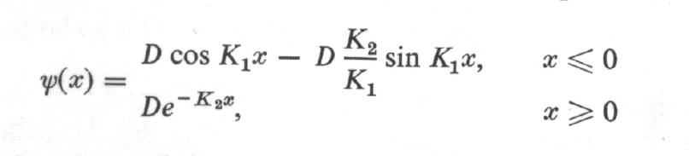

Our approach here is numerical.
Let the solution on the left be ( a standing wave)

ψ( x) = cos (k₁ x) - coef * sin(k₁ x ) (1)

The coef factor is a an unknown. The value of coef must be between 0 and 1.

At x = x_{i} (xinitial) ,

ψ( x_{initial})= cos (k₁ x_{i}) - coef * sin(k₁ x_{i} ) (2)
and
ψ( x_{initial} + dx )= cos (k₁ (x_{i}+dx)) - coef * sin(k₁ (x_{i} +dx)) (3)

We integrate numerically the Schrodinger equation from x_{initial} into the region x<0 , up to a large x value ,using the finite difference expression

psi2=2.*psi1-psi0+dx**2*(-2.*(energy-V(x-dx))*psi1). (4)

Only one solution will satisfy the condition
ψ( x _{large}) ≈0. (5)

The corresponding coefficient is the right one.
A table is given below showing the asymptotic value of ψ and the corresponding coefficient along with correct value of (k2/k1).

k2/k1,coef,psifin= 0.655E+00 0.620E+00 0.391E+00
k2/k1,coef,psifin= 0.655E+00 0.638E+00 0.204E+00
k2/k1,coef,psifin= 0.655E+00 0.655E+00 0.620E-01
k2/k1,coef,psifin= 0.655E+00 0.673E+00 -0.391E-01
k2/k1,coef,psifin= 0.655E+00 0.690E+00 -0.170E+00

Fortran Code
c potential barrier Eisberg eq 8-34
real k1,k2
dimension psifin(200),coef(200)
energy=.7
k1=sqrt(2.*energy)
k2=sqrt(2.*(1.-energy))
xi=-5.
xf=3.
nstep=5000
kp=int(float(nstep)/60.)
kount=kp
dx=(xf-xi)/float(nstep)
reflcoef=.75*(k2/k1)
print*,'k2/k1,reflcoef=',k2/k1 ,reflcoef
print*,' '
niter=40
coeff=.9
coefi=.2
dc=(coeff-coefi)/float(niter)
reflcoef=coefi
do 20 it=1,niter
c psi0=cos(k1*xi)-(k2/k1)*sin(k1*xi)
psi0=cos(k1*xi)-reflcoef*sin(k1*xi)
c psi1=cos(k1*(xi+dx))-(k2/k1)*sin(k1*(xi+dx))
psi1=cos(k1*(xi+dx))-reflcoef*sin(k1*(xi+dx))
c print 100,xi,psi0
do 10 i=2,nstep
x=xi+dx*float(i)
if(x.lt.0.)then
psi2=2.*psi1-psi0+dx**2*(-2.*energy*psi1)
endif
if(x.ge.0.)then
psi2=2.*psi1-psi0+dx**2*(-2.*(energy-V(x-dx))*psi1)
endif
psi0=psi1
psi1=psi2
if(i.eq.kount)then
c print 100,x,psi2
kount=kount+kp
endif
10 continue
coef(it)=reflcoef
psifin(it)=psi2
reflcoef=reflcoef+dc
20 continue
do 30 i=1,niter
print 110 ,k2/k1,coef(i),psifin(i)
30 continue
110 format(1x,'k2/k1,coef,psifin=',3(4x,e10.3))
100 format(1x,' x,psi=',2(4x,e10.3))
stop
end

function v(x)
if(x.lt.0.)v=0.
if(x.ge.0.)v=1.
return
end

k2/k1,coef,psifin= 0.655E+00 0.200E+00 0.359E+01
k2/k1,coef,psifin= 0.655E+00 0.218E+00 0.344E+01
k2/k1,coef,psifin= 0.655E+00 0.235E+00 0.330E+01
k2/k1,coef,psifin= 0.655E+00 0.252E+00 0.319E+01
k2/k1,coef,psifin= 0.655E+00 0.270E+00 0.306E+01
k2/k1,coef,psifin= 0.655E+00 0.288E+00 0.294E+01
k2/k1,coef,psifin= 0.655E+00 0.305E+00 0.284E+01
k2/k1,coef,psifin= 0.655E+00 0.323E+00 0.265E+01
k2/k1,coef,psifin= 0.655E+00 0.340E+00 0.249E+01
k2/k1,coef,psifin= 0.655E+00 0.358E+00 0.237E+01
k2/k1,coef,psifin= 0.655E+00 0.375E+00 0.224E+01
k2/k1,coef,psifin= 0.655E+00 0.393E+00 0.214E+01
k2/k1,coef,psifin= 0.655E+00 0.410E+00 0.204E+01
k2/k1,coef,psifin= 0.655E+00 0.428E+00 0.182E+01
k2/k1,coef,psifin= 0.655E+00 0.445E+00 0.169E+01
k2/k1,coef,psifin= 0.655E+00 0.463E+00 0.156E+01
k2/k1,coef,psifin= 0.655E+00 0.480E+00 0.148E+01
k2/k1,coef,psifin= 0.655E+00 0.498E+00 0.130E+01
k2/k1,coef,psifin= 0.655E+00 0.515E+00 0.114E+01
k2/k1,coef,psifin= 0.655E+00 0.533E+00 0.102E+01
k2/k1,coef,psifin= 0.655E+00 0.550E+00 0.919E+00
k2/k1,coef,psifin= 0.655E+00 0.568E+00 0.763E+00
k2/k1,coef,psifin= 0.655E+00 0.585E+00 0.599E+00
k2/k1,coef,psifin= 0.655E+00 0.603E+00 0.485E+00
k2/k1,coef,psifin= 0.655E+00 0.620E+00 0.391E+00
k2/k1,coef,psifin= 0.655E+00 0.638E+00 0.204E+00
k2/k1,coef,psifin= 0.655E+00 0.655E+00 0.620E-01
k2/k1,coef,psifin= 0.655E+00 0.673E+00 -0.391E-01
k2/k1,coef,psifin= 0.655E+00 0.690E+00 -0.170E+00
k2/k1,coef,psifin= 0.655E+00 0.707E+00 -0.347E+00
k2/k1,coef,psifin= 0.655E+00 0.725E+00 -0.458E+00
k2/k1,coef,psifin= 0.655E+00 0.742E+00 -0.542E+00
k2/k1,coef,psifin= 0.655E+00 0.760E+00 -0.751E+00
k2/k1,coef,psifin= 0.655E+00 0.777E+00 -0.871E+00
k2/k1,coef,psifin= 0.655E+00 0.795E+00 -0.955E+00
k2/k1,coef,psifin= 0.655E+00 0.812E+00 -0.116E+01
k2/k1,coef,psifin= 0.655E+00 0.830E+00 -0.128E+01
k2/k1,coef,psifin= 0.655E+00 0.847E+00 -0.136E+01
k2/k1,coef,psifin= 0.655E+00 0.865E+00 -0.156E+01
k2/k1,coef,psifin= 0.655E+00 0.882E+00 -0.168E+01

