Klein Gordon equation : an exact numerical solution (Part 1)

by Reinaldo Baretti Machín
www.geocities.com/serienumerica3
www.geocities.com/serienumerica2
www.geocities.com/serienumerica

reibaretti2004@yahoo.com

References:
- The Klein Gordon equation
http://people.umass.edu/phys811/sixcomp.pdf

- http://en.wikipedia.org/wiki/Klein-Gordon_equation
- Modern Quantum Mechanics (Revised Edition) by J. J. Sakurai
- Relativistic Quantum Mechanics by James D Bjorken and Sidney D. Drell
- Relativistic Quantum Theory (Course of Theoretical Physics) by L.D. Landau and E.M. Lifshits

( A numerical mehod is used to solve the KG equation.The FORTRAN code is given below.)

The Klein Gordon equation is the tool to explore pionic atoms.

Understandably relativistic quantum mechanic has to resort to
approximations to obtain analytic expressions for the energy.

The energy levels for a particle of mass m in a central potential
V(r) = –Z/r are given approximately by (Ref. 1.)

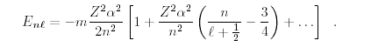 (1)

The energy is a function of the principal quantum number n and the orbital quantum number ,“small L”.

Other facts that must be taken into account for pionic atoms
are (ref. 1)
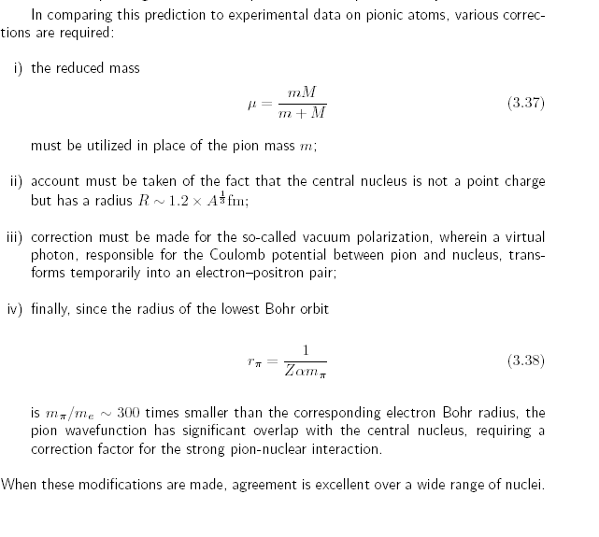

We take the Klein Gordon equation to be

( p² c² + c⁴ ) Ψ = ( E – V(r ) )² Ψ (2)

where p² is the Laplacian operator.

Let the angular momentum be zero , l=0.

Eq(2) gives the differential equation

-[ ∂² /∂r² + (2/r) ∂/∂r] Ψ = { - c² + ( E- V)² /c² } Ψ

≡ g(r) Ψ . (3)

Eq (3) is solved by the finite difference method. The solution is

Ψ_{i} = 2 Ψ_{i-1} - Ψ_{i-2} - (∆r)² { (2/r_{i-1})( Ψ_{i-1} - Ψ_{i-2} )/ ∆r + g(r_{i}) Ψ_{i-1} } . (4)

We employ the initial conditions, Ψ(0)=1. , (∂ Ψ/∂r)_{r=0} =-1 .

As a first test let the atomic number be Z=20.

We compare the numerical result with that of formula (1).

The energies of the Bohr , Klein Gordon and Dirac equations are listed for comparison.
z,ebohr,edkg,edir= 20. -200. -205.325135 -201.076523

According to eq(1) the energy is
E= -205.325135 au

We obtain an energy of about -0.205200E+03 .

e,phifinal= -0.205400E+03 0.313489E+00
e,phifinal= -0.205333E+03 0.223713E+00
e,phifinal= -0.205267E+03 0.133685E+00
e,phifinal= -0.205200E+03 0.434041E-01
e,phifinal= = -0.205200E+03 -0.471304E-01
e,phifinal= -0.205067E+03 -0.137919E+00
e,phifinal= -0.205000E+03 -0.228963E+00
e,phifinal= -0.204933E+03 -0.320262E+00
e,phifinal= -0.204867E+03 -0.411817E+00

FORTRAN code
c numerical determination of the energy and eigenfunction for the
c Klein Gordon equation
implicit real*8(a-h,o-z)
real*8 nprime,nprinc
data z , nprinc,al,ajtotal, niter, nstep /20.d0,1.d0, 0.d0,.5d0
$ ,30 ,9990/
data c /137.035999679d0 /
dimension phi(0:10000)
ebohr(z,nprinc)= -.5d0*(Z/nprinc)**2
den(z)=( nprime+dsqrt( (ajtotal+.5d0)**2- (z/c)**2 ) )**2
edirac(z)=-c**2 + c**2/dsqrt(1.d0 + (Z/c)**2/den(z) )
ekg(z,nprinc)=ebohr(z,nprinc)*( 1.d0 +(z/(nprinc*c))**2*(
$nprinc/(al+.5d0) -.75d0 ) )
c g(r)= -c**2 + ((E-v(r))/c)**2
pi=2.d0*dasin(1.d0)
nprime=nprinc-(ajtotal+.5d0)
c enri=-1.06d0*z**2/2.d0
enri=-206.d0
c enrf=-.999d0*z**2/2.d0
enrf=-204.d0
denr=(enrf-enri)/dfloat(niter)
kp=int(float(nstep)/60.)
enr=enri
E=enr+c**2
print*,'z,ebohr,edkg,edir=',z,ebohr(z,nprinc) ,ekg(z,nprinc),
$ edirac(z)
print*,' '
do 20 it=1,niter
c ri , rf limits of integration
rf= 6.5d0*(-z/enr)
ri=0.d0
dr=(rf-ri)/dfloat(nstep)
kount=kp
phi(0)=1.d0
phi(1)=phi(0) -dr
if(niter.eq.1) print 150, ri ,phi(0),0.d0
do 10 i =2,nstep
r=ri+dr*dfloat(i)
phi(i)=2.d0*phi(i-1)-phi(i-2) -dr**2*( (2.d0/(r-dr))*
$ (phi(i-1)-phi(i-2))/dr +g(r-dr,z,c,e)*phi(i-1) )
c print*,'dphi, d4phi=',dphi, d4phi
if(niter.eq.1)then
if(i.eq.kount)then
print 150, r , phi(i)
kount=kount+kp
endif
endif
10 continue
print 100, enr , phi(nstep)
enr=enr+denr
e=enr+c**2
20 continue
print*,' '
if(niter.eq.1)call norm(phi,dr,nstep)
c if(niter.eq.1)call plotphi(phi,ri,dr,nstep,kp)
100 format('e,phifinal=',4(3x,d13.6))
150 format(1x,'x,phi(i)=',2(3x,d13.6))
stop
end

function g(r,z,c,e)
implicit real*8(a-h,o-z)
v(r)=-z/r
g= -c**2 + ((E-v(r))/c)**2
return
end

subroutine norm(phi,dr,nstep)
implicit real*8(a-h,o-z)
dimension phi(0:10000)
sum=0.d0
do 10 i=1,nstep
sum=sum+(dr/2.d0)*(phi(i)**2 +phi(i-1)**2)
10 continue
anorm=1.d0/sqrt(sum)
do 20 i=0,nstep
phi(i)=anorm*phi(i)
20 continue
return
end

subroutine plotphi(phi,ri,dr,nstep,kp)
implicit real*8(a-h,o-z)
dimension phi(0:10000)
print*,' '
print*,'phi plot'
do 10 i=0,nstep,kp
r=ri+dr*dfloat(i)
print 100, r, phi(i)
10 continue
100 format(1x,'x, phi =',2(4x,d10.3))
print 100, r, phi(nstep)
return
end

