Pionic p- states in ²⁰⁷ Pb

by Reinaldo Baretti Machín
www.geocities.com/serienumerica3
www.geocities.com/serienumerica2
www.geocities.com/serienumerica

reibaretti2004@yahoo.com

References:

1. Mesic Atoms and Mesic Nuclei http://www.rcnp.osaka-u.ac.jp/~chiral07/files/16am/chiral07_hirenzaki.pdf

2. http://en.wikipedia.org/wiki/Woods_Saxon_potential

3. Klein Gordon equation: an exact numerical solution (Part 2)

4. Klein Gordon equation: an exact numerical solution (Part 1)
5. http://hyperphysics.phy-astr.gsu.edu/hbase/nuclear/shell.html#c3

We will use the Klein Gordon (KG) equation for the pionic atom ,with a single negative π – ,to calculate the energies and wave functions of the first two p levels. The s- levels have been treated in Ref 6.

The Klein-Gordon equation to find the energy levels of nucleons subjected to the Woods Saxon potential cannot be solved analytically, and must be treated numerically.

The net nuclear potential will include an approximation to the optical potential plus the Coulomb potential of the nuclei of finite size.

-[ ∂² /∂r² + (2/r) ∂/∂r - l (l+1)/r²] Ψ = { - c² + ( E- V)² /c² } Ψ

≡ g(r) Ψ (1)

with the total potential V(r) = V_{optical} (r) + V_{C}(r).

In nuclear physics the Woods Saxon potential is a mean field potential for the nucleons (protons and neutrons) inside the atomic nucleus, which is used to approximately describe the forces applied on each nucleon, in the shell model for the structure of the nucleus.

We redefine the use of the Woods Saxon potential. Let the absolute value of the Woods Saxon potential represent the nucleons repulsion of the pion.
Then

V_{optical} (r) = V₀ / [ 1 + exp( (r-R)/a ) ]

a is some length , R the nuclear radius , V₀ = 50 MeV
We employ typical values for the parameters.

a= 0.5 fm = au , R= r₀ A^{1/3} =(1.25E-15 meters) A^{1/3} ,

where A is the atomic mass number.

The Coulomb potential is taken to be

V_{C}(r) = -(Z/R) { 1 +(1/2) ( 1- (r/R)² ) } , r ≤ R

V_{C}(r) = - Z/r , r > R .

Equation (1) is solved buy the finite difference method and the asymptotic iteration procedure. A Fortran code is provided below.
Figure 1. shows the potentials
Figure 1.
For L = 1 , the initial conditions are Ψ (0) =0 , (dΨ /dr)_{r=0} = +1.

Energies :
2p state , E2p ≈ - 4.52 Mev
e,e(ev),phifinal= -0.610284E+03 -0.455000E+07 0.306362E+03
e,e(ev),phifinal= -0.603578E+03 -0.450000E+07 -0.251626E+03

3p state , E3p ≈ -2.202 Mev
e,e(ev),phifinal= -0.293741E+03 -0.219000E+07 0.860438E+05
e,e(ev),phifinal= -0.294412E+03 -0.219500E+07 0.464671E+05
e,e(ev),phifinal= -0.295083E+03 -0.220000E+07 0.862124E+04
e,e(ev),phifinal= -0.295753E+03 -0.220500E+07 -0.275550E+05
e,e(ev),phifinal= -0.296424E+03 -0.221000E+07 -0.621206E+05
e,e(ev),phifinal= -0.297095E+03 -0.221500E+07 -0.951325E+05
e,e(ev),phifinal= -0.297765E+03 -0.222000E+07 -0.126646E+06

These results are very close with the s states values reported in Fig 2 from reference 1.
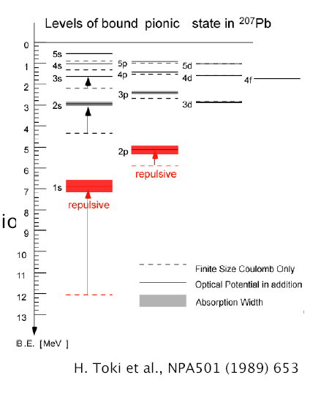
Fig 2 . Taken from reference 1.
Rn =7.39 fm in our approximation.

Now we plot 4π (r Ψ)² ~ fm⁻¹ vs r in fm for the 2p state.
2p state - Compare with the solid curve for the 2p state given below.

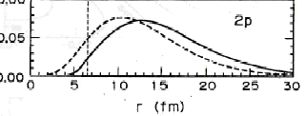
Figure from reference 1.

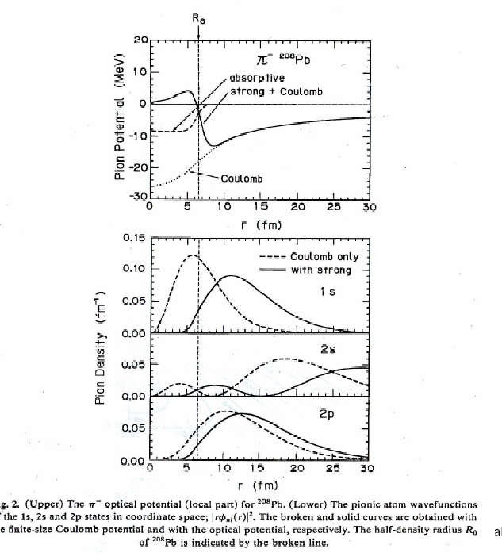
Fig. 4 from Ref 1.

Fortran code
c numerical determination of the energy and eigenfunction for the
c Klein Gordon equation
implicit real*8(a-h,o-z)
real*8 nprime,nprinc , Lscale
data z , amass ,niter, nstep /82.d0, 207.d0, 40 ,4000/
data nprinc,al,ajtotal/1.d0,0.d0,0.5d0/
data c /137.035999679d0 /
data rn, a ,v0/ 1.25d-15, 0.65d-15, 50.d6 /
dimension phi(0:10000)
ebohr(z,nprinc)= -.5d0*(Z/nprinc)**2
den(z)=( nprime+dsqrt( (ajtotal+.5d0)**2- (z/c)**2 ) )**2
edirac(z)=-c**2 + c**2/dsqrt(1.d0 + (Z/c)**2/den(z) )
ekg(z,nprinc)=ebohr(z,nprinc)*( 1.d0 +(z/(nprinc*c))**2*(
$nprinc/(al+.5d0) -.75d0 ) )
pi=2.d0*dasin(1.d0)
Lscale=.5292D-10/(274.d0)
c escale in ~ eV
escale=274.d0*27.21d0
v0=v0/escale
rn=rn/Lscale
a=a/Lscale
nprime=nprinc-(ajtotal+.5d0)
c enri=-1.5d0*z**2/(2.d0*nprinc**2)
c enrf=-.2d0*z**2/(2.d0*nprinc**2)
enri= -6.5d6/escale
enrf= -5.5d6/escale
rn=rn*amass**(1.d0/3.d0)
rcoul=rn
denr=(enrf-enri)/dfloat(niter)
kp=int(dfloat(nstep)/60.d0)
enr=enri
E=enr+c**2
print 110,z,ebohr(z,nprinc)*escale
$ ,ekg(z,nprinc),ekg(z,nprinc)*27.21d0*274.d0
print*,' '
do 20 it=1,niter
c ri , rf limits of integration
rf= 5.d0*(-z/enr)
ri=0.d0
dr=(rf-ri)/dfloat(nstep)
kount=kp
c L=0 Initial conditions
if(al.eq.0.d0)then
phi(0)=1.d0
phi(1)=phi(0) -dr
endif
c L=1 Initial conditions
if(al.eq.1.d0)then
phi(0)=0.d0
phi(1)=phi(0) + dr
endif
if(niter.eq.1) print 150, ri ,(ri*phi(0))**2
do 10 i =2,nstep
r=ri+dr*dfloat(i)
phi(i)=2.d0*phi(i-1)-phi(i-2) +dr**2*( -(2.d0/(r-dr))*
$ (phi(i-1)-phi(i-2))/dr +al*(al+1.d0)*phi(i-1)/(r-dr)**2
$ -g(r-dr,rn,a,v0,z,c,e)*phi(i-1) )
c print*,'dphi, d4phi=',dphi, d4phi
if(niter.eq.1)then
if(i.eq.kount)then
print 150, r*1.931d2 , (r*1.931d2*phi(i))**2
kount=kount+kp
endif
endif
10 continue
print 100, enr ,enr*escale, phi(nstep)
enr=enr+denr
e=enr+c**2
20 continue
print*,' '
if(niter.eq.1)call norm(phi,dr,nstep)
c if(niter.eq.1)call plotphi(phi,ri,dr,nstep,kp)
100 format('e,e(ev),phifinal=',3(3x,d13.6))
110 format('z,ebr(eV),ekg ,ekg(ev)=',4(2x,d11.4))
150 format(1x,'x(fm),(r*phi(i))^2=',2(3x,d13.6))
stop
end

function g(r,rn,a,v0,z,c,e)
implicit real*8(a-h,o-z)
if(r.le.rn)vc= -(Z/rn)*(1.d0 +.5d0*(1.d0-(r/rn)**2) )
if(r.gt.rn)vc=-z/r
vws= (3.d0*Z/(2.d0*rn))*(1.d0/(1.d0+exp((r-rn)/a)) )
vt=vc+vws
g= -c**2 + ((E-vt)/c)**2
return
end

subroutine norm(phi,dr,nstep)
implicit real*8(a-h,o-z)
dimension phi(0:10000)
sum=0.d0
do 10 i=1,nstep
sum=sum+(dr/2.d0)*(phi(i)**2 +phi(i-1)**2)
10 continue
anorm=1.d0/sqrt(sum)
do 20 i=0,nstep
phi(i)=anorm*phi(i)
20 continue
return
end

subroutine plotphi(phi,ri,dr,nstep,kp)
implicit real*8(a-h,o-z)
dimension phi(0:10000)
print*,' '
print*,'phi plot'
do 10 i=0,nstep,kp
r=ri+dr*dfloat(i)
print 100, r, phi(i)
10 continue
100 format(1x,'x, phi =',2(4x,d10.3))
print 100, r, phi(nstep)
return
end

Fortran code modified to normalize Psi in fermis
c Fortran code
c numerical determination of the energy and eigenfunction for the
c Klein Gordon equation
implicit real*8(a-h,o-z)
real*8 nprime,nprinc , Lscale
data z , amass ,niter, nstep /82.d0, 207.d0, 1 ,4000/
data nprinc,al,ajtotal/1.d0,0.d0,1.5d0/
data c /137.035999679d0 /
data rn, a ,v0/ 1.25d-15, 0.65d-15, 50.d6 /
dimension phi(0:10000)
ebohr(z,nprinc)= -.5d0*(Z/nprinc)**2
den(z)=( nprime+dsqrt( (ajtotal+.5d0)**2- (z/c)**2 ) )**2
edirac(z)=-c**2 + c**2/dsqrt(1.d0 + (Z/c)**2/den(z) )
ekg(z,nprinc)=ebohr(z,nprinc)*( 1.d0 +(z/(nprinc*c))**2*(
$nprinc/(al+.5d0) -.75d0 ) )
pi=2.d0*dasin(1.d0)
Lscale=.5292D-10/(274.d0)
c escale in ~ eV
escale=274.d0*27.21d0
v0=v0/escale
rn=rn/Lscale
a=a/Lscale
c fconv converts from our length scale into fermis
fconv=1.931d2
nprime=nprinc-(ajtotal+.5d0)
c enri=-1.5d0*z**2/(2.d0*nprinc**2)
c enrf=-.2d0*z**2/(2.d0*nprinc**2)
enri= -6.074d6/escale
enrf= -4.487d6/escale
rn=rn*amass**(1.d0/3.d0)
rcoul=rn
denr=(enrf-enri)/dfloat(niter)
kp=int(dfloat(nstep)/50.d0)
enr=enri
E=enr+c**2
print*,'rn ,rn(fm)=',rn ,rn*fconv
print 110,z,ebohr(z,nprinc)*escale
$ ,ekg(z,nprinc),ekg(z,nprinc)*27.21d0*274.d0
print*,' '
do 20 it=1,niter
c rf limit of integration
c rf= 5.d0*(-z/enr)
rf=30.d0/fconv
ri=0.d0
dr=(rf-ri)/dfloat(nstep)
kount=kp
c L=0 Initial conditions
if(al.eq.0.d0)then
phi(0)=1.d0
phi(1)=phi(0) -dr
endif
c L=1 Initial conditions
if(al.eq.1.d0)then
phi(0)=0.d0
phi(1)=phi(0) + dr
endif
if(niter.eq.1) print 150, 0.d0*1.931d2 ,phi(0)
do 10 i =2,nstep
r=ri+dr*dfloat(i)
phi(i)=2.d0*phi(i-1)-phi(i-2) +dr**2*( -(2.d0/(r-dr))*
$ (phi(i-1)-phi(i-2))/dr +al*(al+1.d0)*phi(i-1)/(r-dr)**2
$ -g(r-dr,rn,a,v0,z,c,e)*phi(i-1) )
c print*,'dphi, d4phi=',dphi, d4phi
if(niter.eq.1)then
if(i.eq.kount)then
c print 150, r*fconv ,phi(i)
kount=kount+kp
endif
endif
10 continue
print 100, enr ,enr*escale, phi(nstep)
enr=enr+denr
e=enr+c**2
20 continue
print*,' '
du =dr*fconv
rfn= rf*fconv
if(niter.eq.1)call norm(phi,rfn,du,nf)
if(niter.eq.1)call plotphi(phi,du,rfn,kp)
100 format('e,e(ev),phifinal=',3(3x,d13.6))
110 format('z,ebr(eV),ekg ,ekg(ev)=',4(2x,d11.4))
150 format(1x,'r(fm),phi(i)=',2(3x,d13.6))
stop
end

function g(r,rn,a,v0,z,c,e)
implicit real*8(a-h,o-z)
if(r.le.rn)vc= -(Z/rn)*(1.d0 +.5d0*(1.d0-(r/rn)**2) )
if(r.gt.rn)vc=-z/r
vws= (3.d0*Z/(2.d0*rn))*(1.d0/(1.d0+exp((r-rn)/a)) )
vt=vc+vws
g= -c**2 + ((E-vt)/c)**2
return
end

subroutine norm(phi,rfinal,du,nf)
implicit real*8(a-h,o-z)
dimension phi(0:10000)
f(r,i)=4.d0*pi*( u*phi(i) )**2
pi=2.d0*dasin(1.d0)
sum=0.d0
nf=int(rfinal/du)
do 10 i=1,nf
u=du*dfloat(i)
sum=sum+(du/2.d0)*(f(u,i) + f(u-du,i-1) )
10 continue
anorm=1.d0/dsqrt(sum)
do 20 i=0,nf
phi(i)=anorm*phi(i)
20 continue
return
end

subroutine plotphi(phi,du,rfn,kp)
implicit real*8(a-h,o-z)
dimension phi(0:10000)
pi=2.d0*dasin(1.d0)
nf=int(rfn/du)
print*,' '
print*,'phi plot'
do 10 i=0,nf,kp
u=du*dfloat(i)
c print 100, r , (r*phi(i))**2
print 100 , u , 4.d0*pi*(u*phi(i))**2
10 continue
100 format(1x,'u(fm), 4.*pi*(u*phi)^2 =',2(4x,d10.3))
return
end

