Transmission coefficient for a double potential barrier
by Reinaldo Baretti Machín

www.geocities.com/serienumerica3
www.geocities.com/serienumerica2
www.geocities.com/serienumerica

reibaretti2004@yahoo.com

References:

1.Fundamentals of Modern Physics by Robert Martin Eisberg , Chapter 8

2. Quantum Mechanics: Non-Relativistic Theory, Volume 3, (Quantum Mechanics) by L. D. Landau and L. M. Lifshitz

3. Reflection by a step potential barrier (numerical approach)

4.http://electron6.phys.utk.edu/phys594/archives/quantum/Potential/potential1.htm

5. http://www.geocities.com/serienumerica3/Transmissionpotentialbarrier9sep2008.doc
6. Resonant tunnelling diode http://en.wikipedia.org/wiki/Resonant_tunnelling_diode

A typical double barrier with equal height V₀ is represented in the figure.
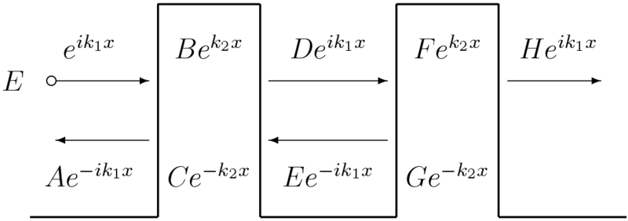

Fig 1. Double barrier. We adopt another notation in Fig 3.

In ref 5 ,the standard problem of quantum mechanics ,of finding transmission coefficient through a single potential barrier of width –a- and height V ₀ was worked by numerical integration of Schrodinger equation.

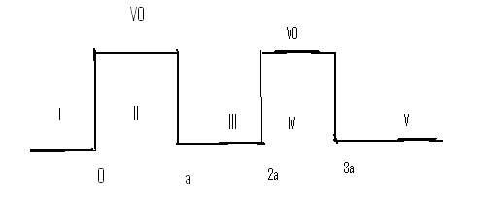
Fig 2. Double square barrier potential of width a and height V₀ .

The wave function for each region is

Ψ_{I} = A exp(ik₁ x) + B exp(-ik₁ x) , x≤ 0 (1a)

Ψ_{II} = D exp(-k₂ x) + E exp( k₂ x) , 0 ≤ x ≤a (1b)

Ψ_{III} = F exp(ik₁ x) + G exp(-ik₁ x) , a≤ x ≤2a (1c)

Ψ_{IV} = D2 exp(-k₂ x) + E2 exp( k₂ x) , 2≤ x ≤3 (1d)

Ψ_{V} = Cexp( ik₁ x) , x ≥ 3a (1e)

The transmission coefficient is (see Ref. 1)

T = v ₁(C ∙ C*)/( v₁ A ∙ A*)

and the reflection coefficient is

R= 1-T

Assume the initial condition ,C=1 and thus Ψ_{V}(x =3a) = exp( i k₁ 3a) . Let also Ψ_{V}(x=3a+dx) = exp(i k₁( 3a+dx)) . This is sufficient to start the integration towards x=0.

At x=0, from the integration we have numerical values of Ψ(x=0) and
(d Ψ/dx)_{x=0} . The coefficients A and B are readily found ,

A= (1/2) {ψ₀ +(1/ik₁) (dψ/dx)₀ } (9)

B =(1/2) {ψ₀ - (1/ik₁) (dψ/dx)₀ }

Since C was set equal to 1.0 , the transmission coefficient is just ,

T = v ₁(C ∙ C*)/( v₁ A ∙ A*)= 1./ (A ∙ A*) (10)

In the following integration (see Fortran code below) a=2. , V₀ =5 .
Figure 4 shows a resonance at E ≈ 0.5 V₀ .For an energy equal to ≈ .5V₀ the transmission coefficient is one.

A closer look reveals that the resonance is at E =.53663V₀ ,

E/v0,log10(T)= 0.53670E+00 -0.50856E+00
E/v0,log10(T)= 0.53668E+00 -0.32209E+00
E/v0,log10(T)= 0.53665E+00 -0.15215E+00
E/v0,log10(T)= 0.53663E+00 0.10211E-01
E/v0,log10(T)= 0.53660E+00 -0.10564E+00
E/v0,log10(T)= 0.53658E+00 -0.22261E+00
E/v0,log10(T)= 0.53655E+00 -0.36535E+00
E/v0,log10(T)= 0.53653E+00 -0.54253E+00

Fig 3. Log₁₀ (T) vs (E/V₀)

Fig 4. Real (Psi) , with parameters , awidth=2 , V₀ =5.

FORTRAN code
c Transmission through a double potentail barrier, Ref R. M. Eisberg
c (Fundamentals of Modern Physics,1961)c Chapter 8 sec 3
c ,pp 231 - 239
c V0 and awidth are adjusted
real k1,k2,k3
complex psi0,psi1,psi2 ,dpsi, a, b ,c,rooti,coef
data niter,awidth,v0 / 80, 2. ,5./
rooti=cmplx(0.0,1.0)
c=cmplx(1.,0.)
energyi=.01*v0
energyf=1.5*v0
de=(energyf-energyi)/float(niter)
energy=energyi
c the integration is carried out from the right to to the left(set C=1.)
xi=3.1*awidth
xf=-0.*awidth
nstep=1000
kp=int(float(nstep)/70.0)
kount=kp
dx=(xf-xi)/float(nstep)
do 20 it=1,niter
k1=sqrt(2.0*energy)
k2=sqrt(2.0*(v0-energy))
if(energy.gt.v0)k3=sqrt(2.0*(energy-v0))
c initial conditions for a step potential
c psi0=c*exp(-k2*xi)
c psi1=c*dexp(-k2*(xi+dx))
c initial conditions for a finite barrier
psi0=c*exp(rooti*k1*xi)
psi1=c*exp(rooti*k1*(xi+dx))
if(niter.eq.1)print 100,xi,real(psi0),aimag(psi0)
do 10 i=2,nstep
x=xi+dx*float(i)
psi2=2.0*psi1-psi0+dx**2*(-2.0*(energy-V(x-dx,v0,awidth))*psi1)
dpsi=(psi2-psi1)/dx
psi0=psi1
psi1=psi2
if(niter.eq.1)then
if(i.eq.kount)then
print 100,x, real(psi2), aimag(psi2)
kount=kount+kp
endif
endif
10 continue
a=.50*(psi2+dpsi/(rooti*k1) )
b= .50*(psi2-dpsi/(rooti*k1) )
coef=-rooti*(a-b)/(a+b)
c print*,' '
c print*,'e,v0,k1,k2,k3=', energy,v0,k1,k2,k3
c print*,' real(a), aimag(a)=',real(a) ,aimag(a)
c print*,' real(b), aimag(b)=',real(b) ,aimag(b)
c Tapprox=16.*(energy/v0)*(1.-Energy/v0)*exp(-2.*k2*awidth)
print 120,energy/v0,log10(abs(c)**2/abs(a)**2)
c print*,'coef,k2/k1=',coef ,k2/k1
energy=energy+de
20 continue
110 format(1x,'k2/k1,coef,psifin=',3(4x,e10.3))
100 format(1x,' x,Real(psi),aimag(psi)=',3(4x,e10.3))
120 format(1x,'E/v0,log10(T)=',2(3x,e10.3))
stop
end

function v(x,v0,awidth)
if(x.lt.0.)v=0.0
if(x.ge.0.0.and.x.le.awidth)v=v0
if(x.gt.awidth.and.x.lt.2.*awidth)v=0.
if(x.ge.2.*awidth.and.x.le.3.*awidth)v=v0
if(x.gt.3.*awidth)v=0.0
return
end

function transteo(e,awidth,v0,k2,k3)
real k1,k2,k3
sinch(k2,awidth)=(1.0/2.0)*(exp(k2*awidth)-exp(-k2*awidth))
den(e,v0)=(4.0*e/v0)*(1.0-(e/v0) )
if(e.lt.v0)transteo=1.0/(1.0+ sinch(k2,awidth)**2/den(e,v0))
if(e.gt.v0)transteo=1.0/(1.0- sin(k3*awidth)**2/den(e,v0))
return
end

