Lecture 2.

First order differential equations in dilution problems and other situations

by Reinaldo Baretti Machín

www.geocities.com/serienumerica4
www.geocities.com/serienumerica3
www.geocities.com/serienumerica2
www.geocities.com/serienumerica
For questions and suggestions write to:
reibaretti2004@yahoo.com

Reference :

1. Mathematical Techniques for Biology and Medicine (Dover Publications- Paperback)
by William Simon ; http://www.amazon.com/Mathematical-Techniques-Biology-Medicine-William/dp/0486652475/ref=sr_1_1?ie=UTF8&s=books&qid=1223731765&sr=8-1

2. http://geocities.com/serienumerica4/Lecture1Biolologymedicine.doc

Examples and problem from:
Chapter 2 . Reference 1. The problem numbers refer to the textbook listing.

Section 1. One compartment dilution problem.

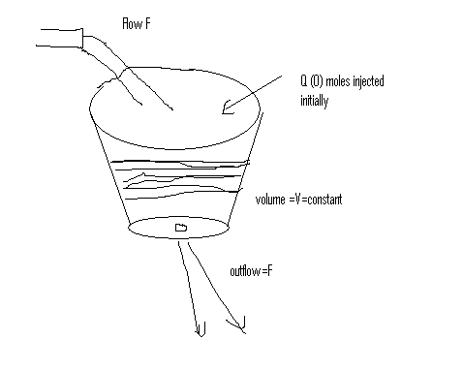
Fig 1.
A bucket contains say V=10 liters of water. The volume is kept constant becaues the inflow F =2 liter/minute is adjusted is equal to the outflow F at the bottom. Thres moles of a tracer Q(0)= 3 moles are injetct at t=0 and we assume it is instantly mixed throughout the volume V.

At any instant ,the concentration C(t) (moles/liter) = Q(t) /V .

The initial concentration C(0) = 3 moles/10 liters =0.3 moles/liter

Establish a first order differential equation and solved it.

In an interval ∆t (minutes) the number of moles diminishes by ∆Q .

A finite difference equation is

∆Q = - ∆t F C(t) (1)
moles ~ minutes * (liters/minute) * (moles/liter)
We can write an equation for either Q or C.

Substitute ∆Q = V ∆C above an get
∆C = - ∆t ( F/V) C(t) . The differential equation follows from invoking the

limit (∆t→0) (∆C / ∆t ) = - (F/V) C

i.e dC/dt = -(F/V) C (2)

This is of the form dy/dt = -k y (see chapter 1) and the solution is

y(t) = y(0)exp(-kt) . Hence the solution is,

C(t) = C(0) exp( -(F/V) t) . The numerical values are
C(0)= 0.3 moles/liter , F/V =k or λ = 2(liters/min)/10(liters) = .2 /minute
Tscale = 1/λ = 5 minutes The plot of C(t) is shown next.

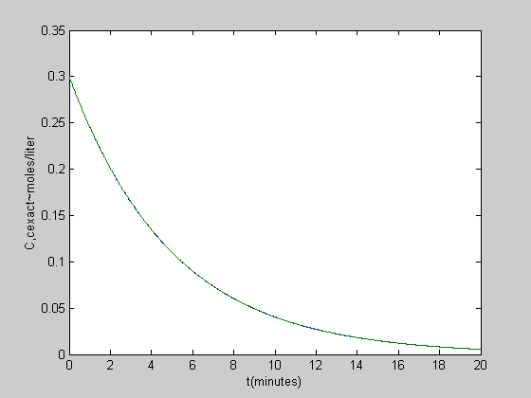

Plots of C(t) analytical and the numerical result from an integration.

The differential equation
dC/dt = -(F/V) C leads to the finite difference equation

(C_{n} – C_{n-1} )/∆t = -(F/V) C_{n-1} wrere C_{n} = C( n ∆t)

Solving for C_{n}

C_{n} =C_{n-1} - ∆t (F/V) C_{n-1} (3)
C₀ = C(t=0) is given , then the solution is constructed from the previous
values of C which are known.

C₁ =C₀ - ∆t (F/V) C₀ ,
C₂ =C₁ - ∆t (F/V) C₁ …

Now ∆t has to be small relative to the time scale 1/λ .
The following MATLAB code integrates numerically the DE.
The value of ∆t is chosen to be small in comparison with Tscale.
C analytical i.e C(0) exp(-λt) and C _{numerical} are plotted together. They are practically identical within the resolution of the graph.

tscale = 5 minutes , dt= 2.0 E-2 minutes

MATLAB code
%numerical solution of dC/dt= -(F/V)*C(t)

F=2 ; V=10 ; Q0= 3; c(1)=Q0/V ;
lambda=F/V; tscale=1/lambda ,
cexact=c(1)*exp(-lambda*t);
ti=0 ; tf = 4*tscale ; nstep=1000;
dt=(tf-ti)/nstep ,
% k is the index kounter it starts with k=1 at t=0
% c(1) is given as initial condition , we wil find c*2) ,
% c(3)...etc
k=0 ;
for x=[ti+dt:dt:tf]
k=k+1;
c(k+1)=c(k) +dt*(-(F/V)*c(k));

end

t=[ti:dt:tf];
plot(t,c,t,cexact), xlabel('t(minutes)'),ylabel('C,cexact')

Other examples of exponential decay.

Section 2.

Consider a metabolite of Q₀ moles to which a small quantity of radioactively

labeled q(0) is added at t=0. ( i.e q(0) << Q₀ ) . The total quantity is

Q_{total} = Q₀ + q(t) ≈Q₀ .
q decays at a fixed rate of R ~ moles/time

Before writing an equation for ∆q let’s rewrite eq (1)

∆Q = - ∆t F C(t) as

change in q =(moles)= - ∆t (time) R (moles/time) (radioactive moles/total moles)

∆q = - ∆t R q(t)/Q₀ from which we can pass to the DE

dq/dt = -k q k= R/Q₀ ~ 1/time (4)

Radioactive decay
It is empirically found that from a total of N atoms, there is a decay , ∆N<0 , in an interval ∆t such that

∆N =- λ N ∆t , λ~ 1/time . The corresponding DE is

dN/dt = - λ N(t) . Let the initial condition be N(t=0) = N₀ , then
N = N₀ exp( - λt)

Absorption of X- rays
The intensity I ~ energy/(time-area) , of X-rays after penetrating a material slab of thickness ∆x is diminished acording to
∆I = - D I(x) ∆x , D ~ 1/length

this leads to the DE dI/dx = - D I . Let the initital condition
be I(x=0) = I₀ , then I (x) = I_{o} exp(-Dx)

Sec 5. One compartment with constant injection (see figure)
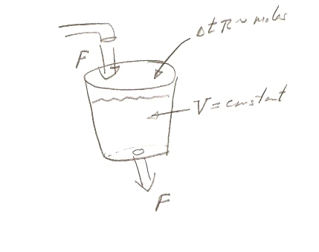
Assume the intial concentration of substance Q is zero , C(0)=0.

A volume V~ liter is kept fixed by a constant inflow flow and outflow of F ~
liters /time . The quantity of Q(t) moles of a tracer suffers in an interval
a loss

∆Q_{loss} = - ∆t F Q/V ~ - ∆t ( volume/time) * (moles/volume).

At the same time a quantity ∆t R ~ time *(moles/time) is injected instantly.

R is the rate of injection in moles/time .

∆Q_{gain} = ∆t R . Adding the loss and gain parts of Q ,

∆Q = ∆t ( R - F Q/V) = ∆t ( R - F C(t) ).

Dividing by ∆t V and taking the limit ∆t→0 , results in the DE

d C /dt = ( R/V – (F/V) C(t) ) , (5)

with initial condition C(t=0) =0.

Remember R , V , F are parameters. They assume constant values in a given example. The independent variable is time , the dependent variable is the concentration C(t) ~ moles/volume.

The DE equation (5) is of a type called separable. One can separate the variables C and t , in two different integrals.

∫ dC /(b -a C(t) ) = ∫ dt , where , b=R/V a= - F/V .

If you go to a table of integrals you will find the indefinite integral in a form like this ;

∫ dx /(b+ax) = (1/a) ln (b+ax) . Hence

∫ dC / { (R/V) – (F/V) C(t) } =
-(1/(F/V) ) ln [ (R/V) – (F/V) C(t)] .

Equating this to the right hand side integral gives

the indefinite integral

-(1/(F/V) ) ln [ (R/V) – (F/V) C(t)] = t + A

A is the integration constant that can be related to the initial condition as we shall show.

It is convenient to rewrite the integral as

ln [ (R/V) – (F/V) C(t)] = - (F/V) t + A* where A* = (F/V) A is still a constant. To simplify matters call A all constants that originate with the original A.

Then
(R/V) – (F/V) C(t) = A exp(-(F/V)t ) , (another A)
and solving for C(t)

C(t) = (V/F) { (R/V) - A exp(-(F/V)t ) } (6).

Apply now the initial condition to determine A

C(0)= 0 = (V/F) { (R/V) – A } , thus A =R/V and finally

C(t) = (R/F) { 1- exp( -(F/V) t) } (7)
which dimensionally checks ,

moles/volume = ( moles/time)( time/volume) .
At t=” infinty” C(∞) = R/F = constant .
The time scale of the problem is T _{scale} = V/F

Example : Plot of eq (7) . Such plot is called an inverted exponential.
set % R=.1 mol sec , F =2 liter/(60 sec) , V=10 liters

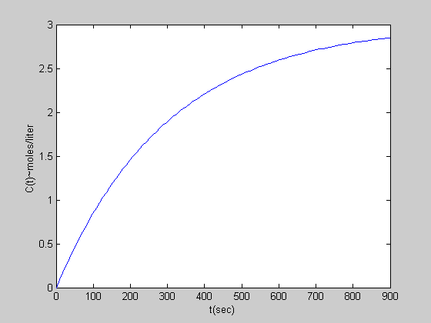

Matlab code
% One compartment with constant injection
% R=.1 mol sec , F =2 liter/(60 sec) , V=10 liters
R=0.1 , F =2/60 , V=10 ,
tscale=V/F; tfinal=3*tscale ;dt = tfinal/100;
t=[0:dt:tfinal];
c=(R/F)*(1-exp(-t/tscale));
plot(t,c) , xlabel('t(sec)') ,...
ylabel('C(t)~moles/liter ' )

The two compartment series dilution
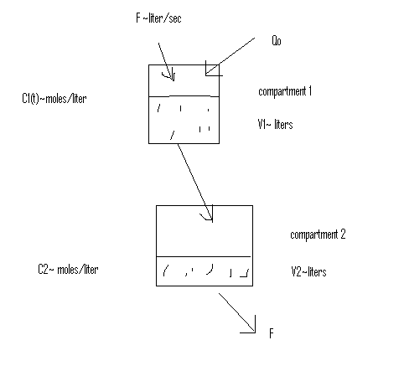
The one compartment dilution problem have already been solved
and the solution is C₁(t)=C₁(0) exp( -(F/V₁) t) where the subscript 1 refers to compartment #1. The initial condition was C₁(0)= Q₀ /V₁ i.e a total amount of tracer Q₀ is injected and mixed instantly at t=0.
Volumes V₁ and V₂ are kept constant by insuring that F = F₁ = F₂ .

The problem is to set up a differential equation for C₂(t) and to find its solution. Remember C₂(t) = Q₂(t) /V₂ and Q₂ ~ moles in the second compartment. The initial condition is C₂(t) =0.

The quantity ∆Q₂ ~ moles ,in compartment 2 within an interval ∆t is increased by the amount

∆Q_{2 gain} = inflow rate * C₁ * ∆t~ (liter/sec)(moles/liter) (sec)
= F C₁ ∆t

The loss is ( negative quantity)
∆Q_{2 loss} = - outflow rate * C₂ * ∆t~ (liter/sec)(moles/liter) (sec).

= - F C₂ (t) ∆t

So the net change is

∆Q₂ = F C₁ ∆t - F C₂ (t) ∆t and the corresponding DE is

d Q₂ /dt = F C₁ - F C₂ (t) divide by V₂ to obtain the DE for C₂ ,

dC₂/dt = (F/V₂ ) ( C₁(t) – C₂ (t) ) . (8)

Rearranging (8) , and introducing the solution for C₁ get

dC₂/dt +( F/V₂ ) C₂ (t) = (F/V₂ ) C₁(0) exp( -(F/V₁) t ) . (9)

This is a first order linear DE of the form

dy/dx + P(x) y = Q(x) (10)

which has the general solution

y = exp(-I) ∫ Q(x) exp(I) dx + B exp(-I) (11)

B is an integration constant and I = ∫ P(x) dx .

To avoid the burden of too many symbols let’s put some data in (9).

Set , C₁ (0)=0.3moles/liter , V₁= 10 liters , V₂= 5 liters ,

F= 2liters/min= 2liters/(60sec) = 3.33E-2 liters/sec.
There are two time scales ; (F/V₁) = 3.33E-3 sec⁻¹ ; T_{scale1} = V₁/F= 300 sec and (F/V₂) = 6.66E-3 sec⁻¹ ; T_{scale2} = V₂/F = 150 sec.

With the proposed data and the value of C₁(0)=.3 moles/liter , eq (9) becomes

dC₂/dt + 6.67E-3 C₂ (t) = 6.67E-3 *(.3) * exp( -3.33E-3 t ) . (12)

Identify P(t) = 6.67E-3 ~ 1/sec and
Q(t) = 2.00E-3 *exp(-3.33E-3 t) ~ moles/(liter-sec)

Proceed to implement the method of eq (11)
I = ∫ P(t) dt = 6.67E-3 * t (13)

∫Q(x) exp(I) dx = ∫ 2.00E-3 *exp(-3.33E-3 t)*exp(6.67E-3 t) dt

= ∫ 2.00E-3 *exp(+3.33E-3 t) dt
= ( 2.00E-3/3.33E-3) exp( +3.33E-3 t)

= 6.01E-1 exp( 3.33E-3 t) . (14)

Inserting (13), (14) in (11) results in

C₂(t) = exp(-6.67E-3 t) * 6.01E-1 exp( 3.33E-3 t) + Bexp(-6.67E-3 t)

= 6.01E-1 exp(-3.33E-3t) + B exp(-6.67E-3 t) .
Now invoke the initail condition

C₂(0)= 0 = 6.01E-1 + B ; thus B= -6.01E-1 and

C₂(t) = 6.01E-1 { exp(-3.33E-3t) – exp (-6.67E-3 t) } . (15)

Applying (11) but keeping the data (the parameters) unspecified gives,

C₂(t) = [ V₁ C₁(0)/(V₁-V₂ )] {exp(-(F/V₁)t ) – exp(-(F/V₂)t ) } . (16)

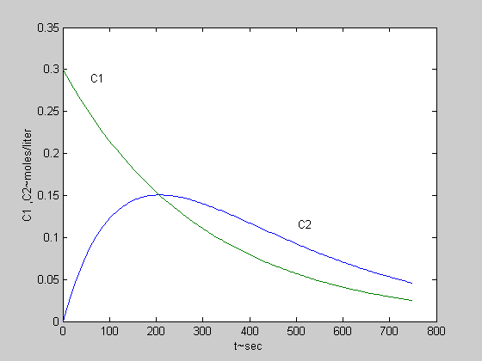
Plot of C1 , C2

Matlab code

% two compartment dilution
tscale=1/6.67E-3 ; tf=5*tscale;
dt=tf/200;
t=[0:dt:tf];
c1=.3*exp(-3.33E-3*t);
c2=6.01E-1*(exp(-3.33E-3*t)-exp(-6.67E-3*t) );
plot(t,c2,t,c1), xlabel('t~sec') ,...
ylabel('C1 ,C2~moles/liter')

Roughly speaking without solving the DE we can anticipate the following

results. The 3 moles are emptied from compartment one in roughly 300 seconds ( tscale 1). If there is no loss in compartment #2 the concentration would be 3 moles/5 liters = 0.6 moles/liter but in 300 sec there are two half lifes of tscale2 (tscale2=150 sec) . Thus the concentratio reduces to (1/2)²=1/4 . So at t=300 sec the concentration at compartment # 2 ,is at a maximum and roughly equals (1/4)(.6moles/liter) = 0.15 moles/liter .

A check of the plot above bears out this estimate.

Numerical integration of eq.(8).

We expand next on the procedure already used ( in these notes) to integrate numerically a DE by finite differences.

The equation

dC₂/dt +( F/V₂ ) C₂ (t) = (F/V₂ ) C₁(0) exp( -(F/V₁) t ) (17)
has initial condition C₂(t=0) = 0 . Suppose you want the solution in intervals

of size ∆t where , ∆t = ( t_{final} – t_{initial}) /nsteps , and ∆t << tscale1 or
∆t << tscale2 , whichever is the samller one.

The finite difference generic solution is ,

C₂ (t_{n}) = C₂ (t_{n-1}) +
∆t {- ( F/V₂ ) C₂ (t_{n-1}) + (F/V₂ ) C₁(0) exp( -(F/V₁) t_{n-1} ) } . (18)

note that every term in the right hand is known.

The Fortran given below uses this method. The plot is given next , which , of course is identical to the previous one.

Same initial data C1(0)= 0.3 moles/liter , c2(0)=0, but V1=V2=10 liters.

Fortran code (two compartment series dilution)
c the two compartment series dilution
c F~liters/min ,V ~liters
data c10 /.3 /
data F, V1,V2/2. ,10., 5./
c1(t) = c10*exp(-F*t/v1)
c f is changed to liters /second by the next declaration
f=f*(1./60.)
tscale1=V1/f
tscale2=V2/f
tsmall=amin1(tscale1,tscale2)
tlarge=amax1(tscale1,tscale2)
dt= tsmall/50.
nstep=int(3.*tlarge/dt)
c20=0.
kp=int(float(nstep)/70.)
kount=kp
print 100 , 0. , c1(0.) ,c20
do 10 i=1,nstep
t=dt*float(i)
c21= c20 + dt*(-(F/v2)*c20 +(f/v2)*c1(t-dt) )
if(i.eq.kount)then
print 100 ,t ,c1(t),c21
kount=kount+kp
endif
c20=c21
10 continue
100 format(1x,'t(sec),c1, c2 ~moles/liter=',3(3x,e10.3))
stop
end

Section 8. Mother Daughter Radioactive Decay

This problem is analogous to the two compartment dilution series.

A mother (M) nuclei species decays like

dM/dt = - λ₁ M ( 19 ).

The daughter nuclei ( D) are born at the rate + λ₁ M and decay at a rate
- λ₂ D , therefore the DE for the daughter nucei is

d D/dt = λ₁ M(t) - λ₂ D (t) (20)
The equation is analogous ( though not the same) to

dC₂/dt = (F/V₂ ) ( C₁(t) – C₂ (t) ) if we make C₁=M , C₂= D

and λ₁ = λ₂ = (F/V₂) . But in general λ₁ ≠ λ₂ .

We need two initial conditions to solve (19) and (20) , set M(0)= 1mol
D(0)=0 and t_{scale1} =1/ λ₁ = 5 minutes , t_{scale2} = 1/λ₂ =10 minutes.

We can modify slightly the above FORTRAN code to integrate , both equations simultaneously. The finite difference solutions to (19)-(20) are

M(t_{n} ) = M(t_{n-1}) - ∆t λ₁ M(t _{n-1}) (21)

D( t_{n} ) = D(t_{n-1}) + ∆t ( λ₁ M(t_{n-1} ) - λ₂ D (t_{n-1}) ) . (22)

Solution of (21)-(22) with the above parameters

FORTRAN code
c Fortran code for mother daughter radioactive decay
real m0 ,m1 ,lambda1, lambda2
data m0 ,D0 /1.,0. /
c time scales are in minutes
data tscale1 , tscale2/5.,10. /
lambda1=1./tscale1
lambda2=1./tscale2
tsmall=amin1(tscale1,tscale2)
tlarge=amax1(tscale1,tscale2)
dt= tsmall/50.
nstep=int(3.*tlarge/dt)
kp=int(float(nstep)/70.)
kount=kp
print 100 , 0. , m0 ,d0
do 10 i=1,nstep
t=dt*float(i)
M1 = M0 - lambda1*dt*M0
D1=d0+ dt*(lambda1*m0-lambda2*d0)
if(i.eq.kount)then
print 100 ,t ,m1,d1
kount=kount+kp
endif
m0=m1
d0=d1
10 continue
100 format(1x,'t(min),mother,daughter~moles=',3(3x,e10.3))
stop
end

Section 9. Circular reactions

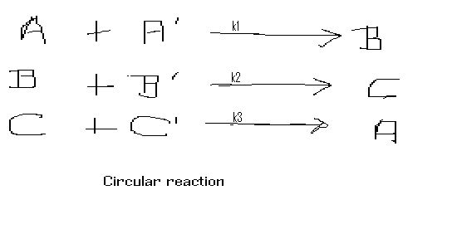
The concentration A has a gain in an interval ∆t of

∆t k₃ C C ‘ (third line) and a loss of - ∆t k₁ A A ‘ (first line). The balance is

∆A = ∆t k₃ C C ‘ - ∆t k₁ A A ‘ , which leads to the DE

dA/dt = k₃ C C ‘ - k₁ A A’ (23)

the k_{i} ~ ( 1/time)*(1/concentration) .
Similarly

dB/dt = k₁ A A ‘ - k₂ B B’ (24)

dC/dt = k₂ B B ‘ - k₃ C C’ . (25)

To simplify matters suppose A’ , B’ and C’ are practically constants and can be absorbed into new constants , capital K₁ , K₂ , K₃ .

The capital K’s are ; K₁ ≡ k₁ A ‘ , K₂ ≡ k₂ B ‘ , K₃ ≡ k₃ C ‘ ~1/time . The
equations take the new form

dA/dt = K₃ C - K₁ A , 26-a

dB/dt= K₁A -K₂ B , 26-b

dC/dt = K₂ B – K₃ C . 26-c

We will solve numerically this system of three first order coupled DE.

Let tscale1= 10 minutes =1/K₁ , tscale2=5minutes =1/K₂ ,

Tscale3= 3minutes=1/K₃ . A(0)=1.0 moles , B(0)=0 moles , C(0)=0 moles

The finite difference solutions to eqs 26 a to 26 c are

A( t_{n} ) =A(t_{n-1}) + ∆t { K₃ C (t_{n-1}) - K₁ A(t_{n-1} ) }
B( t_{n} ) =B(t_{n-1}) + ∆t { K₁ A (t_{n-1}) - K₂ B(t_{n-1} ) }
C( t_{n} ) =C(t_{n-1}) + ∆t { K₂ B (t_{n-1}) - K₃ C(t_{n-1} ) }
and ∆t has to be small relative to the smallest of the Tscale. In the present
case ∆t << Tscale 3.

The next FORTRAN code expands the mother –daughter code to deal with the circular reaction. The results are plotted next.
We see that in about 10 minutes a steady state is reached with constant concentrations
A=.56 , B= .28 , C= .16 .

Problem 3. A substance Q~ moles , diffuses from the compartment of volume V at a rate proportional to the product of the diffusion constant K ~ volume/time and the difference in concentration with the environment (C- C_{environment}) ~ moles/volume. The initial condition is C(0)= Q₀/V.
Also assume C > C_{environment} hence there is a loss of Q in the compartment,
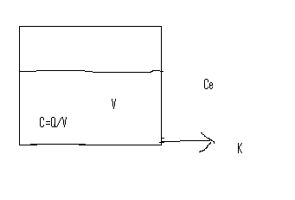
V is kept constant , the mechanism is not shown in the drawing.
Then in an interval ∆t , a loss occurs

∆Q = - ∆t K (C- C_{environment}) ~ time( volume/time)*(moles/volume)

Dividing by the volume V and by ∆t we obtain the differential equation

dC/dt = -(K/V) (C(t) - C_{environment}) .

Problem 4. Assume that in the compartement of Prob. 3 a quantity ∆Q_{in}
is pumped given by flow rate R(moles/time) * ∆t .

The net ∆Q is now

∆Q = - ∆t K (C- C_{environment}) + R ∆t and the DE is

dC/dt = - (K/V)(C- C_{E} ) + R/V

Example : Solve the DE dC/dt = - (K/V)(C- C_{E} ) + R/V .
Let K= F=2liter/minute , V=10 liter ,C(0)=0.3 moles/liter ,

C_{environmnet}=.05 moles/liter , R =.1mole/minute.

Tscale = 1/(F/V) =10/2 = 5 minutes .

The finite difference solution is

C ( t_{n}) = C(t_{n-1}) + ∆t { - (K/V)(C(t_{n-1}) - C_{E} ) + R/V }.
FORTRAN code
real k
data c0 , cE/.3, .10/
data k,v, R/2.,10.,0.1/
c time scales are in minutes
tscale=V/K
dt= tscale/100.
nstep=int(6.5*tscale/dt)
kp=int(float(nstep)/70.)
kount=kp
print 100 , 0. , c0
do 10 i=1,nstep
t=dt*float(i)
c1 = c0 +dt*( -(K/v)*(c0-ce) +R/V)
if(i.eq.kount)then
print 100 ,t ,c1
kount=kount+kp
endif
c0=c1
10 continue
100 format(1x,'t(min),C~ moles/liter=',2(3x,e10.3))
stop
end

Problem 5 . In a one compartment dilution the concentration falls with time according to the data :
t(sec) | C (moles/liter)
0 | .024
1 | .011
2 | 4.8E-3
3 | 2.4E-3
4 | 1.0E-3

If Q(0)=0.1 mole , find F ~liters/sec and V ~liters

C(0) =.024 ≡ Q(0)/V , hence V= .1/.024 = 4.17 liters

If we assume a perfect fit , which may not be the case ,

then C(t) = C(0) exp(- (F/4.17) t) . Any value from the table will serve to solve for F. At t=1 sec

.011 = .024 exp( -.240F) . Taking the natural log

ln(.011/.024) = -.780 = -.240F

F = 3.25 liters/second

Problem 6.
In a radioactive process half the atoms decayed in one day.What fraction existed at 10 hours. We know that the half life (t_{1/2} ), is related to the rate λ by

λ = .693 / t_{1/2} = .693 /24 hours = 2.89E-2 hour⁻¹ .

After 10 hours the fraction of atoms left is

N/N₀ = exp( - λ t) = exp( -2.89E-2 (10) ) = .749 .

Problem 8. Substance A is created at a rate R ~moles/sec and destroyed at the rate - K(1/sec) * A(moles) ~ moles/sec. Let the initial condition be A(0) =0.
In an interval ∆t the net change in A is

∆A = R ∆t – K A ∆t
The corresponding DE is

dA/dt = R – K A .

A steady state is reached when dA/dt =0 . This gives A(t=∞) = R/K.
Again the solution is an inverted exponential as mentioned in a previous example of the one compartment dilution with constant injection.

Data: R= .5 moles/sec , K = 0.1/sec , A(0)=0.
The asymptotic value of A is A (t=∞) = R/K=5 moles

MATLAB code

% R~moles/sec K ~(moles/mole-sec)
A(1)=0; R =.5 ; K= .1 ;
tscale= 1/K ;tfinal=3*tscale ;nstep=2000;
dt=tfinal/nstep;
n=0;
t=[dt:dt:tfinal];
n=n+1;
A(n+1)=A(n) + dt*(R-K*A(n));

t=[0:dt:tfinal];
plot(t,A),xlabel('t~sec'),ylabel('A~moles')

END OF CHAPTER II

