Lecture 3.

Second order differential equations – Part 2

by Reinaldo Baretti Machín

www.geocities.com/serienumerica4
www.geocities.com/serienumerica3
www.geocities.com/serienumerica2
www.geocities.com/serienumerica

For questions and suggestions write to:
reibaretti2004@yahoo.com

This is the continuation of Ref 4.

Reference :

1. Mathematical Techniques for Biology and Medicine (Dover Publications- Paperback)
by William Simon ; http://www.amazon.com/Mathematical-Techniques-Biology-Medicine-William/dp/0486652475/ref=sr_1_1?ie=UTF8&s=books&qid=1223731765&sr=8-1

2. http://geocities.com/serienumerica4/Lecture1Biolologymedicine.doc
3. Mathematical Biology: I. An Introduction (Interdisciplinary Applied Mathematics) by James D. Murray

4. http://www.geocities.com/serienumerica4/Lecture3Biolologymedicine.doc

Examples and problem are taken from:
Chapter 3 . Reference 1. The problem numbers refer to the textbook listing.

Section 10. Diffusion between Compartments

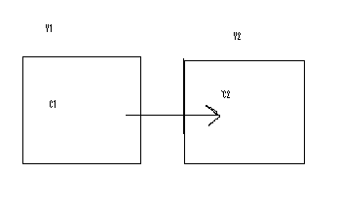
Fig 3.9 . Diffusion between compartments. The volumes V₁ and V₂ are not constant but if the initial concentrations C₁(0) and C₂(0) are very equilibrium can be reached without an appreciable volume change.

In an interval ∆t a quantity ∆Q (moles) diffuses from left to right proportional to the product of a diffusion constant (K~volume/time) and the difference in concentrations C₂ – C₁,

∆Q = ∆t K ( C₂ – C₁ ) ~time (volume/time) ( moles/volume) .
Note that if C₂ – C₁ < 0 then compartment #1 ,on the left, empties into #2.

Dividing by V₁ and ∆t gives for C₁ = Q(t)/V₁ ,

d C₁/dt = (K/V₁) {C₂(t) – C₁ (t) } (20)

To obtain the equation for C₂ let V= V₂ and write instead {C₁(t) – C₂ (t)}
because if one concentration is increasing the other is decreasing.

d C₂/dt = (K/V₂) {C₁(t) – C₂ (t) } . (21)

The initial conditions are C₁(0) and C₂(0) ~moles/volume .

Solving (20 ) - (21) by finite differences gives

C₁( t_{n} ) = C ₁(t_{n-1} ) + ∆t (K/V₁) {C₂(t_{n-1}) – C₁ (t_{n-1}) } (22)
C₂( t_{n} ) = C ₂(t_{n-1} ) + ∆t (K/V₂) {C₁(t_{n-1}) – C₂ (t_{n-1}) } . (23)

There are two time scales

t_{scale 1} = V₁/K and t_{scale 2} = V₂/K .
To assume that the volumes are constant would require that
t_{equilibrium} << t_{scale1} so that V₁ is approximately constant , or
t_{equilibrium} << t_{scale2} so that V₂ is approximately constant.

Numerical example : Let V₁ = V₂ = 10 liters , K=(1/3) liter/minute
C₁(0)=0.3 moles /liter , C₂(0) =0.

Fig. 3.10 Difussion between compartments .Asuming that V₁ and V₂ are constants which can not be entirely right if there is a flow from V₁ to V₂ .

Fig 3.11 C1(0)=.3 moles/liter , C2(0)=.2moles/liter , V1=20 liters , V2=10 liters , K = 2 liter/min

Fortran code
c Diffusion between two compartments
real K
data v1,v2/10.,10./
k=1./3.
c10=0.3
c20=0.
ts1=v1/k
ts2=v2/k
tlarge=amax1(ts1,ts2)
tsmall=amin1(ts1,ts2)
dt=tsmall/200.
tfinal=4.*tlarge
nstep=int(tfinal/dt)
kp=int(float(nstep)/60.)
kount=kp
print 100 , 0.,c10,c20
do 10 i=1,nstep
t=dt*float(i)
c11=c10+dt*(k/v1)*(c20-c10)
c21=c20+dt*(k/v2)*(c10-c20)
if(i.eq.kount)then
print 100 , t,c11,c21
kount=kount+kp
endif
c10=c11
c20=c21
10 continue
100 format(1x,'t,c1,c2~moles/liter=',3(3x,e10.3))
stop
end

Section 11. A simple kinetic reaction

A reaction has the chemical formula

a + b → p . (24)

Let the concentration be represented by capital letters A ~ moles/liter ,
B~ moles/liter , P ~ moles/liter.
The concentration P grows at the rate

dP/dt = K A B ~ moles/(liter-time) (25)
The contant K which is specific to the particular reaction and thermodynamics conditions, say temperature and pressure, has dimensions

K~ volume/(mole-time) . Eq (25) can be written for only one dependent variable , P(t) , the product concentration.

Letting A(t) = A₀ – P(t) and B(t) = B₀ – P(t) where A₀ ,B₀ are initial

concentrations. We transform (25) into

dP/dt = K ( A₀ – P(t) ) ( B₀ – P(t)) , (26)
with initial condition P(0)=0.

The finite difference solution of (26) is ,

P( t_{n} ) = P (t _{n-1}) + ∆t * K ( A₀ – P(t_{n-1}) ) ( B₀ – P(t_{n-1}))
A Fortran code (see below) was employed to reduce the following plot.
A(0)=0.5moles/liter , B(0)=0.2moles/liter ,P(0)=0 , K=1liter/(mole-minute).
Fig 3.12

FORTRAN code
c Diffusion between two compartments
c a ~moles/liter time ~ minutes ,K ~ liters/(mole-minute)
real K
data aini , bini , k/.5 ,.2 ,1. /
p0=0.
ts1=1./(aini*k)
ts2=1./(bini*k)
tlarge=amax1(ts1,ts2)
tsmall=amin1(ts1,ts2)
dt=tsmall/200.
tfinal=2.*tlarge
nstep=int(tfinal/dt)
kp=int(float(nstep)/60.)
kount=kp
print 100 , 0.,aini,bini ,p0
do 10 i=1,nstep
t=dt*float(i)
p1=p0+dt*k*(aini-p0)*(bini-p0)
if(i.eq.kount)then
print 100 , t,aini-p1,bini-p1, p1
kount=kount+kp
endif
p0=p1
10 continue
100 format('t~min,a,b,p~moles/liter=',4(3x,e10.3))
stop
end

Problems:

Find by using finite difference the solution to

d² C/dt² + a t dC/dt +exp(-bt) C(t)² = 0 . (27)
This is a non linear DE with variable coefficients. Table III-1 is not useful in this problem.
Let
a =3./sec² b= 1/sec , C(0)=1 , dC(0)/dt=0.

The generic solution is

C(t_{n} ) = 2C(t_{n-1}) –C(t_{n-2}) + (∆t)² { -a t_{n-1} (C(t_{n-1}) –C(t_{n-2}) ) /∆t

-exp(-bt_{n-1}) C ²(t_{n-1} ) } . (28)

Thee are two time scales

t₁ = (1/a)^{1/2} = ( 1/3)^{1/2} and t₂ =1/b =1 .

Select ∆t << t₁ .

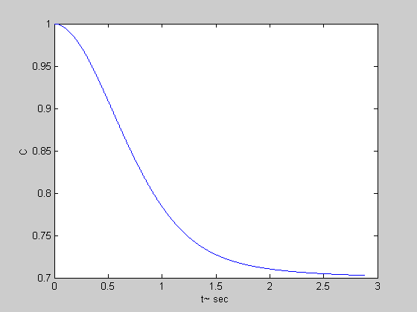
Fig 3.13 Solution of eq . (27) .

MATLAB code
% Chap 3 problems-non linear DE
C(1) =1 ; C(2) =1;
a= 3 ; b=1; ts1=(1/a)^.5 ; ts2=1/b ;

tf=5.*ts1 ; nstep=5000 ; dt=tf/nstep;

k=1;
for t=[2*dt:dt:tf];
k=k+1;
acel=( -a*(t-dt)*( C(k)-C(k-1) )/dt...
-exp(-b*(t-dt))*C(k)^2 ) ;

C(k+1) = 2*C(k)-C(k-1) +(dt^2)*acel;
end
t=[0:dt:tf];
plot(t,C) ,xlabel('t~ sec') ,ylabel('C')
Chapter 3 . Problem 17.

A beaker of water initially at 20 celsius is placed over a hot plate at 80 celsius. Ten minutes later the beaker water reaches 50 celsius. Develop an eqaution for the temperature as a function of time. Assume the heat loss rate from the beaker is proportional to the difference in temperature between the beaker and the room.

Data: Initial temperature 20 C , T _{room} =20 C ,final temperature 80 C ,
heat loss rate ~ constant*( T_{beaker} (t) – T_{room}) ~ constant*( T_{beaker} (t) – 20) .
and T(t=10 minutes) = 50 celsius.

Guessing the solution. Suppose the solution includes an inverted exponential and a constant term.

T(t) = A + B ( 1- exp(-λt) .
We have three data points that allow finding A , B and λ.
T(0)= 20 = A + 0 ; A=20 celsius
T(t=∞) = 80 = 20 + B ; B =60 celsius

T(t=10min) = 50 = 20 +60 (1-exp(-10λ) )

exp(-10λ) = 1/2
λ = ln(2) /10 = 6.93E-2 min⁻¹ .

Hence the equation is
T(t) = 20 + 60 {1-exp(-6.93E-2 t) } , t~ minutes

From the plot (see below) we see it has reached 65 celsius in 20 minutes.
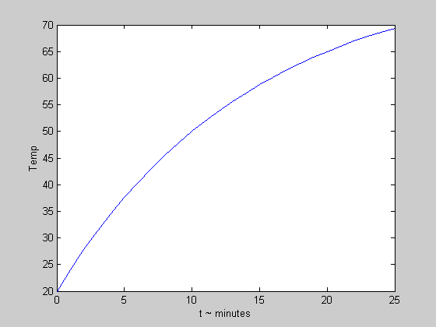

Fig 3.14 Temperature of the beaker.

MATLAB code
lambda=6.93E-2;
t=[0:1:25];
Temp= 20 + 60*(1-exp(-lambda*t) );
plot(t,Temp),xlabel('t ~ minutes'),ylabel('Temp')

Continuation of problem 17. Obtain the DE.

Suppose the heat gained by the beaker is proportional to
the difference (T _{hot plate} – T _{room} )

∆ Q _{gained} ~ ( T _{hot plate} – T _{room} ) .
The beaker loses heat ∆ Q _{lost} ~ -( T_{beaker}(t) – T_{room} ).
The net heat flow is

∆ Q ~ T _{hot plate} – T _{room} - (T_{beaker}(t) – T_{room})

~ (T _{hot plate} - T_{beaker}(t) ) .

The temperature increase in an interval ∆t is proportional to ∆ Q ,

∆ T = ∆t λ λ ~ 1/time . The DE for the beaker temperature is

dT/dt = λ ( 80-T ).
Integrating gives
- ln( 80 –T) = λ t + constant . Solving for T(t)

80- T(t) = A exp( - λ t) or

T(t) = 80 + A exp(- λ t) .

Applying the IC T(t=0) =20 determines the value A= -60 celsius.Then
T(t) = 80 -60 exp(- λ t) or T(t)= 20 + 60(1-exp(- λ t) .

Problem 18.
A patient is given 5 microcuries of iodine , ¹³¹ I. Two hour later 0.5 microcuries had been absorbed by the thyroid. Assume it is a linear process an estimate the absorption at two hours if the initial dose was 15 microcuries. Since the initial dose has been multiplied by three the absorption at two hours increases by the same factor of three. Thus we can expect the thyroid to absorb 3 (0.5) =1.5 microcuries of ¹³¹ I .

END OF CHAPTER 3.

