Lecture 5. - Part 2

Compartmental Problems

by Reinaldo Baretti Machín

www.geocities.com/serienumerica4
www.geocities.com/serienumerica3
www.geocities.com/serienumerica2
www.geocities.com/serienumerica

For questions and suggestions write to:
reibaretti2004@yahoo.com

Reference :

1. Mathematical Techniques for Biology and Medicine (Dover Publications- Paperback)
by William Simon ; http://www.amazon.com/Mathematical-Techniques-Biology-Medicine-William/dp/0486652475/ref=sr_1_1?ie=UTF8&s=books&qid=1223731765&sr=8-1

2. http://geocities.com/serienumerica4/Lecture1Biolologymedicine.doc
3. Mathematical Biology: I. An Introduction (Interdisciplinary Applied Mathematics) by James D. Murray

4. http://www.geocities.com/serienumerica4/Lecture3Biolologymedicine.doc

5. Schaum's Outline of Advanced Mathematics for Engineers and Scientists by Murray R Spiegel
6. Schaum's Outline of Laplace Transforms by Murray R Spiegel

7. http://www.mathworks.com/access/helpdesk/help/toolbox/symbolic/index.html?/access/helpdesk/help/toolbox/symbolic/laplace.html&http://search.yahoo.com/search?p=MATLAB+laplace+transfom&ei=utf-8&fr=b1ie7

Examples and problems are taken from:
Chapter 5 of Reference 1. The problem numbers refer to the textbook listing.

Sections 7 and 8.

The following example uses arbitrary parameters for I , F ,C not reflecting physiological values.

In a one compartment problem with out flow F ~ liters/minute the initial concentration is given as C(0) = 1 mole/liter with an input

I(t) = 10 ~ moles/min 0 ≤ t ≤ 10 minute
I(t) = 0 t >10 minute

Write the DE and solve it. In an interval ∆t the gain and loss in the one compartment are

∆Q = (∆t) ( I – F C ) , divide by V and take the limit ∆t→ 0 ,

lim (∆Q/(V ∆t)) = dC/dt = I(t)/V – (F/V) C(t) .

Using finite differences we get the solution

C(t_{n}) = C(t_{n-1}) + (∆t) { I(t_{n-1})/V – (F/V) C(t_{n-1}) }

Data

V=8. liters ,F= 1.25liters/minute ,Input= 10. moles/minute

Fig. C(t) when the input is a step function of 10 minutes duration

FORTRAN code
c from page 108 MATh Tech Biol & Med.
real input
data v,input,tf /8.,10,20./
f=10./v
tscale=V/F
dt=tscale/1000.
nstep=int(tf/dt)
print*,'nstep', nstep
kp=int(float(nstep)/60.)
kount=kp
c0=1.
Print*,'V,F,Input=', V,F,Input
print*,' '
print 100 ,0. ,c0 ,input
do 10 i=1,nstep
t=dt*float(i)
if(t.gt.10.)input=0.
c1=c0+dt*(input/V-(F/V)*c0)
if(i.eq.kount)then
print 100 ,t ,c1 ,input
kount=kount+kp
endif
c0=c1
10 continue
100 format(1x,'t,c(moles/liter),Input=',3(3x,e10.3))
stop
end

Problem 1.

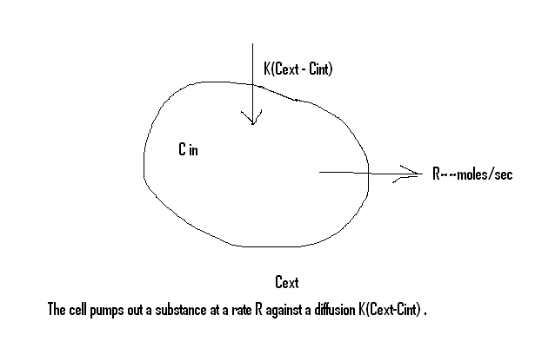
Write the corresponding DE.
In an interval ∆t the loss and gains are

∆Q = ∆t { -R + K ( C_{ext} – C_{int} (t) ) }
Dividing by (∆t V) wher v is the cell’s volume we get

dC/dt = { -R/V +(K/V) ( C_{ext} – C_{int} (t)) }.
When the steady state value is achieved dC/dt=0 ,so

C_{ext} – C_{int} = (V/K)(R/V) or

C_{int} = C_{ext} –R/K .
Let -R/V +(K/V)C_{ext} = a and (K/V) = b . The Laplace transform with C(0)=c0 of the DE gives

sc(s) –c0 =a/s –bc(s) , thus ;

c(s) = c0/(s+b) +a/(s*(s+b))

Employing MATLAB we get
syms a b s t c0 ;
>> cs=c0/(s+b) +a/(s*(s+b)) ;
>> ilaplace(cs)

ans =

C(t) = a/b+exp(-b*t)*(c0*b-a)/b .

Problem 4. An organ and its contained blood are represented by a two compartment scheme , see figure. Both contain identical initial concentrations of a tracer C₀ = C₁(0) = C₂(0). There is diffusion of the tracer between blood and tissue. At time zero blood begins to flow outside of tissue. Find the DE for C₁ and C₂ and show that C₂ satisfies the 2nd order

V₁ V₂ d² C₂/dt² +[V₁K +(F+K)V₂ ] dC₂/dt + FKC₂ = 0 (a)

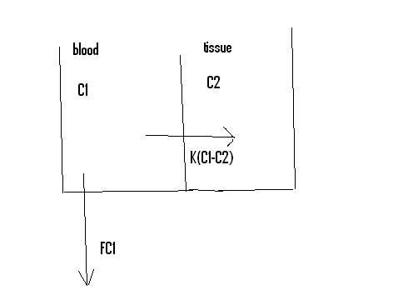
Figure for problem 4.

Eq (a) is corresponds to a damped oscillator ,see for example eq. 9 table III-1 of Simon textbook. Let in this case K₁² < 4 K₂. Part of the exponential solution become imaginary i.e. produces oscillatory motion.

Our solution:
Recall always that C~moles/volume , K ~volume/time
F~ volume/time

From what was explained in previous lectures about the two compartment problem we pose the DE ,

V₁ d C₁/dt = - K (C₁ – C₂) – F C₁ ~ moles/time (b)

V₂ d C₂/dt = +K (C₁ – C₂) ~ moles/time (c )
with IC C₀ = C₁(0) = C₂(0).

In the next plot we have solved numerically (b) and (c) simultaneously with arbitray values C₁(0)=C₂(0)= 0.5 , V1=V2=1 , K=0.1 ,F=.05 . They do not correspond to any particular physiological problem.

Fig . Solutions of eqs (b) –(c).

FORTRAN code solution (b) (c)
c problem 4 page 110 Math Tech for Biology and Medicine
c V1 d C1/dt = - K (C1 - C2) - F C1
c V2 d C2/dt = +K (C1 - C2)
real k
data c1zero, c2zero /.5 ,.5 /
data V1,V2 , K , f / 1. ,1., .1 ,.05/
a1(c1,c2)=(1./v1)*( -k*(c1-c2) -f*c1)
a2(c1,c2)=(1./v2)*(k*(c1-c2))
tsmall= amin1(V1/k,V2/k,V1/f)
tlarge=amax1(V1/k,V2/k,V1/f)
dt=tsmall/100.
tf=5.*tlarge
nstep=int(tf/dt)
kp=int(float(nstep)/60.)
kount=kp
print 100 ,0. , c1zero,c2zero
do 10 i=1,nstep
t=dt*float(i)
c1one=c1zero + dt*a1(c1zero,c2zero)
c2one=c2zero+ dt*a2(c1zero,c2zero)
if(i.eq.kount)then
print 100 , t, c1one,c2one
kount=kount+kp
endif
c1zero=c1one
c2zero=c2one
10 continue
100 format(1x,'t,c1,c2=',3(3x,e10.3))
stop
end

The numerical solution of eq(a) , the second order eq for C₂ is worked out next.

IC , C₂(0)=0.5 and from (b) dC₂(0)/dt=0.
c problem 4 page 110 Math Tech for Biology and Medicine
c V1 d C1/dt = - K (C1 - C2) - F C1
c V2 d C2/dt = +K (C1 - C2)
c V1 V2 d^2c2/dt^2 = -[V1*K +(F+K)*V2 ]* dC2/dt - F*K*C2
real k
data c1zero, c2zero /.5 ,.5 /
data V1,V2 , K , f / 1. ,1., .1 ,.05/
a3( c2zero,c2one)=(-1./(v1*v2))*( (v1*k+(f+k))*(c2one-c2zero)/dt
$ + f*k*c2one)
dc2dt=(1./v2)*k*(c1zero-c2zero)
tsmall= amin1(V1/k,V2/k,V1/f)
tlarge=amax1(V1/k,V2/k,V1/f)
dt=tsmall/100.
c2one=c2zero+dt*dc2dt
tf=5.*tlarge
nstep=int(tf/dt)
kp=int(float(nstep)/60.)
kount=kp
print 100 ,0. , c2zero
do 10 i=1,nstep
t=dt*float(i)
c2two=2.*c2one-c2zero+dt**2*a3(c2zero,c2one)
if(i.eq.kount)then
print 100 , t, c2two
kount=kount+kp
endif
c2zero=c2one
c2one=c2two
10 continue
100 format(1x,'t,c2=',2(3x,e10.3))
stop
end

Fig . Solution C₂ from the 2nd order DE , eq (a).

We show now how to go from the first order set (b)-(c) to (a).
Take the time derivative of V₁ * eq(c)

V₁ V₂ d² C₂/dt² = +K V₁ ( dC₁/dt – dC₂ /dt )

= K V₁ dC₁/dt

- K V₁ dC₂/dt . (d)

Using eq (b) in (d)

V₁ V₂ d² C₂/dt² = K{- K (C₁ – C₂) – F C₁ }

- K V₁ dC₂/dt

= { -KV₂ dC₂/dt –KF C₁} - K V₁ dC₂/dt

= - { KV₁ + KV₂ } dC₂/dt -FKC₁

Finally substitute for KC₁ = V₂ dC₂/dt + KC₂ to arrive at eq (a),

V₁ V₂ d² C₂/dt² = - { KV₁ + KV₂ } dC₂/dt -F {V₂ dC₂/dt + KC₂}

= -{ FV₂ + K(V₁ + V₂) } dC₂/dt - FKC₂

This shows once that it is possible to go from a set of two 1rst orde DE to second order DE.

However we showed before that we can deal numerically with the simultaneous set.

END OF LECTURE 5

