Lecture 6.

Numerical Methods
by Reinaldo Baretti Machín

www.geocities.com/serienumerica4
www.geocities.com/serienumerica3
www.geocities.com/serienumerica2
www.geocities.com/serienumerica

For questions and suggestions write to:
reibaretti2004@yahoo.com

Reference :

1. Mathematical Techniques for Biology and Medicine (Dover Publications- Paperback)
by William Simon ; http://www.amazon.com/Mathematical-Techniques-Biology-Medicine-William/dp/0486652475/ref=sr_1_1?ie=UTF8&s=books&qid=1223731765&sr=8-1

2. http://geocities.com/serienumerica4/Lecture1Biolologymedicine.doc
3. Mathematical Biology: I. An Introduction (Interdisciplinary Applied Mathematics) by James D. Murray

4. http://www.geocities.com/serienumerica4/Lecture3Biolologymedicine.doc

5. Schaum's Outline of Advanced Mathematics for Engineers and Scientists by Murray R Spiegel
6. Schaum's Outline of Laplace Transforms by Murray R Spiegel

7. http://www.mathworks.com/access/helpdesk/help/toolbox/symbolic/index.html?/access/helpdesk/help/toolbox/symbolic/laplace.html&http://search.yahoo.com/search?p=MATLAB+laplace+transfom&ei=utf-8&fr=b1ie7

Examples and problems are taken from:
Chapter 6 of Reference 1. The problem numbers refer to the textbook listing.

We have already employed a number of tools from numerical methods in solving DE.

Finite difference is perhaps the most simple method to get by.

Another method of choice to solve DE is Taylor series.

If a function and its derivatives are known at a point x₀ one can estimate the value of the function at x₀ + ∆x , using an approximation to the Taylor series. The Taylor series is an infinite sum

y(x₀ + ∆x ) = y(x₀) + ∆x (dy/dx)₀ + (1/2) (∆x)² (d² y/dx²)

+ ..... (1/n!) (∆x)^{n} (d^{n} y/dx^{n}) . (6.1)

In practice we can do with a few terms.

Example 1. (equation 6.4 from ref 1) Consider

dC₂/dt = (F/V₂)C₁(0) exp(-(F/V₁)t) -(F/V₂) C₂(t) (6.2)

with the parameter values V₁= 10 L , V₂ =20 L , F= 1 L/sec and IC
C₁(0)=.3 mole/L , C₂(0)=0.

Substitution in (6.2) gives
dC₂/dt = (1/20)(.3) exp(-.1 t) –(1/20) C₂(t)

dC₂/dt = .015 exp(-.1t) -.05 C₂(t) (6.3)

The second derivative is

d² C₂/dt ² = -1.5E-3 *exp(-.1 t) -.05 dC₂/dt

= -1.5E-3 *exp(-.1 t)
-.05 { .015 exp(-.1t) -.05 C₂(t) } (6.4)

The truncated Taylor series to order (∆t)² is

C₂(t₀ +∆t) = C₂(t₀) + ∆t{ .015 exp(-.1t₀) -.05 C₂(t₀) }

+(1/2)( ∆t)² { -1.5E-3 *exp(-.1 t₀) -.05 [ .015 exp(-.1t₀) -.05 C₂(t₀) ] }

(6.5)

In this equation there are two time scales defined by
tscale1= V₁/F = 10 sec ; tscale2 = V₂/F= 20 sec.

So one must choose ∆t << 10 sec to apply the Taylor series.

Fig 6.1 Taylor series solution of equation (6.3).

FORTRAN code
c solution by Taylor series to 2nd order of
c dC2/dt = .015 exp(-.1t) -.05 C2(t)
data c2zero/0./
tfinal=40.
dt=10./100.
nstep=int(tfinal/dt)
kp=int(float(nstep)/70.)
kount=kp
print 100 ,0., c2zero
do 10 i=1,nstep
t=dt*float(i)
c2one=c2zero+dt*(.015*exp(-.1*(t-dt)) -.05*c2zero) +
$.5*dt**2*(-1.5E-3*exp(-.1*(t-dt))-.05*(.015*exp(-.1*(t-dt)) -
$ .05*c2zero ) )
if(i.eq.kount)then
print 100 ,t, c2one
kount=kount+kp
endif
c2zero=c2one
10 continue
100 format(1x,'t,C2=',2(3x,e10.3))
stop
end

Example 2. Solve by Taylor series the 2nd order DE

d²y/dt² + b dy/dt + c y =0 , (6.6)

where b= 1 /s , c= 1/s² and IC

y(0)=1 , dy(0)/dt=0. This is the equation of a damped oscillator.

The solution to second order is,

y(t₀ + ∆t ) = y(t₀) + ∆t (dy/dt)₀ + (1/2) (∆t)² (d² y/dt²) . (6.7)

One also needs a “Taylor series” for the first derivative which is

dy( t₀ +∆t )/dt = dy( t₀)/dt + ∆t [d² y(t₀) /dt²] (6.8)

This value (6.7) is needed because the equation is of the second order and the previous y(t₀) and (dy/dt)₀ are needed.

Inserting d²y/dt² = - dy/dt - y in (6.7) and (6.8) the two truncated Taylor series become

y(t₀ + ∆t ) = y(t₀) + ∆t (dy/dt)₀ + (1/2) (∆t)² (- (dy/dt)₀ - y₀ ) (6.9)
and

dy( t₀ +∆t )/dt = (dy/dt)₀ + ∆t ( - (dy/dt)₀ - y₀ ) . (6.10)

Fig. 6.2 Solution of d²y/dt² + dy/dt + y =0 , IC y(0)=1, dy(0)/dt=0.

FORTRAN code
c taylor series fro 2nd order DE
data y0,dydt0/1.,0./
dydt2(dydt,y)= -dydt-y
dt=1./100.
tfinal=8.
nstep=int(tfinal/dt)
kp=int(float(nstep)/80.)
kount=kp
print 100 ,0.,y0
do 10 i=1,nstep
t=dt*float(i)
c Taylor series up to dt**2 for the position
y1=y0 +dt*dydt0 +.5*dt**2*dydt2(dydt0,y0)
c Taylor series up to dt for the velocity
dydt1=dydt0+dt*dydt2(dydt0,y0)
if(i.eq.kount)then
print 100 ,t, y1
kount=kount+kp
endif
y0=y1
dydt0=dydt1
10 continue
100 format(1x,'t,y=',2(3x,e10.3))
stop
end

3. Numerical solution of a circular chain reaction with changing rate constant
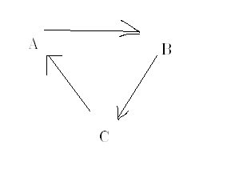
Fi 6.3 Simplified representation of a circular reaction.

The DE are

dA/dt = - K₁ A + K₃ C (6.11)
dB/dt = - K₂ B + K₁ A
dC/dt = - K₃ A + K₂ B

with specified initial conditions A(0) , B(0) and C(0) ~ moles

In chapter 2 the circular reaction DE equations were solved with constant K_{i}.

Now we take one of the rate constants to be variable ,

say K₁ (t) = K₁₀ + m t .

The finite difference solutions to (6.11) are

A(t_{n} ) = A( t _{n-1} ) + ∆t { - K₁(t_{n-1} ) A(t_{n-1}) + K₃ C (t_{n-1}) } (6.12)

B(t_{n} ) = B( t _{n-1} ) + ∆t { - K₂ B(t_{n-1}) + K₁(_{tn-1} ) A(t_{n-1}) }

C(t_{n} ) = C( t _{n-1} ) + ∆t { - K₃ C(t_{n-1}) + K₂(t _{n-1} ) B(t_{n-1}) }

Let A(0) = 300 micro mol, B(0)= 60 micro moles and C(0)=30 micro moles.
Let the rate constants be ;
K₁ = 0.1 + [(10-.1)/2] t for t ≤ 2 s ,
K₁ = .1+9.9=10.0/s for t ≥ 2 s.

while K₂ = 2/s , K₃ = 1.0/s .

The slope m of K₁ is (9.9/2) /s² = 4.95/s²

The results are plotted in fig 6.4

Fig 6.4 Concentrations for the circular reaction with variable K₁.

FORTRAN code
c Problem from Math Tech for BIOL & MED page 119 Simon
real k1,k2,k3
data k2,k3/2.,1./
data a0,b0,c0 /300.,60.,30./
tsmall=amin1(1./10.,1./k2,1./k3)
tf=4.
dt=tsmall/100.
nstep=int(tf/dt)
kp=int(float(nstep)/60.)
kount=kp
print 100 ,0., a0,b0,c0
do 10 n=1,nstep
t=dt*float(n)
a1=a0+dt*(-k1(t-dt)*a0+k3*c0)
b1=b0+dt*(-k2*b0 +k1(t-dt)*a0)
c1=c0+dt*(-k3*c0+k2*b0)
if(n.eq.kount)then
print 100 , t,a1,b1,c1
kount=kount+kp
endif
a0=a1
b0=b1
c0=c1
10 continue
100 format('t(s),A(micromol),B,C=',4(3x,e10.3))
stop
end

function k1(t)
real k1
k1=0.1+ (9.9/2.)*t
return
end

Section 4.

Consider a first order pair of coupled DE for two metabolic substances A and B given by

dA/dt = (R1 – a B) – R1’ ( 6.13 )

dB/dt = R2 - ( R2’ – b A ) . ( 6.14 )

A and B represent the quantity of moles above or below the equilibrium quantities A(equilibrium) and B(equilibrium ). Thus both A and B may oscillate between positive and negative values.

The figure serves to illustrate the kinetics involved.

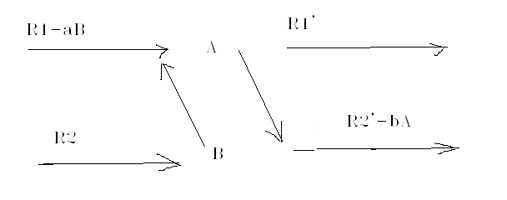
Fig. 6.5 . If B > 0 the term –aB inhibits the formation of A. On the contrary if B < 0, the term –aB augments the formation of A.
Like wise a positive A inhibits the loss of B and a negative value of A increases the loss of B.

The dimensions could be the following.
A, B ~ moles , R ~moles/time , a~1/time , b~ 1/time.
The rate constans R1 , R1’ ,R2, R2’are independent of the concentrations A or B .

Modified example from page Ref 1, 121.

Take the set of values
A(0)= 300 micro moles a= 1/s
B(0)= 200 μ mol b= 10/s

R1= 200 μ mol/s R1’= 100 μ mol/s
R2= 20 μ mol/s R2’ = 10 μ mol/s

We convert (6.13 ) – (6.14) into the finite difference expressions

A(t_{n} ) = A( t _{n-1} ) + ∆t { R1- aB(t_{n-1}) – R1’ } (6.15)
and

dB/dt = R2 - ( R2’ – b A )

B(t_{n} ) = B( t _{n-1} ) + ∆t { R2 – R2’ + bA(t_{n-1}) }

There are two time scales in this DE ,
tscale1 =1/a= 1.0 s , tscale2=1/b =0.1 s .
One has to take ∆t << tscale2.

Fig 6.6- Plot of A and B in a reaction with mutual feedback. Oscillations with a 2.0 second period.

FORTRAN code
c Simon section 4 page 121
data r1, r1prime ,r2,r2prime/200.,100.,20.,10. /
data smalla,smallb/1.,10. /
data a0,b0/300.,200. /
tsmall=amin1(1./smalla,1./smallb)
c tfinal=10.*amax1(1./smalla,1./smallb)
tfinal=4.
dt=tsmall/100.
nstep=int(tfinal/dt)
kp=int(float(nstep)/70.)
kount=kp
print 100 ,0.,a0,b0
do 10 i=1,nstep
t=dt*float(i)
p= r1-smalla*b0
q= r2prime-smallb*a0
c if(p.lt.0.)p=0.
c if(q.lt.0.)q=0.
a1=a0+dt*(p-r1prime)
b1=b0+dt*(r2-q)
c if(a1.lt.0.)a1=0.
c if(b1.lt.0.)b1=0.
if(i.eq.kount)then
print 100 ,t, a1,b1
kount=kount+kp
endif
a0=a1
b0=b1
10 continue
100 format('t(sec),A,B=',3(3x,e10.3))
stop
end

Problem 1 , page 124.

Solve numerically

dC/dt = a t C(t) , a =0.1 /s² , C(0)=2.

tscale = 1/ a^{1/2} = 3.16 s

The finite difference solution is

C(t_{n}) = C( t_{n-1} ) + ∆t { a t_{n-1} C(t_{n-1} ) } .

MATLAB code
% Simon page 124
a=.1; c(1)=2. ; tscale=1/a^(1/2) ;
dt =tscale/100 ; tfinal=3*tscale ;

k=1;
for t=[dt:dt:tfinal];
k=k+1;
c(k)=c(k-1)+dt*a*(t-dt)*c(k-1) ;
end

t=[0:dt:tfinal];
plot(t,c),xlabel ('time '), ylabel('C(t)')

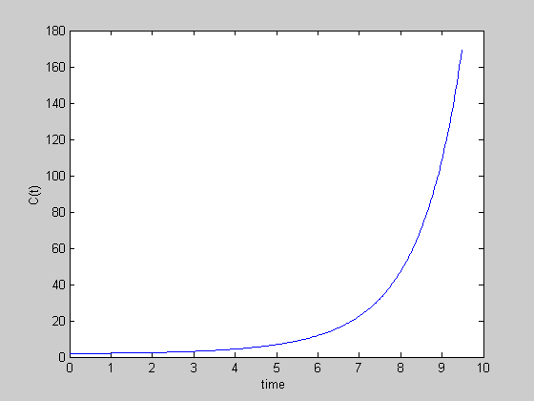

Fig 6.7 Solution of dC/dt = a t C(t) .

Problem 3.
Solve the following DE numerically.

dy/dt = 100 + y , IC y(0)=0.
The analytical answer is readily found

∫ dy/(100+y) = ∫ dt + C

ln ( 100+y ) = t+c
100+ y = exp ( c ) exp( t)

y= 100- exp(c) exp(t) .
Applying the IC y(0)=0 = 100 – exp(c) , gives exp(c) =100. finally
y(t) = 100(1-exp(t) ).

To solve it numerically we write the finite difference solution

y(t_{n}) = y(t_{n-1}) +∆t { 100 + a y(t_{n-1} ) }.

We have introduced a “factor a =1/s ” in order to define the time scale,
tscale= 1/a = 1.0 s

MATLAB code
% Simon Prob 3 -page 125
a=1; y(1)=0. ; tscale=1/a ;
dt =tscale/100 ; tfinal=3*tscale ;

k=1;
for t=[dt:dt:tfinal];
k=k+1;
y(k)=y(k-1)+dt*(100+y(k-1)) ;
end

t=[0:dt:tfinal];
plot(t,y),xlabel ('time '), ylabel('Y(t)')

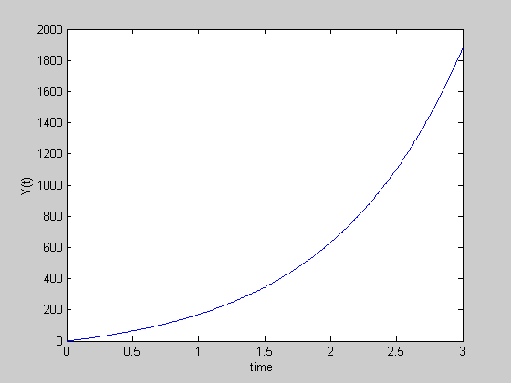

Fig 6.8 Solution of dy/dt = 100 + y , IC y(0)=0 .

Problem 4. The logistic equation (LE).

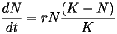

Let N(t) be a population at time t , r a rate of growth ~ 1/time , K some

population “limit”.
If K>>N , dN/dt = r N , and the population grows as N=N(0)exp(rt).

This answer is unrealistic in the long run. The logistic equation sets a limit to growth.

The logistic equation is non linear

dN(t)/dt = r N(t) – (r/K) N(t)² .

We may view the DE as containing two time scales
first tscale1 = 1/r but a larger time scale is represented by

tscale2=K/(rN) = (K/N)tscale1

Let N(0)=1.E 9 K=6.5 E9 and r=.02/year

We solve the LE using the following code with two different values of the limiting population.

MATLAB code

% Simon Prob 4 -page 125
r=.02; N(1)=1.e9 ; K=6.5E9 ; tscale=1/r ;
dt =tscale/100 ; tfinal=6*tscale ;

k=1;
for t=[dt:dt:tfinal];
k=k+1;
N(k)=N(k-1)+dt*(r*N(k-1)-(r/K)*N(k-1)^2) ;
end

t=[0:dt:tfinal];
plot(t,N),xlabel ('t~years'), ylabel('Population')

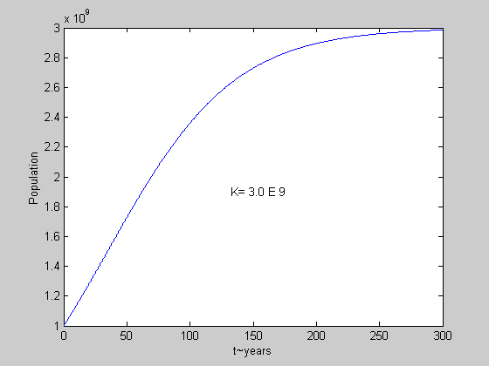
Figure 6.9 Population growth with K= 3 E9.

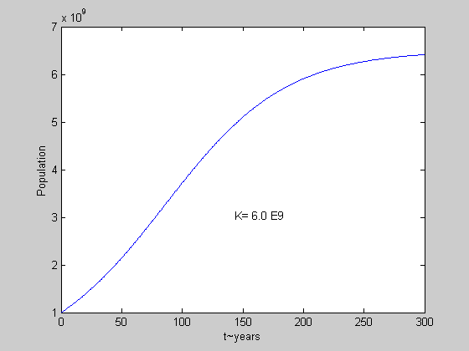

Figure 6.10 . Population growth with K= 6 E9.

Problem 5 . Van der Pol equation (VdP).

Solve the non linear equation

d² y/dt² –λ (1- y²)(dy/dt) + y = 0 .

with y adimensional , λ = 0.4 /s nad IC y(0)=0.1 , dy(0)/dt = 0 .

To know what to expect , recall first the equation of the damped oscillator

d² y/dt² +b (dy/dt) + c y = 0 .

When comparing with VdP we see that c=1 and b is variable like

b ~ –λ (1- y²).

In the damped oscillator the solution is governed by terms

y ~ exp(-bt/2)exp( (+/-)ω t) , where ω = (1/2) ( b² -4 c) ^{1/2} .

It may happen that (1-y²) > 0 , therefore b is negative. It would tend increase the amplitude y through the first factor

exp(-bt/2) , if at the same time (b² -4 c ) > 0 there are no imaginary

exponentials and therefore no oscillatory behavior.

If b < 0 and (b² -4 c ) < 0 there can be oscillatory motion.

Another possibility is that at an instant (1-y²) < 0 , therefore b is positive
and the amplitude y would decrease if there is an oscillatory motion.

But if y decreases sufficiently it send the solution to the first instance where

(1-y²) > 0 .

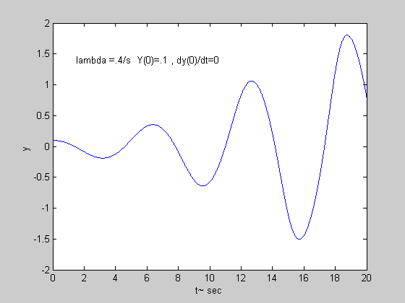
Fig 6.11. An oscillation with increasing amplitude is produced.

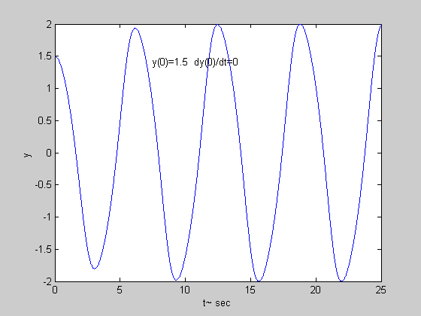

Fig 6.12. The same lambda but different initial conditions y(0)=1.5 , dy/dt=0

MATLAB code for problem 5
% Simon Prob 5 -page 126
lambda=.4; y(1)=.1 ; y(2)=.1 ; tscale=1/lambda ;
dt =tscale/400 ; tfinal=8*tscale ;

k=1;
for t=[2*dt:dt:tfinal];
k=k+1;
dydt=(y(k)-y(k-1))/dt;
y(k+1)=2*y(k)-y(k-1) + dt^2*(+lambda*(1-y(k)^2)*dydt...
-y(k));
end
t=[0:dt:tfinal];
plot(t,y),xlabel('t~ sec'), ylabel('y ')
END OF LECTURE 6

