Lecture 8. Diffusion

by Reinaldo Baretti Machín
and Alfonso Baretti Huertas

www.geocities.com/serienumerica4
www.geocities.com/serienumerica3
www.geocities.com/serienumerica2
www.geocities.com/serienumerica

For questions and suggestions write to:
reibaretti2004@yahoo.com

Reference :

1. Mathematical Techniques for Biology and Medicine (Dover Publications- Paperback)
by William Simon ; http://www.amazon.com/Mathematical-Techniques-Biology-Medicine-William/dp/0486652475/ref=sr_1_1?ie=UTF8&s=books&qid=1223731765&sr=8-1

2. http://geocities.com/serienumerica4/Lecture1Biolologymedicine.doc
3. Mathematical Biology: I. An Introduction (Interdisciplinary Applied Mathematics) by James D. Murray

4. http://www.geocities.com/serienumerica4/Lecture3Biolologymedicine.doc

5. Schaum's Outline of Advanced Mathematics for Engineers and Scientists by Murray R Spiegel
6. Schaum's Outline of Laplace Transforms by Murray R Spiegel

7. http://www.mathworks.com/access/helpdesk/help/toolbox/symbolic/index.html?/access/helpdesk/help/toolbox/symbolic/laplace.html&http://search.yahoo.com/search?p=MATLAB+laplace+transfom&ei=utf-8&fr=b1ie7

8. Theoretical Physics (Paperback) by Georg Joos (Author), Ira M. Freeman , page 489.

9. Numerical Solution of Differential Equations by Ph. D., D. Sc. William Edmund Milne

10. Numerical Analysis by Richard L. Burden and J. Douglas Faires

11. Schaum's Outline of Numerical Analysis by Francis Scheid

Examples and problems are taken from:
Chapter 8 of Reference 1. The problem numbers refer to the textbook listing.

The heat flow equation is

∂² u /∂ x² = (1/α²) ∂ u /∂ t (1)

where u can represent a temperature or a concentration of a diffusing substance like chemical or particles concentrations. x ~ is position along the Xaxis , t time and α ~ length / time^{1/2} is the diffusivity constant which depends on specific properties of the material

Consider an infinitesimal volume dV= dx dy dz =A dx or Ady or A dz from which heat is flowing out due to a temperature gradient at the walls.

For simplicity let the heat flow be only at the walls xith x= 0 and the the wall x = dx.

∂Q/∂t = k A ( (∂T /∂x)_{x=0 + dx} - (∂T /∂x)_{x=0} ) (2)

where k~ energy/(time-length-kelvin) .

The substraction comes because the area A and the the gradients are vectors.
The area at the right extreme (x=0) points left and the area at x=dx points to the right.

Expanding (∂T /∂x)_{x=0 + dx} ≈ (∂T /∂x)_{x=0} + (dx)( (∂ ²T /∂x²)_{x=0} converts (2) in

∂Q/∂t = k A (dx)( (∂ ²T /∂x²)_{x=0} = k (∂ ²T /∂x²)_{x=0} dV . (3)

On the other hand the calorimetry formula relates heat with mass, specficic heat c and change in temperature

∆ Q = m c ∆ T = ρ ∆ V c ∆ T (4)

where ρ ~mass/volume , ∆ V element of volume , c ~energy/(mass-kelvin).

Passing to infinitesimals (4) becomes

∂Q/∂t = ρ c dV ∂T/∂t (5)
Equating (3) with (5) gives

k (∂ ²T /∂x²) = ρ c ∂T/∂t ,
or
(∂ ²T /∂x²) = (ρ c/k) ∂T/∂t ,

≡ (1/α²) ∂ T/∂ t (6)

where α² = k/(ρ c) ~ length²/time.

Section 12. Time dependent diffusion.

The analytical solution of (6) will be obtained for a uniform bar ( or infinite slab) that extends from x=0 to x= L . The initial temperature of the bar is 100 degrees , T(x,t=0)=100. The end point points ,(“ boundary conditions” ) are kept at 0 degrees, i.e. T(x=0,t) =T(x=L,t) =0. Heat diffuses out of the bar from both ends and eventually will reach the equilibrium temperature of 0 degrees.

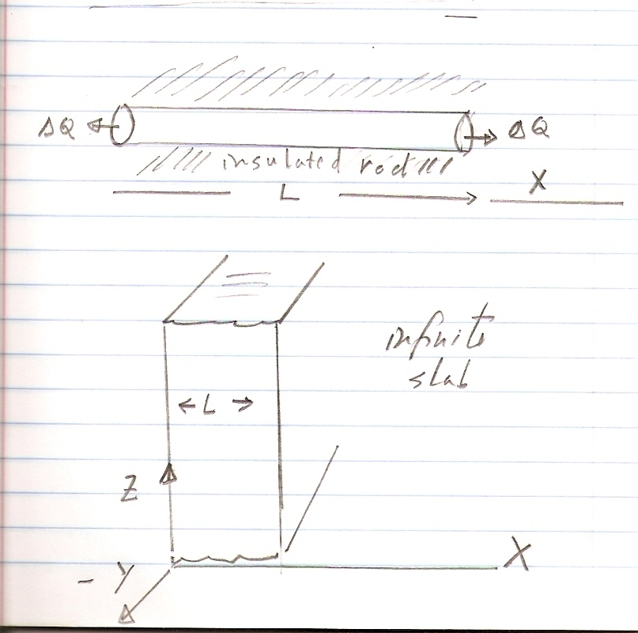
Fig 8.1 In this example an insulated rod or an infinite slab is initially, at its interior points, at a temperature T(x,0)=100 degrees while its extremes are kept fixed at T(x=0,t)=T(x=L,t) = 0. degrees at all times. Heat flow occurs only at the end points.

For convenience we rewrite now the diffusion equation as

∂ T/∂ t = K (∂ ²T /∂x²) , (7)

with K ~ length²/time .

The standard analytical method for the solution of (6) consists in assuming separation of variables. One takes

T(x,t) = g (t) h(x) . (8)

Then eq(7) leads to

h(x) d g(t)/dt = K g(t) d² h(x)/dx² . (9)

Divide (9) by g(t) h(x) to get

(1/g) dg/dt = K (1/h) d² h(x)/dx² . (10)

The left side of (10) is a function of t only and the right side is a function of the position x.

A separation parameter λ is introduced to satisfy

(1/g) dg/dt = - β = K (1/h) d² h(x)/dx² . (11)

As will be seen shortly there is a whole set of parameters β ~1/time , that are necessary when the boundary conditions are applied. For this reason we append a subscript (n) to read

(1/g) dg/dt = - β _{n} = K (1/h) d² h(x)/dx² (12)

The solution will in the from of a series

T(x,t) = ∑ _{n} g_{n}(t) h_{n}(x) . (13)

Let
g_{n} (t)=exp(-β _{n} t) . (14)
The DE for h(x) is

d² h(x)/dx² = - (β _{n} /K ) h(x)
≡ - λ² _{n} h(x) , (15)
where λ² _{n} = β _{n} /K ~ 1/length² .
Equation (15) is the DE of the “harmonic oscillator” , whose general solutions are the sum of sine and cosine functions.

Thus
h_{n}(x) = A_{n} cos(λ _{n} x) + B_{n} sin(λ _{n} x ) . (16)

At this point we will justify the inclusion of the subscript n.

Applying the boundary conditions
T(x=0,t) = 0 = g (t) {A_{n} cos(λ _{n} x) + B_{n} sin(λ _{n} x )}_{x=0} , (17)
gives
0 = A_{n} = 0 .
At x=L we have that ,
T(x=L,t) = 0 =g(t) { B_{n} sin(λ _{n} x ) }_{x=L} .

B_{n} can not be zero because we are left without a solution.
So the trigonometric function has to satisfy
sin(λ _{n} L) = 0 ,which implies

λ _{n} L = n π ( n=1,2,3,4…..)

and therefore
λ _{n} = (n π /L ) . (18)

So the expression (13) is

T(x,t) = ∑ _{n=1} B_{n} exp(-β _{n} t) sin(λ _{n} x) , (19-a)

or
T(x,t) = ∑ _{n=1} B_{n} exp(-K(λ _{n} )² t) sin(λ _{n} x) . (19-b)

with B_{n} to be determined from the initial temperature distribution T(x,t=0).

Let T(x,t=0) = f(x) .
Then from (19)
f(x) = ∑ _{n=1} B_{n} sin(λ _{n} x) . (20)

Multiply by a specific sine term, say sin (λ _{m} x) and integrate from from x=0 to x = L. We get

∫ ^{L} ₀ f(x) sin (λ _{m} x) dx = (L/2) B_{m} ,
or
B _{m} = (2/L) ∫ ^{L} ₀ f(x) sin (λ _{m} x) dx . (21)

In our example f(x) =100. The coefficients turn out to be

B_{n} = (4/(nπ)) (100) for odd n

B_{n} = 0 for even n .

Inserting B_{n} in (19) gives the final expression

T(x,t) = ∑ _{n=0} {400/((2n+1)π)} exp(-K (λ _{2n+1} )² t) sin(λ _{2n+1} x) . (22)

Example : In eq(22) let L= 1 meter , K=1.0E-3 m²/s , find T(x,t) various time instants. T_{scale} = L²/K = 1E3 seconds.

Fig 8.2 Plots of T(x,t) –eq (22) with L=1 meter , K= 1.E-3 m²/s

Fig 8.3 shows the result of applying a parabolic approximation to the diffusion problem given here. It is based on the forward difference method. From eq (7) we have ( see references 9,10)

T(x,t+∆t) = T(x,t) +
(∆t K/ (∆x)² ){ T(x+∆x,t) -2T(x,t)+T(x-∆x,t) } . (23)

In eq(23) T(x,t) is known.

Let x= L/2 and ∆x=L/2 , taking into account the BC, T(x+∆x,t)= T(L,t)=0 and T(x-∆x,t)=T(0,t)=0. We have to calculate only one value of T at a time
t + ∆t , which is (since T(L/2,t) is known ) ,

T(L/2,t+∆t) = T(L/2,t) + (∆t K/ (∆x)² ){ -2T(L/2,t) } . (24)

The intervals ∆t and ∆x have to satisfy the inequality
(∆t K/ (∆x)² << ½ . (25)

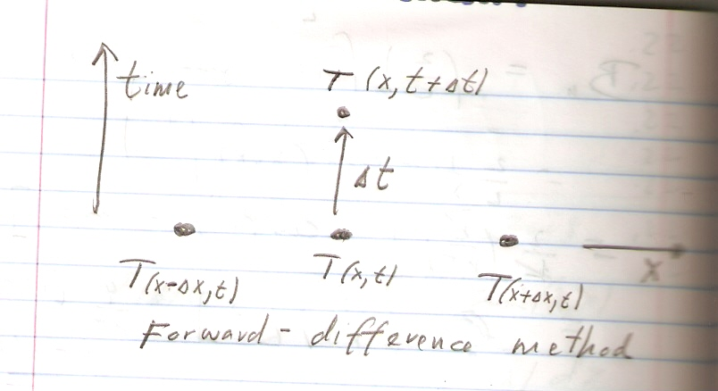
Fig 8.3 Forward difference method.

At a given instant we have three values of the temperature
g₀ = T(0,t) , g₁ = T(L/2,t) , g₂ = T(L,t) at fixed points
x₀ = 0 , x₁=L/2 and x₂=L .

A Lagrange interpolation polynomial of the second order (see Ref 11 ,chapter 12) would be
T(x,t) ≈ g₀*(x-x1)*(x-x2)/((x0-x1)*(x0-x2)

+ g₁*(x-x0)*(x-x2)/((x1-x0)*(x1-x2))

+ g₂*(x-x0)*(x-x1)/((x2-x0)*(x2-x1)) (26)

In the actual example g₀ = g₂ =0 .

The parabolic approximation to T(x,t) is

T(x,t) = g₁ ( x-x₀) (x-x₂)/ {(x₁-x₀)(x₁-x₂)} ,

= g₁ ( x) (x-L)/ {(L/2)(L/2-L)} ,

= g₁ ( x) (x-L)/ {(L/2)(L/2-L)} ,

= -(4/L²) g₁x(x-L) . (27)

Fig 8.2 Plot with a parabolic approximation. Compare with the exact solution in fig 8.1 .

FORTRAN code for eq (22).
c heat diffusion in a bar or slab
real L ,k
data L,k/1.,1.e-3/
data nt,nx,nterms/4,10, 10/
pi=2.*asin(1.)
tscale=L**2/k
deltat=.2*tscale/float(nt)
deltax=L/float(nx)
do 10 it=1,nt
t=deltat*float(it)
do 20 ix=0,nx
x=deltax*float(ix)
call temp(pi,nterms,L,K,x,t,tempx)
print 100 , t,x,tempx
20 continue
print*,' '
10 continue
100 format('t,x,Temp=',3(3x,e10.3))
stop
end

subroutine temp(pi,nterms,L,K,x,t,tempx)
real L , K
sum=0.
do 10 n=0,nterms
an=2.*float(n)+1.
bn=(400./(an*pi))
al=an*pi/L
arge=k*al**2
sum=sum+bn*exp(-arge*t)*sin(al*x)
10 continue
tempx=sum
return
end

FORTRAN code for a parabolic approximation
c parabola approximation to heat diffusion equation
real L ,k
dimension told(0:200),tnew(0:200)
data L,k/1.,1.e-3/
data nx,nx2,x0,x1,x2/2,10,0.,.5,1./
pi=2.*asin(1.)
deltax=L/float(nx)
dx=L/float(nx2)
tscale=deltax**2/(2.*k)
dt=tscale/50.
tfinal=200.
nt=int(tfinal/dt)
told(0)=0.
told(1)=100.
told(2)=0.
do 10 it=1,nt
t=dt*float(it)
tnew(1)=told(1)+(dt*K/(deltax)**2)*(-2.*told(1))
told(1)=tnew(1)
tnew(0)=told(0)
tnew(2)=told(2)
10 continue
g1=tnew(1)
g0=told(0)
g2=told(2)
do 20 ix=0,nx2
x=dx*float(ix)
call tlagr(g0,g1,g2,x0,x1,x2,x,tempx)
print 100 , t,x,tempx
20 continue
print*,' '
100 format('t,x,Temp=',3(3x,e10.3))
stop
end

subroutine tlagr(g0,g1,g2,x0,x1,x2,x,tempx)
real Lg0,LG1,Lg2
Lg0(x)=g0*(x-x1)*(x-x2)/((x0-x1)*(x0-x2))
Lg1(x)=g1*(x-x0)*(x-x2)/((x1-x0)*(x1-x2))
Lg2(x)=g2*(x-x0)*(x-x1)/((x2-x0)*(x2-x1))
tempx=lg0(x)+lg1(x)+lg2(x)
return
end

Section 4. Chemical diffusion

Chemical diffusion through a thin layer, with no losses, obeys eq (1)

∂C(x,t)/ ∂t = K ∂²C(x,t) /∂x² (28)

where C~ moles/volume , K ~ length²/time.

Experimentally it is found that there may be two kinds of losses of the substance C. The substance may decay and be lost at a rate – λC , where
λ ~ 1/time. This is a a concentration dependent loss.
The rod or slice can be porous and a concentration independent loss exists at a rate -R ( R~ moles/(volume-time) ) may occur.
These two terms must be included in the right hand side of (28),

∂C(x,t)/ ∂t = K ∂²C(x,t) /∂x² -R - λC . (29)

Generalizing eq. (23) the forward difference solution to (29) is

C(x,t+∆t) = C(x,t)
+ (∆t K/ (∆x)² ){ C(x+∆x,t) -2C(x,t)+C(x-∆x,t) }

+ ∆t ( -R – λC(x,t) ) . (30)

The inequality involving ∆t and ∆x is now ,

∆t { 2K/ (∆x)² + λ } << 1 . (31)

Examples of steady state one dimensional diffusion:
In the steady state ∂C(x,t)/ ∂t =0 and (29 ) becomes an ordinary DE

d² C(x)/dx² = + (λ/K)C (x) + (R/K) (32)

We may visualize the flow along the X axis in a slab like that of figure 8.1.
The flow , F(x₁), at a plane x= x₁ is defined by

F(x₁) = - A K dC(x₁)/dx ~ length² (length²/time)(moles/volume-length)

~ moles/time

a) Let the IC be C(0) = C0 , dC(0)/dx = C0prime , the solution of (32) are the complementary plus the particular solution.

C(x) = A exp(r x) +B exp(-rx) -R/λ , (33)

where r = (λ/K)^{1/2} .

Applying the IC gives
C0= A + B -R/λ , (34)
C0prime = r A – r B , or
C0prime/r = A – B . (35)
Adding or substracting (34)-(35) leads to

A = (1/2) { C0 + C0prime/r + R/λ } , (36)

B = (1/2) { C0 – C0prime/r + R/λ } . (37)

If one fixes the IC to be C0=0 and C0prime =0 , then

A=B= R/(2 λ) and

C(x)= R/(2 λ) { exp((λ/K)^{1/2} x) + exp(-(λ/K)^{1/2} x) } -R/λ . (38)

Matlab code for plot of (38)
K=1; L=1; R=1;r=(L/K)^(1/2);
x=[0:.05:2.5];

C= -R/L + (R/(2*L))*(exp(r*x)+exp(-r*x));
plot(x,C),xlabel('x '),ylabel('Concentration')

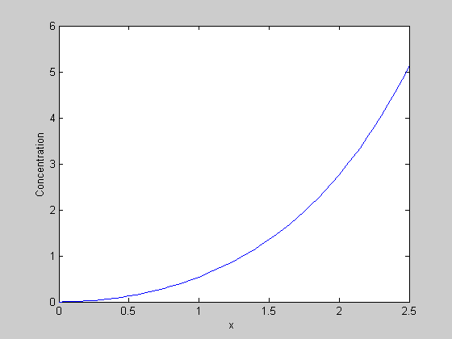

Fig 8.4 Concentration in a semi infinite medium with arbitrary values of λ=1, K=1 , R=1 and IC C(0)=0 , dC(0)/dx=0.

Section 7 : Threshold dependent loss

Suppose we have two regions where eq (32) is modified such that

d² C(x)/dt² = + (λ/K)C (x) , x ≤ 0 (39)

and
d² C(x)/dt² = + (λ/K)C (x) + (R/K) , x ≥ 0 . (40)

We call the C(x=0), the concentration threshold

C(x=0) = C_{T} (R=0) for C ≤ C_{T} .
Let C₁(x) be the solutions of (39) and (40 ) respectively.
The solutions must satisfy

C₁(x=0) = C₂(0) = C_{T} (41)

and

dC₁(x=0) /dx = dC₂(x=0)/dx (42)

The general solution of (39) is

C₁(x) = A exp ((λ/K)^{1/2} x) + B exp ( -(λ/K)^{1/2} x ) . (41)

But by requiring that C₁(x = -∞ ) =0 and C₁(x = 0) = C_{T} , (41) reduces to

C₁(x) = C_{T} exp ((λ/K)^{1/2} x) , x ≤ 0 . (42)

The derivative at the origin is

dC₁(0)/dx = ( λ/K)^{1/2} C_{T} . (43)

C₂(x) is the sum of two exponentials and the particular solution,

C₂(x) = D exp ((λ/K)^{1/2} x) + E exp ( -(λ/K)^{1/2} x ) -R/λ . (43)

Applying the IC we get

C₂(0) = C_{T} = D + E - R/λ (44)

dC₁(0)/dx = ( λ/K)^{1/2} C_{T} = ( λ/K)^{1/2} (D – E ) , or

C_{T} = D – E . . (45)
Thus
D= ( C_{T} + R/(2λ) ) ; E = R/(2λ) . (46)

Inserting in (43) gives

C₂(x) = ( C_{T} + R/(2λ) )exp ((λ/K)^{1/2} x)
+ ( R/(2λ)) exp ( -(λ/K)^{1/2} x ) -R/λ ,

x ≥ 0 . (47)

Fig 8.5 The arbitary values chosen are C_{T} =1moles/volume ,
R=1 mole/(volume-time), L =1/time , K= 1 length² .

Fortran code for figure 8.5
c Simon plot fig 8.8
real k , L ,lscale
data r,L,K,ct/1.,1.,1.,1./
lscale=sqrt(k/l)
xi=-2.*Lscale
xf= Lscale
nstep=60
dx=(xf-xi)/nstep;
do 10 i=0,nstep
x=xi+dx*float(i)
if(x.le.0.)c=CT*exp(sqrt(L/K)*x)
if(x.gt.0.)c=((CT+R/(2.*L))*exp(sqrt(L/K)*x)
$+(R/(2.*L))*exp(-sqrt(L/K)*x)-(R/L) )
print 100,x,c
10 continue
100 format(1x,'x,C(x)=',2(3x,e10.3))
stop
end

Section 8. Semi-Infinite Section with Internal Generation

Recall eq (29)

∂C(x,t)/ ∂t = K ∂²C(x,t) /∂x² -R - λC , where R represents a concentration independent loss. Suppose that instead of a loss, we have a concentration independent gain I ~ moles/(volume-time) .

Then (29 would be
∂C(x,t)/ ∂t = K ∂²C(x,t) /∂x² + I - λC . (47)

In the steady state ∂C(x,t)/ ∂t has become zero and

d²C(x) /dx² -( λ/K) C = -(I/K) . (48)

If we do not apply the criteria of a threshold ,the general solution is the particular solution plus the complementary.

C(x) = (I/λ) + B₁ exp( ( λ/K)^{1/2} x ) + B₂ exp( -( λ/K)^{1/2} x ) . (49)

To find the coefficients B₁ and B₂ one must know two conditions on C(x) , very much like in eqs (44) and (45) above.

Given the the two IC
C(0) = C₀ = (I/λ) + B₁ + B₂ (50)

dC(0)/dx = ( λ/K)^{1/2} (B₁ - B₂ ) (51)

allows us to solve for B₁ , B₂ .
In the next example we solve the finite difference equation

C(x_{n}) = 2 C(x_{n-1}) – C(x_{n-2}) + (∆x)² {( λ/K) C(x_{n-1}) -(I/K) } (52)

choosing (∆x) < < (K/λ)^{1/2} .

Example : IC , C(0) = 1.0E-2 moles/volume , dC(0)/dx =1 moles/length⁴ .
Fig 8.6 Semi infinite section with internal generation I .

FORTRAN code
c Simon page 180
real L , K ,lscale, Intern
data L,k,Intern/1.,1.,1./
data nstep/2000/
lscale=sqrt(k/L)
xi=0
xf=2.*lscale
dx=(xf-xi)/float(nstep)
dcdx=1.
c0=1.e-2
c1=c0+dx*dcdx
kp=int(float(nstep)/60.)
kount=kp
print 100, xi,c0
do 10 i=1,nstep
x=xi+dx*float(i)
c2=2.*c1-c0+dx**2*((L/K)*c1-intern/K)
if(i.eq.kount)then
print 100, x, c2
kount=kount+kp
endif
c0=c1
c1=c2
10 continue
print 100, x, c2
100 format(1x,'x,c(x)=',2(3x,e10.3))
stop
end

Section 9. Finite section with internal generation

Let the size of the slab section or rod be 2D. Assume again there is internal generation I and the DE is
d²C(x) /dx² -( λ/K) C = -(I/K) , -D ≤ x ≤ D.

The choice for the range of x is a matter of conevenience.

The general solution is ( see eq(48) )
C(x) = (I/λ) + B₁ exp( ( λ/K)^{1/2} x ) + B₂ exp( -( λ/K)^{1/2} x ) . (53)

The IC may consist in specifying arbitrary values of C(-D) and C(D) .
Or alternatively one could specify at any point the value of C(x) and its derivative at such point e.g. C(-D) , dC(-D)/dx.

One possible choice is the symmetric case C(-D) = C(D) ≡ A.
Then from (53) we get

A = (I/λ) + B₁ exp( -( λ/K)^{1/2} D ) + B₂ exp( ( λ/K)^{1/2} D ) , x=-D ,
A = (I/λ) + B₁ exp( ( λ/K)^{1/2} D ) + B₂ exp( -( λ/K)^{1/2} D ) , x = +D ,
implying B₁ = B₂ = B .

Then
A = (I/λ) + 2 B cosh(( λ/K)^{1/2} D) , (53)
where the hyperbolic cosine is cosh(u) = (exp(u)+exp(-u))/2.

Then B ={ A- (I/λ) }/(2 cosh(( λ/K)^{1/2} D) and

C(x) = (I/λ) + [A- (I/λ) }/(2 cosh(( λ/K)^{1/2} D) ] 2cosh( ( λ/K)^{1/2} x ) . (54)

Example: Plot (54) with the values A=1.e-2 , I=1 , λ=1 , K=1 , D=1 .

Fig 8.7 Finite section with internal generation.
FORTRAN code for the example
c Simon page 182
real inter,K,L
data inter,A,K,D,L/1.,1.e-2,1.,1.,1./
data nstep/50/
C(x) = (Inter/L) + ((A- (inter/L))/(2.*cosh(sqrt(L/K)*D) ))*
$ 2.*cosh(sqrt(L/K)*x )
xi=-d
xf=d
dx=(xf-xi)/float(nstep)
do 10 i=0,nstep
x=xi+dx*float(i)
print 100,x,c(x)
10 continue
100 format(1x,'x,C(x)=',2(3x,e10.3))
stop
end

Section 10. Spherical radial diffusion

(January 20 , 2009)

UNDER CONSTRUCTION

