Oscillations in the Oral Glucose Tolerance Test (OGTT)
by Reinaldo Baretti Machín

www.geocities.com/serienumerica4
www.geocities.com/serienumerica3
www.geocities.com/serienumerica2
www.geocities.com/serienumerica

For questions and suggestions write to:
reibaretti2004@yahoo.com

References:

1. The human body's response to glucose and three physical models American Journal of Physics -- July 1987 -- Volume 55, Issue 7, pp. 641-645

2. E. Ackerman et. al, Phys. Med. Biol. , 9 ,203, (1964) .
A normal glucose response curve to an oral glucose test (OGTT) looks like a damped oscillator (see fig 1.) around baseline values of 90-100 mg/dL.
The DE describing the glucose concentration g(t) and the insulin concentration in the blood h(t) are those given in a model proposed by Ackerman (ref 2) by

dg/dt = -k₁ g(t) –k₂ h(t) + S(t) (1)
dh/dt = -k₃ h(t) + k₄ g(t) . (2)
where k₁ , k₂ , k₃ , k₄ ~ 1/minutes and S(t) represents the ingestion of glucose per unit time ~ concentration/minute administered to a person (see fig 2). S(t) can be approximated by a constant value S₀ for an interval τ , the time it takes to ingest a high glucose cola.

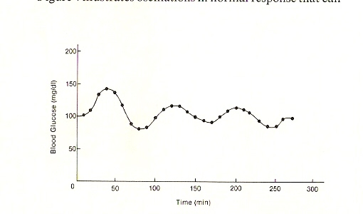
Fig 1. (Taken from Ref 1) Oscillations of the blood glucose level during an OGTT.
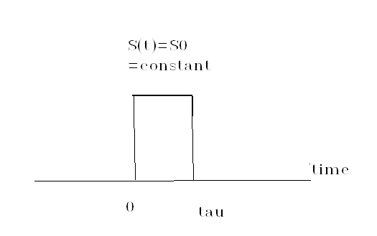
Fig 2. Ingestion of glucose at the rate S(t) during τ .

Ou aim in this note is to ascertain, using fig (2) , some plausible values for the rate constants k₁ , k₂ , k₃ , k₄ . After finding k₁ , k₂ , k₃ , k₄ , we solve numerically the differential equations (1) and (2) to see if it reproduces the data of figure 1.
First lets dispense with S(t). That is we start at t=50 minutes when the dosage S(t) has been fully delivered. The DE are now

dg/dt = -k₁ g(t) –k₂ h(t) (3)
dh/dt = -k₃ h(t) + k₄ g(t) . (4)
Some insight is gained by eliminating h(t) from(3) and obtaining the second order DE for a damped oscillator
d²g/dt² + (k₁ + k₃ ) dg/dt + ( k₁ k ₃+ k₂ k₄ ) g = 0 (5).
Eq (5) is of the form
d²g/dt² + 2β dg/dt + (ω₀ )² g = 0 (6)

where 2β =(k₁ + k₃ ) , (ω₀ )² =( k₁ k ₃+ k₂ k₄ ) .
β ~ 1/minute , (ω₀ )² ~ 1/minute² .
The solution of (6) is of the form
g(t) = A exp(-βt )sin (ω₁ t ) (7-a)
with
( ω₁)² = ( ω₀ ² – β² ) . (7-b)

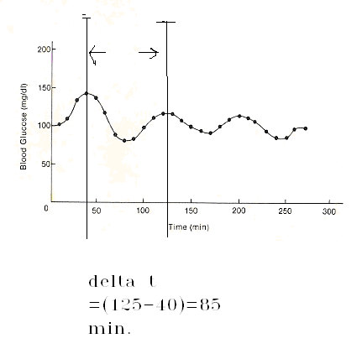
Fig 3. In the interval of 85 minutes g(t) undergoes an oscillation of frequency ω₁ = 2π/(85) ~ rad/minute . It also decays from an amplitude of 150 mg/dL to nearly 125 mg/dL.

Examining fig. 3 we have that
ω₁ = 7.39E-2 rad/min , (8)
and
exp(-β 85) = 125/150 = 0.833 . (9)
From (9)
β = - ln (.833) /85 = 2.15 E-3 minute⁻¹
= =(k₁ + k₂ )/2 . (10)
To find the rate constants k_{i} we introduce the following “ansatz” .
Let k₁ = k₃ and k₂=k₄ .
This gives , from (10)
k₁=2.15E-3/min (11)
and from (7-b) k₂ = ω₁ = 7.39E-2 rad/min . (12)

Fig 4. Oscillations of g(t) assuming k1=2.15E-3/min ,k2=7.39E-2/min. Compare with the experimental data in Fig 1.
Fig 5. Oscillation with increased k1=55E-3/min , k2=7.39E-2. The figure is closer to Fig 1.

CONCLUSION
A near fit to blood glucose oscillations during OGTT can be modeled by assuming initially k1=k3 and k2=k4 in equations (3) and (4).
FORTRAN code
c DE equations for OGTT oral glucose tolerance test
c ref AJP Vol 55 (7),page 645 , July 1987
c assume k1=k3 , k2=k4
real k1,k2,k3,k4
data k1,k2/5.e-3,7.39E-2 /
data ti,tf,tstop/50.,300.,50./
k3=k1
k4=k2
pi=2.*asin(1.)
tau=100.
beta=(k1+k3)/2.
w0=sqrt((2.*pi/tau)**2 +beta**2)
t1=1./k1
t2=1./k2
t3=1./k3
t4=1./k4
w0=sqrt(k1*k3+k2*k4)
w1=2.*pi/100.
dt=amin1(t1,t2,t3,t4)/100.
nstep=int(tf/dt)
kp=int(float(nstep)/80.)
kount=kp
c g ~ glucose concentration in mg/dL
gbase=100.
c g0 ,g1 ,h0 ,h1 refer to values above a baseline
c at t=50 min g(t) passes through a maximum dg/dt =0 and h0=-k1*g0/k2
g0=50.
h0=k1*g0/k2
print*,'t1,t2,t3,t4=',t1,t2,t3,t4
print*,'tau0,tau1=',2.*pi/w0,2.*pi/w1
print*,'w1**2,w0**2-beta**2=',w1**2,w0**2-beta**2
print*,' '
print 100,ti,g0+gbase
do 10 i=1,nstep
t=ti+dt*float(i)
g1=g0+dt*(-k1*g0-k2*h0+s(t-dt,tstop))
h1=h0+dt*(-k3*h0+k4*g0 )
if(i.eq.kount)then
print 100,t,g1+gbase
kount=kount+kp
endif
g0=g1
h0=h1
10 continue
100 format('t,g+gbase=',2(3x,e10.3))
stop
end

function s(t,tstop)
c if(t.le.tstop)s=2.3
c if(t.gt.tstop)s=0.
s=0.
return
end

