Design & Technology/ Technical Studies Common Homework Papers

Please answer all questions. To be hand up when school reopens. Any questions please email – department website. When email, please let me know your name and class so that I can know who the student is.

1. You have been asked to make the sports trophy shown in Fig 1.

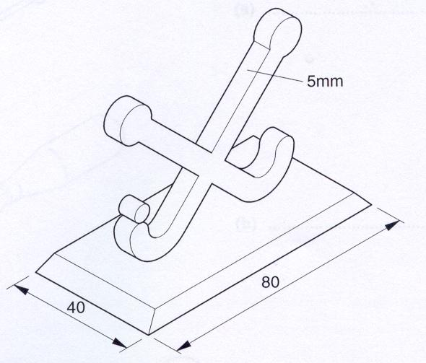

Fig 1

The top part of the trophy is to be made from non-ferrous metal and the base from hardwood.

(a) Name a suitable non-ferrous metal and a hardwood. [2]

(b) Make notes and sketches to describe the method of making the top part of the trophy. Include details of how you would finish the material and join this part to the base. [12]

(c) Make notes and sketches to describe how you would make the base. [6]

2. Fig 2 shows a kitchen storage box for holding coffee. The box is to be made from 12mm thick hardwood.

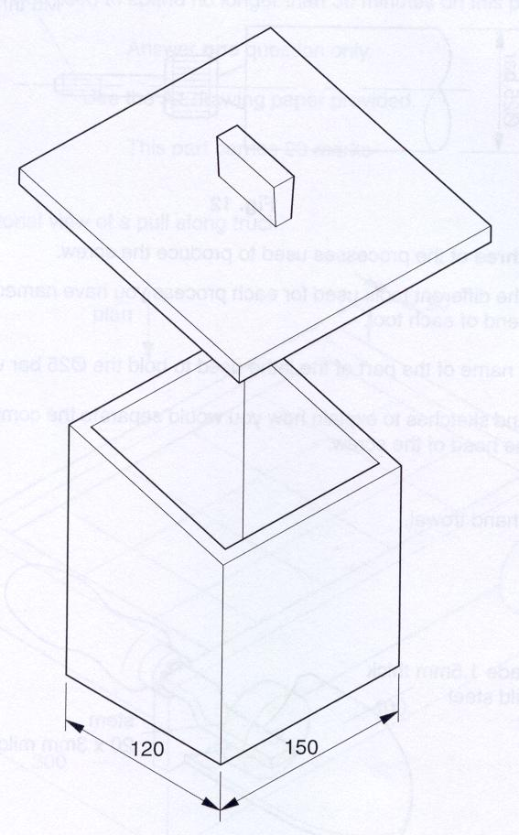
Fig 2

(a) name and sketch the joint you would use for the corners. [5]

(b) Use notes and sketches to describe how you would mark out and cut the joint you have named in part (a). [10]

(c) Use notes and sketches to describe a method of fitting a base to the box. [5]

3. Fig 3 shows a partly completed steel screw which has been turned on a lathe.

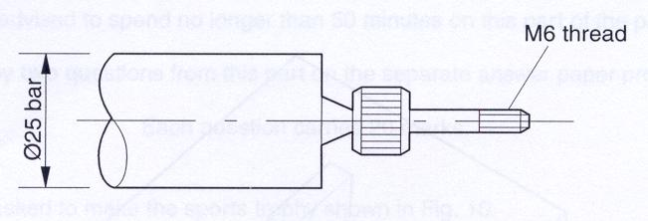

Fig 3

(a) (i) name three of the processes used to produce the screw. [3]

(ii) name the different tools used to each processes you have named in part (a)(i). Sketch the cutting end of each tool. [6]

(b) Give the full name of the part of the lathe used to hold the Ø25 bar when turning. [3]

(c) Use notes and sketches to explain how you would separate the completed screw from the bar and finish the head of the screw. [8]

4. Fig 4 shows a hand trowel.
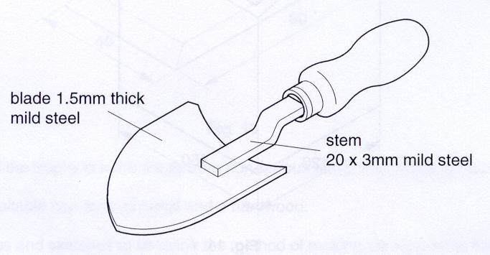
Fig 4

Using notes and sketches describe how you would:
(a) mark out the outline shape of the blade of the trowel. [3]

(b) Cut out the shape and finish the edges of the blade. [3]

(c) Form the curve in the blade. [3]

(d) Form the bends in the stem. [5]

(e) Join the stem to the blade. [6]

