Notable Shofarot

Below are some of the more notable shoforot expressive of its importance to the Jewish people.

Temple Period

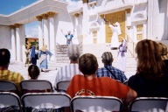
Rosh Hashanah With the sound of the shofar begins the showcase of Jewish festivals. One of the original shows at the Holy Land Experience, the Festivals of the Ancient world reconstructs Jewish festivals in a Christian paradigm. With most singing performed in Hebrew, the show gives the audience an illusion of Jewish observance.

http://www.pluralism.org/resources/

Medieval



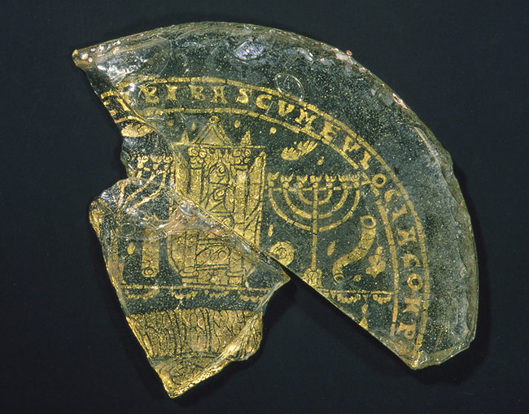
Description

Bowl Fragments with Menorah, Shofar, and Torah Ark, 4th century
Roman or Byzantine
Glass, gold leaf; 2 11/16 x 2 3/4 x 1/4 in. (6.9 x 7 x .64 cm)
Rogers Fund, 1918 (18.145.1 ab)

http://www.metmuseum.org/toah/ho/05/eust/hob_18.145.1ab.htm

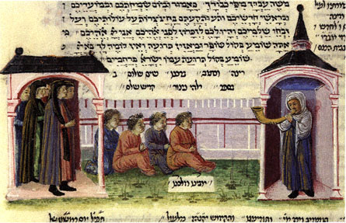

From a Polish Ghetto c.1600

Holocaust

Shofar (Ram’s Horn)
made in the forced labor camp Skazysko-Kamienna in Poland in 1943
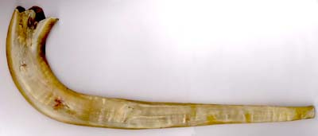
The Shofar was made in anticipation of Rosh Hashana 5704 (1943) by Moshe (Ben-Dov) Winterter from the city of Piotrkow, Poland who was an inmate in the camp and worked in the metal workshop of the armaments factory.
The idea of making a shofar was initiated by the Radoszyce Rabbi, Rabbi Yitzhak Finkler who was incarcerated in the camp. He yearned to fulfill the commandment of blowing the shofar at the Jewish New Year. Finding the horn of a ram, as required by Jewish law for the making of a shofar, was far from a simple task. A Polish guard was bribed and brought a horn to the camp but it turned out to be the horn of an ox. Only in exchange for a further bribe did he bring a ram’s horn. The Rabbi approached Moshe Winterter, whom he knew from Piotrkow and asked him to make the shofar. He did not at first agree. Preparing an item which was not an armament in the metal workshop, or even carrying something from the workshop to the barracks, carried with it a penalty of immediate death.
In spite of the danger, Moshe Winterter carried out the task and on the eve of the holiday brought the shofar to the Rabbi. Word spread and on the holiday eve the inmates gathered for prayers and to hear the sounds of the shofar.
Moshe Winterter kept the shofar with him throughout his incarceration in Skazysko Kamienna and managed to keep it with him even when he was transferred to the camp at Czestochowa. When he was transferred from there to Buchenwald it remained in Czestochowa until the camp was liberated. At that time, the shofar was passed on to the local Jewish community and later taken to the United States. Moshe Winterter immigrated to Israel after the war. In 1977 he assisted in its transfer to Yad Vashem for safe keeping.
Yad Vashem Collection, Jerusalem, Israel
Donation, Moshe (Winterter) Ben-Dov z”l, Bnei Brak, Israel
Copyright ©2004 Yad Vashem The Holocaust Martyrs' and Heroes' Remembrance Authority
http://yad-vashem.org.il/exhibitions/museums/histmuseum/from_coll/data/shofar.html

