Note Variations in the Jewish World

There are several note variations beginning with the Mishnah (200 CE) when the Teruah note was argued over. The Rabbi's did not remember if the notes in the Temple were nine staccato notes (yelp) or three slurring notes (cry). Three short, straight blasts - what we commonly refer to as shevarim; Nine (9) very short, staccato blasts - what we commonly refer to as teruah; A combination of both of the above sounds - a shevarim- teruah compound.
To satisfy all of the above opinions, the Rabbis established that the three sets of tekios be blown in three different ways, alternating the teruah sound in each set. Thus we blow tekiah shevarim-teruah tekiah (TaSHRaT) three times; tekiah shevarim tekiah (TaRaT) three times; tekiah teruah tekiah (TaSHaT) three times. All together that adds up to thirty different blasts - eighteen tekios, three shevarim-teruahs, three shevarim and three teruahs. This is the minimum number of blasts that every adult male is required to hear on Rosh Hashanah. These are called tekios d'myushav, since the congregation is permitted to sit while they are being blown. In practice, however, it is universally accepted to stand during these tekios. (Mishnah: Rosh Hashanah 33b)
Further, the Mishnah Berurah refers to community practice. See Mishnah Berurah 585:4 (14) (18); 590:4 (20); 596:1 (1),(2); 597:2(5), among other examples.
Moreover, Rabbenu Tam (b. 1140, Rabbeinu Tam R. Ya’akov B. Me’in and a grandson of Rashi)
introduce the custom (followed by East European communities) that the tekiah, shevarim, Teruah, tekiah shall be sounded three times each in the malkuyot, zichronot and shoforot sections of the Rosh Hashanah service. (EJ 349)
Probably the oldest know Shofar calls are contained in the Codex Adler form the 13th century, which resides in the library of the Jewish Theological Seminary (No. 932, folio 21b). Other medieval notations are found on the late 14th century manuscript, the Codex Shem, No. 74 (in the Parma library) and in Juan de Gera's Mahzor (Venice, 1587, p. 190)
Ashkenazic and Sephardic Differences
There is a basic distinction between Ashkenazic (European) and Sephardic (derived from Spanish Jewry). Specifically the Teruah has a note at the end that is an octave higher than the nine staccato notes. (Encl. Judaica, p. 356)

Lithuanian Version
A Lithuanian Version allows for the shevarim elongating its last slurring note and then finishing it with a tonal note. The Teruah begins with a grace note to the tonal; then nine staccato notes, ending with a long note a fourth above. The tekiah gedolah consists of three long but different note beginning with lowermost note.
Although the notes usually rise in thirds, the practice of the London Western Synagogue is to rise the notes on fourths. (EJ, p. 359) Indeed, Sir Edward Elgar uses the Shofar call in "The Apostles," although the interval is consistently in sixths. Thus, he must have heard the Shofar call played elsewhere.
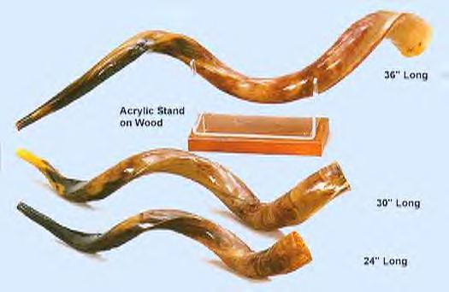
Yemenite Jews
The Yemenite Jews have huge Shofarot, sometimes a yard long with a triple bend. However, their sounds are almost identical to the Ashkenazim. (EJ, p360)

