

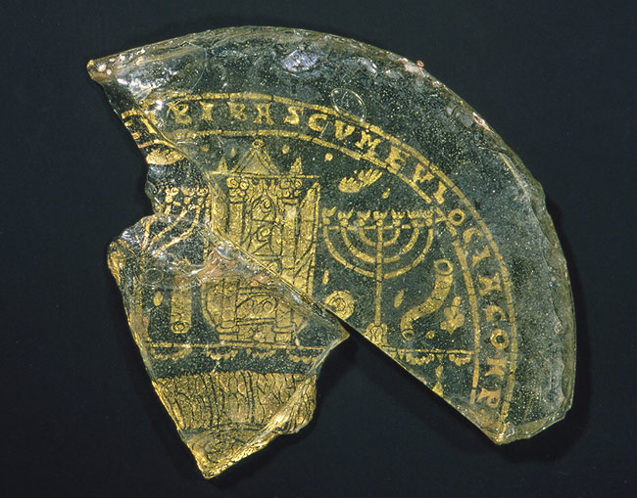
Description

Bowl Fragments with Menorah, Shofar, and Torah Ark, 4th century
Roman or Byzantine
Glass, gold leaf; 2 11/16 x 2 3/4 x 1/4 in. (6.9 x 7 x .64 cm)
Rogers Fund, 1918 (18.145.1 ab)

http://www.metmuseum.org/toah/ho/05/eust/hob_18.145.1ab.htm

