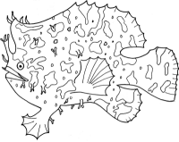
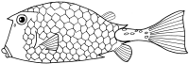
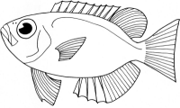

In this activity you will be marine biologists who have discovered a new species of fish. Think about what you have learned about fish adaptations such as body shapes, mouth shapes, coloration, camouflage, and defense mechanisms.

Materials: large sheet of white bulletin board paper
markers
scissors
glue
pencil
stapler

Instructions:
- Draw a large picture of your fish on a large sheet of folded paper.
- Draw the pectoral and pelvic fins on a separate piece of paper.
- Trace the drawing with a permanent black marker.
- Turn the paper over and trace the drawing on the other side.
- Color both sides of the paper and keeping the paper folded, cut it out.
- Staple the two sides together leaving an opening.
- Stuff the fish with crumpled paper to give it a three-dimensional look and staple it closed.
- Glue on the pectoral and pelvic fins.
- Write a description of your fish. Be creative. You may write your description in the form of a newspaper article, an interview or a scientific journal report. Your information may be hand written or typed.

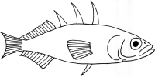
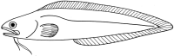
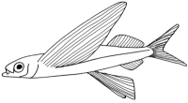

Think about the following information when creating your drawing and written description:

Name of your fish - ____________________________________

type of fish – agnatha, chondrichthyes (cartilaginous fish), osteichthyes (bony fish) __________________________________

habitat – where does your fish live in the ocean? (coral reef, kelp forest, abyss)__________________________________________

migration – does your fish migrate or live its entire life in one region?
_____________________________________________________

location in the world - what ocean(s) does your fish live in? _____________________________________________________

coloration/camouflage, defense adaptations - _________________
_____________________________________________________

how they swim/move/anchor - _____________________________

physical features – body shape, type of fins and # of fins, scales, size, mouth position, eye position, nostril position, barbels, etc. ______
__________________________________________________________________________________________________________

predators/prey – what does your fish eat and what eats your fish? __
_____________________________________________________

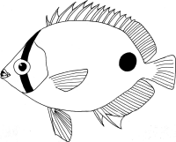
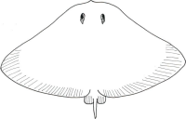
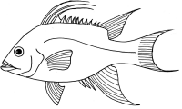

Answer the following questions regarding the Fashion a Fish activity:

Did you include a lot of scientific information about your fish? | yes | no
Did you elaborate on your written description and include a lot of details? | yes | no
Is your information neat and clearly written? | yes | no
Did you add details to your fish model? | yes | no
Is your fish model neat? | yes | no
Did you use your time wisely? | yes | no

What could you have done to improve your model?

What could you have done to improve your written description?

