Decide whether each of the statements below is true of sharks, a bony fish, or both.

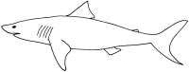
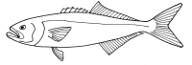

 | sharks | bony fish | both
- have fins
- have rays or spines on their fins
- have a swim bladder
- gills take oxygen from the water
- have a lateral line
- have a skeleton made of cartilage
- have spiracles behind the eyes
- have scales made of tiny teeth
- have a backbone
10. have anal fins
11. have an operculum (gill cover)

