The Center for the Study of Spirituality and Sexuality

 studies the Christian humanistic writings of its patron, St. Aelred of Rievaulx, a gay saint, best known for his writings on love and friendship.

 seminars, workshops, retreats on a wide variety of subjects associated with the integration of spirituality and sexuality in a sex-positive theology which contradicts the Church’s sex-negative theology and explores the parameters of sex-positive thinking.

 couple’s growth groups for the support and enhancement of committed same-sex relationships.

 counseling hotline which deals with gay and lesbian-related issues.

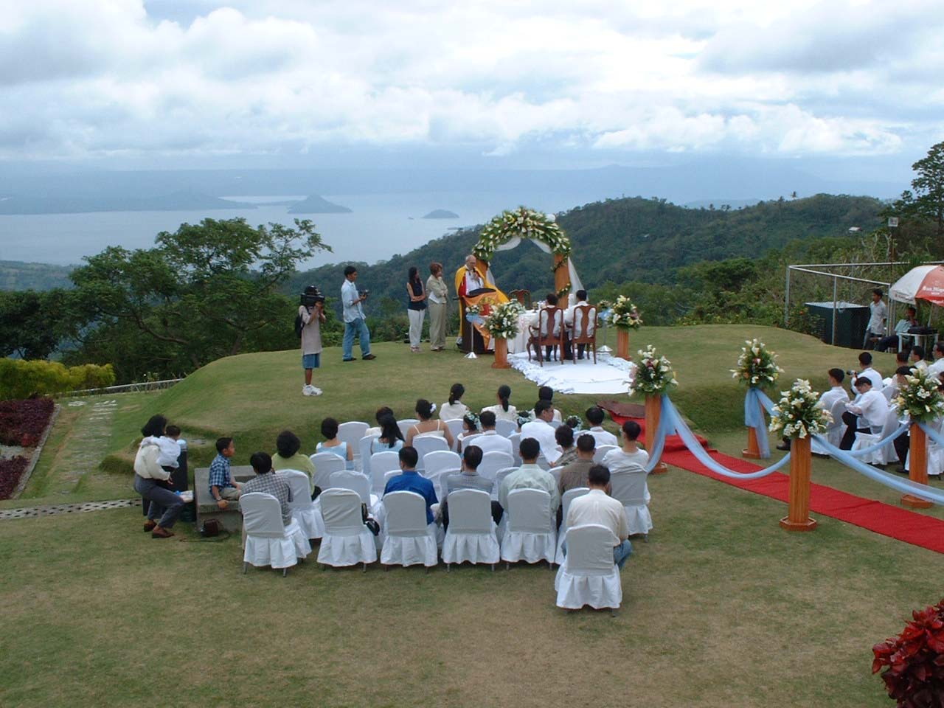
A same-sex wedding in a beautiful garden setting in Tagaytay, overlooking the Taal Lake.

The Gay Men’s Support Groups

Over the years the Gay Men’s Support Groups have brought dozens of gay men to new understandings and personal growth through weekly meetings of support and encouragement in wholistic ways of living and enjoying intense personal friendships with one another.

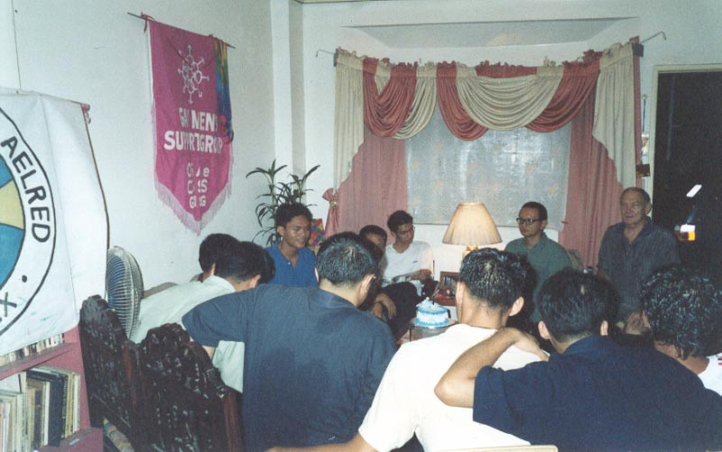
Weekly sessions of the Gay Men’s Support Groups deal with the ups and downs of life and result in happier lives and rewarding friendships.

Affiliation

The Order of St. Aelred is affiliated with:
- Association for Contemporary Catholic Life (ACCL)
- International Lesbian and Gay Association (ILGA)
- Lesbian and Gay Legislative Advocacy Network (LAGABLAB)
- Task Force Pride (TFP)
- Manila OUT

The Order of St. Aelred
www.geocities.com/staelredmonasterymanila

53-A Mapang-akit St.
Barangay Pinyahan, 1100 Quezon City
Metro Manila, Philippines
Tel.: 63 2 4337277
Mobile: 63 920 9034909
E-mail: st_aelred@hotmail.com

“Our mission is to pray, study and work to promote a just and peaceful society, to live and teach the integration of spirituality and sexuality, to be fully human, enjoying life-enriching friendships, while bringing ourselves and others to a life in union with God.”

The Order

The Order of St. Aelred is a religious society of mostly gay, lesbian, bisexual and transgender (LGBTI) members who work to build a better world of fulfillment and freedom from homophobia.
The members of the Order take vows as religious. Their ministry is one of personal growth and service to the community.

The Order has a vision of a just and peaceful society where friendships abide and spirituality and sexuality merge on the path to God while living our God-given humanity in wholistic health and happiness.

Founded on July 1, 1995 following inspiration given to Fr. Richard R. Mickley, O.S.Ae., Ph.D., the Order was incorporated as a religious society in the Philippines.


St. Aelred (1110-1167) of Rievaulx, monk, abbot, writer, is our patron because of the holiness of his life in the struggle to love as "Jesus loved the beloved disciple."

The Monastery

St. Aelred Monastery is the center of activity for the prayer, study and works of the Order.
From the hub of the Monastery the various activities of the Order spring into action – from the religious life of the monks and sisters, to the support groups for same-sex couples and gay men.
In this modern ecumenical, inclusive, wholistic community, some of the members live and work in their homes during their job in society; others live and work in the monastery.

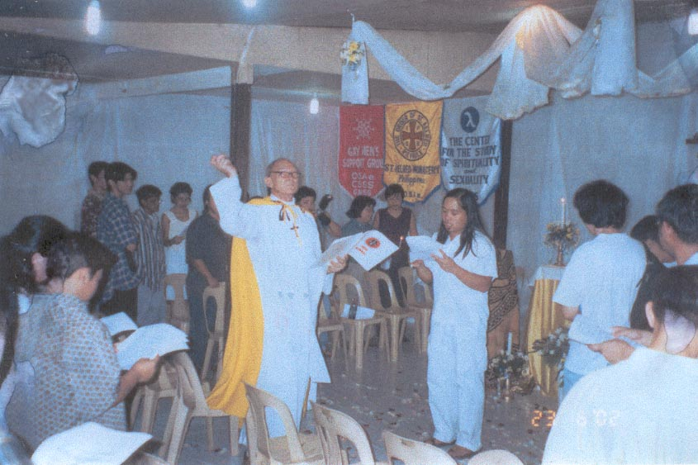
A Gay and Lesbian Pride Mass at St. Aelred Monastery Chapel.

The works of The Order of St. Aelred are conceived and directed by a core group of monks and sisters who have a special religious life together in community.
But the works of the Order include many persons from the LGBTI community who are not members of the religious community but are seeking various services which the Order offers.
For example, the Gay Men’s Support Groups are not religiously oriented but focused on the personal emotional and social needs of individuals.

The Seminary

In order to perpetuate the ministry of the Order, St. Aelred Seminary educates and prepares women and men for ordination to carry out the sacramental and priestly ministries of the church, mass and other worship services, funerals, weddings for committed couples in Holy Union, Bible study and prayer meetings.
The Seminary is a non-residential tutorial program in which learners study independently with a mentor and come together regularly to interact and share their learning.

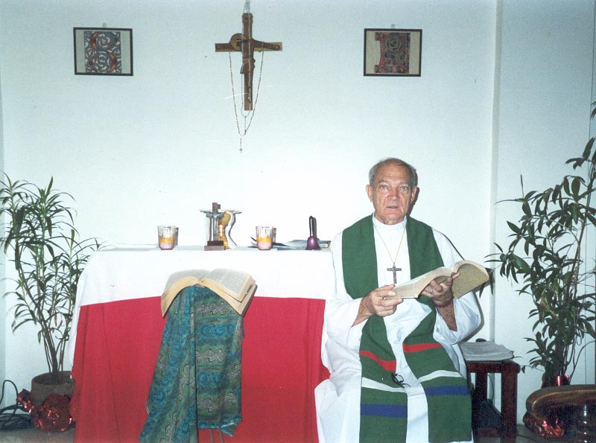
Father Richard, President and Dean of St. Aelred Seminary, discusses learning requirements with learners studying for the holy priesthood.

A whole new approach to seminary learning is required. Besides the standard requirements in Scripture, theology, church history, and ministry, it is necessary for St. Aelred students to be able to deal with the whole gamut of sex-positive theology in contradiction to the sex-negative theology the churches have used to reject gay and lesbian people and in effect alienate them from God. A primary mission of St. Aelred ministry is to restore the rightful place of God to a people who have been told that God rejects them. A whole new theology of unconditional love must be learned so as to be taught

