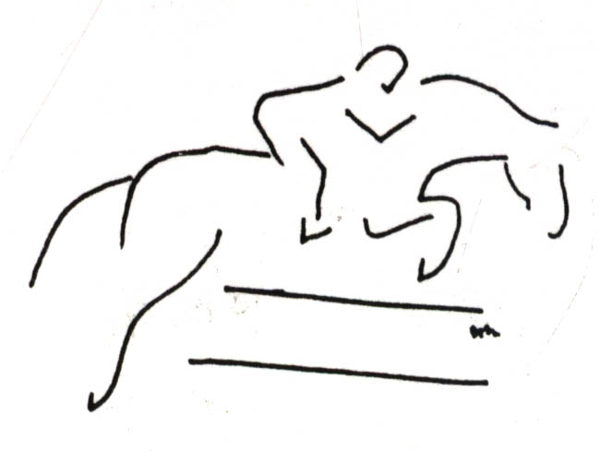

SUNNY SANDS

DRESSAGE & COMBINED TRAINING

Fort Lee, VA NCDCTA Recognized HORSE SHOW July 19, 2003
Judge: Janice Mumford, USA Equestrian “L” rated

Opening Date: June 17, 2002 Closing Date: July 8, 2003
Organizer: CPT Kelly L. Dobert Honl - (804) 732-6545 kellyhonl@yahoo.com (804) 931-6450 cell
Show Website: http://geocities.com/sunnysands2003 Show Email: sunnysands2003@yahoo.com

COMBINED TEST - $25 / division DRESSAGE - $20 / test

WALK/TROT WALK/TROT
Amoeba Dressage: Intro Test 1 Introductory Level Test A
Stadium “Jumps:” Ground Rails Introductory Level Test B
Tadpole Dressage: Intro Test A WALK/TROT/CANTER
Stadium Jumps: 18" X Rails max. Training Level Test 1
Maiden Dressage: Intro Test B Training Level Test 2
Stadium Jumps: 2' max. Training Level Test 3
VOLUNTEERS NEEDED!!!
(No experience needed. We’ll help you learn everything you need to know.)
SIGN UP NOW:
FREE FOOD & PRIZES!

WALK/TROT/CANTER Training Level Test 4
PreNovice Dressage: Novice Test C First Level Test 1
Stadium Jumps: 2'7" max. USEA Novice Test of Choice
Novice Dressage: Novice Test D USEA Training Test of Choice
Stadium Jumps: 2’11” max. USEA Preliminary Test of Choice
~ Concessions will be sold. USEA Intrmed. Test of Choice
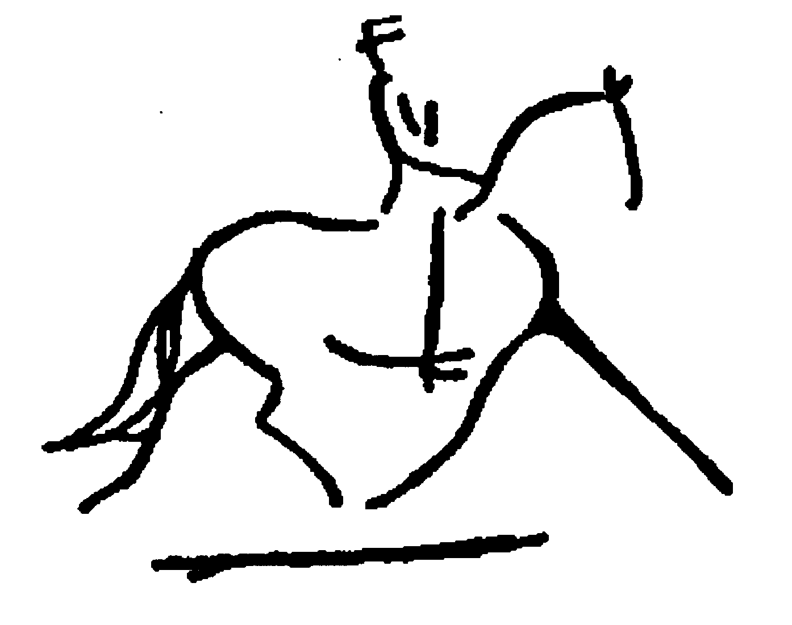~ Entries can be made online.
~ Limited entries– get your entry in early!
~ Dressage & Stadium Arena – Sand; Warm Up - Grass
~ All refunds: less $5 office fee. NO REFUNDS AFTER Closing Date!!
~ Ride Times will be emailed and posted on Show Website after 9pm July 16th.
~ Schooling Jump Rounds @ all divisions (after CT rounds) - $5 or $8 post entry.
~ Safety equipment is REQUIRED (i.e. boot w/ a heel, helmet with harness for jumping).
~ Entries received COMPLETE, on time and with no changes will receive a $2 rebate when # returned.
~ If schedule permits, entries RECEIVED AFTER the closing date will require a late fee of $10 / test or division.
~ If you do not know the rules please feel free to ask questions; education for all (competitors and spectators) is the goal!
~ Classes may be combined or split – Adult (Sr), Jr, YR, First Timers, 4-H, PC and/or Academy - based on number of entries.
~ USA Equestrian & USEA rules apply except: braids waived; dress for the heat, no chaps; whips, leg wraps, dressage test callers allowed, and no eliminations.
~ Horses & riders can enter multiple tests &/or divisions with the same &/or different horses. Horses may be shared by two or more riders w/ prior permission.
~ Prizes & ribbons to 6th Place & Champ./Res. for Dressage, CT Dressage and CT. Competitor and Volunteer Prizes totaled $1200 for 2001-2002. Sponsors needed for 2003!!!
~ This will be a fun & educational event to introduce the equestrian sports of Dressage and Combined Training; judge will provide written & oral feedback for each test. No one will be eliminated, but given penalty points, instruction, and allowed to continue safely in the competition. All judge and organizer decisions are final.

DIRECTIONS to FORT LEE SHOW GROUNDS: See website at www.geocities.com/sunnysands2003

Mail entries (payable to Sunny Sands) & valid 1 year Coggins to: CPT Kelly Dobert Honl, 76 Ivy Lane, Petersburg, VA 23805-1367; or pay online & email Coggins.
-------------------------------------------------------------------------------------------------------------------------------------------------------------------------------------------------------------------------------------------
Rider's Name: ________________________________ Owner’s Name: ______________________________
Horse's Name: ________________________________ Horse’s Name on Coggins: ______________________
Rider’s NCDCTA # (not required) __________ Horse’s NCDCTA # (not required) __________ Is horse for sale? ◊Yes ◊No
Rider’s Mailing Address: ___________________________________________________________________
Rider’s Email Address: ___________________________________ Rider’s Phone#: ____________________
Rider’s Birthday: ______ 4-H / PC / Academy (circle one) Club Name ______________ I will VOLUNTEER: ◊YES ◊No
Dressage Tests ($20 ea.): ◊IntroA ◊IntroB ◊T1 ◊T2 ◊T3 ◊T4 ◊F1 ◊N ToC ◊T ToC ◊P ToC ◊I ToC
Tests of Choice (specify): __________________________________________________________________
Dressage / CT experience: _________________________________________________________________
Combined Tests - includes dressage & jumping ($25 ea.): ◊Amoeba ◊Tadpole ◊Maiden ◊PreNovice ◊Novice
Schooling Jumping Round ($5 ea. or $8 post entry): ◊Amoeba ◊Tadpole ◊Maiden ◊PreNovice ◊Novice

HOLD HARMLESS LIABILITY RELEASE: ALL ENTRIES ARE AT MY OWN RISK. I understand that equine activities are inherently dangerous and agree not to hold Ft. Lee, its officials, volunteers, spectators or competitors liable for injuries, loss of life, theft or damage to horses, property, spectators or competitors.
Signature __________________________________________________________________________ Date ____________________
(Legal Parent or Guardian if Under 18)

