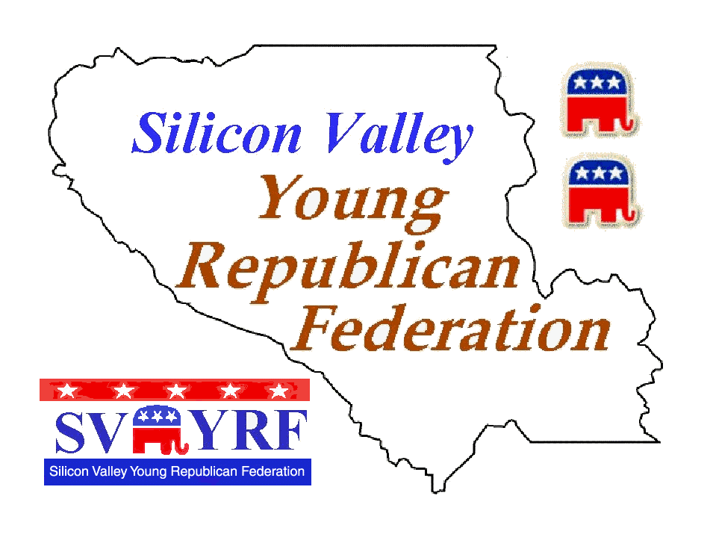

THE NEXT GENERATION
The Newsletter of the Silicon Valley Young Republican Federation
http://www.young-republicans.org
Winter 2003/2004

Barbecue Great Success

The SVYRFC Annual Barbecue was held on August 23rd. To say it was a great success would be a serious understatement. The event raised over $3200.00. Amongst the more than 100 people in attendance were five to six candidates and party officials. Credit for the success of the event should be given to club treasurer Theri Rowen, club vice president Jay Kirkman, directors at large Alan Hall, Nolan Chen, club member Jackie Kennedy, and College Republican Presidents Andrea Irvin, Brett Rodriguez, and Laurie Hauf.
The event honored State Assemblyman and State Senate candidate Abel Maldonado and CRP Associate Representative Jeff Corless. Both were given honorary club memberships. Also receiving honorary club memberships were YRFC State Chair Chuck Hess, LMU Chair Kyle Redding, CRP Party Vice Chair Mario Rodriguez, and CRP Chair Duf Sundheim. State Senator Jeff Denham awarded the SVYRFC an official certificate from the California State Senate.
Seventy percent of the profits of the barbecue were given to the New York City Fire and Police Widows Fund, Operation Yellow Ribbon, The Cal Patriot, BCR, UC Santa Cruz CRs, and the DVC College Republicans. The rest of the money will be used to fund a hospitality suite at the Spring CRP convention in Burlingame.

.
Club Election & Endorsement Meeting Recently Held
On November 11th the SVYRFC held their endorsement and election meeting at the Marriott Hotel. Over twenty members attended along with six candidates from all over the area. The SVYRFC had already endorsed George W. Bush for President, Tony Strickland for US Senate, and Abel Maldonado for the 15th Senate District.
At the November 11th meeting the group made the following endorsements:
In the 12th Congressional District they endorsed Chris Huskins, in the 14th Congressional District Chris Haugen, the 15th Congressional District Raymond Chuckwu, and in the 16th Congressional Doug McNea. In state legislative race the club endorsed the following candidates: John Zoheffler in the 11th State Senate District, in the 13th State Senate District we endorsed Shane Patrick Connolly. For State Assembly we endorsed Steve Poizner who is running in the 20th District. In local races in the Silicon Valley the SVYRFC voted to endorse Rich De La Rosa for San Jose City Council. The Executive Board of the SVYRFC at its January Board Meeting will discuss the other races.
In club election, Ed Rowen was re-elected to a seventh term as club president making him on of the longest serving GOP volunteer club presidents in the history of the California GOP. Many consider him one of the most respected Republican leaders in Northern California. Theri Rowen was elected club Treasurer after doing a great job as club secretary. Jay Kirkman was re-elected Club Vice President after doing a great job as both Vice President and as a Director at Large. Alan Hall was re-elected as a Director At Large. Charles Settle and Kuici Settle were also elected Directors At Large. Lastly, Jackie Kennedy was appointed as Parliamentarian. Other positions will be filled at the first Board of Directors meeting held in the start of the 2004.
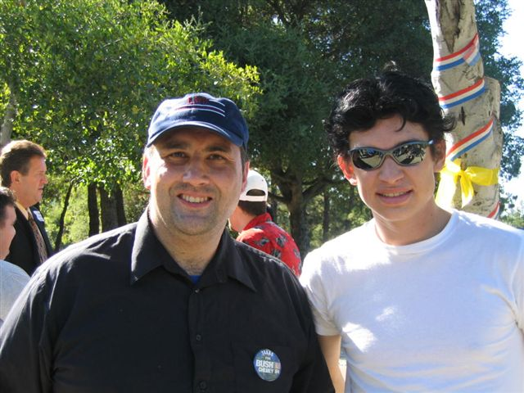

Inside This Issue
1 | Club News
2 | President’s Message
2 | “The Shadow”
3 | Membership News
4 | Calendar of Events

President’s Message

By Ed Rowen

A Job Well Done…

It has been a policy of mine to never single out one member of the group, but to always thank the group as a whole. In addition, I always prefer to thank those who
work the hardest in getting something done that will benefit the Republican Party and to help make the SVYRFC the number one political group in the Silicon Valley.

The SVYRFC has had many outstanding members including Richard Bray, Tom Askeland, Jeff Wald, and Laurie Thompson. This year one member did more than any member in keeping the group together and that was Theri Rowen.
True, Theri is my niece and we work on projects as a family, but when it came to precinct walk, events, and doing the things had to be done Theri was there. As president there are time that I have to do a lot of the work myself in getting things done. There has been one person that has been there and has helped me and that’s Ms. Theri Rowen.
She can be a little wacky, but her heart is in the right place There are times that she is smarter than you can give her credit for. So, along with many others in the Republican Party I would like to thank Theri Rowen for all her work and help. She will always be my pal. I also think she also has a great future in the Republican Party and in politics.

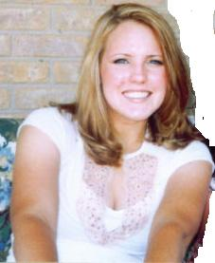

SVYRFC Member Jackie Kennedy
“The Shadow”
(For Reasons Unknown The Shadow Would Prefer to be Anonymous...)

Campaign 2004 is here!!
California has a new Governor and his name is Arnold Schwarzenegger.
Does that mean a change for the Republican Party? Does that mean we can now win seat?
Who knows?

Do I think Abel Maldonado can win at this point? The answer is yes. The fact is that unlike most Republicans in the area, Abel has lost any real Democrat challenge with Cohn pulling out of the race and no real Democrat running against him. He also has almost a million dollars in the
bank. Hey, he is sitting pretty and ready to become a State Senator in 2005. Any other races of interest for Republicans in this area? Well, lets see as I look at my notebook and read my notes. Rich De La Rosa running for City Council in the Almaden Valley. Maybe this
guy named Chris Huskins in the Peninsula can win. Mr. Huskins is making a run against my favorite Democrat loudmouth, Congressman Tom Lantos. Chris is a nice young guy who has charisma. Steve Poisner running for State Assembly in the 21st. Please note this is an open seat.

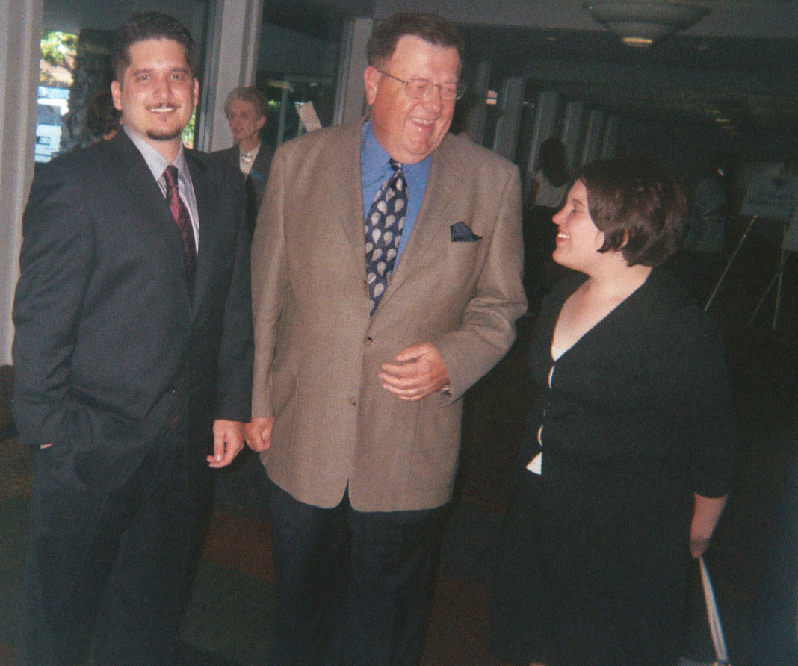
FreedomPAC's Robert Molnar w/Ernie Konnyu and Theri Rowen

Club Membership News

New Members
Keith Blane, Neil Dave, Joel Gorman, Charles Huskins, Sherri Perkins, Richard Romo, Charles & Kuici Settle, Nicholas Sutton, Sara Warner

How To Debate Liberal Students:
A Concise Conservative Student’s Guide

By: Kyle F. Redding

Most of you realize that a majority of your fellow classmates are militantly left-wing. The point in debating them isn’t to change their minds, as they’ve already been too brainwashed by their “Progressive” professors. The point is to either shake their own resolve or to convince those with no political stance. If you let the libs go it alone, they’ll be able to brainwash all those potential Conservatives you couldn’t get to. So here’s a few tips based on my years debating with liberal students to help you make them look like the radical fools they are.

The first thing to remember is that they don’t actually like to debate. They’ll avoid making any clear statements at all if they can get away with it. They like to say things that sound pretty but in reality don’t make any real point. Don’t let them. Simply calling them “Commies” is fun, but unfortunately it doesn’t work anymore because they’re actually proud of the fact that they adhere to the Bolshevik philosophy. Instead keep them on point and they’ll naturally be on the defensive.

Once you keep them on the issues, you’re halfway to winning, but making any concessions is a quick road to defeat. It’ll make you look like you’re unsure of your position and give them a buoy to grasp on to. If they make a point that sounds like it makes sense, trust me it isn’t as good as it sounds. Stick to your guns, hold to your beliefs, and you’ll pull through. Proper preparation can avoid the urge to concede a point. Use facts, preferably historical ones, too. Liberals hate facts because they’re never on the same side as them. Remember: everyone’s entitled to their own opinion but not their own facts.

In desperation Liberals like to play cards. The race card, the homophobe card, the compassionate card, so on. If you’ve read Hannity or Coulter, you all know how to respond to these so I’m not going to get into it. But recognize the tactic; they’re trying to get you angry. Interject only if they really go off the deep end, because while a Churchillian (we will fight them on the beaches) approach works at times, in campus debates it’s much more effective to keep your cool and talk in a conversational tone. Then they look desperate (which they are) and you look mature and confident (which you are). Delivery is everything to a lot of people. The libs want to get under your skin. Not letting them only makes them angrier at you for kicking their arguments back to Stalingrad.

Lastly, when they know they’re being handed a plateful of crow, they like to say something along the lines of “well, that’s your opinion and I respect your right to speak freely.” This is a common tactic that always gets applause, but it’s easily shot down with the response, “that’s great, I feel the same way. Now what do you think of my argument?”

Keep in mind that practice only makes you better. So if you don’t do so well the first time or so, don’t be bothered, with a few of these under your belt you’ll be sounding like Rush before you know it.

So there’s a little mini-guide to debating on campus. If hate letters and smear columns about you start appearing in your campus newspaper, fear not for you know you’ve done your job and gotten under their skin. And making liberals angry is where the real fun is.

Member Profile

Jackie Kennedy

Quote--Great Minds talk about ideas, average minds talk about events, and small minds talk about people.

Hero--Former First Lady Jackie Kennedy--I admired her political poise and grace.

Why GOP--I love what we as Republicans stand for. From the protection of hard earned salaries from the government to the sustaining of family values I find the Republican National Platform to be morally correct.



Calendar

January
---------
January 9 -- SVYRFC Night at Santa Clara University...7:30 PM at Toso Pavilion, Santa Clara University
Vs. USF. Tickets $9 a person & $20 a couple.

February
-----------
February 20 –22 --State GOP Convention at the Hyatt Regency Burlingame.

March
--------
March 2 -- Primary Election Day.

April
------
April 16 -- SVYRFC Night at the San Jose Arena - San Jose Sabercats Vs Chicago. Tickets $15 a person & $25 a couple.

Please note these events are open to change. Please check the website for more information: http://www.young-republicans.org.

MEMBERSHIP FORM

Silicon Valley Young Republican Federation
65 Washington St., Suite 129
Santa Clara, CA 95050
Club Hotline: 408-243-4761
Club Website: http://www.young-republicans.org

Name:

Street Address:

City/State/Zip:

Mailing Address (If Different):

Phone Number:

Pager/Message Number:

E-Mail Address:

Date of Birth:

Are You a Registered Republican?

Signature: Date:

ANNUAL MEMBERSHIP DUES

(Check One)

New Member ($15.00) Renewal ($7.00) Couple ($20.00 Student ($10.00)

SPOUSAL MEMBERSHIP
(If Applicable)

Spouse Name:
Spouse Birthdate:
Registered Republican?
Signature: Date:



Silicon Valley Young Republican Federation
65 Washington Street, Suite 129
Santa Clara, CA 95050

ADDRESS CORRECTION REQUESTED

