LOCATION :
- JL. GUNUNG BALONG RAYA No. 10, CILANDAK
- VERY QUIET AND FRIENDLY AREA
- MINIBUS STOPS IN FRONT OF THE GATE EVERY 5 min.
- 300 m FROM FATMAWATI BOULEVARD AND
SIMATUPANG JUNCTION (TRAFFIC LIGHT)
- 5-10 MIN. DRIVE FROM THE JAKARTA INTERNATIONAL SCHOOL & ECOLE FRANCAISE & JAPANESE SCHOOL
- 5 MIN. FROM THE BIGGEST BUS TERMINAL

DESCRIPTION :
- VERY SPACIOUS LIVING cum DINING ROOM
- 4 SPLIT LEVEL SUITES
- 11 STANDARD AND DELUXE ROOMS
- 5 SUPER DE LUXE ROOMS
- 1 DELUXE 100 SQ MTR SUITE- THE TAJ MAHAL
- ALL ROOMS DESIGNER FURNISHED AND AIRCONDITIONED
- TV and TELEPHONES (WITH FACILITY HUNTING SYSTEM)
LOCAL CALLS ARE FREE WITHIN LIMITS
- ATTACHED BATHROOMS (HOT/COLD WATER)
- GARAGE FOR CARS ( + 10 CARS)
- GARDEN FOR BARBEQUE + BREAKFAST

( THE TAJ MAHAL SET UP WILL BE PREPARED ON REQUEST )

AVAILABLE : DECEMBER 2000, ONWARDS

EXPECTED RENT : DAILY/MONTHLY/BASED IN US DOLLAR
NEGOTIABLE IN RUPIAH DEPENDING ON TERMS

CURRENT PRICE LIST

STANDARD : PETUNIA, LOTUS, DAISYS, MERLIN, TULIPS, RAFFLESIA
US$ 300/MONTH
US$ 14/DAY

SEMI DELUXE : CAMELLIA, GARDENIA, SCABIOSA
US$ 400/MONTH
US$ 16/DAY

DELUXE : OLYMPIA, LAGUNA
US$ 500/MONTH
US$ 20/DAY

SPLIT LEVELS : BORONIA FLAMINGO
US$ 700/MONTH US$ 600/MONTH
US$ 30/DAY US$ 27/DAY

SUPER DELUXE : POLARIS, CATELYA, ATLANTICA, MAGNOLIA,
CARRIBEAN
US$ 800/MONTH
US$ 35/DAY

SUITES : HACIENDA, SHALIMAR ( SPLIT LEVELS )
US$ 975/MONTH
US$ 45/DAY

DELUXE SUITE : TAJ MAHAL ( + 100 sq. meters )
US$ 1,500/MONTH
US$ 75/DAY

REQUIRED BOOKING 2 WEEKS IN ADVANCE

PRICE/RATE CAN CHANGE DUE TO ECONOMICAL OR POLITICAL CIRCUMSTANCES

FULL COMMUNICATION FACILITIES AVAILABLE INCLUDING OPTIONAL INTERNATIONAL CALLING CARDS.
ALL ROOMS OCCUPY COUPLES + KING + QUEEN SIZE BEDS.
CHOICES OF BREAKFAST: CONTINENTAL STANDARD OR ASIAN NOODLES + AN INDONESIAN FRIED RICE + FULL AMERICAN BREAKFAST FOR THE SUITES.

MASSAGE SERVICES AVAILABLE ON REQUEST (RP. 20,000 to RP. 30,000 for 45 minutes relaxation / RP. 50,000 for healing)

SWIMMING POOL + CHILDREN POOL + TENNIS COURT + FITNESS CENTER IS INCLUDED IN THE SPLIT LEVELS, THE SUPER DE-LUXE AND THE SUITES, OR AS PER AGREEMENT PRIOR TO CHECK IN.
THESE FACILITIES ARE VOID IF DISCOUNTS OR CORPORATE CONTRACTS ARE NEGOTIATED.

HOME MADE

LUNCH OR DINNER WILL BE PROVIDED FOR SPLIT LEVELS, SUPER DE-LUXE AND SUITES, DEPENDING ON AGREEMENTS.

EXTRA PERSON (STANDARD & SEMI DELUXE ONLY) WILL BE CHARGED US$ 10.00 FOR BED + BREAKFAST + ALL FACILITIES.

CONTACT : PHONE : (62-21) 765.5552, 765.5554
FAX : (62-21) 769.5353
E-MAIL : tamaraworld2001@yahoo.co.uk
Website: www.geocities.com/tamaraguesthouse

W E L C O M E
to
TAMARA GUEST HOUSE
Jl. Gunung Balong Raya No. 10, Lebak Bulus-Cilandak
Jakarta 12440 - Indonesia
Phone (62-21) 765.5552, -4. Fax. (62-21) 769.5353
e-mail: tamaraworld2001@yahoo.co.uk
Website: www.geocities.com/tamaraguesthouse

Re: ACCOMODATION QUOTATION

Dear madam/sir,

We run a small luxurious guest house and would like to introduce our comfortable accomodation services as follows:

ROOMS:
A guest house with 18 uniquely designer furnished rooms with complete facilities, clean, safe and friendly, particularly for the professional working expats in Jakarta.

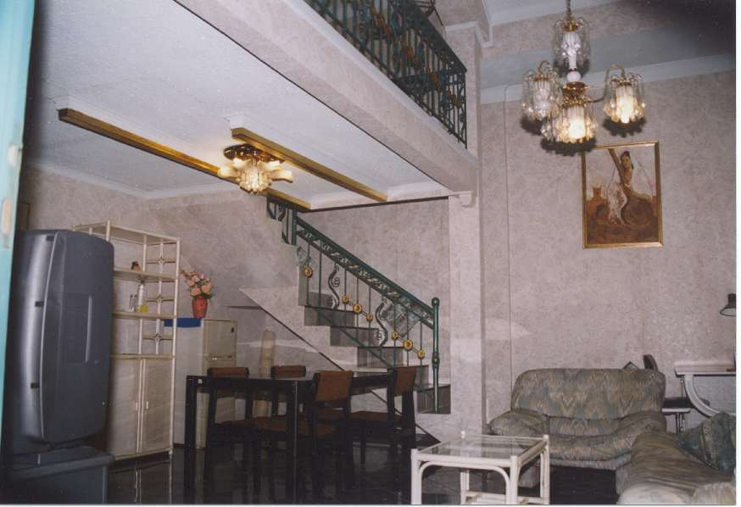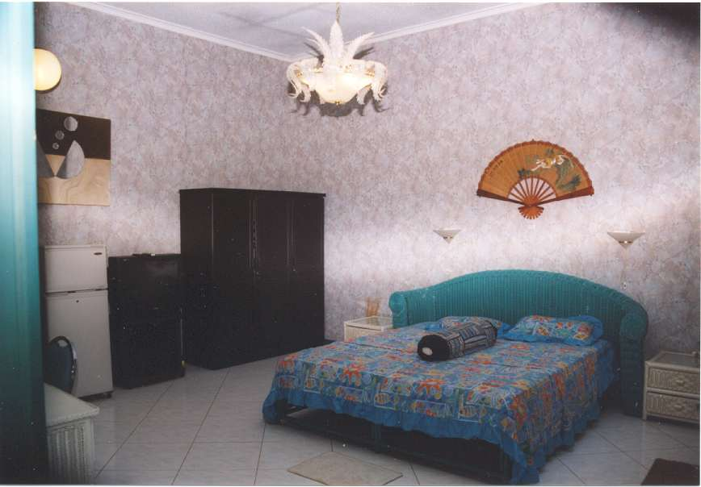

We are located at Jl. Gunung Balong Raya no. 10, Lebak Bulus, Cilandak, South Jakarta. Being across housing estate “Bona Indah Garden” which is the area of a lot of foreigners and close to sports clubs, it is a very safe area round the clock. We are 10 minutes from Pondok Indah Mall and 15 minutes from KemChicks (foreigners groceries shopping store).

AVAILABLE ROOM TYPES AND RATES/MONTH :
- 5 STANDARD ROOMS AT US$ 300
- 3 SEMI-DELUXE ROOMS AT US$ 400
- 2 DELUXE ROOMS AT US$ 500
- 2 SPLIT LEVELS AT US$ 500 TO US$ 600
- 4 SUPER DELUXE ROOM AT US$ 800
- 2 SUITES AT US$ 900 TO US$ 1500

FACILITIES:
Full communication facilities available including optional international calling cards.
Breakfast included. Light lunches and dinners are available upon request. Extra meals will be charged accordingly. Barbeque equipment is available, main kitchen is provided for, selfcooking includes usage of kitchen utensils.

Washing and ironing only. Linen services, towel and soap are provided.
Sports and pool facilities are at walking distance.
Satellite tv stations are available including CNN, BBC World, H.B.O, MTV, NHK is possible on request with extra payment.

Massage services available on request (relaxation and healing for approx. Rp. 50,000)
In addition we can offer special business programs to facilitate businesspeople (be it for the experienced or the incubators) to manage all paperwork necessary in Indonesia, e.g. permits, visa, licences, registration, etc….

Roomboys are on service to your need, such as for calling taxi’s, show you around the city:, where to shop safely, etc… (specially for visiting tourists) Hero supermarket is only at walking distance and the Bona Plaza shopping area / beauty salon / fitness center / lab clinic / 24 hours doctor services are just in front of our compound. Fastfood delivery services are available.

Swimming, sport and fitness facilities are only valid for split levels, super de-luxe and suites. These facilities are void if a discount or corporate contract is negotiated.

Please call us for inspection of the rooms along with further information.

We trust you could make use of our services and hope to hear from you soon to make an appointment for inspection of our guesthouse facilities.

Thank you for your kind attention.

Mrs. Jade P. Lorraine, manager

