 Year of the Bull !
Cuisine & Culture www.geocities.com/tangweihua_un Jan. 2009
Well come back, colleagues and friends. Cuisine & Culture wishes you, albeit in a somewhat belated manner, a happy and harmonious New Year while ushering in the Chinese Lunar New Year of the Bull arriving on January 26 in a timely fashion though.
As the eventful year that barely ended saw the Bull almost buried on the Wall Street with the world coming to senses its financial system needs not just forceful retooling but fundamental redesigning the Year of the Bull can’t arrive sooner!
Cuisine & Culture, however, is not in the business of finding a way out for the fragile financial system in the coming year also known as the Year of the Ox but rather helping us have good health in the year further known as the Year of the Cow.
With its mission to help us eat well and eat healthy all the while sharing our colorful cultural diversity of our world family, Cuisine & Culture will, as usual, offer you delicious and yet nutritious delicacies while sharing with you fun facts of the Chinese astrology.
More so, Cuisine & Culture will milk the Cow harder during the coming Year of the Bull for more entertaining healthy food tips and more enlightening cultural anecdotes to hopefully help mint a happier and healthier New You in the New Year.
Finally, one definitively auspicious sign for the Year of the Bull—Barak Obama, born in August of 1961, is a Bull!

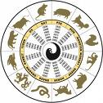Chinese Astrology
For colleagues and friends unfamiliar with the Chinese and other Asian cultures, Cuisine & Culture takes the liberty to once again present the following brief description of the lunar year system which, allegedly coinciding with an ancient agricultural calendar based on the cycles of the moon, dates back to approximately 2600 BC, when Yuhuang Dadi (the Jade Emperor of Heaven) introduced the first cycle of the Chinese Zodiac.

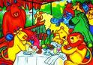Legends abound as to how said zodiac came into being. One has it that on one of his birthday anniversaries the Emperor invited all the animals on earth to join in celebrations. Only 12 showed up, however, for the party, who were Rat, Bull (or Ox), Tiger, Rabbit, Dragon, Snake, Horse, Goat, Monkey, Dog, and Pig.

For their loyalty, the Emperor honoured each party animal with a year of its own in the above order which makes up a cycle of twelve. Because of cyclical lunar dating, the first day of each lunar year can fall anywhere between late January and mid-February. This year, it falls on January 26, 2009—Lunar Year 4707, the Year of the Bull (or OX).
Please note the lunar calendar determines which zodiac sign you fall under. If you were born in early January you should follow the zodiac symbol for the previous year. If you were born in late January or early February it gets tricky. You need to find out when the lunar year began during that particular calendar year.
Again, as legend goes, when the 12 party animals were honored with a year of its own for their loyalty it was also decreed that henceforth those born in the year of the animal would assume the nature and characteristics of that animal. Cuisine & Culture, however, stops short on that, for anything further gets tantalizingly close to superstition.
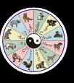Asia, however, is full of possibilities for anyone seeking the help of the divine. The Chinese, with a civilization of over 5,000 years, have produced some of the best ways by which fortune may be met and misfortune kept in check. For those who’re indeed interested you may want to take a look at the Chinese Horoscope to get further mystified at: Chinese-Astrology.co.uk
With that, Cuisine & Culture can’t wait to introduce to you Spring Rolls as a holiday delicacy to feature this special edition.

Spring Rolls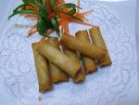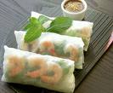
Spring roll enjoys a long history of over a thousand years. Spring Rolls are fried or non fried pastries that are popular in several Asian countries. In China they were called Spring Cakes in the Song Dynasty (960-1279 AD or CE). Paper thin pastry wrapping round shredded ingredients, Spring Rolls are especially popular during the Chinese New Year or the Spring Festival. The fillings can be meat with veggies or purely vegetarian. They vary to certain extent from region to region in China. The Fujianese version has very thin pastry and exotic fillings. It’s the best of all Spring Rolls. Shanghai Spring Rolls boast a diversity of fillings with one typical ingredient in bamboo shoot. The Cantonese Spring Rolls have travelled overseas and are known in the West as Egg Rolls.
Ways of preparing fried Spring Rolls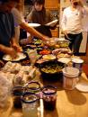
Ingredients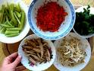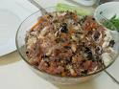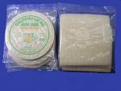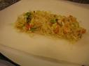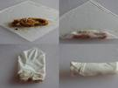
12 sheets Spring Roll wrappers (They may be round or square in shape)
1 egg, beaten
6 cups oil for frying
115 g chicken breast meat
115 g pork
140 g cooked and shelled shrimps
60 g roast pork
6 dried mushroom, soaked
1 cup shredded bamboo shoot
170 g chives
Seasoning of chicken meat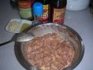
2 tsp egg white
1/4 tsp salt
1/2 tsp each rice wine and cornstarch
sesame oil, pepper and sugar
Glaze
1/3 cup chicken broth
2 tsp light soy sauce
1 heap tsp of cornstarch
Preparation
Cut chicken into strips and mix with the seasoning
Cut mushroom into strips
Cut bamboo shoots into slices and blanch in boiling water
Cut chives into 5 cm lengths
Filling
Pre-fry seasoned chicken and pork in oil
Put wok over high flame and add 1 tbsp oil
Add chives and stir fry for a few seconds add salt to taste, remove and set aside
Add 1 tbsp oil and stir fry the mushroom, bamboo shoot, and shredded meat.
Add roast pork strips and stir fry for a few seconds over high heat
Add the glaze and stir well
Remove and leave to cool
Mix together all the filling ingredients adding the cooked shrimp and chives
Wrapping
Place a piece of the Spring Roll pastry on the table one corner facing you
Put 2 tbsp of the filling in the center of the pastry
Fold the nearest corner of the wrapper up covering the filling
Fold the two sides
Finish by rolling away from you
Glue the last corner with the beaten egg
Repeat for all the 12 Spring Rolls
Deep Frying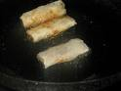
Set wok over high flame
Add oil for frying
Once oil is heated to approx. 180 degrees C.
With pair of long wooden chopsticks hold one piece of the Spring Rolls at a time in the oil for a few seconds, pinching the fold to prevent from opening, before letting go.
Fry each piece until golden brown
Drain off excess oil in a colander.
Enjoy! 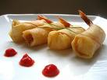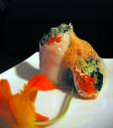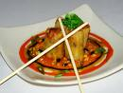
 From the Editor:
Cuisine & Culture obtains its materials both online and off line with sources omitted for reason of simplicity but can be provided upon request. Certain materials come in languages other than English which Cuisine & Culture renders into English to the best of its ability. Cuisine & Culture is not in a position to verify the veracity of the materials obtained online/off line and provided herein. Reader’s discretion is kindly advised.

A Special Acknowledgement of Thanks from Cuisine & Culture

Cuisine & Culture wishes to express its heartfelt thanks to Kevin Wambura of the ITS team here at UNON in Nairobi and Yawtsong Lee, a veteran interpreter at UN headquarters, now retired, for their technical advice and assistance and is happy for having retained them as Technical Advisors to Cuisine & Culture.

Cuisine & Culture

Weihua Tang/Editor
United Nations Office at Nairobi
Division of Conference Services
Interpretation Section
Ext.1024/Rm.CW-205

