Cuisine & Culture  special 2008
www.geocities.com/tangweihua_un
Colleagues and friends, once again on this special occasion of International Working Women’s Day, Cuisine & Culture takes its hat off to all our female colleagues and the better halves of our male colleagues for their dedication and hard work both in office and at home and for their exemplary roles as working women, working wives and working mothers as well.

“Women holding up half of the sky” is fast becoming a reality. Within the UN family, gender mainstreaming and women empowering is rapidly gathering steam. Here on the Nairobi campus of the UN African Headquarters, WAVE (Women As Voice for Environment) is making its voice heard. Elsewhere in the Organization, CSWs (Commission on Status of Women), and in the world, NOWs (National Organization of Women) are cropping up like mushrooms, epitomizing the improvement of the fate of women and the rise of their status.

Cuisine & Culture hails the monumental achievements and immense progress made by and for women. With its mission to help us, and our sister colleagues in particular, eat well and eat healthy Cuisine & Culture again takes great pleasure in presenting in this special issue some more WISH (Women In for Solid Health) lists for the commemoration of the special festival.

WISH List 1—Healthy Breakfast Helping Working Women Retain Youth

The family and the world need a healthy mother. With the working mother already stressed out with taking care of the family and work, she must do her best to find time to care for herself. Maintaining a healthy diet and managing to enjoy a healthy breakfast in particular is thus of utmost importance. Mothers just can’t afford to get sick.

What’s an ideal healthy breakfast for working women?

Well, it goes without saying that it must be nutritious, easy to prepare, easy to digest, and tasty too. So let’s take a look at the following breakfast delicacies:

- Fresh yogurt + whole wheat bread + fresh tomato
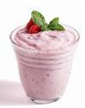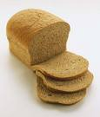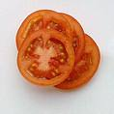
Both yogurt and tomato take pride in their high content of Vitamin A, which is credited as guardian angel for our eyes. Women whose jobs require them gluing to their desk tops need to take particular care of their eyes.

Vitamin A additionally functions to effectively regenerate surface skin cells and accelerate renewal of deep skin cells as well thereby strengthening the cell conjugation while regulating the cutinization process of skin cells, the result—smooth skin full of elasticity.

- Millet congee with red dates and chicken sandwich
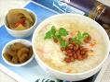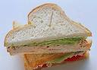
Millet, high in content of carotene and vitamins, with red dates, both blood and energy enriching, together work to beef up the immune system. With an addition of a chicken sandwich, a healthy breakfast of this sort is like a battery charger providing sufficient energy for a busy morning of heavy workload professional women often face.

WISH List 2---Healthy and Easy to Prepare Lunch Helping Working Mothers Recapture Youth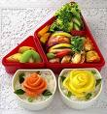

Salad and More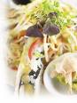

Our female colleagues, how about a healthy and hearty salad with nuts as toppings that you’ll find easy to prepare, pack and keep in the fridge in the night ready to go in the morning—the healthy greens and nuts give your bodies the great antioxidant Vitamin E and the fiber they need to stay energetic the whole day?

Add a couple of nutritious whole wheat dinner rolls with low cal spread or dressing and you have a refreshing lunch to keep them going the whole day.

Hot Lunch Tips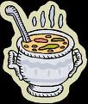

Another quick and yet healthy recipe that can be done the evening before—a hot hearty soup, vegetarian or not, can be extremely filling and nutritious which keeps you full and alert at your work the whole day. Add milk for enrichment and a spread of whole wheat bread crunches and you have the required calories for the day.

Stir Fried Noodles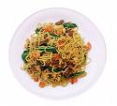

Get some veggies in your lunch routine, working moms and it’ll do you wonders. Simple stir fried noodles can be ready in as little time as 15 minutes. Prepare at night or if you can spare a little time before you get ready for work.

--Boil your favorite healthy whole wheat noodles; stir fry some frozen veggies in a skillet, season with some salt, pepper and herbs; add light soy sauce or any of your own favorite sauce for more flavor.

--While your noodles are nice and soft and your veggies are getting nice and crisp, mix them well, add a few drops of lemon and pack your lunch.

WISH List 3—Healthy Dinner Recipes Helping Working Wives Remain Young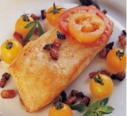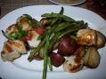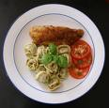
What do we mean by a "healthy" dinner recipe? This can of course mean different things to different people, whether you are a vegetarian or not, if you like seafood, whether you are on a diet and your own preferences.
However any healthy dinner recipe should follow these sound nutritional guidelines:
Balanced proportions of carbohydrate, protein and fat
You need to serve the correct amount of each type of food. One popular diet – the Zone – recommends we consume 40% of calories from carbs, 30% from protein and 30% from fat.

While you don’t need to follow this exactly it does serve as an overall guide.

Low in saturated fat
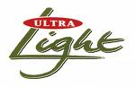
It’s commonly accepted that saturated fats can be bad for you, leading to high cholesterol and heart conditions. Make sure your dinner recipe is healthy by limiting the amount of saturated fats like rich sauces, fatty meats and cream deserts.

High in Nutrient Value
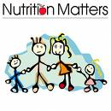
Heat destroys the vitamins and nutrients in food, so the less you cook it the healthier it will be. Salads are great, and lightly steamed vegetables like broccoli are very tasty.

Fresh vs. Frozen?
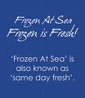
Many fresh products spend days or weeks before they arrive on the supermarket shelves. By the time we get around to eating them, much of the fresh fruit and vegetables have lost a lot of their nutritional value. Most frozen fruits and vegetables are processed very quickly (often on the day they are picked), before vitamins have had time to be destroyed. The freezing process also helps to preserve nutrients.

Canned Foods
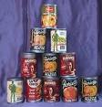
Canned food can form part of a healthy dinner. It’s often assumed that canned foods are a poor source of vitamins and minerals. Canned foods in many cases provide similar amounts of vitamins and minerals to the fresh version. Read the label and make sure there is not a lot of salt.
Healthy Dinner Recipes: Portion Sizes 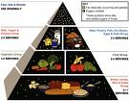

When you are looking for a healthy meal, if you over-eat you will end up counter-acting all the benefits you got from the food. North Americans generally eat too much, and this is as much by habit as anything else.
Try cutting back on some of the serving quantities. For example if you take the standard size 12 oz steak and cut it in two, this is an ideal size for the average person. Likewise with potato, try eating just half of the (usually big) baking potato. If you're still hungry you can increase the portion size of things like green vegetable or salads.
From the Editor:
Cuisine & Culture obtains its materials both online and off line with sources omitted for reason of simplicity but can be provided upon request. Certain materials come in languages other than English which Cuisine & Culture renders into English to the best of its ability. Cuisine & Culture is not in a position to verify the veracity of the content presented herein. Reader’s discretion is kindly advised.

A Special Acknowledgement of Thanks from Cuisine & Culture

Cuisine & Culture wishes to express its heartfelt thanks to Kevin Wambura of the ITS team here at UNON in Nairobi and Yawtsong Lee, a veteran interpreter at UN headquarters, now retired, for their technical advice and assistance and is hereby extremely pleased to retain them as Technical Advisors to Cuisine & Culture.

Cuisine & Culture

Weihua Tang/Editor
UNON/DCS
Ext.1024/Rm.CW205

