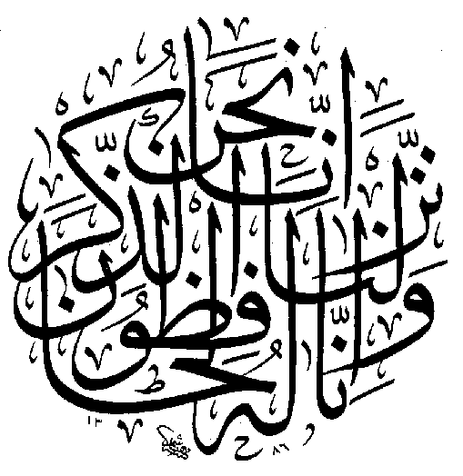

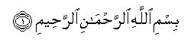 | Bismillaahir rahmaanir raheem  -  In the Name of Allâh, the Most Beneficent, the Most Merciful.
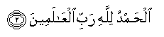 | Alhamdu lillaahi rabbil ‘aalameen  -  All the praises and thanks be to Allâh, the Lord of the 'Alamîn (mankind, jinns and all that exists).
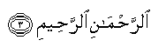 | Arrahmaanir raheem  -  The Most Beneficent, the Most Merciful.
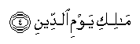 | Maaliki yawmid deen  -  The Only Owner (and the Only Ruling Judge) of the Day of Recompense (i.e. the Day of Resurrection).
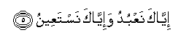 | Iyyaaka na’ budu wa-iyyaaka nasta ‘een  -  You (Alone) we worship, and You (Alone) we ask for help (for each and everything).
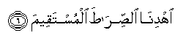 | Ih-dinas siraatal mustaqeem  -  Guide us to the Straight Way.
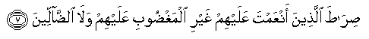 | Siraatal ladheena an ‘amta ‘alayhim ghayril maghdoobi ‘alayhim walad daalleen  -  The Way of those on whom You have bestowed Your Grace, not (the way) of those who earned Your Anger (such as the Jews), nor of those who went astray (such as the Christians).

Surah Al-Fâtihah

Bismillaahir rahmaanir raheem
-
In the Name of Allâh, the Most Beneficent, the Most Merciful.

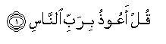 | Qul-a ‘oodhu birabbin naas  -  I seek refuge with (Allâh) the Lord of mankind.
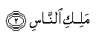 | Malikin naas  -  The King of mankind.
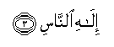 | Ilaahin naas  -  The Ilâh (God) of mankind.
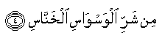 | Min sharril waswaasil khannaas  -  From the evil of the whisperer (devil who whispers evil in the hearts of men) who withdraws (from his whispering in one's heart after one remembers Allâh).
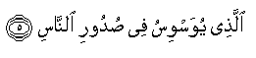 | Alladhee yuwaswisu fee sudoorin naas  -  Who whispers in the breasts of mankind.
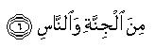 | Minal jinnati wannaas  -  Of jinns and men.

Surah An-Nâs

Bismillaahir rahmaanir raheem
-
In the Name of Allâh, the Most Beneficent, the Most Merciful.

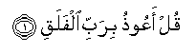 | Qul-a ‘oodhu birabbil falaq  -  I seek refuge with (Allâh) the Lord of the daybreak.
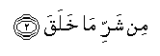 | Min sharri maa khalaq  -  From the evil of what He has created.
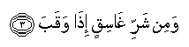 | Wamin sharri ghasiqin idha waqab  -  And from the evil of the darkening (night) as it comes with its darkness.
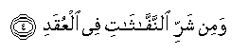 | Wamin sharrin naffaathaati fil ‘uqad  -  And from the evil of the witchcrafts when they blow in the knots.
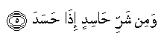 | Wamin sharri haasidin idha hasad  -  And from the evil of the envier when he envies.

Surah Al-Falaq

Bismillaahir rahmaanir raheem
-
In the Name of Allâh, the Most Beneficent, the Most Merciful.

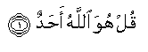 | Qul huwallaahu ahad  -  He is Allâh, (the) One.
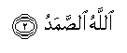 | Allaahus samad  -  Allâh-us-Samad (The Self-Sufficient Master, Whom all creatures need, He neither eats nor drinks).
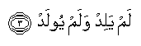 | Lam yalid walam yoolad  -  He begets not, nor was He begotten.
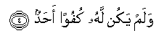 | Walam yakullahu kufuwan ahad  -  And there is none co-equal or comparable unto Him.

Surah Al-Ikhlâs

Bismillaahir rahmaanir raheem
-
In the Name of Allâh, the Most Beneficent, the Most Merciful.

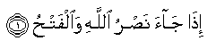 | Idha jaa a nasrullaahi walfat-h  -  When comes the Help of Allâh (to you, O Muhammad (Peace be upon him) against your enemies) and the conquest (of Makkah).
 | Wara-aytan naasa yadkhuloona fee deenillaahi afwaaja  -  And you see that the people enter Allâh's religion (Islâm) in crowds.
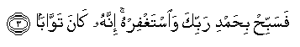 | Fasabbih bihamdi rabbika wastaghfirhu innahu kaana tawwaaba  -  So glorify the Praises of your Lord, and ask for His Forgiveness. Verily, He is the One Who accepts the repentance and forgives.

Surah An-Nasr

Bismillaahir rahmaanir raheem
-
In the Name of Allâh, the Most Beneficent, the Most Merciful.

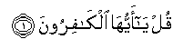 | Qul yaa ayyuhal kaafiroon  -  Oh Al-Kâfirûn (disbelievers in Allâh, in His Oneness, in His Angels, in His Books, in His Messengers, in the Day of Resurrection, and in Al-Qadir, etc.)!
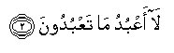 | Laa a‘ budu maa ta’ budoon  -  I worship not that which you worship.
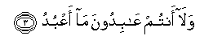 | Walaa antum ‘aabidoona maa abud  -  Nor will you worship that which I worship.
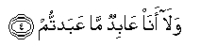 | Walaa ana ‘aabidummaa ‘abattum  -  And I shall not worship that which you are worshipping.
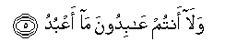 | Walaa antum ‘abidoona maa ‘abud  -  Nor will you worship that which I worship.
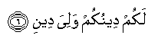 | Lakum deenukum waliya deen  -  To you be your religion, and to me my religion (Islâmic Monotheism).

Surah Al-Kâfirûn

Bismillaahir rahmaanir raheem
-
In the Name of Allâh, the Most Beneficent, the Most Merciful.

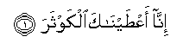 | Innaa ‘ataynaakal kawthar  -  Verily, We have granted you (O Muhammad (Peace be upon him)) Al-Kauthar (a river in Paradise).
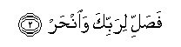 | Fasalli li rabbika wan-har  -  Therefore turn in prayer to your Lord and sacrifice (to Him only).
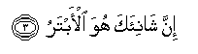 | Inna shaani aka huwal-abtar  -  For he who makes you angry (O Muhammad (Peace be upon him)), - he will be cut off (from every good thing in this world and in the Hereafter).

Surah Al-Kauthar



The 5 Pillars of Islam

(Submission to Allah)

La ilaaha illa-llaah Muhammadur-Rasool ullah

“There is no true God but Allah Subhanahu wa ta’ala (High and Exalted is He) and Mohammad Salal-layhu alayhi wasalam (Peace be upon him), is His last Messenger”.

Salaat (Prayer)
Perform the 5 mandatory prayers a day (Al-Fajr, Dhuhr, Asr, Mughrib & Isha). Allah does not need one's prayer because He is free of all needs. Prayer is for our immeasurable benefit, and the blessings are beyond all imagination.

Zakaat (Purification)
Obligatory giving to the poor. A very important pillar of Islam, it draws Allah’s blessings and strengthens the relationship between the rich and the poor.

Sawm (Fasting)
Fast in the month of Ramadhan. Fasting is abstaining from eating, drinking, intimate male / female contact and smoking from sunrise till sunset in this Holy Month.

Hajj (Pilgrimage)
One should perform this once in your lifetime. Muslims from all over the globe assemble in Mecca before the Ka’bah in response to the call of Allah (S.W.T.).

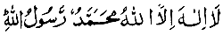



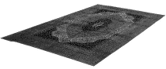

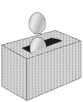





Fundamental Articles of Imaan (‘Faith’)

A true Muslim Believes in..

One God - Allah (Subhanahu wa ta’ala), Supreme and Eternal, Infinite and All Mighty, Merciful and Compassionate, Creator and Provider.

Allah’s Angels - purely spiritual and splendid beings ordered by Allah.

Allah’s Revealed Books - a Muslim believes in all scriptures and revelations of God, as they were complete and in their original forms.

His Messengers - all Messengers were mortals, human beings, endowed with Divine revelations and appointed by God to teach mankind.

The Last Day of Resurrection - everything we do, say, make, intend and think are accounted for and kept in perfect records, they are brought up on this Day.

Al-Qadr - Allah has ordained everything. One must not believe that anything but Allah controls the present or future (luck charms, horoscopes, one’s own actions).

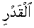

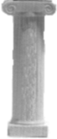

Prophet Mohammad (Peace be upon him) said “Pray as you have seen me praying”
The Pillar of Salaat

The conditions of Salaat

- Acceptance of Islamic Faith - The one who believes in Allah is required to perform Salaat.

- Niyyat - Intention in one’s heart to perform a particular prayer.

- Cleanliness - This includes cleanliness of the worn clothes, the place of prayer and the body.

- Purification - Performing Wudhu (ablution) before undertaking Salaat.

- Concealing the body - A man’s body must be covered between the navel and the knees
and also the shoulders. Women must be clothed fully with opaque covering, revealing
no shape of figure or hair at all.

- Facing the Qiblah - One must face the sacred Mosque of Makkah to pray. If the direction is unknown, it can be guessed and the prayer will be accepted, insh’Allah (“if Allah wills it so”).

- Observed times of performing Salaat - Prayers are to be observed at the prescribed times.

- Neglected Prayers - Salaat that is forgotten must be done even when late (“Kadaah”), the longer one leaves it the more the reward of the prayer diminishes.

Invalidation of Salaat (that requires repeating the entire prayer)

- Talking deliberately, or to do any acts outside the movements of prayer.
- Laughing, eating & drinking (residual food in the mouth).
- To significantly shift direction from the Ka’bah during the prayer.
The Second Pillar of Islam

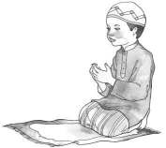
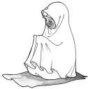

Please Note: situations such praying on a train or plane mean involuntary shifting of direction will not invalidate prayer.

Performing Wudhu For Your Daily Prayers

- Niyyat - Make intention to perform Wudhu in one’s mind for the purpose of worshipping Allah Subhanahu wa ta’ala.

- Bismillah - Invoking Allah at the start of Wudhu by saying Bismillah (in the Name of Allah)

- Hands - Wash the hands 3 times up to the wrists with water, allowing water to run between the fingers.

- Mouth - Rinsing the mouth with water three times. The mouth must be empty of food.

- Nose - Cleaning one’s nostrils by sniffing water in then out 3 times.

- Face - Clean the face 3 times from the top of the forehead down to the chin and from ear to ear.

- Arms - Wash the arms three times, from the elbows. Right arm first, then left.

- Head - Moisten the hands and pass them over the head from the forehead to the back of the
neck (over the head), and from there back to the forehead. Never wet the neck. Then
wipe the earlobes with the fore-fingers cleaning the inside of the ears and the thumbs
cleaning the external side.

- Feet - Finally wash both feet beginning with the right first, up to the ankles. The feet should
be rubbed whilst washed and water must run between the toes. No part of the foot remains dry.

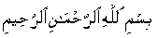

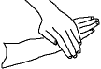

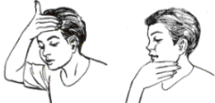

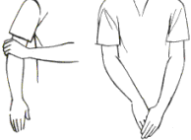

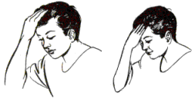

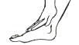

Matters that invalidate one’s acquired Wudhu
- Passing of excrement, wind or urine.
- Sleep of any sort.
- Touching of sexual organs even unintentionally, whether naked or clothed.
- Not sweat or mud (contrary to rumour).

Impurities are

Excrement.
- Urine.
- Blood shed.
- Pig & dead animal.

Clean water which is permissible for Wudhu

- Natural water such as rain or lake water.
- A large quantity of water even mixed with
impure substances but has not changed in
it’s taste, colour or odour.

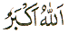

Acts of Salaat

Obligatory Daily Salaat

It is obligatory to perform the following five prayers during each day and night at their stated times
- Dawn prayer (Al-Fajr) - 2 Rakaats (2 prostrations of salaat).
- Midday (Al-Zuhr) and Afternoon prayer (Al-Asr) - each one consisting of 4 Rakaats.
- Dusk prayer (Al-Mughrib) - 3 Rakaats, and finally the Night prayer (Al-Isha) - 4 Rakaats.

Performing a 4 Rakaat Salaat step-by-step (all steps must be performed correctly for the prayer to be valid)

- Niyaat - Intention to perform a particular prayer.

Stand straight facing Al-Ka’bah, hands at sides and form the following intention to yourself in your mind

“Oh Allah, I offer the prayer, of Rakaats (prostrations)”

- Takbir - Then lift both hands up to the ears with thumbs touching the earlobes and say

“Allahu Akbaar” - Allah is Great. It is obligatory to begin any prayer with this.

One must fold their arms over their chest (right hand over left) after this Takbir.
When ever you are standing (“Qawam”) in Salaat, you must keep your arms folded.

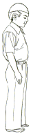

Fajr
Dhuhr
‘Asr
Maghrib
‘Ishaa’

Two
Three
Four

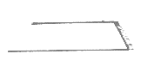

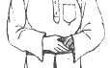
§

3) Recite Al-Fâtihah - At the beginning of every Rakaat one must recite Surah Al-Fâtihah, the opening passage of the Holy Qur’an. No prayer is accepted without the recitation of this Surah.

Upon every recitation of Al-Fâtihah (only),
one must finish by saying slowly and softly

“Ameen”

This concludes Al-Fâtihah and is to ask Allah Subhanahu wa ta’ala for acceptance of your prayer.

4) Recitation after Surah Al-Fâtihah - Al-Fâtihah is followed by at least one more chosen Surah from the Qur’an. This is considered as Sunnah (Followings of the life of Prophet Mohammad S.A.W.).

5) Takbir - As before, place hands to ears and say “Allahu Akbaar”

6) Ruku - Bow down to the extent that the finger tips rest upon the knees.

Whilst in Ruku say at least 3 times

“Subhaana Rabbi al Adheem” - Glory be to my Lord who is the Very Greatest.

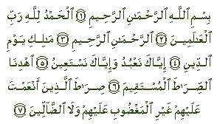

general note: one must always look down just in front of themselves whilst in Salaat.
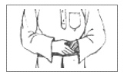

¤

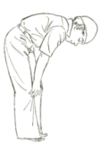

back is straight

arms do not touch body

fingers spread
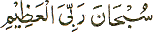
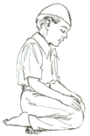
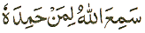
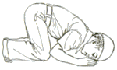
the elbows must not touch the ground
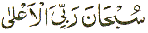
left hand spread on left knee and right hand spread on right knee

7) Qawam (standing straight) - After Ruku stand up to Qawam, raising the hands to your ears and say

“Saami-‘Allah Huliman Hamidah” - Allah listens to one who praises Him.

8) Takbir - Place the hands to ears and say “Allahu Akbaar”

9) Sajdah - Go down to Sajdah. In this prostration, parts of the body must touch the ground are:

- Forehead,
- Tip of nose,
- Both palms,
- Both knees,
- The bottom surface of the toes.

The Sajdah is to lie before Allah Subhanahu wa ta’ala in the intention of humility before Him.

10) In Sajdah, whilst one is on the floor, say at least 3 times

“Subhana Rabbi al A'la” - Oh Allah, glory be to You, the Most High

11) Sit up whilst saying “Allahu Akbaar” (no hand gesture)

sit up to the kneeling position with hands resting on thighs and knees

recite Al-Fâtihah and one more Surah.
Ruku
Sajdah
Sajdah again
Qawam
§
do not rise to Qawam
continue to step 15.

12) Back down to Sajdah - Repeat Sajdah (step 10): Say at least 3 times

“Subhaana Rabbi al A'la” - Oh Allah, glory be to You, the Most High

13) Rise to Qawam - Rise to the standing position then say Takbir (with hand gesture) to now begin the second Rakaat.

14) The second Rakaat is essentially the first Rakaat (with the end being different), ie. steps 3 - 12 again:

15) After the last Sajdah, do not rise to the standing position, rise to the sitting-up posture whilst saying “Allahu Akbar” (with no hand gesture)

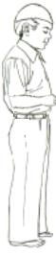

16) At-Tashahud - The words of witness. Whilst sitting, recite the following to yourself

Note: Whilst reciting only the 2nd part of At-Tashahud, one’s right fore-finger must be raised.
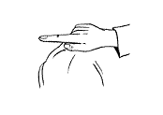
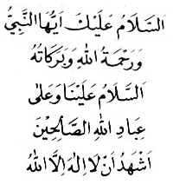

- “At-tahiy-yatu lil-lah was salawatu wat-taybaat.
As-salamu alaykam ay-yahan-nabiy-yu
Wa rahma tullahi wa barakatu
As-salaamu alayna wa’ala ibadi his-saliheen.”
-
“All compliments and worship are for Allah.
Peace be upon you, Oh Prophet, and Allah’s mercy and blessings.
Peace be on us and all righteous slaves of Allah”
- “Ash hadu anla ilaha illal lah
wa ash hadu an-na Mohammadan rusool Allah.”
-
“I bear witness that no one is worthy of worship except Allah,
and I bear witness that Mohammad (S.A.W.) is His Messenger”
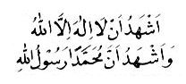

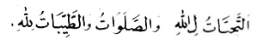

the right fore-finger

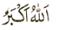

17) The 3rd Rakaat - Rise to Qawam then say Takbir (with hand gesture).

Note: Recite only Surah Al-Fâtihah and no more, in this Rakaat.

18) The 4th Rakaat - Stand then say Takbir (with hand gesture) to begin the 4th Rakaat.

Again, recite Surah Al-Fâtihah and no more. Once the end of this Rakaat is reached, remain sitting.

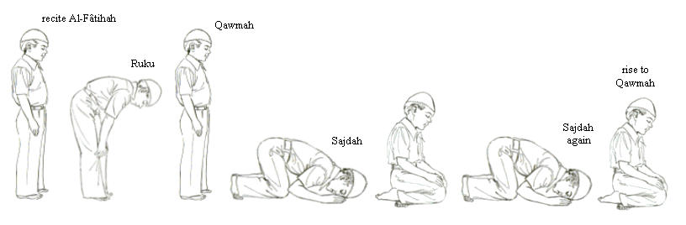
follow steps 3 to 12 loosely

(i.e. omit step 4 )

§ §

¤

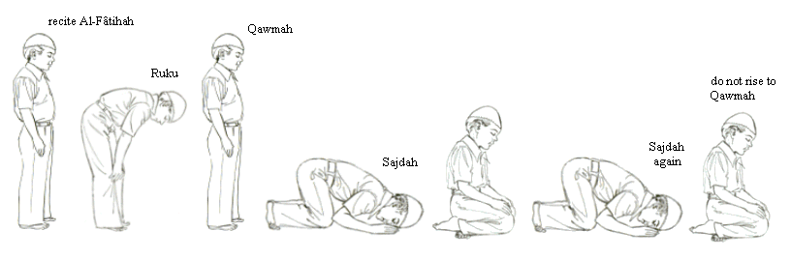
the 4th Rakaat is similar to the 3rd except one must remain sitting at the end

19) At-Tashahud - The words of witness. Whilst sitting, again recite the following to yourself

Again whilst reciting only the 2nd part of At-Tashahud, one’s right fore-finger must be raised.

- “At-tahiy-yatu lil-lah was salawatu wat-taybaat.
As-salamu alaykam ay-yahan-nabiy-yu
Wa rahma tullahi wa barakatu
As-salaamu alayna wa’ala ibadi his-saliheen.”
-
“All compliments and worship are for Allah.
Peace be upon you, Oh Prophet, and Allah’s mercy and blessings.
Peace be on us and all righteous slaves of Allah”
- “Ash hadu anla ilaha illal lah
wa ash hadu an-na Mohammadan rusool Allah.”
-
“I bear witness that no one is worthy of worship except Allah,
and I bear witness that Mohammad (S.A.W.) is His Messenger”

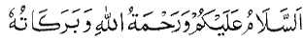
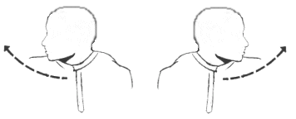
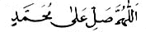
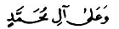
“Allah-Hu-Ma Sa-li A-Laa Muhammad”
-
Oh Allah, do show Your grace upon Mohammad (S.A.W.)
“Wa A-Laa Aa-Lee Muhammad”
-
And upon the family of Mohammad (S.A.W.).
“Assalamu alaykum wa rahmatullahi wa barakatuh”
-
Allah's peace, blessings and grace be on you believers

20) Recite the words of supplication for the Prophet Mohammad (Peace be upon him).

21) Once the words of supplication for the Prophet (S.A.W.) have been recited, say the following Salaam once to the direction of each shoulder, first right then left:

This concludes the entire 4 Rakaat prayer.

Acts of Salaat (Al-Mughrib example)

Obligatory Daily Salaat

It is obligatory to perform the following five prayers during each day and night at their stated times
- Dawn prayer (Al-Fajr) - 2 Rakaats (2 prostrations of salaat).
- Midday (Al-Zuhr) and Afternoon prayer (Al-Asr) - each one consisting of 4 Rakaats.
- Dusk prayer (Al-Mughrib) - 3 Rakaats, and finally the Night prayer (Al-Isha) - 4 Rakaats.

A 3 Rakaat Salaat (Mughrib) step-by-step (all steps must be performed correctly for the prayer to be valid)

- Niyaat - Intention to perform a particular prayer.

Stand straight facing Al-Ka’bah, hands at sides and form the following intention to yourself in your mind

“Oh Allah, I offer the prayer, of Rakaats (prostrations)”

- Takbir - Then lift both hands up to the ears with thumbs touching the earlobes and say

“Allahu Akbaar” - Allah is Great. It is obligatory to begin any prayer with this.

One must fold their arms over their chest (right hand over left) after this Takbir.
When ever you are standing (“Qawam”) in Salaat, you must keep your arms folded.

Fajr
Dhuhr
‘Asr
Maghrib
‘Ishaa’

Two
Three
Four

§

3) Recite Al-Fâtihah - At the beginning of every Rakaat one must recite Surah Al-Fâtihah, the opening passage of the Holy Qur’an. No prayer is accepted without the recitation of this Surah.

Upon every recitation of Al-Fâtihah (only),
one must finish by saying slowly and softly

“Ameen”

This concludes Al-Fâtihah and is to ask Allah Subhanahu wa ta’ala for acceptance of your prayer.

4) Recitation after Surah Al-Fâtihah - Al-Fâtihah is followed by at least one more chosen Surah from the Qur’an. This is considered as Sunnah (Followings of the life of Prophet Mohammad S.A.W.).

5) Takbir - As before, place hands to ears and say “Allahu Akbaar”

6) Ruku - Bow down to the extent that the finger tips rest upon the knees.

Whilst in Ruku say at least 3 times

“Subhaana Rabbi al Adheem” - Glory be to my Lord who is the Very Greatest.

general note: one must always look down just in front of themselves whilst in Salaat.

¤

back is straight

arms do not touch body
fingers spread

7) Qawam (standing straight) - After Ruku stand up to Qawam, raising the hands to your ears and say

“Saami-‘Allah Huliman Hamidah” - Allah listens to one who praises Him.

8) Takbir - Place the hands to ears and say “Allahu Akbaar”

9) Sajdah - Go down to Sajdah. In this prostration, parts of the body must touch the ground are:

- Forehead,
- Tip of nose,
- Both palms,
- Both knees,
- The bottom surface of the toes.

The Sajdah is to lie before Allah Subhanahu wa ta’ala in the intention of humility before Him.

10) In Sajdah, whilst one is on the floor, say at least 3 times

“Subhana Rabbi al A'la” - Oh Allah, glory be to You, the Most High

11) Sit up whilst saying “Allahu Akbaar” (no hand gesture)

sit up to the kneeling position with hands resting on thighs and knees

the elbows must not touch the ground

left hand spread on left knee and right hand spread on right knee
§

12) Back down to Sajdah - Repeat Sajdah (step 10): Say at least 3 times

“Subhaana Rabbi al A'la” - Oh Allah, glory be to You, the Most High

13) Rise to Qawam - Rise to the standing position then say Takbir (with hand gesture) to now begin the second Rakaat.

14) The second Rakaat is essentially the first Rakaat (with the end being different), ie. steps 3 - 12 again:

15) After the last Sajdah, do not rise to the standing position, rise to the sitting-up posture whilst saying “Allahu Akbar” (with no hand gesture)

recite Al-Fâtihah and one more Surah.
Ruku
Sajdah
Sajdah again
Qawam
do not rise to Qawam
continue to step 15.

16) At-Tashahud - The words of witness. Whilst sitting, recite the following to yourself

Whilst reciting only the 2nd part of At-Tashahud, one’s right fore-finger must be raised.

- “At-tahiy-yatu lil-lah was salawatu wat-taybaat.
As-salamu alaykam ay-yahan-nabiy-yu
Wa rahma tullahi wa barakatu
As-salaamu alayna wa’ala ibadi his-saliheen.”
-
“All compliments and worship are for Allah.
Peace be upon you, Oh Prophet, and Allah’s mercy and blessings.
Peace be on us and all righteous slaves of Allah”

“Ash hadu anla ilaha illal lah
wa ash hadu an-na Mohammadan rusool Allah.”
-
“I bear witness that no one is worthy of worship except Allah,
and I bear witness that Mohammad (S.A.W.) is His Messenger”

17) Rise to Qawam - Rise to the standing position then say Takbir (with hand gesture) to now begin the third final Rakaat.

18) The third Rakaat is essentially the second Rakaat (with the end being longer):

Note: Recite only Surah Al-Fâtihah and no more, in this Rakaat.

19) After the last Sajdah, do not rise to the standing position, rise to the sitting-up posture whilst saying “Allahu Akbar” (with no hand gesture)

recite Al-Fâtihah and one more Surah.
Ruku
Sajdah
Sajdah again
Qawam
do not rise to Qawam
continue to step 15.

20) At-Tashahud - The words of witness. Whilst sitting, recite the following to yourself

Whilst reciting only the 2nd part of At-Tashahud, one’s right fore-finger must be raised.

- “At-tahiy-yatu lil-lah was salawatu wat-taybaat.
As-salamu alaykam ay-yahan-nabiy-yu
Wa rahma tullahi wa barakatu
As-salaamu alayna wa’ala ibadi his-saliheen.”
-
“All compliments and worship are for Allah.
Peace be upon you, Oh Prophet, and Allah’s mercy and blessings.
Peace be on us and all righteous slaves of Allah”

“Ash hadu anla ilaha illal lah
wa ash hadu an-na Mohammadan rusool Allah.”
-
“I bear witness that no one is worthy of worship except Allah,
and I bear witness that Mohammad (S.A.W.) is His Messenger”

21) Recite the words of supplication for the Prophet Mohammad (Peace be upon him).

22) Once the words of supplication for the Prophet (S.A.W.) have been recited, say the following Salaam once to the direction of each shoulder, first right then left:

“Allah-Hu-Ma Sa-li A-Laa Muhammad”
-
Oh Allah, do show Your grace upon Mohammad (S.A.W.)

“Wa A-Laa Aa-Lee Muhammad”
-
And upon the family of Mohammad (S.A.W.).

This concludes the entire 3 Rakaat prayer.
“Assalamu alaykum wa rahmatullahi wa barakatuh”
-
Allah's peace, blessings and grace be on you believers
Overview for all Daily Prayers.

The previous guide is only for a 3 or 4 Rakaat prayer (Al-Dohr, Mughrib, Asr & Isha).
Below is a brief overview of all prayers.

start first Rakaat
1st
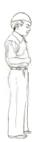
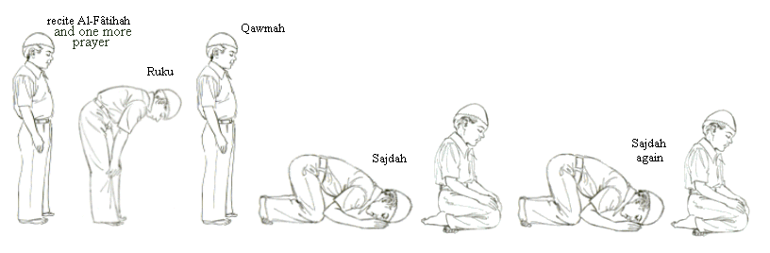

At-Tashahud:
“At-tahiy-yatu lil-lah was salawatu wat-taybaat.
As-salamu alaykam ay-yahan-nabiy-yu
Wa rahma tullahi wa barakatu
As-salaamu alayna wa’ala ibadi his-saliheen.
Ash hadu anla ilaha illal lah
wa ash hadu an-na Mohammadan ab-duhu wa rusool.”

Al-Fajr (2 Rakaats)

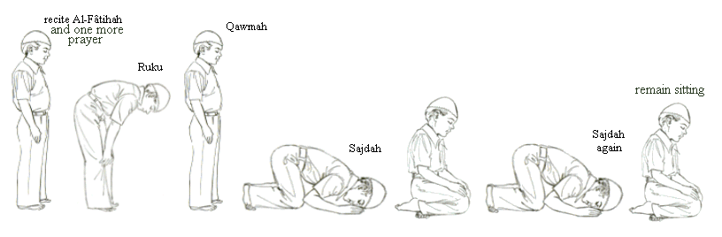

Al-Dohr, Asr, Isha or Mughrib
2nd

Supplication:
“Allah-Hu-Ma Sa-li A-Laa Muhammad
Wa A-Laa Aa-Lee Muhammad”
Salaam:
“Assalamu alaykum
wa rahmatullahi wa barakatuh”

Say only Tashahud and no more.

remain sitting

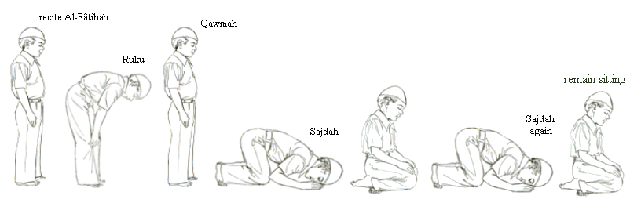
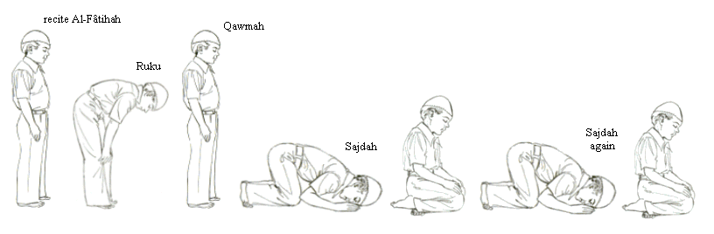
3rd

Al-Mughrib (3 Rakaats)
Al-Dohr, Asr or Isha (4 Rakaats)
4th

Salaat

Salaat has been practiced since the birth of Prophet Adam. Adam’s first words to Allah Subhanahu wa ta’ala were Bismillah ir-Rahman ir-Rahim and as creation once again returns to the oneness of Allah our words shall be Bismillah ir Rahman ir-Rahim. Prophet Adam shared his love this way and so shall we.

When you speak Allah listens, when you are silent Allah listens to the voice of your heart, the voice of the soul that strives to free it’s self from the cages of your own lower desires. The inward importance of Salaat is of the inward importance of the Qur’an.

If the oceans were ink and the trees writing instruments you would still not be able to write the entirety of Salaat. This guide you hold in your hands is but a stepping stone of the basics, a starting point in the great mystical journey to the golden Mosque within our hearts.

The best way to learn Salaat lies in instruction from a Muslim teacher, friend, or family member. In using this guide, practice Salaat carefully, keep it next to you for reference as you perform the routines. Any part you are confused or unsure about, you must ask a practicing Muslim.

The passing of the rites of Salaat is a time honoured Islamic tradition that passed from Allah to Prophet Adam to Prophet Ibraham to Prophet Isa to Prophet Muhammad (peace be upon them) and to you.

In Salaat every muscle of the body joins the soul and the body in the worship and celebration of the glory of Allah. Salaat is a matchless and unprecedented formula of meditation, spiritual devotion, moral elevation and physical exercise, all combined; where one motion equals a thousand years of awakening.

Truly Salaat is one of the greatest gifts Allah provided to us. It is a blessing to be guided to the beauty and strength that lies at the center of true prayer. For in Salaat the heart, the recitations, and body postures of the true believer, the Muslim, the complete person, seek only one truth and it’s the eternal remembrance of
La ilaha illa Allah!

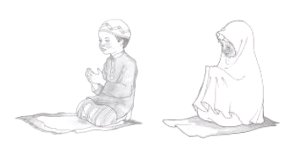

Ikhlas (Sincerity) to Allah

Which means to do good deeds purely for the pleasure of Allah and not out of self-conceit to seek appreciation or praise from people.

Kaliph Omar ibn Al-Khattab said: I heard Allah’s Messengers saying "The reward of deeds depends upon the intentions, and every person will get the reward according to what he has intended. Thus he whose migration was for Allah and His Messengers, his migration had been for Allah and His Messenger, and he whose migration was to achieve some worldly benefit or take some woman in marriage, his migration had been for that for which he migrated."
The belief in Tawhîd (Oneness of Allah)

"If you join others in worship with Allah, then surely all your deeds will be in vain, and you will certainly be among the losers" Revelation to Prophet Muhammad peace be upon him.
Deeds must be in accordance with the Qur’an and the Sunnah.

The third condition implies that we as Muslims should refrain from committing innovation or fabrication in religion. We should know that Islaam is a perfect religion. It is not only complete, but applies to all generations at all times, under any circumstances. The Prophet S.A.W. serves as the best example for all of us. He not only stresses the importance of knowing and holding on to the Qur’an and Sunnah, but also warns us to avoid Bid‘ah (innovation or fabrication) in our religion.
Deeds

Allah Subhanahu wa ta’ala bestows love on those who believe and work deeds of righteousness, He listens to those who believe and do deeds of righteousness and gives them an increase of His Bounty. He grants the need of every creature. His bounties are not closed to any one. This is the reason why non-Muslims who desire and work for material prosperity, fame and other needs in this world attain success in this temporary life. They receive Allah’s reward for any righteous deed or virtuous act done in this world. If they desire happiness in this present world and work for it, Allah grants them their needs. However, their rewards will only be temporary because they do not meet the (below) conditions by which good deeds are rewarded both in this present life and in the eternal life Hereafter.

Abu Hurairah narrated that the Prophet S.A.W. said "Allah ordered the appointed angels over you that the good and the bad deeds be written. If somebody intends to do a good deed and he does not do it, then Allah will write for him a full good deed in his account with Him. If he intends to do a good deed and actually did it, then Allah will write it for him in his account its reward equal from ten to seven hundred times to many more. If somebody intended to do a bad deed and he does not do it, then Allah will write a full good deed in his account, and if he intended to do it (a bad deed) and actually did it, then Allah will write one bad deed (in his account)."

For Allah (High and Exalted is He) is the best of Judges, the most merciful is He.

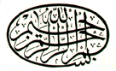


Judgement Day Faith In The Last Day

..We believe that there will be another life after this short life..

When the determined term of this world comes to an end, Allah Subhanahu wa ta’ala will command an Angel to sound the Trumpet and all mankind and other creatures will die, all the world will move towards destruction, disintegration and everything will be annihilated.

Then the Angel will sound it again, when, behold, all dead since Prophet Adam will stand out of their graves.
Then, Allah will gather all people to account them for what they did. On the Day of Judgement everything will be accounted. Anyone who has done an atom’s weight of good and an atom’s weight of evil shall see it. Allah will take account everything on the scales of justice so that not a soul will be dealt with unjustly in the least. Allah will reward all Muslims who follow the Qur’an and Sunnah and do good deeds solely for His Pleasure. He will reward us insh'Allah, if not in this world, then surely in the Hereafter.

Allah states “As for those who had transgressed all bounds; and had preferred the life of this world; the abode will be Hell-Fire. And for those who had feared of standing in front of their Lord’s Tribunal; and had restrained their souls from lower desires; their Abode will be Paradise.”

Those who rejected the Messengers and disobeyed Allah’s commands, will be put in Hell. In Hell Fire, they will be in continuous eternal punishment. One's evil deeds will be manifested in hideous, loathsome, terrifying, harmful figures and will be a source of pain, suffering and torture.
Those who believed in Allah, accepted the Messengers and did good deeds for Him, He will put them in Paradise, where they will enjoy eternal bliss. Virtuous deeds and acquisitions will be manifested in beautiful, attractive, pleasant figures and will be a source of eternal joy and happiness.

To seek help or forgiveness from other than Allah is shirk. This is considered even greater shirk, there is none more misguided than the one who calls on other than Allah for sustenance and provision. Calling for others beside Allah is no benefit in this world and leads to disbelief (Kufr).
It is clear that those who practice the ways of polytheism, hypocrisy, innovation in religion and Kufr in Islam will have grievous punishments in Hell-Fire. The hypocrites and non-Muslims must turn to Islam as it is the only salvation. Verily, the polytheists, the hypocrites, the innovators in religion and the unbelievers will go to Hell-Fire, if they die in non-Islamic way or condition

Worshipped idols are not only considered as other gods and goddesses, statues and relations of God, but humans (particularly people in a position of fame) and material objects (cars,
money, sport, music, television, adornments).
To seek refuge in anyone other than Allah is shirk. Though it is possible that one may achieve worldly benefits from a thing such as prevention of harm and evil, it does not mean that it is not shirk.

Shirk

(associating partners with Allah in worship)

..Whoever dies in a state of shirk, will not be forgiven and not be allowed into Paradise..

- Major shirk – Hypocrisy (“Nifâq”), praying and worshipping idols (polytheism), disbelieving in the Oneness of Allah Subhanahu wa ta’ala

- Minor shirk - To swear by those other than Allah Subhanahu wa ta’ala. To vow other than that to Allah is an act of shirk. Since making a vow is an act of worshipping Allah, vowing other than to Allah is shirk.

- Disguised major or minor shirk - To do good deeds without sincerity (“Ikhlas”) and beautify them to be seen by people, pretending to be true Muslims and concealing one’s faith.

Qur’an, Sunnah and Hadith

The Qur'an is a Message from Allah to humanity. It was transmitted to us in a chain starting from the Almighty Himself to the Angel Gabriel to the Prophet Muhammad. This message was given to the Prophet in pieces spanning 23 years (610 CE to 622 CE). The Prophet was 40 years old when the Qur'an began to be revealed to him, and he was 63 when the revelation was complete. The language of the original message was Arabic, but it has been translated into many other languages.

The Qur'an is one leg of two which form the basis of Islam. The second leg is the Sunnah of the Prophet. What makes the Qur'an different from the Sunnah is primarily its form. Unlike the Sunnah, the Qur'an is quite literally the Word of Allah, whereas the Sunnah was inspired by Allah but the wording and actions are the Prophet's. The Qur'an has not been expressed using any human's words. Its wording is letter for letter fixed by no one but Allah.

Prophet Muhammad was the final Messenger of Allah to humanity, and therefore the Qur'an is the last Message which Allah has sent to us. Its predecessors such as the Torah, Psalms, and Gospels have all been superceded. It is an obligation and blessing for all who hear of the Qur'an and Islam to investigate it and evaluate it for themselves. Allah has guaranteed that He will protect the Qur'an from human tampering, and today's readers can find exact copies of it all over the world. The Qur'an now is the same as the one revealed to the Prophet.

In Islam, the Arabic word Sunnah has come to denote the way Prophet Muhammad, lived his life. The Sunnah is the second source of Islamic jurisprudence, the first being the Qur'an. Both sources are indispensable; one cannot practice Islam without consulting both.

The Prophet used to teach the Sunnah to his companions in word and deed, and urged them to follow it, as he said in his Hadith “Adhere to my Sunnah” and “Whoever neglects my Sunnah does not belong to me.” ‘Abd-Allaah ibn Mas’ood narrated that the Messenger of Allah said “There is no Prophet whom Allah sent to any nation before me, but he had disciples from among his nation, and companions who followed his Sunnah and obeyed his commands.”
Some aspects of the Sunnah are waajib (obligatory) and some are mustahab (encouraged). The Muslim should follow the Sunnah of the Prophet, whether it is waajib or mustahab, as long as it is proven in sound reports. The Sahaabah (companions of the Prophet) used to spread the Sunnah of the Prophet among people and they called people to follow it.

The Arabic word Hadith (plural: Ahadith) is very similar to Sunnah, but not identical. A Hadith is a narration about the life of the Prophet or what he approved, as opposed to his life itself, which is the Sunnah as already mentioned.



geocities.com/teachmesalaat

