Wu, Xiu Mei
801, Humanities
10-23-02

Argument on Ad that is Offensive to Me

Everyday when you are walking down the streets, you can see that there are a lot of ads; ads that make you become desensitized and don’t feel the emotional feelings that you are suppose to normally have. Calvin Klein for example is a form of ad that manipulates us into thinking things that we don’t want to think about. They show us images of people showing so much skin that it makes us think that it’s no big deal when seeing people in reality do so is fine. It gets us into thinking that there is no limit in doing inappropriate things. Showing female models that are ultra thin and male models that are ultra muscular, big, buffed, strong and powerful, gets us into believing that we are not as good as models, and we want to change who we truly are, making ourselves have artificial body shapes and gives us habits and behaviors that are stubborn and unhealthy. All this kind of images lowers our self-images and self-esteem making us only care for outer beauty.

Coming upon a series of ads that are insulting, offensive, annoying and just nasty, the series of Calvin Klein Men’s Cologne. Even though they try to accomplish that sexy and dirty idea of what the cologne will bring, you see that the ideal image only applies to the models and participants in the ad, and not the consumers that are going to put on his cologne. So far, the many ads that are advertising Calvin Klein products uses incredibly good looking and sex-related images, and I can’t believe people are drawn into the fact that putting on colognes like Escape and Obsession from CK can give them the comfort and more important stats that they want.

The ads are shown to be repulsive and down earth inappropriate for kids. If youths see it they will give a face and a laugh of naked people walking around showing their muscular and thin butts. While adults will find it attracting and what to be like them, having the same body figure and muscular thighs. Old people would feel the same way as I do right now, they might say something like “Oooh… look at those kids these days, showing so much skin,” in their little squeaky voices.

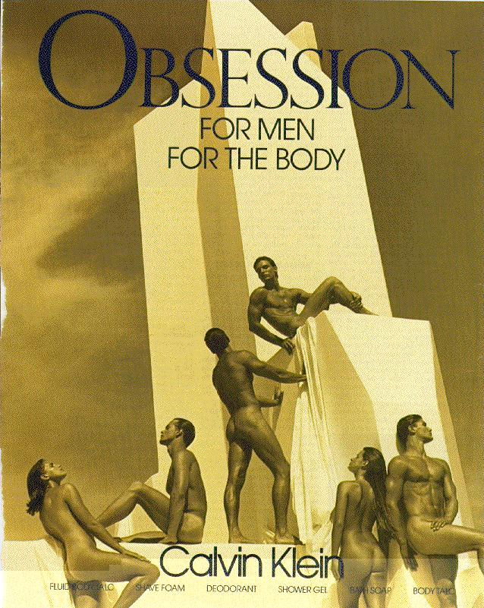
When advertising for a man’s product, Calvin Klein usually uses woman in a sexual perspective, making them seem like they are meant to be sexual objects. Shown on this ad of Obsession for men from Calvin Klein, Women in this ads shows a lot of their skin and also they show parts of their private parts, like a bit of their breast and having their butt as the part that they would like to show for the ad. Taken this picture from a close up shot, filling in all the parts of the ads with the whole bottle of Obsession Lotion, they made the product bigger by computer enhancing it into a gigantic status making it have power even though it is not alive. They make the product more bigger then the people also, because they wanted to show you that expensive product is the key to having power, and control, if you don’t use this product you will not be popular and get the satisfaction that you want, ether will you get the self image that you want other people to see you as. They make the scene look extremely tan and the people are a darker shade of penny color. They show the viewers that they can get this kind of body, power and sexy look if only you use Obsession for Men. All this kind of hints that the Advertisers is trying to give you, is saying that men can get naked women, and they can become muscular just by simply purchasing this product and using it.

People who are influenced by what they see in the media world, denies the truth that they are being manipulated. They don’t want to face the truth that they are becoming obsess with certain things that they have never care about until they saw other people having the same thing but better then them. Owen and Walsh (2002) stated that, “Nevertheless, in spite of this view, Dyer argues that much of the population (Especially you students here at MAT) is skeptical of this phenomenon and will deny that they are influence by such ‘lies.’ (Dyer 1982:72)” (Pg. 1).
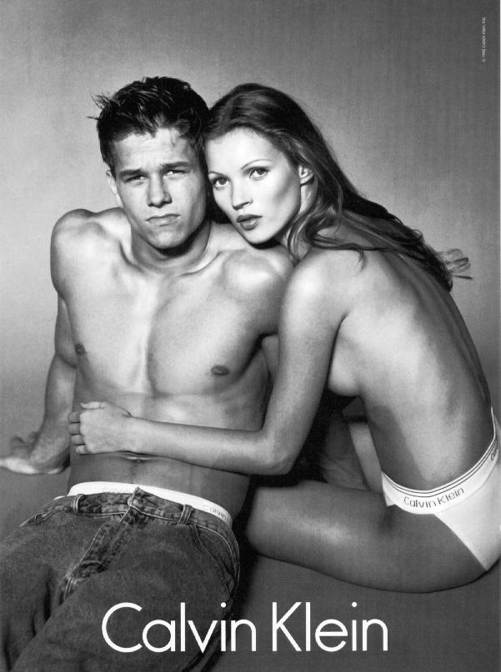
When being the stereotypical appeal for ad, women appears to be more low stats then men, women has to do the action that will make the men look powerful, strong and higher stats. The woman that is shown on this Calvin Klein ad has to hold on to the man, which is next to her, giving him the pleasure, and idea that she goes to him for improvement and also protection. This not only gives the man higher stats but also shows that he is macho and relievable on. In this picture, the scene is all black in the background, making the 2 people in the ads look very light colored and also making them seems like the center of attraction. If you wear Calvin Klein Briefs for both Women and Men, you can get what the 2 models are getting in the ad; find your mate, someone that will match you up very nicely and prettily. Women are being put into both sexual positioning and also they are so ultra thin, that it lowers the self-esteem and ideal self-image of how other women see themselves.

They are trying to appeal it to young adult that are in their teenage years. Making them feel that they are going to be very sexy, popular and nice looking by dressing up in Calvin Klein Clothing and putting on Calvin Klein product. The models weights about 23% less then average people, Chris (2002) supports my idea by arguing that “Researchers have found that girls and women who work as models weight 23% less than the average female their age” (Pg.1). And they do this by surgery and becoming anorexic or bulimic.

These ads ruin our self-image and self-esteem, making people feel that they are not as good as people in the ads. Do not give in your self-image and esteem just because how other look better than you. Choosing to put yourself in that position, you will deal with feeling bad every time you meet or see someone better then you, especially when there are a lot of people in this world that are, even if you are the best, there will always be someone that is much better. Be happy for who you really are and don’t put yourself into the position of thinking negatively, think positive and make yourself feel good about yourself, do something that will make your self image and self-esteem more strong, by showing others you are beauty on the inside and not only on the outside.

