Name Nick DiMucci

Date 4/30/07
Fetal Pig Dissection
Introduction: Animalia is the kingdom that we are most familiar with and includes organisms such as humans, dogs, whales, and reptiles. In this laboratory you will study the anatomy of the fetal pig. Pigs are very similar to humans, and much of the experimental cloning of human organs is being conducted on pigs.

Purpose:
- The purpose of this lab is to explore why pigs are used as dissection specimens.
- The purpose of this lab is to compare the digestive and circulatory systems of pigs and humans.
- The purpose of this lab is to review the function of the: mouth, esophagus, stomach, small intestines, large intestines, gallbladder, liver, rectum and anus.
- The purpose of this lab is to review the basic function and purpose of the circulatory system.

Key Anatomical Directions (in reference to the specimen)
Dorsal –
Ventral –
Anterior –
Posterior –

Proximal-

Distal-

Superficial-

Anatomical Position-

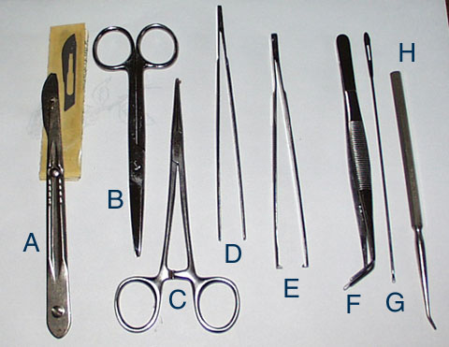
Dissection Kits:

A. Scalpal

B. Scissors

C. Scissors

D. Tweezers

E. Tweezers

F. Tweezers

G.

H.

Rules for Dissection
- Whenever possible use scissors over scalpel.
- Never carry dissection tools face out.
- Always pin or tie the specimen to the dissection tray before dissecting.
- Never cut with excessive force. It is better to have to re-cut than to cut too deep.
- Never make a cut without being told to do so. (YOU CAN’T TAKE IT BACK.)
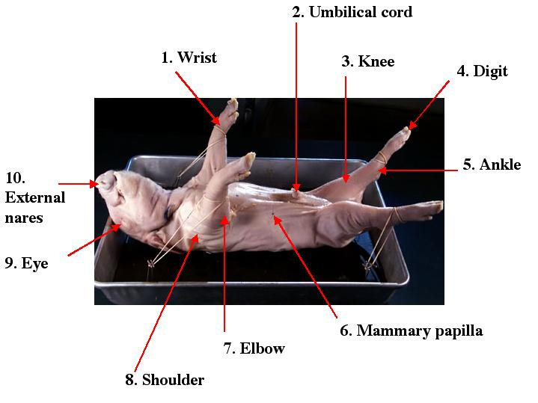

External Anatomy

Directions:
- Rinse your pig to remove all excess preservative.
- Place your pig in a dissection pan ventral side up.
- Examine your pig and locate all of the structure located above.
- Decide whether you pig is male or female ________________.
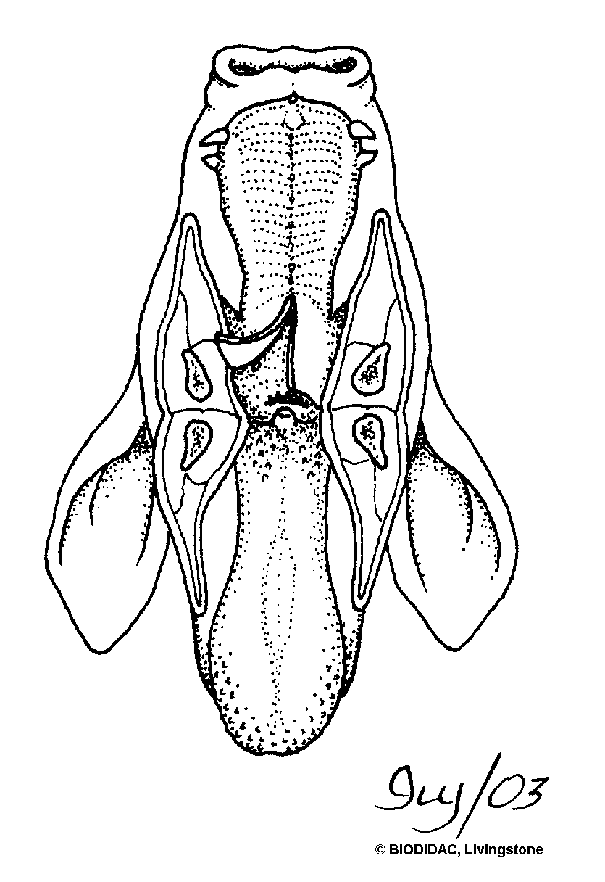
- Open the mouth of your pig using forceps or a probe to investigate the type of oral cavity. Try and find the following structures: esophagus, tongue, and epiglottis.
- Once you have completely examined the external anatomy of your pig, wrap you pig as instructed, clearly label you pig and clean thoroughly your dissection area.
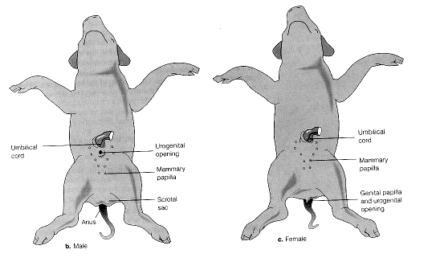

Internal Anatomy

Directions:
- Place pig ventral side up in the dissection pan.
- Pin CAREFULLY all four limbs down to the pan. Do not make a cut until you are sure the specimen is secure.
- Make your first cut using the scalpel posterior to anterior. CUT AROUND NOT THROUGH THE UMBILICAL CORD.!!!!!!!
- Just above the umbilical cord make a lateral cut.
- Just below the jugular and above the forelimbs make another lateral cut. At this point your incisions should look like a capital “I”.
- Slowly are carefully pull back all of the layers of the epidermis. You may need the assistance of scissors.
- Pin the epidermis to the tray so you have a clear field.
- Using the provided diagram locate and remove the alimentary canal.
- Follow instructor’s instructions from this point forward.
- Note the thin peeling layer of tissue covering the body of your pig. This layer is the epitrichium, a layer of embryonic skin that peels off as hair develops beneath it.

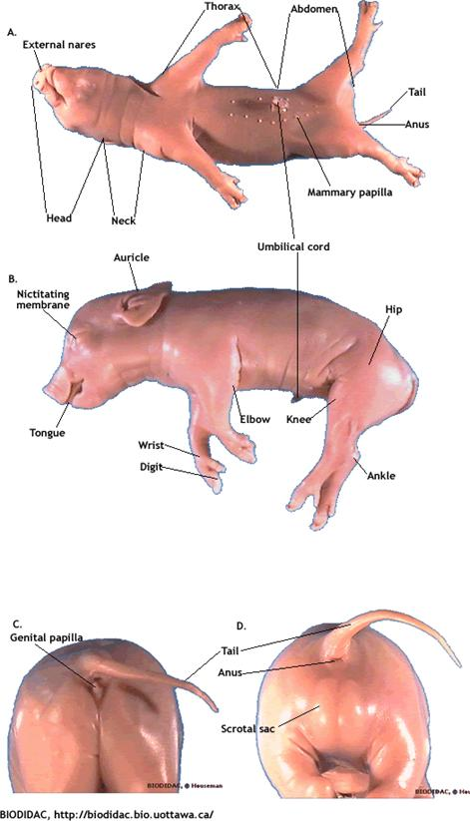
Identify the regions of the body :
- head (cranial) region
- neck (cervical) region
- trunk region (thoracic region)
- tail (caudal) region (abdomoninal region)

Head: Find the following:
- pinna (auricle): external ear
- external nares (nostrils)
- upper and lower eyelids
- nictitating membrane (third eyelid)

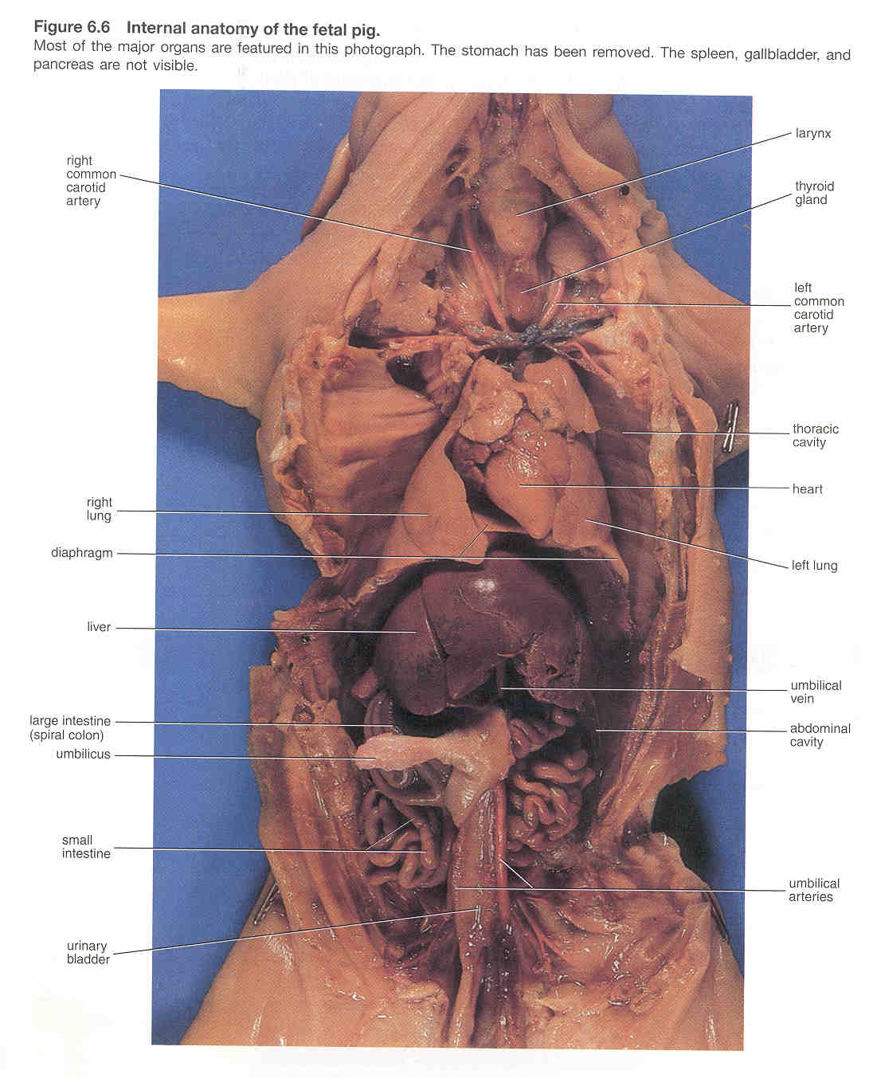

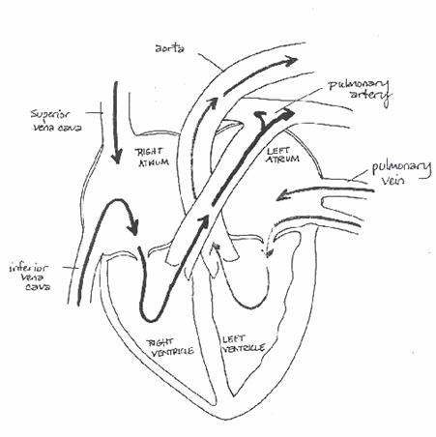

Answer the following concluding questions after you have completed your dissection. Please these questions should be answered in numbered form, typed and incomplete sentences. This is a major part of your grade. Do the research!

1. Identify and describe the function of the main organs and structures in the respiratory system.
The main organs are the trachea which filters the air we breathe and branches into the bronchi. The bronchi that are two air tubes that branch off of the trachea and carry air directly into the lungs. The diaphragm which function is when you breathe in, the diaphragm contracts. When it contracts it flattens out and pulls downward. This movement enlarges the space that the lungs are in. This larger space pulls air into the lungs. When you breathe out, the diaphragm expands reducing the amount of space for the lungs and forcing air out. The diaphragm is the main muscle used in breathing. And the lungs. In the lungs oxygen is taken into the body and carbon dioxide is breathed out.

2. Describe the movement of air into and out of the lungs.
Oxygen enters the respiratory system through the mouth and the nose. The oxygen then passes through the larynx and the trachea which is a tube that enters the chest cavity. In the chest cavity, the trachea splits into two smaller tubes called the bronchi. Each bronchus then divides again forming the bronchial tubes. The bronchial tubes lead directly into the lungs where they divide into many smaller tubes which connect to tiny sacs called alveoli. The average adult's lungs contain about 600 million of these spongy, air-filled sacs that are surrounded by capillaries. The inhaled oxygen passes into the alveoli and then diffuses through the capillaries into the arterial blood. Meanwhile, the waste-rich blood from the veins releases its carbon dioxide into the alveoli. The carbon dioxide follows the same path out of the lungs when you exhale.
3. Apply this knowledge to organismal adaptive strategies and problems in human physiology.

4. Describe how the circulatory and respiratory systems work together to bring about the integrated functioning of the body.

The respiratory system in organs deliver oxygen to the circulatory system for transport to all body cells. Oxygen is essential for cells, which use this vital substance to liberate the energy needed for cellular activities. In addition to supplying oxygen, the respiratory system aids in removing of carbon dioxide, preventing the lethal buildup of this waste product in body tissues.

5. Notice how the number of toes is reduced in your pig. The middle two digits form hooves. Ungulates (hooved animals) like the pig walk with the weight of the body borne on the tips of the digits (unguligrade locomotion). Cats and dogs use digitigrade locomotion (walking on the balls of their feet). Humans typically use the entire foot for walking (plantigrade locomotion). What form of locomotion do you use when you sprint? Which is more of an evolutionary adaptation for speed? Explain.
We use unguligrade locomotion when we sprint. Unguligrade more evolutionary because humans normally walk around using plantigrade locomotion but switch to unguligrade when sprinting because it’s a better form of locomotion than plantigrade.

6. Why are arteries injected with a red latex and veins injected with a blue latex? What do each indicate in relationship to the amount of oxygen contained within them.
So we can see them better and identify the two and because the veins are naturally blue and arteries naturally red. Veins contain no oxygen while arteries are rich in oxygen.
7. The dual circulation of mammals is reflected not only in separate pulmonary and systemic circulatory systems, but also in the four-chambered heart. Fish blood leaves the heart, goes to the gills for oxygenation, and then continues out to the body. How many atria do fish have? How many ventricles?
One atrium and ventricle.

8. Some salamanders that "breathe" (exchange gases) through their damp skins have lost their lungs. Do you think their hearts have one or two atria?
Two atria.

9. The condition known as jaundice (yellow skin and eyes) is a result of a build-up of bilirubin and is usually a sign of liver malfunction. Newborn human infants often go through a period of fetal jaundice in which they turn yellow. This usually reflects not a liver malfunction, but rather the destruction of huge numbers of red blood cells. Why would newborns be cashing in so many red blood cells? In serious cases, neonates are often put under special lights that promote the breakdown of bilirubin. However, recent evidence demonstrates that bilirubin is a potent anti-oxidant. Why would a neonate need so many anti-oxidants?
Bilirubin is a byproduct of the normal breakdown of red blood cells. The liver processes bilirubin so that it can be excreted by the body as waste. At birth, a baby's liver is still developing its ability to process bilirubin. Therefore, bilirubin levels are a little high at birth and jaundice is present to some degree in almost all newborns. This form of jaundice usually appears between day 2 and 5 and clears by 2 weeks. It usually causes no problems. Potentially toxic oxygen free radicals (OFRs) are generated continuously in neonates. Under physiological conditions, the human body has developed a complex network of antioxidant defenses sufficient to protect cells against oxidative damage. Oxidative stress results from a loss of this protective balance either because of overproduction of free radicals or because of inadequate antioxidant defenses. In prematures, the concentrations of most antioxidant enzymes are reduced, particularly during the early neonatal period. Impaired antioxidant defenses, occurring at a time when OFR production is both frequent and severe, render the premature neonate extremely susceptible to the development of OFR-mediated diseases.

10. Identify and describe the function of the main organs and structures in the circulatory system.
The heart pumps your blood and keep the blood moving throughout your body. The blood transport oxygen to all the cells in the body and remove waste. Red Blood Cells are responsible for carrying oxygen and carbon dioxide. White Blood Cells help the body fight off germs. Platelets are blood cells that help stop bleeding. Plasma is the liquid part of the blood. Arteries are blood vessels that carry oxygen rich blood away from the heart. Capillaries are tiny blood vessels that connect arteries to veins. Nutrients, oxygen and wastes pass in and out of your blood through the capillary walls. Veins carry blood back toward your heart.

11. Trace the flow of blood through the pulmonary and systemic circuits.
Deoxygenated blood returning from the organs and tissues of the body travels from the right atrium of the heart to the right ventricle. From there it is pushed through the pulmonary artery to the lung. In the lung, the pulmonary artery divides, forming the pulmonary capillary region of the lung. At this site, microscopic vessels pass adjacent to the alveoli, or air sacs of the lung, and gases are exchanged across a thin membrane: oxygen crosses the membrane into the blood while carbon dioxide leaves the blood through this same membrane. Newly oxygenated blood then flows into the pulmonary veins, where it is collected by the left atrium of the heart, a chamber that serves as collecting pool for the left ventricle. The contraction of the left ventricle sends blood into the aorta, completing the circulatory loop.

12. Identify and describe the functions of the main organs of the digestive system.
The mouth is the first structure through which food passes in the process of digestion. Saliva, excreated into the mouth from adjacent salivary glands, is slightly acidic and is used to soften and begin chemically breaking down the food. The esophagus is the tube that connects the pharynx to the stomach. The stomach both chemically and mechanically digests food. The small intestine is where most of the digestion and absorption occur. The large intestine serves to manufacture certain vitamins, complete absorption and form and expel feces from the body.
13. Saliva contains water (to moisten food), mucus (to lubricate food), salivary amylase (to break down starch), bicarbonate (to buffer acids in food), and antibacterial agents. Why might these last three components be necessary when the stomach is the next destination anyway?
Proteins are chemically digested by pepsin and hydrochloric acid.
14. In humans, the uvula hangs as a pendant from the posterior end of the soft palate. During swallowing, it lifts upward and closes off the nasal passage. Why is this important?
So food doesn’t enter the trachea and we don’t choke.
15. Is diarrhea a defense strategy to rid your body of pathogens or a way for intestinal pathogens to spread to others (still occurs in less developed countries with no sewage treatment)?
A way to spread intestinal pathogens to others.
16. In olden days, coal miners often suffered from rickets, a disease characterized by brittle bones. Miners rarely see the sun, a "source" of vitamin D. What's going on here?
Vitamin D is required for proper calcium absorption from the gut. In the absence of vitamin D, dietary calcium is not properly absorbed, resulting in hypocalcemia, leading to skeletal and dental deformities and neuromuscular symptoms.
17. Would you expect carnivores to have longer or shorter intestines than herbivores?
Shorter.
18. What happens if the contents of the colon pass too rapidly through the colon? too slowly?
Contents that pass rapidly through the colon and little water is reabsorbed resulting in diarrhea. Too slowly causes constipation.
19. Why does the trachea have cartilaginous rings?
So it doesn’t easily collapse.

  - Why is it important for air to be moist when it enters the lungs? Many desert mammals have extremely convoluted nasal cavities. How might these large and complex nasal cavities conserve water during exhalation?
Oxygen must be dissolved in water for us to uptake it. The cells that make up the liver are packed with objects called mitochondria. The mitochondria change food into energy for growth and other functions in living things. This process requires oxygen, and the oxygen comes from air that animals breathe. By shrinking their livers during times of extreme water shortages they decrease the number of active mitochondria.

